Predicting Clinical Trial Enrollment Failure from Trial Design and Eligibility Criteria
Team members: [Name 1], [Name 2], [Name 3], [Name 4], [Name 5]
Project repository: [GitHub link]
Date: [Date]

Summary
Clinical trials are the main way new treatments are tested, yet a substantial share of trials stop before they finish. Among trials that report why they stopped, the most common reason is that they could not enroll enough patients. Early termination wastes funding, delays access to new therapies, and exposes enrolled participants to research that never produces an answer. One factor that trial designers control directly is the eligibility criteria, the rules that determine who may join a study. Very strict or complex criteria may shrink the pool of eligible patients, but designers currently have little evidence to tell them, before launch, whether their criteria put the trial at risk.
This project uses the Aggregate Analysis of ClinicalTrials.gov (AACT) database, a free, daily-updated relational copy of ClinicalTrials.gov containing more than 600,000 registered studies with information on each trial’s status, stated reason for stopping, design, sponsor, sites, and full-text eligibility criteria. We will (1) statistically analyze which trial characteristics are associated with early termination, (2) convert the free-text eligibility criteria into measurable features, (3) build a classification model that predicts, using only information available when a trial starts, whether it will complete or be terminated for low enrollment, and (4) measure how much the eligibility criteria improve that prediction by comparing models with and without them. We will also check whether any effect of strict criteria survives after accounting for the type of disease being studied, and package the results in a simple tool that flags high-risk eligibility criteria.

Proposed Plan
Data processing. We access AACT through its hosted PostgreSQL database using Python (SQLAlchemy and pandas) and save a single frozen extract as Parquet files so that every team member works from identical data. The study cohort consists of interventional trials that started between 2008 and 2020. A trial is labeled positive if its status is “Terminated” and its stated reason for stopping concerns enrollment or accrual, and negative if its status is “Completed”; trials stopped for other reasons are retained for the statistical analysis but excluded from the classifier. Because stopping reasons are free text, they are first categorized with keyword rules and then refined with a zero-shot or large-language-model classifier, which will be validated against approximately 500 hand-labeled trials using Cohen’s kappa. To prevent data leakage, we exclude every field that is updated after a trial ends (actual enrollment, number of sites and countries, completion dates) and use only information recorded at registration. Eligibility text will be converted into structured features, such as the number of inclusion and exclusion items, age limits, laboratory thresholds, prior-treatment requirements, and comorbidity exclusions, using biomedical natural language processing (scispaCy or medspaCy) and schema-constrained extraction, and these will be combined into a single strictness score.
Statistical and machine learning methods. The statistical analysis will use chi-square tests and multivariable logistic regression to estimate adjusted odds ratios for termination across phase, sponsor type, design, disease area, and eligibility features. Kaplan–Meier curves and Cox proportional hazards models will describe how quickly trials stop, and a Fine–Gray competing-risks model will separate termination for low enrollment from termination for safety, efficacy, funding, or business reasons. For prediction, we will compare a baseline model using design features only against a full model that adds eligibility features, using regularized logistic regression and gradient-boosted trees (XGBoost or LightGBM), with a fine-tuned clinical language model (BioClinicalBERT) applied to the raw criteria text as an extension. SHAP values will identify which criteria contribute most to predicted risk. Because strict criteria are common in rare and severe diseases that are inherently hard to recruit for, we will control for disease area (derived from MeSH condition terms), a rare-disease indicator from Orphanet, and the number of competing trials recruiting for the same condition, using propensity score weighting and mixed-effects models with E-value sensitivity analysis. Results will be visualized with matplotlib and seaborn, and the final model will be deployed as a Streamlit web application. All code is managed in a shared GitHub repository.
Evaluation. Positive cases make up only about 5% of labeled trials, so accuracy is not a meaningful measure. Models will be evaluated on the area under the precision–recall curve (primary metric), the area under the ROC curve, F1 score, and calibration (Brier score and calibration plots). To reflect real-world use, models will be trained on earlier trials and tested on later ones rather than on a random split. The contribution of eligibility criteria will be measured as the difference in performance between the baseline and full models, with bootstrapped 95% confidence intervals. The keyword and model-based stop-reason labels will be judged against hand labels (target kappa of at least 0.8), eligibility feature extraction against a manually annotated sample (precision, recall, and F1), and confounding adjustment by covariate balance (standardized mean differences below 0.1). The project will be considered successful if the full model improves meaningfully on the baseline and the eligibility effect remains after adjustment for disease type, or, if it does not, if we can show convincingly that disease type rather than criteria explains enrollment failure.

Preliminary Results
We have connected to AACT, extracted the cohort, and completed an initial exploratory analysis. The cohort contains 231,776 interventional trials that started between 2008 and 2020, with no duplicate records. Of these, 156,707 completed and 20,039 were terminated. Enrollment was the most common reason for termination (7,886 trials, 39% of terminations), well ahead of business decisions, funding, safety, and efficacy, which each accounted for 5–7%. Among labeled trials, the positive rate is 4.8%, roughly one positive per twenty negatives, and it is stable across start years (4.5–5.4%). Single-factor comparisons show higher enrollment failure in Phase 2 trials (8.6%) than Phase 1 (3.0%), in academic- and NIH-sponsored trials than industry-sponsored trials (3.1%), and in trials limited to patients rather than healthy volunteers (6.2% versus 1.7%). The highest-risk combination observed so far is academic-sponsored Phase 2 trials, at 11.9%.
The clearest early signal concerns eligibility criteria. Using the length of the criteria text as a simple proxy for complexity, the termination-for-enrollment rate rises almost steadily from 1.9% in the shortest tenth of trials to 7.1% in the longest tenth (Figure 1), and the gradient is steepest in Phase 2 trials (2.7% to 10.9%). Each individual factor is only weakly associated with the outcome (Cramér’s V of 0.10 or less), indicating that a model must combine many signals, and these comparisons are not yet adjusted for disease area. The analysis also confirmed the leakage risk: the median recorded enrollment is 13 for terminated trials versus 60 for completed trials, because the field reports actual rather than planned enrollment, so it and similar fields are excluded from modeling. We further identified data-quality issues to resolve, including 37,943 trials with an unknown status that become more common in later years, 1,736 terminated trials with no stated reason, and a small number of placeholder enrollment values.
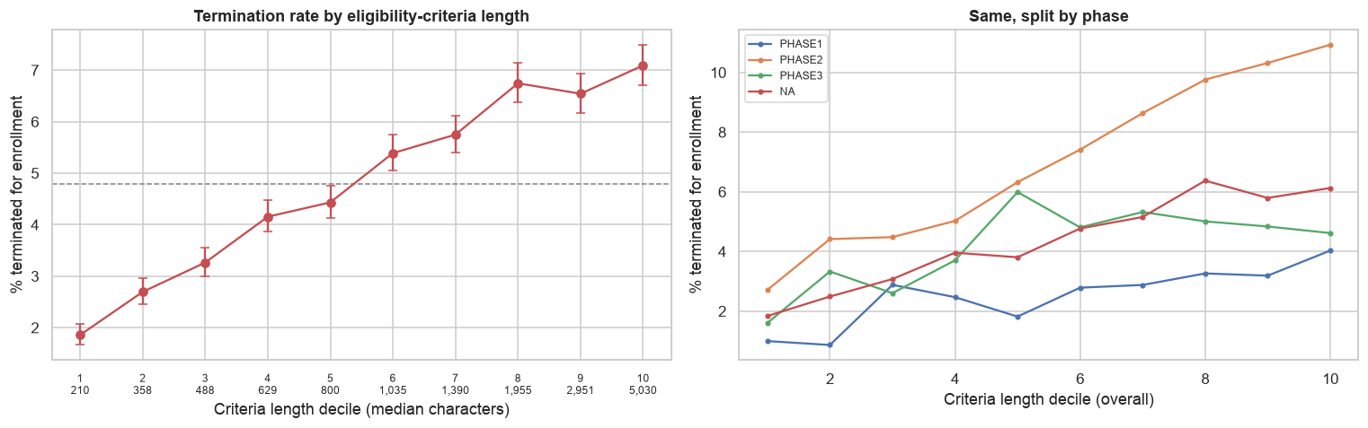
Figure 1. Percentage of trials terminated for low enrollment by length of eligibility criteria (deciles; median character count shown). Left: all labeled trials with 95% confidence intervals; dashed line is the overall rate. Right: the same trend split by phase.

Project Milestones
Weeks | Deliverable | Success check
1–2 | Data pipeline and frozen AACT extract; cohort and outcome definitions; exploratory analysis (complete) | Reproducible dataset of 231,776 trials; EDA notebook
3–4 | Validated stop-reason labels; cleaned, leakage-free feature set; disease-area feature | Kappa ≥ 0.8 against ~500 hand labels
5–6 | Statistical analysis (logistic regression, survival curves); first eligibility NLP features; baseline prediction model | Adjusted odds ratios reported; baseline PR-AUC recorded
7–8 | Full eligibility feature set and strictness score; full prediction model; competing-risks model | Extraction F1 on annotated sample; baseline vs. full comparison
9–10 | Confounding analysis (disease area, rarity, competing trials); SHAP interpretation | Covariate balance achieved; E-values reported
11–12 | Streamlit decision-support tool; draft final report | Working app that scores a pasted set of criteria
13–14 | Final report, presentation, and documented code release | All results reproducible from the repository
Table 1. Project timeline, deliverables, and intermediate success checks.

References
- Clinical Trials Transformation Initiative. AACT: Aggregate Analysis of ClinicalTrials.gov [database]. https://aact.ctti-clinicaltrials.org. Data extracted October 7, 2026.
- Tasneem A, Aberle L, Ananth H, et al. The database for aggregate analysis of ClinicalTrials.gov (AACT) and subsequent regrouping by clinical specialty. PLoS One. 2012;7(3):e33677.
- Williams RJ, Tse T, DiPiazza K, Zarin DA. Terminated trials in the ClinicalTrials.gov results database: evaluation of availability of primary outcome data and reasons for termination. PLoS One. 2015;10(5):e0127242.
- Liu R, Rizzo S, Whipple S, et al. Evaluating eligibility criteria of oncology trials using real-world data and AI. Nature. 2021;592(7855):629–633.
- Kim ES, Bruinooge SS, Roberts S, et al. Broadening eligibility criteria to make clinical trials more representative: American Society of Clinical Oncology and Friends of Cancer Research joint research statement. J Clin Oncol. 2017;35(33):3737–3744.
- Fine JP, Gray RJ. A proportional hazards model for the subdistribution of a competing risk. J Am Stat Assoc. 1999;94(446):496–509.
- Lundberg SM, Lee SI. A unified approach to interpreting model predictions. Advances in Neural Information Processing Systems. 2017;30.
- VanderWeele TJ, Ding P. Sensitivity analysis in observational research: introducing the E-value. Ann Intern Med. 2017;167(4):268–274.

