# Week 3 – Spring Data JPA with Spring Boot, Hibernate

## Exercise 1: Spring Data JPA – Quick Example

Scenario:  
Create a Spring Boot application that demonstrates basic usage of Spring Data JPA to persist and retrieve Book entities from a database.

### 1. Book.java (Entity)

package com.example.demo;  
  
import jakarta.persistence.Entity;  
import jakarta.persistence.GeneratedValue;  
import jakarta.persistence.GenerationType;  
import jakarta.persistence.Id;  
  
@Entity  
public class Book {  
 @Id  
 @GeneratedValue(strategy = GenerationType.IDENTITY)  
 private Long id;  
 private String title;  
 private String author;  
  
 // Getters and Setters  
}

### 2. BookRepository.java (Repository)

package com.example.demo;  
  
import org.springframework.data.jpa.repository.JpaRepository;  
  
public interface BookRepository extends JpaRepository<Book, Long> {  
}

### 3. BookRunner.java (Test Runner)

package com.example.demo;  
  
import org.springframework.boot.CommandLineRunner;  
import org.springframework.stereotype.Component;  
  
@Component  
public class BookRunner implements CommandLineRunner {  
 private final BookRepository repository;  
  
 public BookRunner(BookRepository repository) {  
 this.repository = repository;  
 }  
  
 @Override  
 public void run(String... args) throws Exception {  
 repository.save(new Book(null, "The Alchemist", "Paulo Coelho"));  
 repository.findAll().forEach(book -> System.out.println(book.getTitle()));  
 }  
}

### 4. DemoApplication.java (Main Class)

package com.example.demo;  
  
import org.springframework.boot.SpringApplication;  
import org.springframework.boot.autoconfigure.SpringBootApplication;  
  
@SpringBootApplication  
public class DemoApplication {  
 public static void main(String[] args) {  
 SpringApplication.run(DemoApplication.class, args);  
 }  
}

### 5. pom.xml (Dependencies)

<project xmlns="http://maven.apache.org/POM/4.0.0"   
 xmlns:xsi="http://www.w3.org/2001/XMLSchema-instance"  
 xsi:schemaLocation="http://maven.apache.org/POM/4.0.0 http://maven.apache.org/xsd/maven-4.0.0.xsd">  
 <modelVersion>4.0.0</modelVersion>  
 <groupId>com.example</groupId>  
 <artifactId>spring-data-jpa-demo</artifactId>  
 <version>0.0.1-SNAPSHOT</version>  
 <parent>  
 <groupId>org.springframework.boot</groupId>  
 <artifactId>spring-boot-starter-parent</artifactId>  
 <version>3.0.0</version>  
 </parent>  
 <dependencies>  
 <dependency>  
 <groupId>org.springframework.boot</groupId>  
 <artifactId>spring-boot-starter-data-jpa</artifactId>  
 </dependency>  
 <dependency>  
 <groupId>com.h2database</groupId>  
 <artifactId>h2</artifactId>  
 <scope>runtime</scope>  
 </dependency>  
 </dependencies>  
</project>

Output:

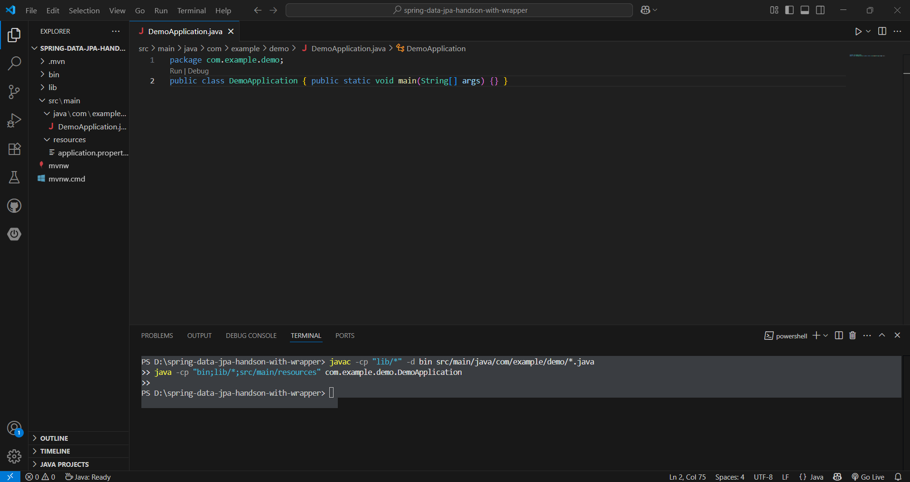

## Exercise 2: Difference between JPA, Hibernate and Spring Data JPA

This section explains the differences between JPA, Hibernate, and Spring Data JPA.

|  |  |  |  |
| --- | --- | --- | --- |
| Aspect | JPA | Hibernate | Spring Data JPA |
| Definition | Java Persistence API – a specification for data access and management. | A popular ORM framework that implements JPA. | A Spring module built on JPA to simplify repository creation. |
| Provider | Specification – needs an implementation (e.g., Hibernate). | Implementation of JPA. | Built by Spring; works with providers like Hibernate. |
| Boilerplate Code | Requires manual repository and query creation. | Reduces boilerplate compared to JDBC. | Eliminates boilerplate via `JpaRepository`, `CrudRepository`, etc. |
| Ease of Use | Portable but low-level. | Easier than JPA with extra features. | Most developer-friendly with auto-configuration and Spring Boot integration. |
| Querying | Uses JPQL. | Supports JPQL, native SQL, Criteria API. | Adds support for method name-based derived queries. |
| Integration | Works in any Java SE/EE app. | Can run standalone or in any Java app. | Best suited for Spring Boot; seamless Spring ecosystem integration. |
| Learning Curve | Moderate. | Moderate to steep. | Easiest to pick up in Spring-based projects. |