**WEEK-5**

**MICROSERVICES**

**Creating Microservices for account and loan**

* **In this hands on exercises, we will create two microservices for a bank. One microservice for handing accounts and one for handling loans.**

**ACCOUNT -**

* **AccountController.java**

package com.cognizant.account.controller;

import org.springframework.web.bind.annotation.*;

import java.util.Map;

@RestController

public class AccountController {

@GetMapping("/accounts/{number}")

public Map<String, Object> getAccount(@PathVariable String number) {

return Map.of(

"number", number,

"type", "savings",

"balance", 234343

);

}}

Output-

<http://localhost:8080/accounts/00987987973432>

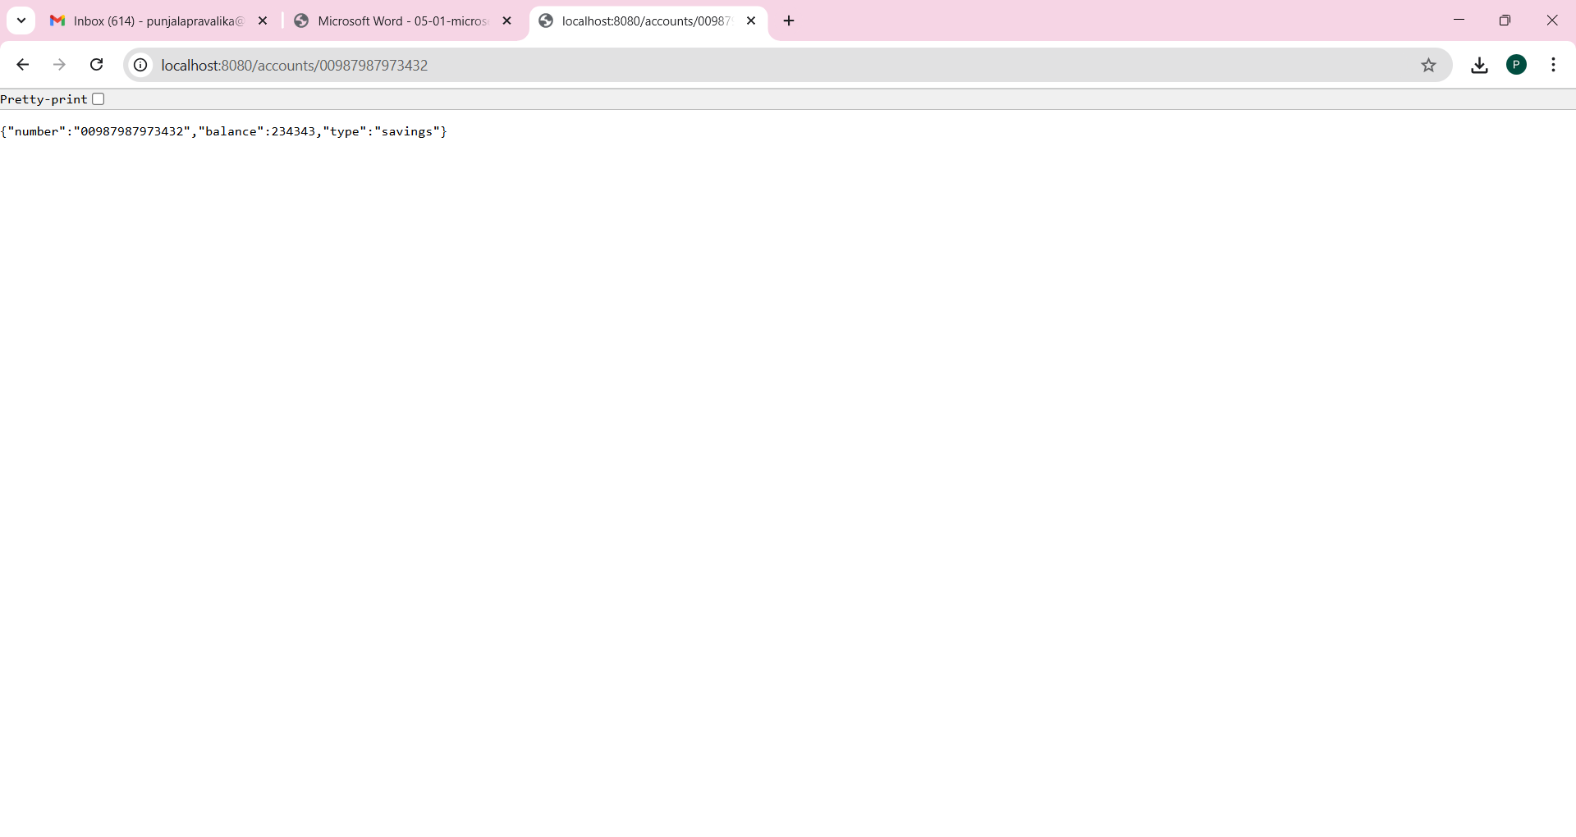

**LOAN**-

* **LoanController.java**

package com.cognizant.loan.controller;

import org.springframework.web.bind.annotation.*;

import java.util.Map;

@RestController

public class LoanController {

@GetMapping("/loans/{number}")

public Map<String, Object> getLoan(@PathVariable String number) {

return Map.of(

"number", number,

"type", "car",

"loan", 400000,

"emi", 3258,

"tenure", 18

);

}

}

OUTPUT:

<http://localhost:8080/loans/ABC123>

