- Hello
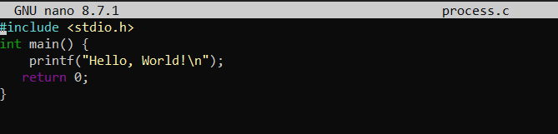
OUTPUT:-
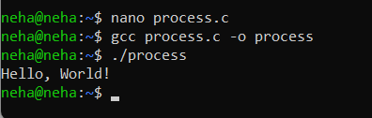

- Readname
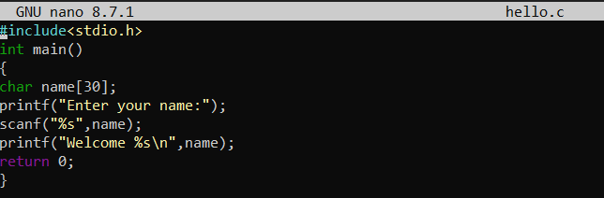
OUTPUT:-
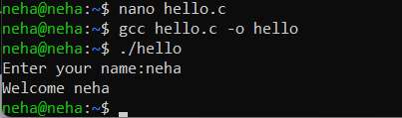

- Display
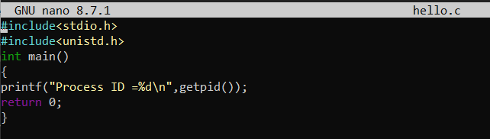
OUTPUT:-
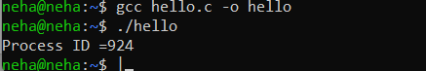

- fork one time
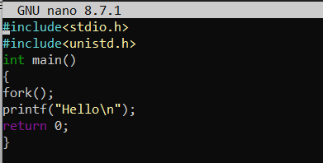
OUTPUT
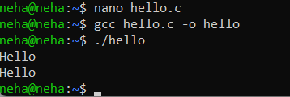

- fork for 2 times
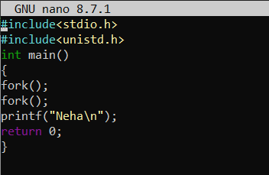

OUTPUT:-
