**A**

**Project Report**

**for OOPS Through JAVA Lab(22CS307PC)**

**On**

**“ATTENDANCE MANAGEMENT SYSTEM”  
Submitted**

**to**

**CMR Technical Campus, Hyderabad**

**In Partial fulfillment for the requirement of the Award of the Degree of**

#### BACHELOR OF TECHNOLOGY

##### in

#### COMPUTER SCIENCE & ENGINEERING

#### by

## K.NEHARIKA (237R1A05V3)

**Under the esteemed guidance of**

## Dr B. LAXMAIAH

****

**DEPARTMENT OF COMPUTER SCIENCE & ENGINEERING**

**CMR TECHNICAL CAMPUS**

***An UGC Autonomous Institute***

**Accredited by NBA & NAAC with A Grade**

**(Approved by AICTE, Affiliated to JNTU, Hyderabad)**

**Kandlakoya (V), Medchal (M), Hyderabad-501 401**

**(2024-2025)**



**CERTIFICATE**

This to certify that, the Presentation entitled **“ATTENDANCE MANAGEMENT SYSTEM”** is submitted by K.NEHARIKAbearing the Roll Number **237R1A05V3** of **B. Tech Computer Science and Engineering**, In Partial fulfillment for the requirement of the Presentation and for the award of the **Degree of Bachelor of Technology** during the academic year 2024-25.

**Subject Faculty**

**Dr B. LAXMAIAH**

**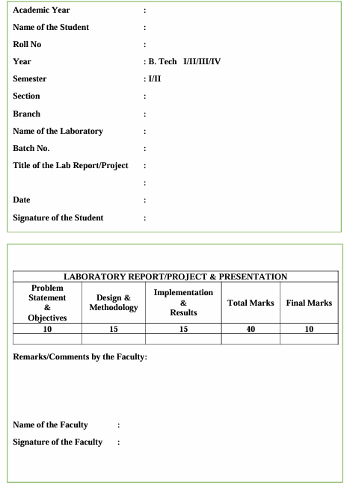**

**TABLE OF CONTENTS**

**S.No Contents Page No.**

1. ABSTRACT 5

2. INTRODUCTION 6

3. PURPOSE 7

4. OBJECTIVES 8

5. USER INSTRUCTIONS 9

6. SAMPLE CODE 11

7. RESULT 18

8. CONCLUSION 21

9. FUTURE IMPROVEMENTS 22

10. REFERENCES 23

**ABSTRACT**

* In the modern educational and corporate landscape, efficient attendance management is crucial for fostering accountability and enhancing productivity. This paper presents an Attendance Management System (AMS) developed using Java, designed to automate and streamline the process of tracking attendance for students and employees. The system leverages Java's robust object-oriented features and cross-platform capabilities to provide a user-friendly interface for administrators, instructors, and users.
* The AMS offers key functionalities such as real-time attendance marking, user authentication, and comprehensive reporting, enabling efficient record-keeping and data retrieval. A relational database is utilized for secure storage of attendance records, ensuring data integrity and facilitating easy access to historical data. By automating attendance tracking, the system minimizes human error and administrative burden while promoting transparency and accountability among users.

**INTRODUCTION**

* In today’s fast-paced educational and corporate environments, effective attendance management is essential for ensuring accountability, enhancing productivity, and maintaining accurate records. Traditional methods of tracking attendance, such as manual roll calls and paper-based systems, are often time-consuming, prone to errors, and can lead to discrepancies in record-keeping. As organizations strive for greater efficiency and accuracy, there is a growing need for automated solutions that can streamline attendance processes.
* This Attendance Management System (AMS) is developed using Java, a versatile and widely-used programming language known for its platform independence, security features, and robust performance. The system is designed to automate the process of attendance tracking, providing a user-friendly interface for administrators, instructors, and users alike. By leveraging the capabilities of Java, the AMS offers a reliable and scalable solution that can be adapted to meet the specific needs of various educational institutions and corporate environments.

**PURPOSE**

The purpose of an Attendance Management System (AMS) developed using Java is to automate and streamline the process of tracking attendance for students, employees, or participants in various settings. Here are some key objectives and purposes of such a system:

****Automation of Attendance Tracking:****

* + The primary purpose of the AMS is to automate the attendance marking process, reducing the reliance on manual methods such as roll calls or paper-based records. This improves efficiency and accuracy.

****Real-Time Data Management:****

* + The system allows for real-time attendance tracking, enabling immediate updates to attendance records. This ensures that data is current and readily available for review by administrators and users.

****Enhanced Accuracy and Reliability:****

* + By automating attendance processes, the AMS minimizes human errors associated with manual entry and tracking, thereby increasing the reliability of attendance data.

**OBJECTIVES**

The objectives of an Attendance Management System (AMS) developed using Java can vary based on the specific needs of the organization or institution, but generally, they can be categorized as follows:

**1. **Automation of Attendance Processes****

* To automate the attendance marking process, reducing manual intervention and minimizing errors associated with traditional methods.

**2. **Real-Time Attendance Tracking****

* To enable real-time recording and updating of attendance data, allowing for immediate access to current attendance records.

**3. **Improved Accuracy and Reliability****

* To enhance the accuracy of attendance records by minimizing human errors and ensuring that data is consistently recorded.

**4. **User -Friendly Interface****

* To develop an intuitive and easy-to-use interface for various users (administrators, instructors, and students) that simplifies navigation and interaction with the system.

**USER INSTRUCTIONS**

Below are step-by-step instructions on how to use the system effective:

****1. Getting Started****

****System Requirements:****

Ensure that you have the necessary hardware and software requirements to run the Attendance Management System (e.g., Java Runtime Environment, database setup, etc.).

****Login Credentials:****

* + Obtain your login credentials (username and password) from your administrator or system manager.

****2. Logging In****

* ****Step 1:**** Open the Attendance Management System application.
* ****Step 2:**** Enter your username and password in the respective fields.
* ****Step 3:**** Click on the "Login" button to access the system.
* ****Note:**** If you forget your password, use the "Forgot Password?" option to reset it.

****3. User Roles and Access****

****Administrators:****

* + Have full access to all system features, including user management, attendance reports, and system settings.

****Instructors:****

* + Can mark attendance for their classes, view attendance reports for their students, and manage class schedules.

****Students:****

* + Can view their attendance records and check for any discrepancies.

****4. Marking Attendance (For Instructors)****

* ****Step 1:**** Log in to the system.
* ****Step 2:**** Navigate to the "Class Management" or "Attendance" section.
* ****Step 3:**** Select the class for which you want to mark attendance.
* ****Step 4:**** Review the list of enrolled students.
* ****Step 5:**** Mark attendance by selecting "Present," "Absent," or "Late" for each student.
* ****Step 6:**** Click on the "Submit" or "Save" button to record the attendance.

****5. Viewing Attendance Records****

* ****For Instructors:****
  + Navigate to the "Attendance Reports" section to view attendance records for your classes.
* ****For Students:****
  + Go to the "My Attendance" section to view your attendance history, including dates and status.

#### ****6. Generating Reports (For Administrators and Instructors)****

* ****Step 1:**** Log in to the system.
* ****Step 2:**** Navigate to the "Reports" section.
* ****Step 3:**** Select the type of report you want to generate (e.g., class attendance, student attendance).
* ****Step 4:**** Specify any filters (e.g., date range, specific class).
* ****Step 5:**** Click on the "Generate Report" button to view or download the report.

****7. Managing Users (For Administrators)****

* ****Step 1:**** Log in to the system.
* ****Step 2:**** Navigate to the "User Management" section.
* ****Step 3:**** Add new users by clicking on "Add User" and filling out the required information (username, role, etc.).
* ****Step 4:**** Edit or remove existing users as needed.

SAMPLE CODE

import java.util.ArrayList;

import java.util.HashMap;

import java.util.Map;

import java.util.Scanner;

class Student {

private String id;

private String name;

public Student(String id, String name) {

this.id = id;

this.name = name;

}

public String getId() {

return id;

}

public String getName() {

return name;

}

}

class AttendanceManager {

private ArrayList<Student> students;

private Map<String, Boolean> attendanceRecords;

public AttendanceManager() {

students = new ArrayList<>();

attendanceRecords = new HashMap<>();

}

public void addStudent(String id, String name) {

students.add(new Student(id, name));

System.out.println("Student added: " + name);

}

public void markAttendance(String studentId, boolean present) {

if (!studentExists(studentId)) {

System.out.println("Student ID not found. Please enter a valid student ID.");

return;

}

attendanceRecords.put(studentId, present);

System.out.println("Attendance recorded for student ID: " + studentId + " - Present: " + present);

}

public void viewAttendance() {

System.out.println("\nAttendance Records:");

for (Student student : students) {

String id = student.getId();

String status = attendanceRecords.getOrDefault(id, false) ? "Present" : "Absent";

System.out.println("Student ID: " + id + ", Name: " + student.getName() + ", Attendance: " + status);

}

}

public void listStudents() {

System.out.println("\nStudents:");

for (Student student : students) {

System.out.println("ID: " + student.getId() + ", Name: " + student.getName());

}

}

private boolean studentExists(String studentId) {

for (Student student : students) {

if (student.getId().equals(studentId)) {

return true;

}

}

return false;

}

}

public class AttendanceApp {

public static void main(String[] args) {

Scanner scanner = new Scanner(System.in);

AttendanceManager manager = new AttendanceManager();

while (true) {

System.out.println("\nAttendance Management System");

System.out.println("1. Add Student");

System.out.println("2. Mark Attendance");

System.out.println("3. View Attendance");

System.out.println("4. List Students");

System.out.println("5. Exit");

System.out.print("Choose an option: ");

int choice = scanner.nextInt();

scanner.nextLine(); // Consume newline

switch (choice) {

case 1:

System.out.print("Enter Student ID: ");

String id = scanner.nextLine();

System.out.print("Enter Student Name: ");

String name = scanner.nextLine();

manager.addStudent(id, name);

break;

case 2:

System.out.print("Enter Student ID to mark attendance: ");

String studentId = scanner.nextLine();

System.out.print("Is the student present? (true/false): ");

boolean present = scanner.nextBoolean();

manager.markAttendance(studentId, present);

scanner.nextLine(); // Consume newline

break;

case 3:

manager.viewAttendance();

break;

case 4:

manager.listStudents();

break;

case 5:

System.out.println("Exiting...");

scanner.close();

return;

default:

System.out.println("Invalid option. Please try again.");

}

}

}}

RESULT

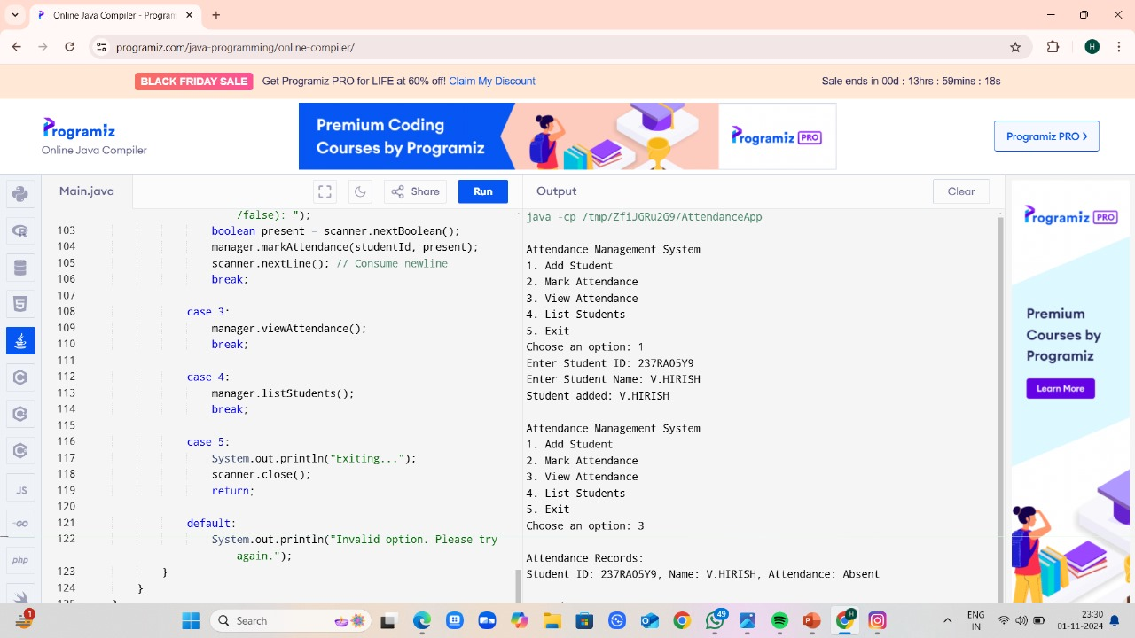

**FUTURE IMPROVEMENTS**

Future improvements for an Attendance Management System (AMS) developed using Java can enhance its functionality, user experience, and overall effectiveness. Here are several potential enhancements:

****Biometric Attendance Tracking:****

* + Integrate biometric systems such as fingerprint or facial recognition to ensure accurate and secure attendance marking. This can help prevent proxy attendance and enhance security.

****Mobile Application Development:****

* + Create mobile applications for both Android and iOS platforms, allowing users to mark attendance and check their records on-the-go. This can improve accessibility and convenience for students and employees.

****Integration with Learning Management Systems (LMS) and Human Resource Management Systems (HRMS):****Enable seamless integration with existing LMS and HRMS platforms to facilitate data sharing, reporting, and analytics. This can streamline processes and reduce redundancy.

**CONCLUSION**

* In conclusion, the Attendance Management System (AMS) developed in Java represents a significant advancement in the way attendance is tracked and managed within educational institutions and corporate environments. By leveraging the capabilities of Java, the system provides a robust, secure, and user-friendly platform that automates the attendance process, thereby enhancing efficiency and accuracy.
* The implementation of this system addresses the shortcomings of traditional attendance tracking methods, such as manual roll calls and paper-based records, which are often time-consuming and prone to errors. With features such as real-time attendance marking, user authentication, and comprehensive reporting, the AMS not only simplifies the attendance process for administrators and instructors but also empowers users by giving them access to their attendance records.

**REFERENCES**

**Java Documentation**:

* Oracle. (n.d.). *Java Platform, Standard Edition Documentation*. Retrieved from [https://docs.oracle.com/javase/8/docs/](https://docs.oracle.com/javase/8/docs/" \t "_new)

**Data Validation Techniques**:

* W3C. (n.d.). *HTML5 Forms*. Retrieved from [https://www.w3.org/TR/html5/forms.html](https://www.w3.org/TR/html5/forms.html" \t "_new)