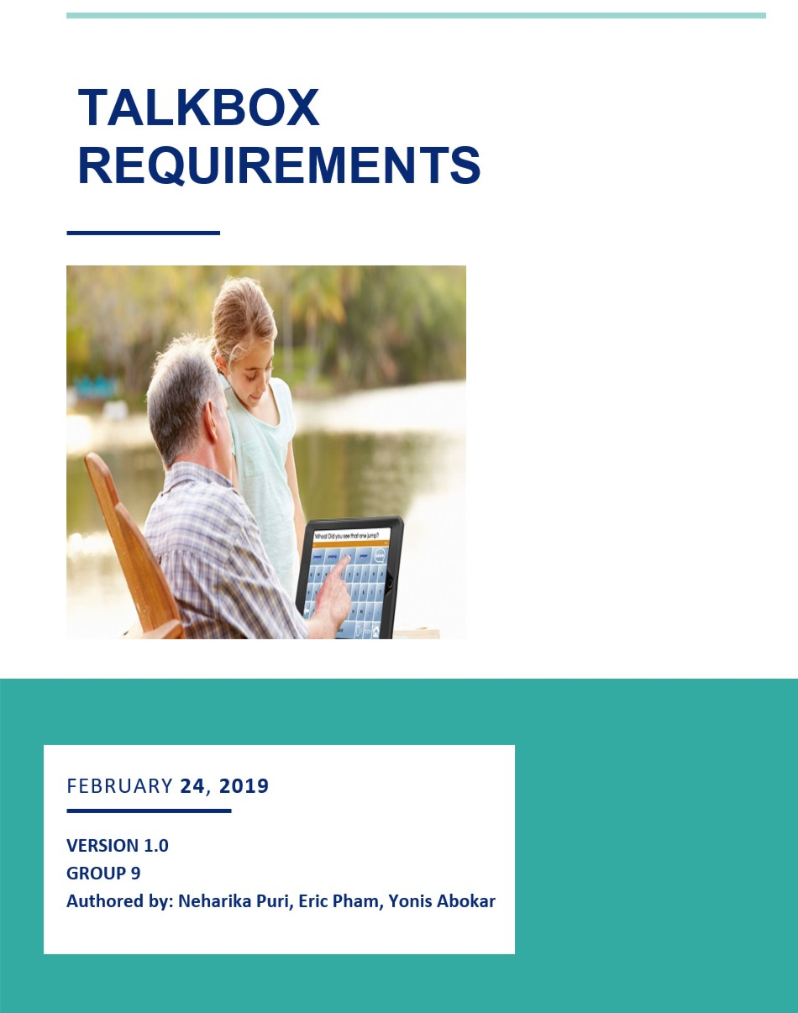

**TABLE OF CONTENTS**

1. **Introduction**

This document states the various requirements for the TalkBox Software. These requirements are based on the project requirements of EECS2311 and the presentation from Prof Baljko. Additional requirements have been added during the SDLC of this project.

* 1. **Document Purpose**

The purpose of this document is to be an aid to the reader, to understand the needs due to which this product was conceived, an overview of what this product can offer, and the use cases and user needs of the potential users. This document will also discuss the team’s vision and what constraints were faced during SDLC and the assumptions used to solve those. Lastly, the reader will be able to see the different test cases used to make user needs and the functionality can align.

1. **Product Description**

This product will help people with special needs to communicate. The TalkBox will be able to talk on behalf of them, when the certain button of that sound would be pressed. The caregivers will be able to record more words in the software and increase the user’s word choice.

1. **Product Scope**This device will aid communication for users who are unable to talk. The user will have the freedom to choose as many buttons they need for their TalkBox. They will also have the flexibility to change the number of the buttons at any time. The users can choose to use the pre-recorded sounds available or they can choose to record different sounds and save it in the buttons.
2. **Business Drivers**
   1. **Cost Difference**This product will replace expensive technologies for a low price. The current technology used by the government for Sound Generating Devices (SGD) are around $14,000, but this product with software and hardware components by Raspberry Pie will in total cost just around $50. This big price difference will be a major business driver for this product.
   2. **Features**

This product will also be very efficient at its use. It will provide much more features than the current technology used. It will give the user more functionality like recording sounds that they would like to use.

* 1. **Ease and Adaptability**

This product is very easy to use and is very interactive. The user will be able to adapt to it very quickly. The product can be used by anyone, who has never used technology before even making it becoming popular among potential users.

**5.0 Product Vision**

The vision of this product is to be an accessibility device to help users who are unable to communicate. The big picture/vision of TalkBox is to be an aid for the users and their caregivers. It will provide both the parties with different communication options whether it is the prerecorded sounds for them to use with ease or the capability to record their own audio and be able to store it in their library. They will be able to use this technology in their everyday life to either communicate or be able to signal their needs.

**6.0 Functional Requirements**

**6.1 Priority**

The following are the major functionality of the TalkBox that it must perform :

1. The TalkBox should be able to make buttons according to the input number of buttons given by the user.
2. The TalkBox must have some pre-recorded audios.
3. The TalkBox must allow the user to select the pre-recorded audios and assign them to the buttons.
4. The TalkBox must allow the user to create a profile and synchronize the buttons and sounds in that profile.
5. The TalkBox should let the user record and save their own/personal audio files.
6. The TalkBox must allow the user to launch their profile and play their audios by clicking the button.

**6.2 Requirement Category 1 : Buttons**

In order to fulfil this requirement, the following requirements should be met:

* There is a place for the user to input the number of buttons
* The configuration, needs to make inputted number of buttons

**6.3 Requirement Category 2 and 3 : Pre-Recorded Audios**

In order to fulfil this requirement, the following requirements should be met:

* Common sounds/audios files are available for the users to use
* These files are able to get exported along with the software, to any computer or laptop, the software runs on.

**6.4 Requirement Category 4: Profile**

In order to fulfil this requirement, the following requirements should be met:

* The user is able to make a profile with a desirable name
* The users are able to add sounds to the profile and synchronize it with the buttons.

**6.5 Requirement Category 5: Recorded Audios**

In order to fulfil this requirement, the following requirements should be met:

* The user is able to record a recording and there are record and stop button for their convenience.
* The user are able to give the recording a desirable name
* The user is able to add the recording in the list of recorded/ pre-recorded audios or sound for the users to select from
* The users are able to select these recording and add them to their profile and buttons.

**6.6 Requirement Category 6: Launch and Play**

In order to fulfil this requirement, the following requirements should be met:

* There is a button for the user to launch their profile
* The stimulator opens and lets the user launch their profile
* Once launched, the information in the profile such as the number of buttons and the names of the buttons are displayed
* Once any button is pressed, the user is able to hear the audio they initially stored in that button

**7.0 Non- Functional Requirements**

Some of the Non-Functional Requirements include:

1. The Talkox must be very easy to use for both the patient and their caregiver.
2. The TalkBox must have a very short setup and execution time.
3. The TalkBox must be interactive to increase the adaptability of the device.

**7.1 Requirement Category 7: Ease**

In order to fulfil this requirement, the following requirements should be met:

* There are no additional buttons that are not required
* The screen is organized and are separated by uses
* Import buttons are identified and easy to access
* The layout is simple yet interactive
* The component placements provide ease for the user

**7.2 Requirement Category 8: Time**

In order to fulfil this requirement, the following requirements should be met:

* The program is coded in an efficient way
* Algorithm’s time complexity is small and unnecessary processing is avoided
* Functionality not used is avoided after comparing results with test coverage
* The program is easy to install and run

**7.3 Requirement Category 9: Interactive**

In order to fulfil this requirement, the following requirements should be met:

* The application design is eye catching
* The layout is easy on the eye, and not very busy
* No background in technology required

**8.0 Users**

**8.1 User Characteristic**

There are 2 types of users for this device:

**Patient:** The patient is the major user as they are characterized as a user, who is unable   
 talk and needs an aid for communication. There could be a different range for the need of this product, the patient might be able to talk a bit but struggle with forming sentences. The patient might not be able to say a single word. For these users, this device will be their major mean of communication. They will be able to use it to call people or even be able communicate their need. For example, if they need water or something, they are not feeling well, if they need to use the washroom. Moreover, they can set sounds for various things as signals; they can have yes or no buttons to answer people. This user will be using this device very often and hence needs something accessible and easy to use.

**Care Giver:** The care giver can use this to record sounds/audios for the patient. He/she should also be able to use the device with ease as they might not be great with technology either. Hence, it’s important that they are able to meet their requirements in minimal steps and find the whole process simple, easy and interactive.