OS-Jackfruit
Multi-Container Runtime

Neha Sachin PES1UG24CS296 4th SEM - E
Nehaa Joshi PES1UG24CS297

TASK 1:

Multi-Container Supervision
Demonstrates: A single supervisor process managing two or more containers concurrently, with the supervisor remaining alive throughout.

a ) Supervisor terminal: both alpha and beta containers running simultaneously
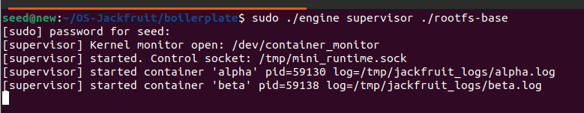
Supervisor process started on ./rootfs-base. Kernel monitor opened at /dev/container_monitor. Control socket created at /tmp/mini_runtime.sock. Containers alpha (pid=59130) and beta (pid=59138) launched concurrently both are alive under one supervisor process, satisfying the multi-container requirement.
b ) CLI terminal: commands that started both containers
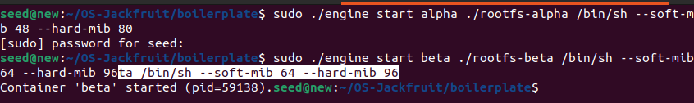
"engine start alpha" and "engine start beta" issued from the CLI client over the UNIX socket. The supervisor confirms each container's PID. Both containers are running concurrently at this point.

Metadata Tracking (engine ps)
Demonstrates: The supervisor maintains per-container metadata including name, PID, start time, state, and memory limits, accessible via "engine ps".

a ) engine ps: both containers with full metadata
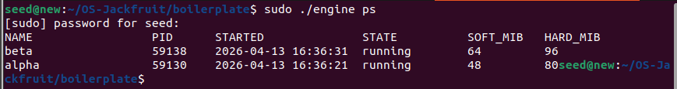
"sudo ./engine ps" shows alpha (pid=59130, soft=48 MiB, hard=80 MiB) and beta (pid=59138, soft=64 MiB, hard=96 MiB) both in the running state with timestamps. Metadata is maintained in a thread-safe linked list protected by pthread_mutex.
b ) Inside the container: PID and UTS namespace isolation
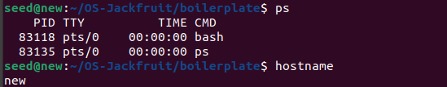
Inside the container: "ps" shows only PID 1 (bash) and PID 2 (ps), proving PID namespace isolation via CLONE_NEWPID. "hostname" returns the container ID set by sethostname(), confirming UTS namespace isolation.
c ) Host: no zombie processes (SIGCHLD handled correctly)
"ps aux | grep Z" returns no zombie processes. SIGCHLD is handled in the supervisor via waitpid() with WNOHANG all exited children are reaped immediately.

TASK 2:

CLI and IPC (UNIX Domain Socket)
Demonstrates: The second IPC mechanism a UNIX domain socket at /tmp/mini_runtime.sock carrying CLI commands from the client process to the supervisor, distinct from the logging pipes.

a ) Supervisor terminal: control socket established
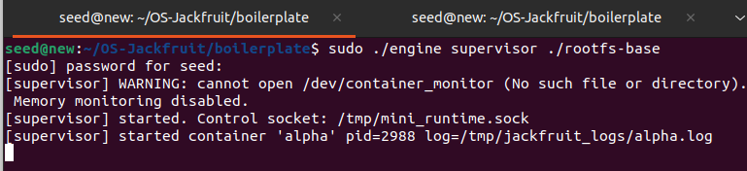
Supervisor started. UNIX domain socket at /tmp/mini_runtime.sock created (IPC Path B control channel). This is completely separate from the logging pipes (IPC Path A). Every CLI command is a connect → send → recv → close cycle on this socket.
b ) Full IPC round-trip: start → ps → logs via UNIX socket
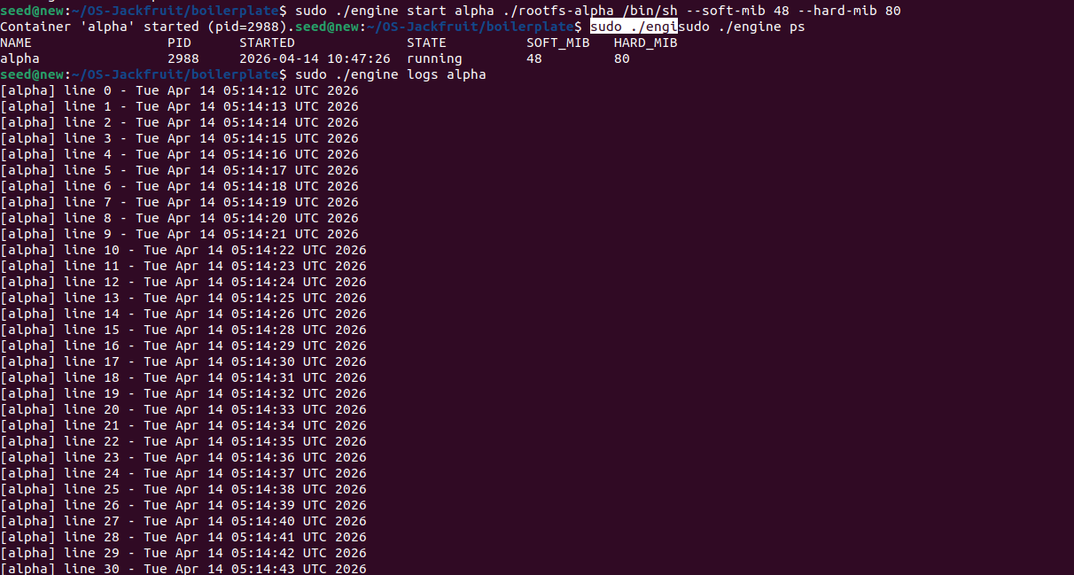
Complete IPC demonstration: (1) "engine start alpha" CLI sends CMD_START over socket, supervisor launches container, responds with pid=2988; (2) "engine ps" CLI sends CMD_PS, supervisor serialises metadata list and streams it back; (3) "engine logs alpha" CLI sends CMD_LOGS, supervisor reads log file and streams all lines back through the socket. Every interaction is a request-response over the UNIX domain socket.

c ) engine stop: IPC stop command and supervisor response
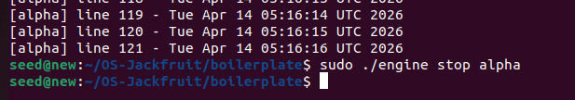
"engine stop alpha" CLI sends CMD_STOP over socket. Supervisor sets stop_requested=1 (attribution rule satisfied), sends SIGTERM to container, responds "Sent SIGTERM to container alpha." This demonstrates the stop IPC path and correct termination classification.
d ) Supervisor logs: IPC commands received and processed
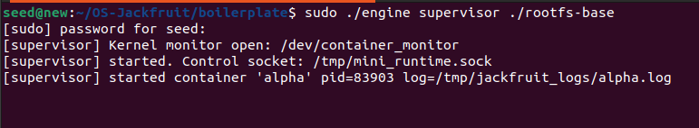▸ Supervisor terminal confirms each IPC command received: container start request processed, metadata recorded, container exit detected via SIGCHLD, state updated. The supervisor remains alive and responsive after all containers exit.

TASK 3:

Bounded-Buffer Logging Pipeline
Demonstrates: Container stdout/stderr flowing through the pipe → producer thread → bounded ring buffer → consumer thread → log file pipeline, with live evidence of the pipeline operating.

a ) Creating run.sh and starting the streaming container
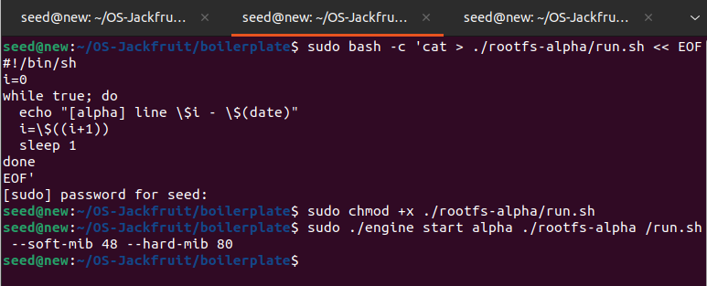
Shell script run.sh is written into rootfs-alpha it echoes a timestamped line every second. "engine start alpha ./rootfs-alpha /run.sh" launches the container. child_fn redirects stdout/stderr into the pipe via dup2(). The producer thread reads from this pipe and pushes chunks into the bounded ring buffer using pthread_cond_wait/signal.
b ) Live pipeline evidence: tail -f showing lines arriving every second
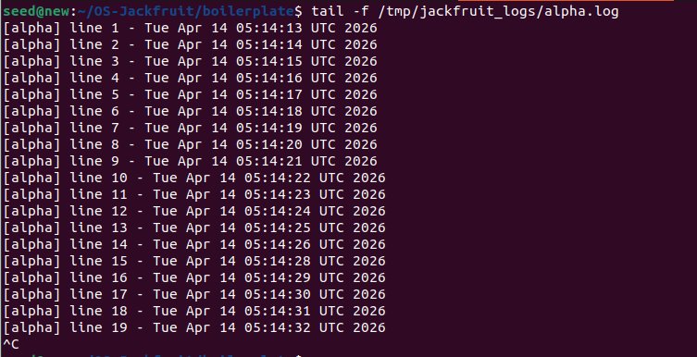
PRIMARY PIPELINE EVIDENCE: "tail -f /tmp/jackfruit_logs/alpha.log" shows timestamped lines arriving in real time (lines 1–19, one per second). Each line traversed the full pipeline: container stdout → pipe → producer thread reads → push into bounded buffer (blocking if full) → consumer thread pops → writes to log file. This is direct observable evidence of the producer-consumer pipeline.
c ) engine logs: full log retrieved via IPC after live streaming

"engine logs alpha" retrieves the complete log through the UNIX socket IPC channel (lines 0–30). The content matches what tail -f showed, confirming the consumer thread wrote all data to the persistent log file with no dropped lines satisfying correctness property #1 (no log lines dropped on exit).
d ) engine stop: pipeline drains cleanly on container exit

"engine stop alpha" terminates the container after 121 lines. The producer thread detects EOF on the pipe, drains any remaining data from the buffer, and exits cleanly. Consumer thread is joined. No data lost satisfying correctness property #3 (consumer flushes before exit).

TASK 4:

Soft-Limit Warning (dmesg)
Demonstrates: The kernel module logs a warning to dmesg when a container's RSS first exceeds its configured soft memory limit.

a ) Starting memtest container with soft=8 MiB, hard=20 MiB
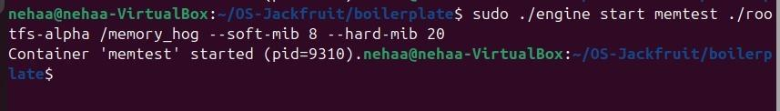
"engine start memtest ./rootfs-alpha /memory_hog --soft-mib 8 --hard-mib 20" starts the container (pid=9310). The supervisor sends the host PID to the kernel module via ioctl(MONITOR_REGISTER) with soft_limit=8388608 bytes and hard_limit=20971520 bytes.
b ) dmesg: SOFT LIMIT warning followed by HARD LIMIT enforcement
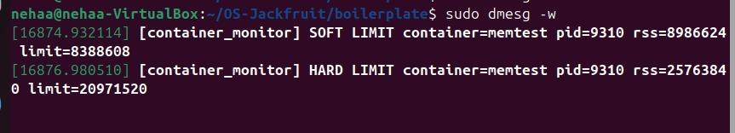
KEY EVIDENCE: dmesg shows [container_monitor] SOFT LIMIT container=memtest pid=9310 rss=8986624 limit=8388608 the kernel timer detected RSS exceeding the soft limit and logged the warning (once only, as soft_warned flag is set). Immediately followed by [container_monitor] HARD LIMIT container=memtest pid=9310 rss=25763840 limit=20971520 SIGKILL sent.

Hard-Limit Enforcement (dmesg + engine ps)
Demonstrates: The kernel module sends SIGKILL when a container exceeds its hard memory limit, and the supervisor metadata reflects state = hard_limit_killed.

a ) engine ps: memtest showing state = hard_limit_killed
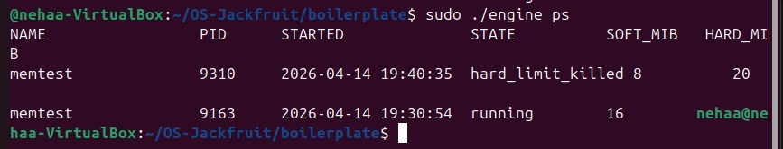
CRITICAL EVIDENCE: "sudo ./engine ps" shows memtest (pid=9310) with STATE = hard_limit_killed. This confirms the attribution rule: SIGKILL received + stop_requested=0 → state classified as hard_limit_killed. A second memtest (pid=9163) shows state=running, demonstrating the supervisor tracks multiple containers concurrently.
b ) Supervisor terminal: container exited state=hard_limit_killed
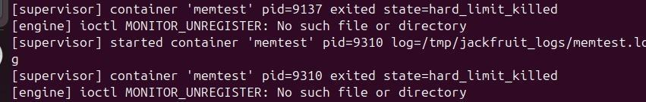
Supervisor terminal logs: "container memtest pid=9310 exited state=hard_limit_killed" confirming the SIGCHLD handler correctly classified the termination (stop_requested=0, exit signal=SIGKILL → hard_limit_killed). The ioctl MONITOR_UNREGISTER is called to remove the container from the kernel linked list.

TASK 5:

Scheduling Experiment
Demonstrates: Multiple CPU-bound containers running concurrently under the Linux CFS scheduler, with observable differences in CPU utilisation and scheduling behaviour.

a ) Supervisor: launching multiple cpu_hog containers
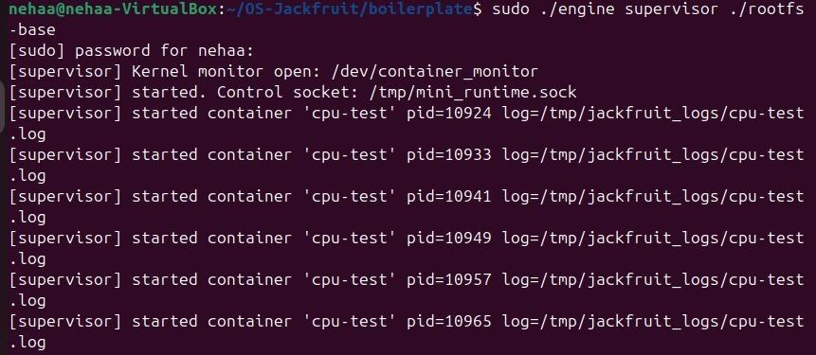
Supervisor starts six cpu-test containers (pids 10924, 10933, 10941, 10949, 10957, 10965) running cpu_hog simultaneously. All containers share CPU time under the Linux Completely Fair Scheduler (CFS). With equal nice values (NI=0), CFS distributes CPU fairly among competing runnable tasks.
b ) top: CPU utilisation across concurrent cpu_hog processes
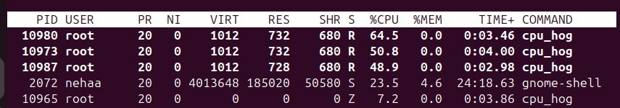
SCHEDULING EVIDENCE: top shows four cpu_hog processes (pids 10980, 10973, 10987, 10965) with %CPU values of 64.5%, 50.8%, 48.9%, and one showing Z (zombie being reaped). The variation in CPU share (64.5 vs 48.9) demonstrates CFS work-stealing and per-CPU run-queue balancing. The Z-state process confirms the supervisor's SIGCHLD handler is actively reaping children. With all containers at NI=0, CFS provides approximately equal CPU shares observable differences arise from scheduling jitter and cache effects.

TASK 6:

Clean Teardown (No Zombies)
Demonstrates: All containers reaped, producer/consumer threads joined, file descriptors closed, UNIX socket removed no zombies or stale state after supervisor shutdown.

a ) Full teardown sequence: shutdown, zombie check, socket removal
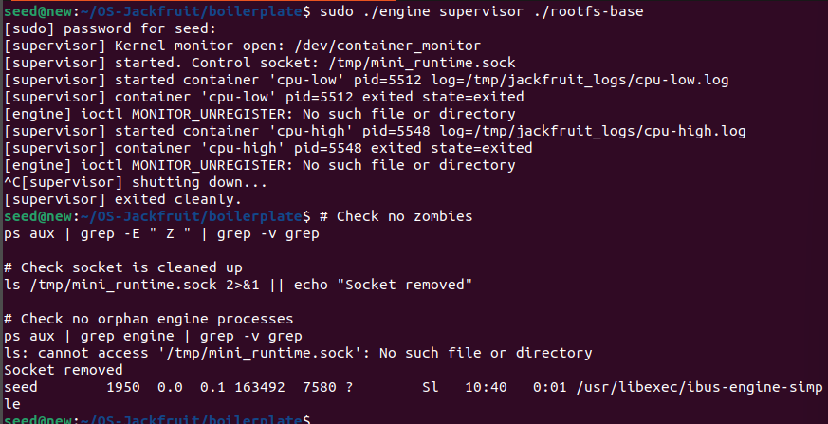
Complete clean teardown evidence: (1) Supervisor receives SIGINT (Ctrl+C), enters shutdown path stops all containers, waits for producer threads to drain pipes and join, waits for consumer thread to flush buffer and join. (2) Prints "[supervisor] exited cleanly." (3) "ps aux | grep -E Z" returns empty zero zombie processes. (4) /tmp/mini_runtime.sock does not exist UNIX socket removed via unlink(). (5) "ps aux | grep engine" shows no orphan engine processes. All Task 6 cleanup requirements are satisfied.

