A knowledge-driven RAG framework for Reliable

Indian Agricultural Policy Question Answering

Neha Sengupta

Research Proposal
Master of Science in Machine Learning & Artificial Intelligence

Liverpool John Moores University & upGrad

November 2025

Abstract
India is a predominantly agriculture-driven economy, yet farmers continue to face barriers in accessing critical information on government schemes, subsidies, and policy benefits. Despite rising technology solutions, digital advisory tools show low adoption due to limited tech familiarity and the complexity of policy documents. These information gaps often lead to poor decisions, financial distress, and, in extreme cases, debt-related farmer suicides. Existing LLMs, including domain-specific agricultural LLMs provide general domain knowledge but still lack citations, and are not optimized for Indian policy interpretation or location-specific recommendations. This research aims to develop a policy-grounded Retrieval-Augmented Generation (RAG) framework for Indian agricultural policy question answering.
The proposed method integrates authenticated policy documents, multi-stage retrieval, geospatial metadata, and validation layers to ensure factuality, contextual relevance, and state-specific policy interpretation. The expected outcome of this thesis is a QA system framework that delivers accurate, location aware, interpretable responses, supporting farmers, extension workers, and policymakers in understanding and leveraging government policies effectively.

TABLE OF CONTENTS
Abstract 2
TABLE OF CONTENTS 3
1. Background 4
2. Related Work 5
3. Research Questions 10
4. Aim and Objectives 10
5. Significance of the Study 11
6. Scope of the Study 11
7. Research Methodology 11
Fig 1-Workflow diagram of Proposed system 12
7.1 Dataset Description 12
7.2 Data Pre Processing 12
7.4 Vector Database Integration 12
7.7 Evaluation Metrics 13
8. Requirements and Resources 13
8.1 Hardware 13
8.2 Software 13
9. Research timelines 14

Background
India is the world's most populous democracy and majority of its population still resides in rural areas where agriculture is the primary occupation. Agriculture contributes as the largest and most important sector of the Indian economy, providing food security and making India self-reliant. Agriculture contributes to 20% of India's entire GDP(Kumar et al., 2023) Despite the importance, the practitioners of Agriculture, the farmers, constantly face multiple risks.(Komarek et al., 2020) Climate catastrophes like floods, excessive rainfall and droughts, financial distress, market risks to name a few. These risks lead to adverse.
Recognizing this centrality and risks associated, the Government of India has introduced an extensive range of farmer-centric policies and welfare programmes over the past decades. Initiatives such as the Pradhan Mantri Kisan Urja Suraksha evam Utthaan
Mahabhiyan (PM-KUSUM)(Kharesaxena et al., 2024) ,Pradhan Mantri Kisan Samman Nidhi (PM-KISAN) income support scheme, Pradhan Mantri Kisan Pension Yojana, Pradhan Mantri Fasal Bima Yojana (PMFBY) for crop insurance (Khan, n.d.)have collectively contributed to improvements in agricultural productivity, risk mitigation, financial inclusion, and access to markets.

Despite these significant advancements, a major challenge persist -accessibility to accurate and appropriate policy information. Policy information is complex, jargon-heavy and difficult for farmers to interpret and apply in practice. Agricultural policy documents. Additionally, this policy information is spread across multiple government websites and portals such as National Portal of India(india.gov.in), Press Information Bureau (PIB) (pib.gov.in), Niti Aayog and many more such diverse platforms. Information gaps lead to poor decisions, financial distress, and, in extreme cases, debt-related farmer suicides. Although India has made major advancements in digital service delivery through platforms such as mKisan , an SMS service Farmer Portal, these tools primarily provide advisories related to crop cultivation, weather, and agronomic practices. They rarely offer interpretive support for understanding government schemes, legal rights or region-specific policy variations.

While recent progress in AI has introduced large language models (LLMs) capable of summarizing and interpreting complex texts, general-purpose policy models such as PolicyStory(Dar et al., 2025) demonstrate that LLMs can capture broad policy narratives, but they lack agricultural policy specialization. They do not handle granular state-wise differences, and often fail to provide source-grounded, citation-backed answers due to weak grounding in official policy documents.
These gaps highlight the need for an interpretable, reliable, and domain-specific framework that can support grounded agriculture policy question answering.
An additional limitation in existing systems is their lack of location-aware contextualization, which is crucial in Indian agriculture since policies schemes differ widely across states, districts, and agro-climatic zones. Emerging geospatial representation learning methods—such as AlphaEarth(Brown et al., 2025)-style geospatial embeddings—offer a promising direction for encoding local environmental, agricultural, features directly into machine learning pipelines.

The real-world relevance of this research is substantial. In this context, this research therefore aims to develop a specialized location-aware Retrieval-Augmented Generation (RAG) framework tailored specifically to the Indian agricultural policy landscape. By combining authenticated and curated policy documents, multi-stage retrieval, geospatial metadata, and transparent citation mechanisms, the proposed solution aims to convert complex policy text into accessible, actionable, and trustworthy insights. In doing so, can empower farmers to make informed financial and operational decisions, help NGOs and rights-based organizations interpret schemes accurately, and support policymakers by providing transparent, evidence-grounded insights on programme design and implementation.

Related Work
In this section, we will analyse the existing research relevant to our proposed RAG framework for Indian agricultural policy QA, under three dimensions: LLMs in agriculture & policy analysis, RAG and QA systems, and geospatial embeddings and spatial context in AI. These works highlight the role of government policies in the upliftment and social security of farmers and how of AI technologies built around the agriculture sector has a major impact on socio economic growth and welfare of farmers.
(Khan, n.d.)navigates through key government policies that have shaped Indian agriculture’s development and financial stability. The various schemes like The Pradhan Mantri Kisan Samman Nidhi (PM-KISAN) the Pradhan Mantri Fasal Bima Yojana (PMFBY), the Pradhan Mantri Krishi Sinchayee Yojana (PMKSY),the Pradhan Mantri Jan Dhan Yojana, Sthe Pradhan Mantri Kisan Pension Yojana collectively provides financial aid, crop insurance, water and irrigation support ,along with easy banking access to all that enhances social security across the rural population. This study highlights how policies supported by technological innovations collectively aim to boost productivity, reduce farmer vulnerability, and promote sustainable practices.
(Meshram et al., 2021) highlights the use of machine learning (ML) and deep learning (DL) in improving crop yield by focusing on different pre and post harvesting stages. ML techniques can play a role in improving soil analysis, seed quality and disease detection, leading to efficient, precise farming with reduced labour. Various supervised and deep learning algorithms are discussed like Support Vector Machines (SVM), and Convolutional Neural Networks (CNN) alongside tools such as AutoML and IoT integration. Some challenges like low quality datasets, high computational costs can hinder industrial deployments of these solutions. The authors recommend creating open datasets, employing transfer learning, and designing user-friendly models to bridge these gaps and enhance practical adoption in agriculture.
(Amarasinghe et al., 2023)examines explainable machine learning in public policy contexts, focusing on its role in high-stakes decisions in areas like health, criminal justice, and education. They analyse common use-cases for explainability, such as model debugging, building trust, deciding when and how to intervene, and providing recourse to affected individuals. It’s found that most existing explainability methods are developed with broad goals and tested on simplified datasets, limiting their real-world applicability. This gap emphases the lack of rigorous evaluations involving real users, real data, and meaningful policy tasks. This work directly serves as a guide in need to design a novel system that can support complex public policy decisions especially in niche sectors like agriculture policy implementation.
(De Clercq et al., 2024) This paper reviews the role of LLMs in agriculture highlighting their potential to improve food production while discussing associated risks. LLMs can provide farmers with tailored agronomic advice through chatbots like KissanGPT, enhance agricultural innovation via research support and assist policymakers by simulating outcomes of agricultural policies. The author points out the challenges such data privacy concerns, socio-economic inequalities, and the spread of misinformation which are counterproductive. These gaps emphasize the need for careful policy frameworks to ensure responsible use of LLMs in food systems, aiming to minimize negative impacts on farmers while harnessing the benefits of these models.
The paper(Rezayi et al., 2022; Nagarajan et al., 2025) introduces AgriBERT, a domain-specific language model trained from scratch on a large corpus of 46,446 agricultural and food-related journal articles containing over 300 million tokens. AgriBERT is pretrained using masked language modelling, enabling it to learn contextual word representations specific to agriculture. To enhance performance, the authors augment both questions and answers with related entities extracted from FoodOn, a food-specific knowledge graph, using querying methods rather than general entity. The model is fine-tuned on this augmented dataset for answer selection, using transformer-based encoders to score candidate matches. Experimental results show AgriBERT significantly outperforms baseline models, especially when trained from scratch on agricultural texts thus demonstrating the effectiveness of knowledge infusion in domain-specific NLP tasks.
PolicyBot (Nagarajan et al., 2025)is a retrieval-augmented generation (RAG) system designed to improve access to complex, jargon-heavy policy documents by providing accurate, transparent, and easily verifiable answers to user queries. It tackles challenges common in legal and policy QA—such as dense text, intricate language, and hallucination—by combining domain-specific semantic chunking, multilingual dense embeddings and a multi-stage retrieval pipeline involving HyDE, RAG-Fusion, and cross-encoder reranking. Using the lightweight Gemma 3n model for generation ensures factual, citation-backed responses. The system’s design emphasizes hallucination control through strict prompting and explicit citation tracing. Extensive evaluation on benchmark datasets demonstrated that semantic chunking preserves legal clause integrity better than fixed-length methods, enhancing retrieval quality. Author suggests as per of future work to expand domain specialized support, enhance hallucination control and integrate user feedback.
(Awais et al., 2025) Presents AgroGPT, a large multimodal model designed specifically for agriculture, addressing the lack of paired image-text data in this domain by leveraging vision-only datasets. It uses a novel pipeline called AgroInstruct, which synthesizes expert-level instruction-tuning data from diverse agricultural images and class-specific knowledge. This enables AgroGPT to perform detailed, multi-turn conversations about plant diseases, insects, weeds, and fruits. The model is fine-tuned through a three-stage process, improving its ability to recognize fine-grained agricultural concepts better than existing models like ChatGPT and Bard. Evaluations using AgroEvals demonstrate its superior performance in identifying diseases and pests and providing practical management advice. AgroGPT also generalizes well to unseen datasets, making it a valuable AI assistant for farmers and agronomists. The system is open source, supporting further research and application in sustainable agriculture.
(Yang et al., 2025) Introduces another agriculture GPT called AgriGPT which is a domain specific LLM ecosystem. Its novelty resides in building a large superior quality domain specific QA dataset “Agri-342K” via a multi-agent data engine. Yang moves away from a traditional RAG and builds a Tri-RAG which is a three-channel retrieval-augmented generation framework combining dense retrieval, sparse retrieval, and multi-hop knowledge graph reasoning to improve accuracy and reasoning. The system is evaluated using AgriBench-13K, a comprehensive benchmark suite covering 13 agricultural tasks of varying difficulty. Experiments show AgriGPT outperforms general-purpose LLMs in domain adaptation and complex reasoning. It also supports multilingual capabilities and maintains strong general-domain performance. Despite limitations such as lack of multimodal inputs and policy dialect coverage, it lays the foundation for scalable, socially impactful AI tools for farmers.
This research(Yang et al., 2024) introduces a custom model ShizishanGPT. Unlike general-purpose LLMs such as ChatGPT-4, ShizishanGPT integrates a Retrieval Augmented Generation (RAG) framework and agricultural knowledge graphs (AgriKG to overcome domain-specific limitations. This modular architecture enhances accuracy and relevance by combining real-time search, vector databases, knowledge graphs, and crop-specific predictive models. The study highlights the importance of domain adaptation, external knowledge integration, and agent-based reasoning frameworks for improving LLM effectiveness in complex, technical fields like agriculture.
AgriBot (Jain et al., n.d.)is an AI-based chatbot developed to assist Indian farmers by answering agriculture-related queries using data from the Kisan Call Centre. It tackles challenges like redundant questions, multilingual and poorly formatted data by employing sentence embedding with entity extraction, improving accuracy from 56% to 86%. The system integrates a weather API for timely updates and uses custom similarity metrics for evaluation. AgriBot has the potential to reduce call centre load, provide 24/7 access via mobile devices, and deliver information in farmers’ native languages. This scalable solution helps farmers access localized, reliable agricultural information easily, promoting better decision-making.
PolicyStory(Dar et al., 2025) is an innovative tool that uses open-source LLMs like Llama-3.2-1B to generate clear, chronological summaries of complex Indian policy news. It collects articles from diverse sources, clusters them by topic, and produces multi-level summaries: brief overviews (L1), detailed narratives (L2), and numeric data summaries. This layered approach helps users grasp evolving policy issues like the Union Budget and recent Farmers’ Protests, the two topics being the choice of news for this study. A preliminary user study also showed that PolicyStory improves understanding, usability, and trustworthiness compared to traditional news consumption, addressing challenges like information overload, jargon, and fragmented coverage. The tool also explains policy-related terms and presents numeric insights, enhancing accessibility and civic engagement. Future enhancements include domain specific policy analysis, source citation, and regional language support, aiming to broaden reach and credibility.
Author (Martin et al., 2024) notes that traditional farming faces constraints like climate change and resource limitations, prompting the integration of machine learning (ML), artificial intelligence (AI), and Internet of Things (IoT) technologies for precision farming. Prior works focus on isolated aspects such as crop yield prediction, irrigation, or soil analysis, often suffering from limited insights and complex responses. Recent advancements involve deep learning models, including Transformer architectures, but these models often behave as “black boxes,” limiting trust and adoption among farmers. To address this, explainable AI (XAI) frameworks like SHAP and LIME have been introduced to provide interpretable and transparent insights, improving decision-making and fostering trust. This study reveal that combining comprehensive datasets (weather, soil, crop) with advanced ML models and XAI tools significantly improves prediction accuracy and sustainability in agriculture.
Abstractive summarization models (Maynez et al., 1906)create short summaries by rephrasing original text but often produce hallucinations—incorrect or unsupported information. These hallucinations can be due to misinterpreting the source or adding unrelated facts. Pretrained models like BERTS2S perform better and generate more factual summaries than older models. Traditional metrics like ROUGE do not effectively measure faithfulness, while entailment-based methods better capture whether summaries are truthful. Human evaluations show hallucination is common, posing a major challenge. Future work aims to improve automatic evaluation and reduce hallucinations for more reliable summarization. This study gives a direction on the evaluation techniques to employ to overcome hallucinations and provide contextually accurate responses.
The foundation paper on Retrieval-Augmented Generation (RAG) models (Lewis et al., 2021)combines pre-trained parametric memory, such as a seq2seq transformer (e.g., BART), with non-parametric memory accessed via a neural retriever over a large text corpus like Wikipedia. This hybrid approach addresses limitations of purely parametric models, enabling accurate, updatable, and interpretable knowledge retrieval for knowledge-intensive NLP tasks. RAG uses either a single retrieved document for full sequence generation (RAG-Sequence) or different documents per token (RAG-Token), trained end-to-end by marginalizing over retrieved passages. Experiments demonstrate that RAG achieves state-of-the-art results on open-domain question answering benchmarks and outperforms extractive and parametric-only baselines. It also excels in abstractive QA, question generation (e.g., Jeopardy), and fact verification tasks. RAG’s retrieval component can be updated independently, allowing the model to adapt to changing world knowledge without retraining. This architecture offers improved factuality, specificity, and diversity in generated text, making it a versatile and effective solution for various knowledge-intensive NLP challenges. Our core methodology is predominantly based on the findings of this paper.
AlphaEarth Foundations (AEF) (Brown et al., 2025)is an advanced embedding field model designed to generate accurate, efficient global maps from sparse Earth observation data. It integrates multi-source, multi-temporal, and multi-modal inputs including optical, radar, LiDAR, climate data, and geotagged text to produce rich geospatial representations. Unlike prior models, AEF supports continuous time modelling and spatial precision at 10-meter resolution with compact embeddings. Evaluated across diverse real-world datasets, AEF consistently outperforms both designed and learned alternatives without retraining. Its robust architecture and training methods enable effective mapping and change detection even with limited labelled data, facilitating improved environmental monitoring and decision-making worldwide.
For building location context-aware systems we need precise integration and understanding of spatial data from multiple heterogeneous sources. Geospatial Entity Recognition (GER)aims to identify and reconcile records that correspond to the same real-world spatial across diverse datasets, which is critical for accurate location-based services such as navigation, ride-hailing, and personalized recommendations. Traditional GER methods rely on hand-crafted rules and token-level similarity metrics and struggle with capturing semantic nuances in entity. The GER-LLM framework (Zhu et al., n.d.) innovatively overcomes these by integrating spatial semantics (AOI-Area of interest) with powerful semantic reasoning from LLMs. The main components of GER-LLM are AOI-aware spatial blocking which helps match location data from different sources and group nearby places together by understanding both their physical closeness and their functional connection. The other feature is group-wise matching with LLMs as it groups likely matches and lets a large language model compare them all at once, saving time and improving accuracy. These innovations make the study of GER-LLM a valuable reference model for systems aiming to leverage location context in heterogeneous spatial data integration.
While there are many existing domain specific LLM based solutions for summarising and efficient question answering, the focus remains mainly on the crop life cycle. There is very little to none research on analysing govt aided policies for Indian agriculture. Existing policy based LLMs are general purpose and do not specialize in the domain specific language and jargons used in the agriculture community. Additionally, all solutions work on analysing large amount of text documents or images. The modality of geo spatial context has not been explored in policy analysis. We try to explore the context of spatial embeddings and how it can be incorporated to provide location aware-actionable insights(state/district-level). By combining retrieval from authenticated policy documents and structured chunking, along with the edge of location awareness our system aims to improve trust and fidelity, while providing answers in plain language making is suitable for farmers and other stakeholders.

Table 1: Summary of Literature Review
Related Work/Title | Methodology | Limitations/Gaps | Relevance to our research
(Khan, n.d.)Indian Agricultural Policies Review | Policy analysis of major Indian agricultural schemes | No AI/LLM integration, lacks digital access framework | Provides policy grounding for Indian agri-policy QA
(Meshram et al., 2021)ML/DL in Agriculture | ML & DL models for crop yield, disease detection | Focuses on agronomy, not policy or QA | Highlights tech gap between agronomy AI and policy AI
(Amarasinghe et al., 2023)Explainable ML in Public Policy | XAI applied to policy decision-support systems | Limited real-world deployment, not agriculture-focused | Supports need for transparent and explainable policy AI
(De Clercq et al., 2024)LLMs in Agriculture | Review of agricultural LLM applications | Risks: misinformation, inequality, privacy issues | Justifies need for controlled, citation-backed RAG
 | Domain-specific BERT + FoodOn KG infusion | No policy understanding or Indian context | Shows benefits of domain-trained agricultural LMs
  (Rezayi et al., 2022)AgriBERT
(Nagarajan et al., 2025)PolicyBot | RAG system for policy documents with citations | Not agriculture-specific, no geospatial context | Direct inspiration for policy RAG design
(Awais et al., 2025)AgroGPT | Multimodal instruction-tuned agriculture LLM | Focus on crop/disease, not policy or governance | Highlights multimodal systems for agriculture but lacks legal/policy focus
(Yang et al., 2025)AgriGPT & Tri-RAG | Tri-RAG (dense+sparse+KG) for agri QA | No Indian policy dialect or multimodal inputs | Provides advanced RAG architecture blueprint
(Yang et al., 2024) ShizishanGPT | RAG + Agriculture Knowledge Graph + agent reasoning | Region-specific, not transferable to Indian context | Supports modular architecture and KG integration
(Jain et al., n.d.)AgriBot | Chatbot using Kisan Call Centre data | Not focused on policy, limited reasoning ability | Shows relevance of localized farmer-facing tools
(Dar et al., 2025)PolicyStory | LLM-based Indian policy summarization tool | No citations, no location-aware insights | Strong background for policy interpretation gap
(Martin et al., 2024)AI & XAI in Farming | AI + IoT + Explainable ML in precision farming | Does not deal with policy or language models | Supports importance of explainability for farmer trust
(Maynez et al., 1906)Hallucinations in Summarization | Analysis of hallucinations in abstractive models | Does not address policy or RAG solutions | Justifies need for hallucination control in QA systems
(Lewis et al., 2021)RAG Model | Retrieval-Augmented Generation architecture | No policy-specific or geospatial focus | Core foundation for RAG framework
(Brown et al., 2025)AlphaEarth Foundations | Geospatial embedding model using Earth observation data | Not applied to policy or QA tasks yet | Enables location-aware context in our policy QA
(Zhu et al., n.d.)GER-LLM | Geospatial entity matching using LLM + spatial reasoning | Does not handle policy QA tasks | Supports our location-aware and spatial grounding approach

Research Questions
This thesis tries to answer the following questions:
- How can a RAG-based system be adapted and fine-tuned for Indian agricultural policy question answering?
- Can the integration of geospatial or location-aware embeddings improve the relevance and precision of policy retrieval for region-specific agricultural queries?
- What are effective evaluation metrics to measure reliability, citation accuracy, and response grounding in a agriculture policy QA system?

Aim and Objectives
Aim: To design and evaluate a RAG framework that enables policy language interpreted, highly contextual, location-aware and citation-backed question answering on Indian agricultural policies.
Objectives:
- Develop a domain-specific knowledge base integrating policy data from sources like PIB, NDAP, and MoAFW.
- Fine-tune a lightweight LLM within a RAG pipeline for policy retrieval and generation.
- Integrate modern geospatial embeddings (e.g., Alpha Earth-like location encoders) to enable region-specific retrieval.
- Implement citation-backed response generation ensuring transparency, simplified explanations and source citation
- Evaluate the framework’s performance using reliability, factual consistency, and precision metrics.

Significance of the Study
This study directly addresses the lack of interpretable, fact-based AI-enabled solution to Indian agricultural policy data. Building such a RAG framework will contribute to:
- Enhancing government policy transparency and data accessibility for the farmers of India.
- Supporting evidence-based agricultural planning and decision-making.
- Building a foundation for domain-specific QA systems for agriculture public policy making.

Scope of the Study
The study focuses on:
- Indian agricultural policies from 2010–2025.
- Data sources: PIB releases, NDAP datasets, MoAFW annual reports, and open data portals.
- English-language documents initially (future scope includes multilingual adaptation).
- RAG framework experiments using open models such as LLaMA-3, Falcon, or Mistral.
It does not include real-time chatbot deployment for end-users but focuses on building the underlying QA system prototype.

Research Methodology
The methodology integrates retrieval and generation stages using the RAG pipeline to ensure accuracy, grounding, and interpretability in policy-related responses. Figure 1 describes the overall RAG framework and flow diagram that describes the methodology.

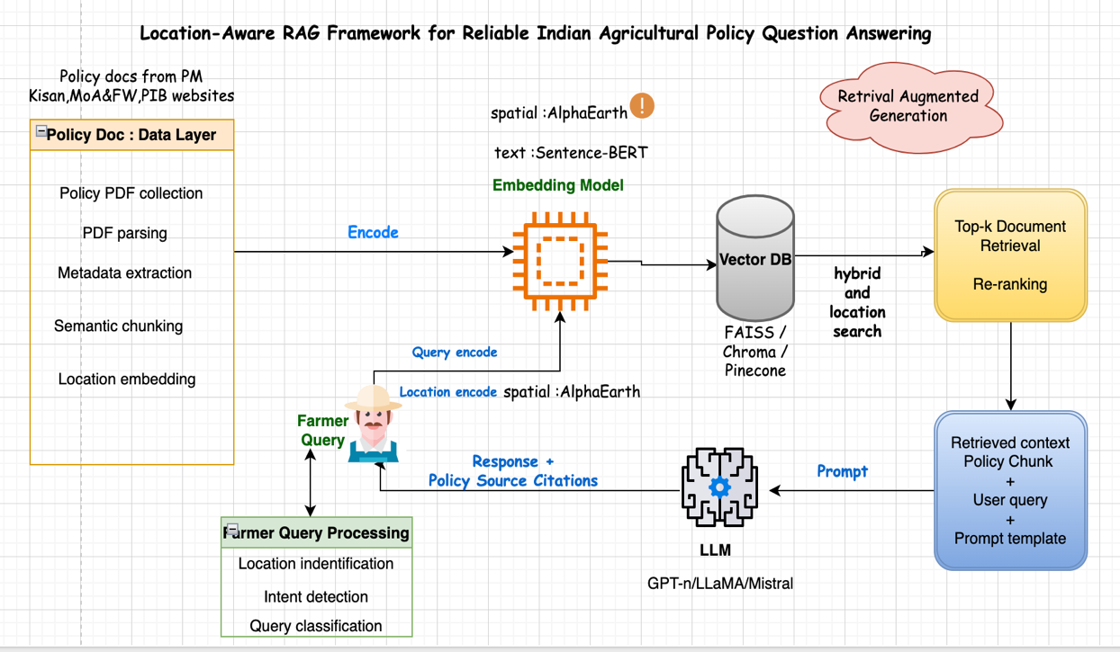

Fig 1-Workflow diagram of Proposed system

Dataset Description
- The dataset is mostly PDF documents stored across various Indian government portals which are open source and available for research.
- Primary Sources: Press information Bureau (PIB) archives, NDAP policy documents, MoAFW reports, and Department of Agriculture open datasets.
- Format:
  - Textual data: PDFs, HTML pages, and structured tables converted to text and embeddings.
  - Geographical metadata (district/state-specific policies)
- Size (estimated): 500+ documents after preprocessing.

Data Pre Processing
The data processing pipeline includes:
- PDF ingestion
- Text extraction using tools like pdfplumber, pypdf, Langchain document loader.
- Metadata tagging: Document title, year, policy type, geo-location
- Data cleaning: Removal of duplicates and non-policy content
- Semantic chunking: policy clause, description, eligibility, location.
- Text Embedding & vectorization: domain-adapted model/sentence-BERT
- Location Embedding & vectorization: AlphaEarth Embeddings.
- At the end of the data pipeline, for every chunk we have:
Final Vector = [Text Embedding + Location Embedding]
  - Farmer query pre-processing

The farmer query also needs to go through the following processing.
    - Intent classification- Is the query about policies?
    - Entity extraction- To identify scheme names, location, crops etc.
    - Location embedding-convert location names into Alpha earth embeddings
    - Query Embedding: combination of Text + location embedding

Vector Database Integration
- All document chunks and metadata will be stored in a vector
database like FAISS/Chroma DB/Pinecone.
- User query embeddings are also stored as dense vectors.
- Apply chunking and contextual retrieval strategies for optimized search relevance.

  - Retrieval-Augmented Generation (RAG) Layer
    - Hybrid vector search and location based search is made on the vector DB
    - This results in top-k relevant chunks by the retriever.
    - Re-ranking strategies fine tunes the retrieved output
    - The retrieved context + user query + custom prompt with instruction to only answer using the context is passed on to an LLM like GPT-4/ LLaMA / Mistral

  - The LLM response
    - The LLM receives the custom prompt and context and applies reasoning to arrive at a response.
    - Here the LLM is only working with our custom context to answer.
    - Reads retrieved policy text and aligns reasoning with policy logic.
    - The resultant is farmer query answer, source citation and simplified definition of policy jargons.

Evaluation Metrics
- Precision
- Recall
- F-1 score
- Response Relevance and Readability (BLEU / ROUGE)
- Ablation studies.
  - RAG vs No-RAG
  - With vs Without Location Embedding
  - With vs Without Policy Citation Constraint

Requirements and Resources

Hardware
The following hardware requirements must be met for this research work:
- A laptop/desktop computer with stable internet access, capable of browsing, doc-writing and compiling/executing code.
- GPU-enabled system (NVIDIA RTX 3090 / A100)
- Minimum 64GB RAM and 2TB storage
- Cloud support via Google Colab or AWS EC2

Software
The following software requirements must be met for this research work:
- Tools: Python, Jupyter notebook, LangChain, HuggingFace Transformers, Vector DB (FAISS, Chroma DB), LLMs
- Dataset handling: Pandas, pdfplumber, Spacy
- Evaluation: OpenAI Eval / BERTScore libraries
- Google AEF (alpha earth embedding), geoJSON
- Other python libraries required for working with data, e.g., Pandas, NumPy, NLTK, etc.

Research timelines

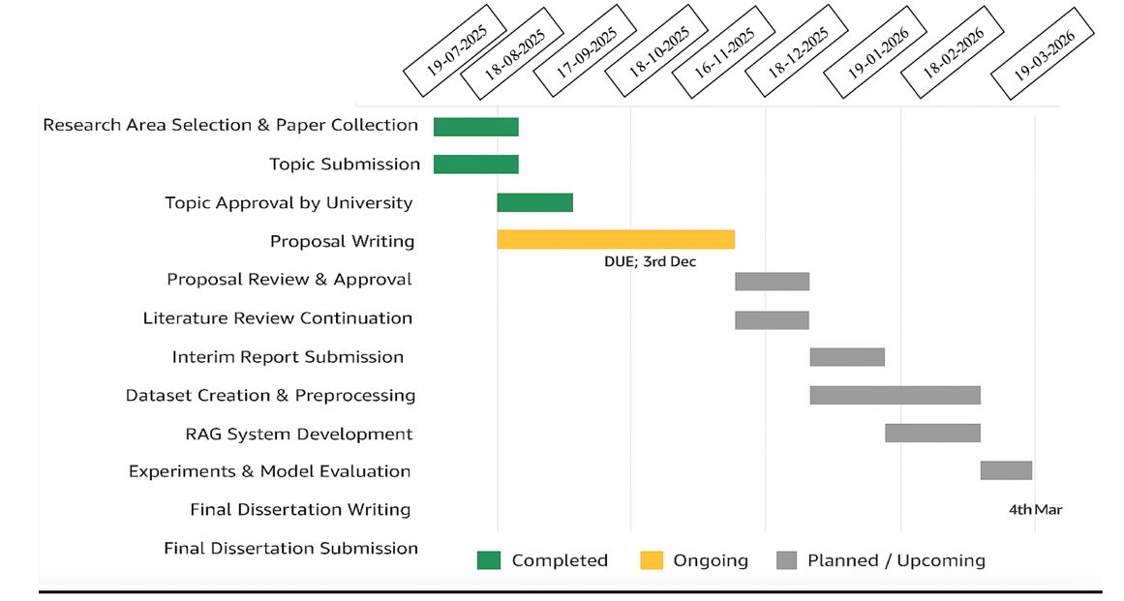
Fig 2-Gant Chart for Research timeline
REFERENCES:

Amarasinghe, K., Rodolfa, K., Lamba, H. and Ghani, R., (2023) Explainable Machine Learning for Public Policy: Use Cases, Gaps, and Research Directions. [online] Available at: http://arxiv.org/abs/2010.14374.
Awais, M., Alharthi, A.H.S.A., Kumar, A., Cholakkal, H. and Anwer, R.M., (2025) AgroGPT: Efficient Agricultural Vision-Language Model with Expert Tuning. [online] Available at: http://arxiv.org/abs/2410.08405.
Brown, C.F., Kazmierski, M.R., Pasquarella, V.J., Rucklidge, W.J., Samsikova, M., Zhang, C., Shelhamer, E., Lahera, E., Wiles, O., Ilyushchenko, S., Gorelick, N., Zhang, L.L., Alj, S., Schechter, E., Askay, S., Guinan, O., Moore, R., Boukouvalas, A. and Kohli, P., (2025) AlphaEarth Foundations: An embedding field model for accurate and efficient global mapping from sparse label data. [online] Available at: http://arxiv.org/abs/2507.22291.
De Clercq, D., Nehring, E., Mayne, H. and Mahdi, A., (2024) Large language models can help boost food production, but be mindful of their risks. [online] Available at: http://arxiv.org/abs/2403.15475.
Dar, A.N., Singh, A.R. and Sen, A., (2025) PolicyStory: Leveraging Large Language Models to Generate Comprehensible Summaries of Policy-News in India. [online] Available at: http://arxiv.org/abs/2509.08218.
Jain, N., Sahit, P.J., Jain, P., Pachpande, S., Singh, M., Kayal, P. and Choudhari, J., (n.d.) AgriBot: Agriculture-Specific Question Answer System. [online] Available at: https://data.gov.in[9][10].
Khan, M.A., (n.d.) Impact of Agriculture sector on Sustainable development of Indian Economy: An Analysis.
Kharesaxena, A., Saxena, S. and Sudhakar, K., (2024) Solar Energy Policy for India: An Overview. CSEE Journal of Power and Energy Systems, 106, pp.2308–2320.
Komarek, A.M., De Pinto, A. and Smith, V.H., (2020) A review of types of risks in agriculture: What we know and what we need to know. Agricultural Systems, .
Kumar, C.M.S., Singh, S., Gupta, M.K., Nimdeo, Y.M., Raushan, R., Deorankar, A. V., Kumar, T.M.A., Rout, P.K., Chanotiya, C.S., Pakhale, V.D. and Nannaware, A.D., (2023) Solar energy: A promising renewable source for meeting energy demand in Indian agriculture applications. Sustainable Energy Technologies and Assessments, .
Lewis, P., Perez, E., Piktus, A., Petroni, F., Karpukhin, V., Goyal, N., Küttler, H., Lewis, M., Yih, W., Rocktäschel, T., Riedel, S. and Kiela, D., (2021) Retrieval-Augmented Generation for Knowledge-Intensive NLP Tasks. [online] Available at: http://arxiv.org/abs/2005.11401.
Martin, R.J., Mittal, R., Malik, V., Jeribi, F., Siddiqui, S.T., Hossain, M.A. and Swapna, S.L., (2024) XAI-Powered Smart Agriculture Framework for Enhancing Food Productivity and Sustainability. IEEE Access, 12, pp.168412–168427.
Maynez, J., Narayan, S., Bohnet, B. and Mcdonald, R., (1906) On Faithfulness and Factuality in Abstractive Summarization. [online] Available at: https://github.com/google-research-.
Meshram, V., Patil, K., Meshram, V., Hanchate, D. and Ramkteke, S.D., (2021) Machine learning in agriculture domain: A state-of-art survey. Artificial Intelligence in the Life Sciences, .
Nagarajan, G., Kumar, O. and Santhiappan, S., (2025) PolicyBot - Reliable Question Answering over Policy Documents. [online] Available at: http://arxiv.org/abs/2511.13489.
Rezayi, S., Liu, Z., Wu, Z., Dhakal, C., Ge, B., Zhen, C., Liu, T. and Li, S., (2022) AgriBERT: Knowledge-Infused Agricultural Language Models for Matching Food and Nutrition. [online] Available at: https://www.ars.usda.gov/northeast-area/.
Yang, B., Zhang, Y., Feng, L., Chen, Y., Zhang, J., Xu, X., Aierken, N., Li, Y., Chen, Y., Yang, G., He, Y., Huang, R. and Li, S., (2025) AgriGPT: a Large Language Model Ecosystem for Agriculture. [online] Available at: http://arxiv.org/abs/2508.08632.
Yang, S., Liu, Z. and Mayer, W., (2024) ShizishanGPT: An Agricultural Large Language Model Integrating Tools and Resources. [online] Available at: http://arxiv.org/abs/2409.13537.
Zhu, H., Li, Z. and Jin, J., (n.d.) GER-LLM: Efficient and Effective Geospatial Entity Resolution with Large Language Model. [online] Available at: https://github.com/luck-seu/GER-LLM.

