**Neha Shah**

**Section A**

**Assignment 6**

**\*\*Note to Kristin\*\*** We discussed over email on 10/11 that because I had designed my “product” differently, with the product being the pastry box, it is OK for me to continue treating my product this way. As a result, I updated functionality on the product browsing page, added a new product page (called pastrybox.html) and updated my shopping cart page (called detailpage.html). The mockups are of the new page. I already had a shopping cart-like page that I simply updated to reflect my true product (a pastry box of rolls rather than the rolls themselves). I have provided my design decisions as part of this iteration within the prototype descriptions below.

**Pastry Box page (new)**

*Lo-fi Prototype*

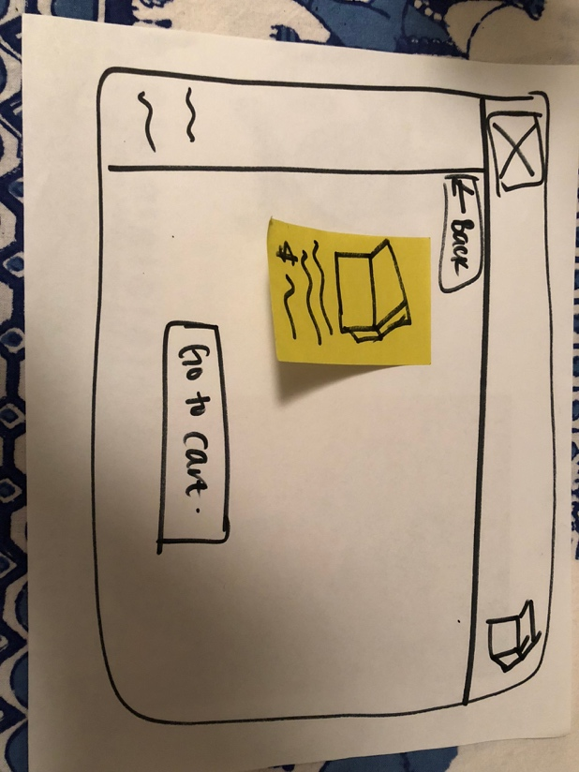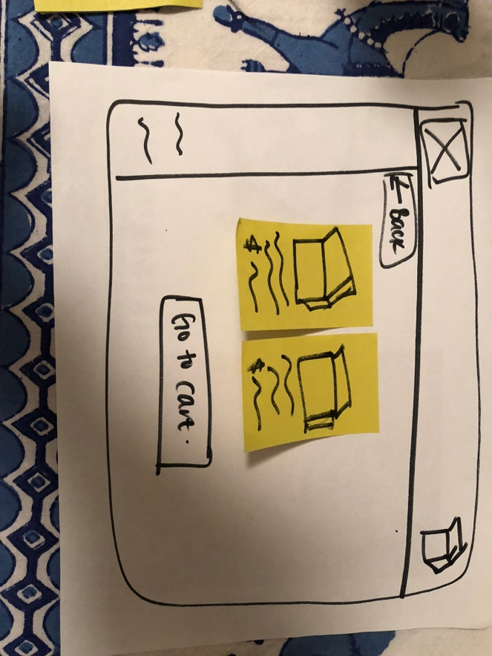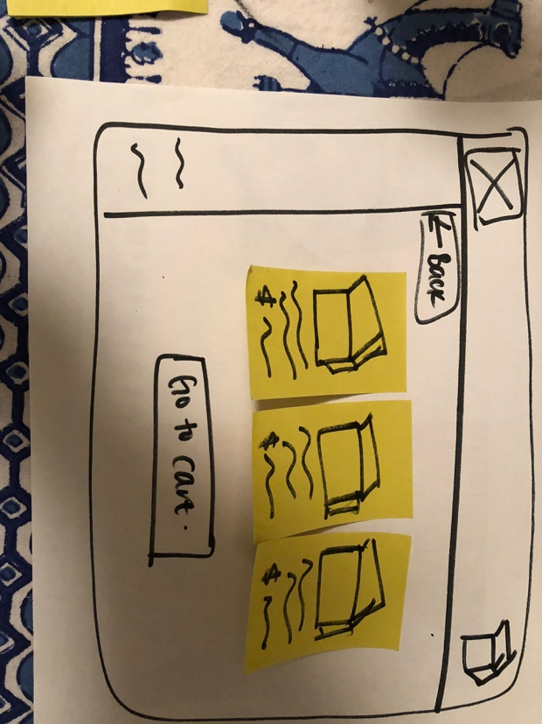

I added a new page which outlines the pastry boxes a user has added to cart. This page serves as a product detail page. It also allows users to see their selections so far, before being taken to the final review page prior to checkout. I limited the number of boxes a user could buy because 3 pastry boxes of rolls is a lot. I don’t think there are many use cases in which a user would purchase more. I also separated each box by flavor and glaze type. It would not be pleasant to have shipped rolls taste like several different flavors from being in the same box. Thus, the user only sees one pastry box added per submission from the browsing page.

*Hi-fi Prototype*

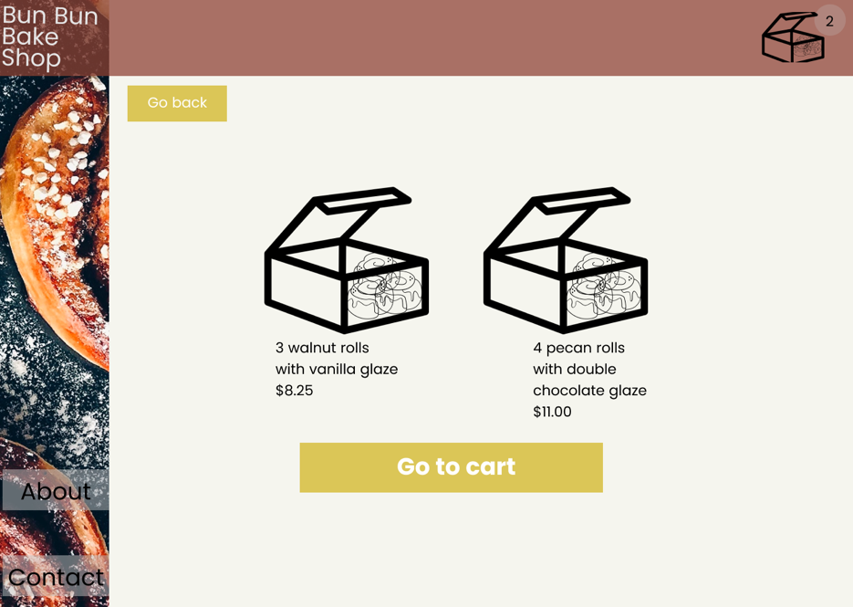

As part of the high-fidelity prototype, I made the buttons contrast colors to follow the design standards I had established from the home page (where main calls to action are on a yellow button).

**Shopping Cart page (adjusted from original)**

*Lo-fi Prototype*

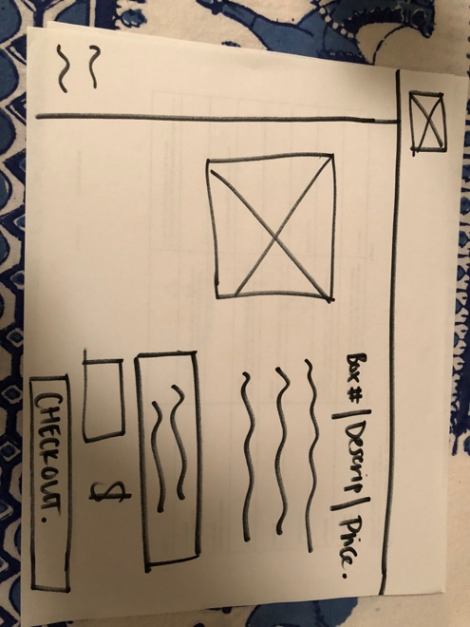

I changed this page to represent the pastry boxes as products, rather than the rolls as products.

*Hi-fi Prototype*

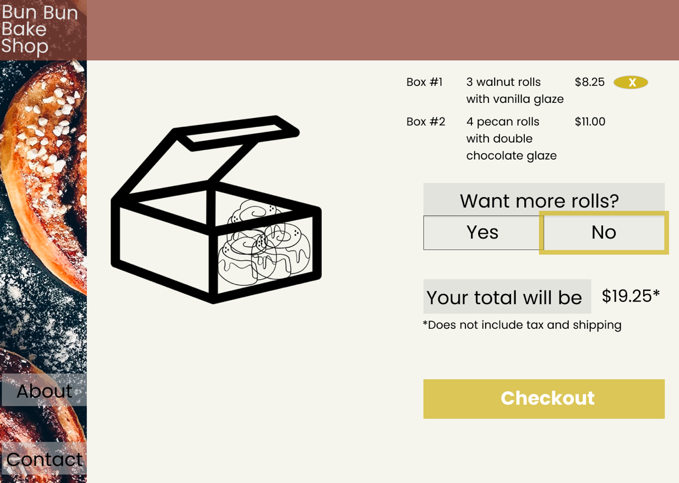

I only allowed the user to remove the first item in the cart. The browsing page gives users the opportunity to review rolls as much as they need to. However, the shopping cart is where the business is trying to clench the sale. As a result, it is in my client’s best interest to only let users remove one specific item at a time. Because we do not use asynchronous loading, the user must refresh the page to be able to remove another item. I am curious if this would be considered a dark pattern of UX!

**Reflection**

I encountered several challenges in building the interactivity with JavaScript and jQuery that required some tricks to solve. The first challenge had to do with the way I had organized categories of information on my browsing page for both flavor and glaze options. I found it was easier to put the information I had in a table format rather than floating items within a div. This allowed me to more easily place images on top of each other, which was a requirement to have an element elicit responses for hover and click events. Determining how to make the same element respond to both hover and click events was a unique challenge. I ended up solving this challenge by inserting a new class. I then used CSS hover styling for hover events and JavaScript for click events. The final critical challenge I encountered was being able to remove an item from the cart. I had accidentally set an internal variable that tracks which item in local storage to remove incorrectly. This resulted in a differently-positioned item being removed every time the user tried to remove an item. I printed data to my console and tracked what was in local storage before and after taking an action to remove an item. Through this process, I was able to successfully debug the issue. Overall, I found that utilizing the structure of HTML and logging in JavaScript helped me significantly in completing this project.