- Introduction of Organization

NAME OF ORGANIZATION: HD Events Planner.
LOCATION: Dhule.
The computer, with its emphasis on accuracy and speed, has had a significant impact on various aspects of society. These are just some of the areas where computers are playing a vital role, leading to a vast increase in the range of computer applications and, correspondingly, the effect computers have on our daily lives.
Nowadays, data management systems have become crucial and widespread. Organizations of all sizes play a significant role in human life and are considered fundamental needs.
Computerization comes into play when the number of transactions increases due to the rising number of organizations and events. Automation helps in managing the vast amount of information required, allowing for quick, accurate summaries and up-to-date information in all areas of the system.
I expect all users of this package to have a basic understanding of the capabilities and important features of the computer system.
In the “Event Planning Recommendation System,” the details of various events, clients are stored in a database, which can easily be retrieved by the admin. The system provides tailored event planning recommendations based on user preferences and requirements.
As time progresses, education becomes the key to a nation’s development. Manual handling of data is complex, so this system was created to automate and streamline the process. The project “Event Planning Recommendation System” is being implemented for event management purposes at ‘XYZ Events’ in ‘ABC City.’

2. Proposed System And
Existing System

- Existing System
In the existing manual event planning process, event organizers are responsible for handling various aspects such as vendor details, guest lists, budget management, and venue booking. These records are maintained on paper or spreadsheets, often leading to inefficiency and errors. Event details such as the client’s name, event type, venue preferences, date, and budget are all manually entered into different registers and records, making the process cumbersome and time-consuming.
The current system lacks integration between different tasks, such as selecting vendors, organizing guest lists, and managing the event budget. This results in disjointed information, which is difficult to track and manage. With the increasing number of events and clients, maintaining these records manually becomes increasingly difficult, and the chances of errors increase significantly.
Moreover, event planners struggle to provide personalized recommendations for clients because the current system does not allow for automated data retrieval or suggestions based on preferences. This makes the entire event planning process tedious and prone to inefficiencies.

The objectives of the Event Planning Recommendation System are as follows:
- Minimize Manual Work: Reduce the time spent on manually entering and maintaining data.
- Easy Access to Data: Allow users to quickly retrieve event details and vendor information.
- User-Friendly Interface: Ensure that the system is easy to use for event planners, even with minimal technical knowledge.

- Propose System:

Need of Proposed System
The event planning process involves managing numerous details related to clients, vendors, venues, and schedules. As the current system is manual, it faces several challenges, such as being time-consuming, prone to errors, and lacking quick access to specific records. To overcome these challenges, computerization is essential. The proposed Event Planning Recommendation System will help manage and streamline the data, enabling faster, more accurate, and efficient planning of events. This system will ensure that event planners can access all relevant information quickly, without the need for manual record-keeping.

- Speed :
The system can quickly search for event details, vendor information, guest lists, and provide instant recommendations. This significantly saves time compared to the manual process of searching through physical records or spreadsheets.

- Accuracy :
Manual systems are prone to errors due to human oversight. Computerization ensures accuracy by validating data and minimizing errors with built-in checks during data entry, ensuring that event details, schedules, and vendor information are correct.

- Large Storage Capacity :
The system can store vast amounts of data, including detailed client profiles, event history, vendor contracts, and more. This is particularly useful when managing multiple events simultaneously, ensuring that all data is stored securely and is easily accessible.

- Security :
All event-related data is stored electronically, ensuring that it is safe from physical damage. Regular backups and secure storage ensure that important event data, such as contracts, schedules, and guest lists, are protected. Furthermore, access to sensitive information can be controlled and monitored to prevent unauthorized use.

3. Need Of Computerization For Organization

Project profile:

Project Title : “EVENT PLANNING RECOMMENDATION SYSTEM”

Aims :
To maintain and organize the event data related to clients and vendors. Provide a computerized process for efficient event planning, offering personalized recommendations and managing event schedules, guest lists, and vendor details.

Organization : HD Events Planner.

Hardware Used : 12th Gen Intel(R) Core(TM) i5-1235U
1.30 GHz

Software Used :
- Back End : Django
- Front End : HTML, CSS, JavaScript

Operating System : Window 7 or up to window 11

Project Guide : Prof . Rupali Chavan

Developed by : Pranjal Santoshsing Pardeshi

4. DATA COLLECTION AND ANALYSIS.

DATA DICTIONARY
A data dictionary is ‘metadata’ is i.e. about data. Data dictionary is list of all data element composing the data flowing thought a system major complaint are data flow, data stores and stores process. I have tried my level best to conserve storage space in this project. Even though there is a large amount of data element on proposed system. Still there is fountain system. The following section gives of detail element.

- Database Name: Usermast (Entry Table)
Purpose: To Store the information about the User.

Serial No | Field Name | Data Type | Field Size | Constraint
1 | User Id | NUMBER | 11 | Primary Key
2 | User name | VarChar | 50 | NOT NULL
3 | User Email | VarChar | 50 | NOT NULL
4 | User Password | VarChar | 50 | NOT NULL
5 | Mobile | VarChar | 11 | NOT NULL

- Database Name: Event (Entry Table)

Purpose: To store the Different Type of Event Packages.

Serial No | Field Name | Data Type | Field Size | Constraint
1 | Event Id | NUMBER | 11 | Primary Key
2 | Event Name | VarChar | 30 | NOT NULL
3 | Event Type | VarChar | 50 | NOT NULL
4 | Event Data | VarChar | 1000 | NOT NULL
5 | Event  Capacity | VarChar | 50 | NOT NULL
6 | Event  Location | VarChar | 50 | NOT NULL
7 | Price | VarChar | 50 | NOT NULL
8 | Event Image | VarChar | 100 | NOT NULL

- Database Name: History (Entry Table)

Purpose: To Store the information about Search History by User and its Search Details.

Serial No | Field Name | Data Type | Field Size | Constraint
1 | Transaction No. | INTEGER | 50 | Primary Key
2 | Transaction Date | DateTime | - | NOT NULL
3 | User  Id | VarChar | 50 | NOT NULL
4 | Search Event Name | VarChar | 100 | NOT NULL
5 | Number of Person | VarChar | 20 | NOT NULL
6 | Location | VarChar | 50 | NOT NULL

5. INTRODUCTION TO ENVIRONMENT

About Python (Django)

Why choose Python (Django)
Introduction to Django environment:
Django is a powerful web framework used to build secure and maintainable web applications. It follows the Model-View-Template (MVT) architecture, enabling efficient separation of concerns. Django comes with a built-in development server, ORM (Object-Relational Mapping) for database management, and a robust security system.

Django Highlights:
1. Rapid Development
Django allows developers to build applications quickly using reusable components.
It reduces code duplication and follows the DRY (Don’t Repeat Yourself) principle.
2. Security
Django provides built-in protection against SQL injection, cross-site scripting (XSS), cross-site request forgery (CSRF), and clickjacking.
It also includes user authentication and session management.
3. Scalability
Django can handle high traffic and large databases efficiently.
It is used by many high-profile applications like Instagram and Pinterest.

Web Services in Django:
Django supports the development of RESTful web services using Django REST Framework (DRF). REST APIs allow applications to communicate over HTTP, enabling seamless data exchange between frontend and backend.
Django and Database Support:
Django provides built-in support for multiple databases, including:
• MySQL
Django ORM simplifies database operations, allowing developers to interact with databases using Python code instead of raw SQL queries.
Language Enhancements:
Python, as a dynamically typed and high-level programming language, continuously evolves to enhance performance, readability, and efficiency. Django, built on Python, inherits these improvements, making web development smoother and more powerful.
1. Improved Syntax and Readability
• Python follows an easy-to-read, indentation-based syntax that makes code clean and maintainable.
• Django’s ORM (Object-Relational Mapping) allows database interaction using Python instead of raw SQL, making queries more readable.
2. Asynchronous Support in Django
• With Django’s newer versions (from 3.1+), asynchronous views, middleware, and database queries are supported, allowing better performance for handling multiple requests concurrently.

3. Enhanced Django Query Set Methods
• Django’s ORM now supports better query optimization techniques like Prefetch() and annotate() for improved database performance.4. Django REST Framework (DRF) Enhancements
• Improved API serialization with serializers
• View Sets and Routers for automatic URL routing
• Token and JWT-based authentication for security
5. Machine Learning Integration in Django
• Python’s ML libraries like TensorFlow, Scikit-Learn, and Py Torch can be integrated with Django to make AI-powered predictions in projects like the Health Disease Prediction System.

6. HARDWARE & SOFTWARE REQUIREMENTS

As I am going to provide computerize Event Planning Recommendation System to the organization. They have to deal with the following hardware & software.

- Hardware Requirement:
The organization will need the following minimum hardware requirement.

Processor : Minimum Intel i3 (5th gen).

Ram : Minimum 4(GB) Ram DDR4.
(For better experience)

Backup Device : 256 Internal H.D.D or External.

Hard Drive : Required of 4.5GB (SPACE) H.D.D
And Max (256 GB)
Monitor : Minimum 14 Colour Monitor.

Mouse : A PS/2 or Serial Mouse.

Printer : 80 Column Dot Matrix Printer.

Keyboard : 105(Key) Key-Board

With above configuration my system will run fast, if higher configuration is available that it will be too good to use it.

- Software Requirement:
As I have developed the system using Django (Python) and a web-based frontend, only Python and Django are compulsory for the system. Since Django is a web framework, it requires any version of Windows, Linux, or macOS that supports Python.
For the database , MySQL can be used as the backend. The frontend is built using HTML, CSS, and JavaScript. No additional software is required apart from a web browser to access the system.

7. FEASIBILITY STUDY

Feasibility Study:
A Feasibility Study is the second stage in the system development life cycle. The Feasibility Study tests the system proposal based on the availability of resources, the organization’s ability to meet user needs, and the effective use of resources.
The Feasibility Study involves:
- Economic Feasibility
- Technical Feasibility
- Behavioural Feasibility

A. Economic Feasibility:
Economic Feasibility is the most frequently used method for evaluating the effectiveness of the proposed system. The costs, benefits, and savings of the proposed system are compared with the overall costs.
The different types of costs to be considered are:
- Manpower Cost: The proposed system will integrate seamlessly with the department’s current systems, allowing a single person to manage the entire event planning process. No extra manpower will be required.
- Hardware Cost: As outlined in the hardware and software requirements, the system will function well with minimal hardware. The required hardware will not incur a significant cost compared to the manual system.
- Operating Cost: The system will require minimal training for operators, as it is user-friendly. This will reduce operational costs associated with training. Within a short period, users will be able to operate the system efficiently without additional support.

B. Technical Feasibility:
Technical Feasibility refers to whether the available software and technologies support the proposed application. It evaluates the pros and cons of using specific software for the development and its feasibility. Additionally, it looks at any additional training needed for users to operate the application.

C. Behavioural Feasibility:
Behavioural Feasibility deals with the user’s resistance or acceptance of the new system. Generally, people are resistant to change, but the proposed system is designed to be easy for users to adopt.
- The Event Planning Recommendation System is designed to be intuitive, and users will find it easy to transition from the current system.
- The system will be well-received as it is aimed at simplifying the event planning process and providing valuable recommendations, making it an attractive tool for users.

8. ENTITY RELATIONSHIP
DIAGRAM

Event name
Event
Uname
Uno
User

Uemail

Event Data date
Event no
HAS

Suggestions
Has

Location
Event name
Event Details
Capacity

Event Planning Recommendation System

MIS

Event
User
Suggestions

Fig: Zero Level Data Flow Diagram

Event Info
2.1
Show
Event
Event Data

New Event Data
2.2
Add
Event
New Event Data
Event Info

Administrator
Event
2.3
Change
Event
The Latest Event Data
Event Info
The Latest Event Data

Fig: Event Data Maintenance Process Diagram

- DATA SYSTEM INPUT AND OUTPUT

- INPUT SCREENS:

Admin Login Form

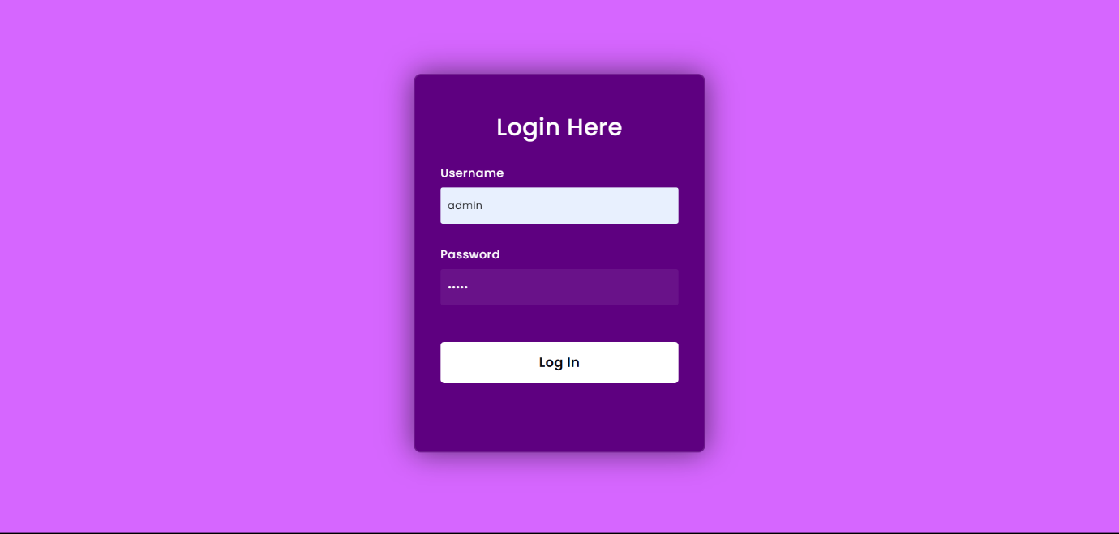

Add Event Form

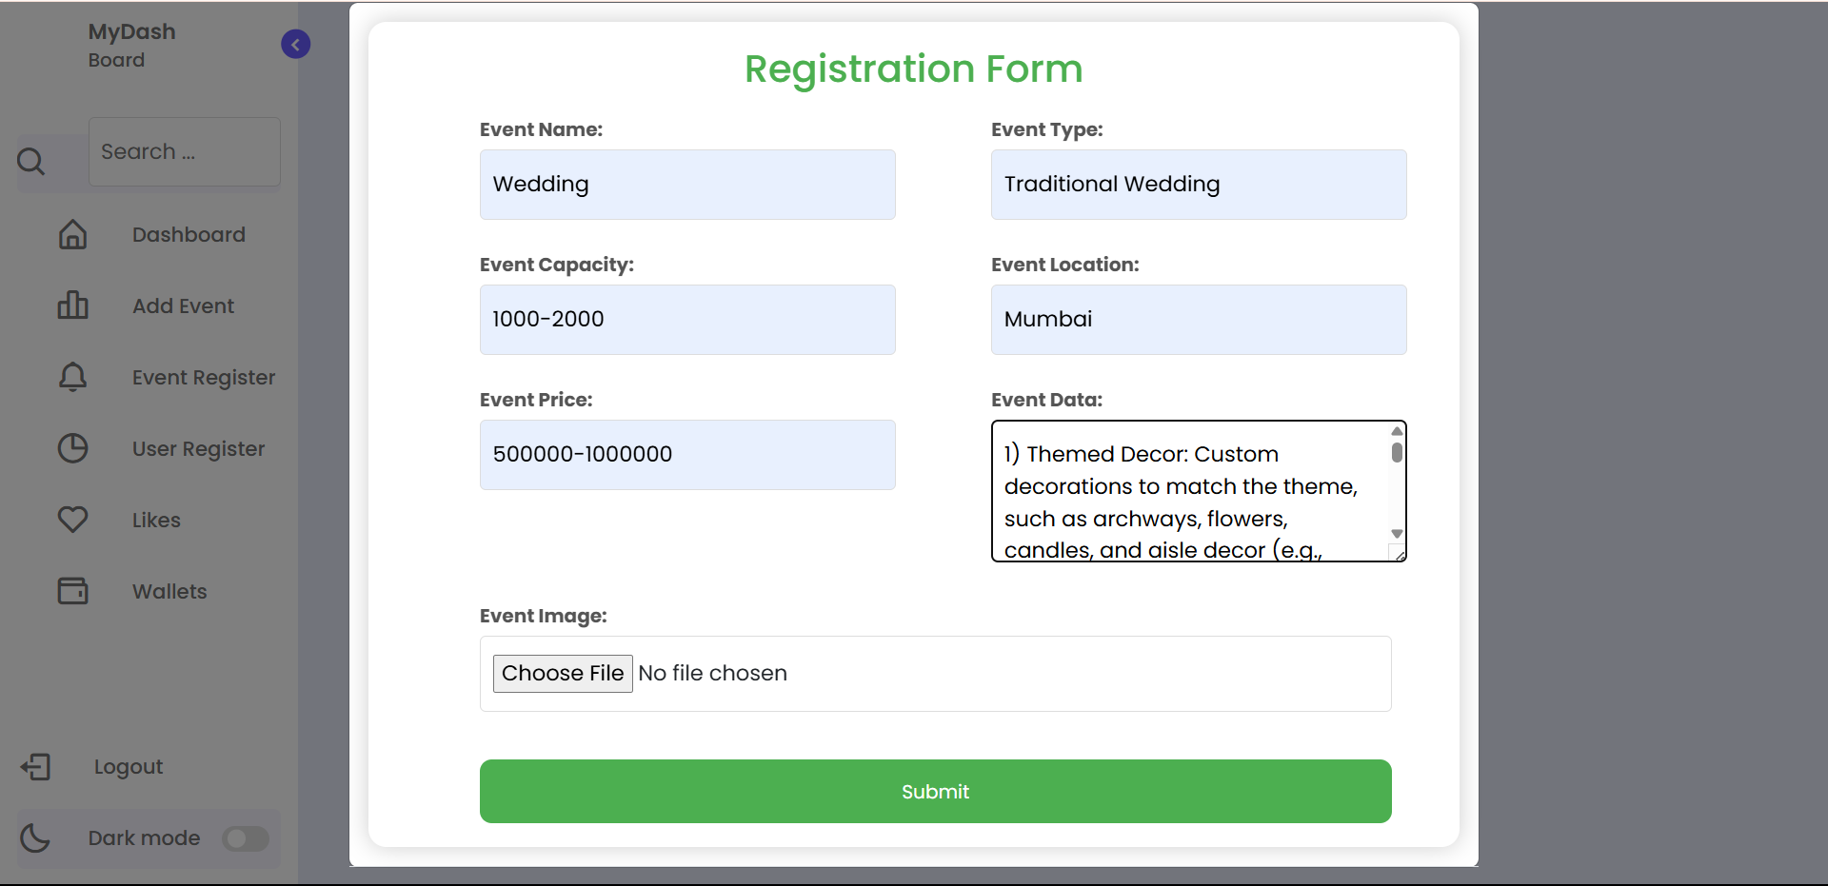

Register Event

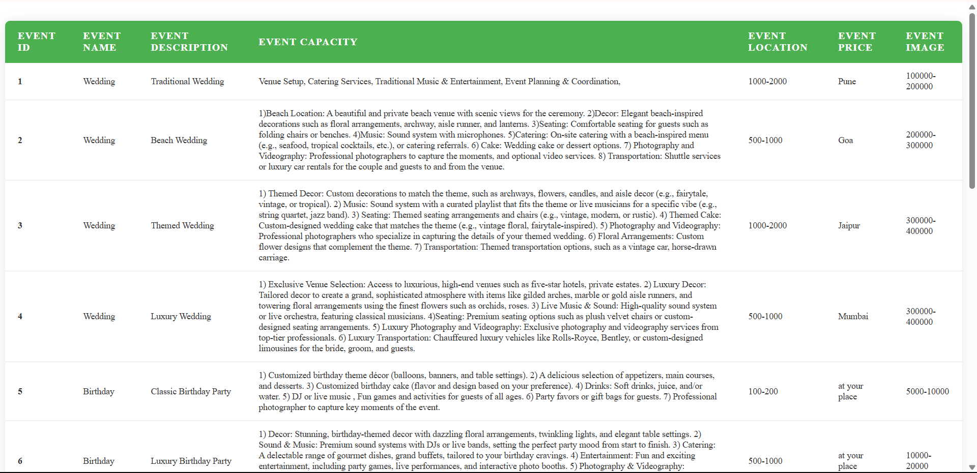

Front Page

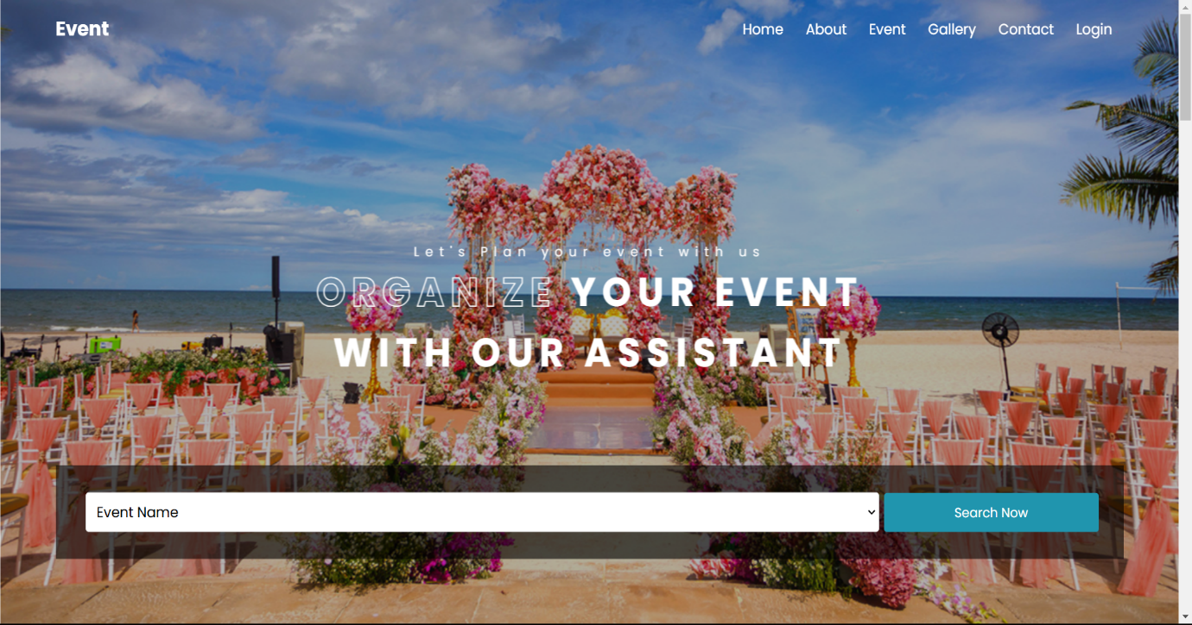

Packages of Event That User Search with Name of the Events





Registration Form

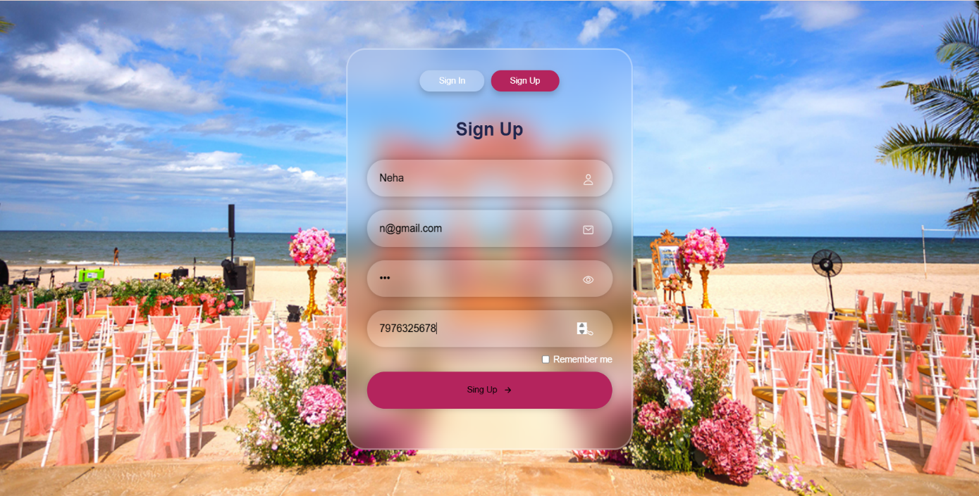

Login Form

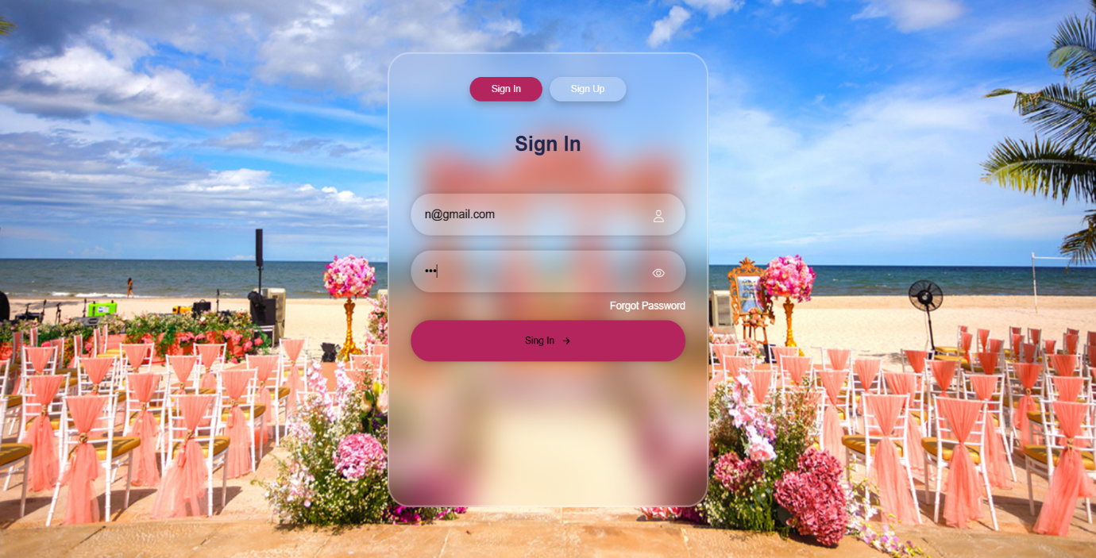

After Login Front Page

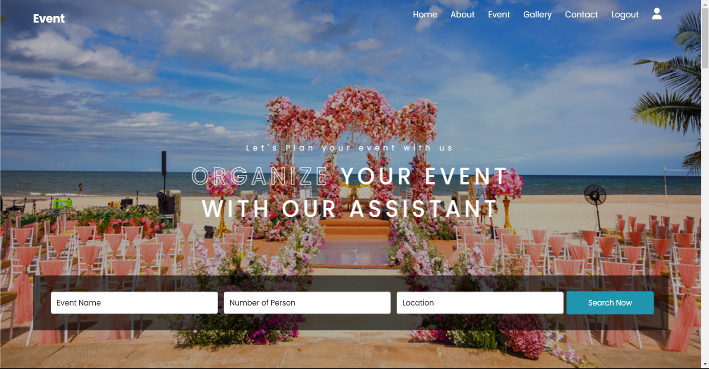

After Login User Previous Search History

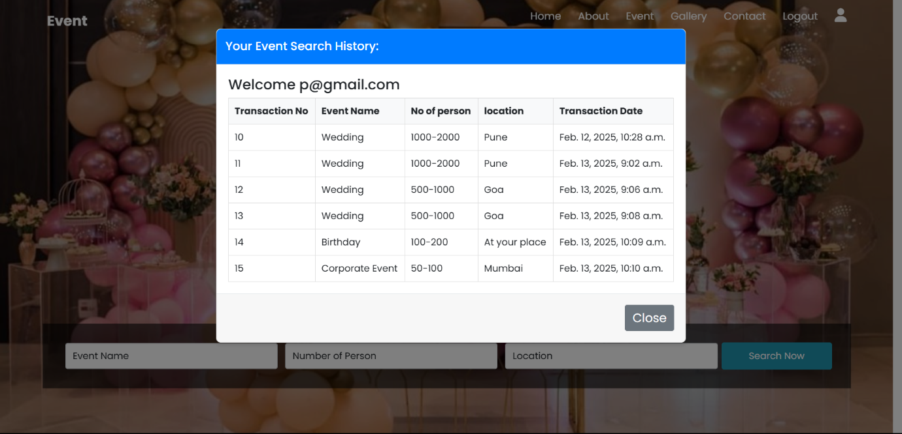

Event Package Recommended
(As per user required)



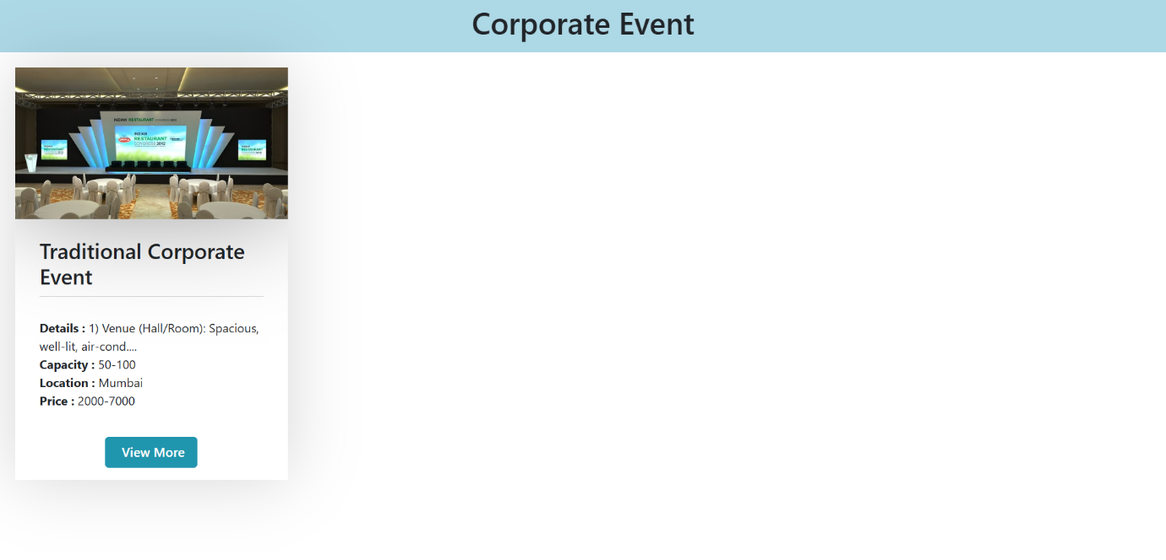

Event Package Details

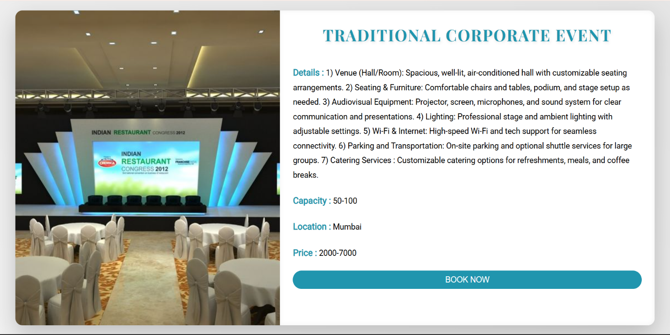



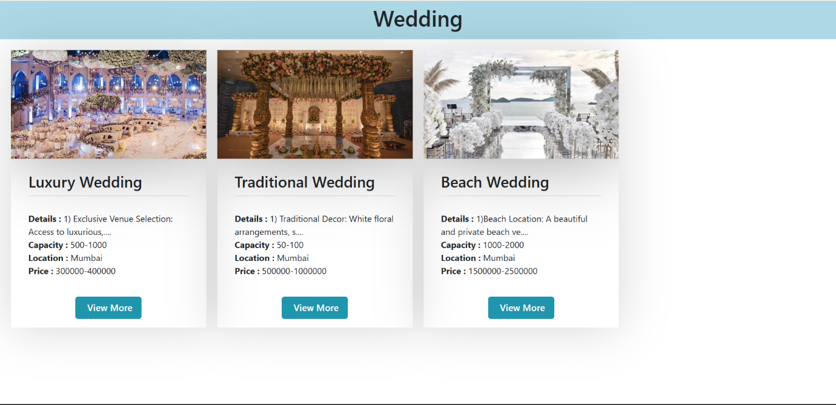



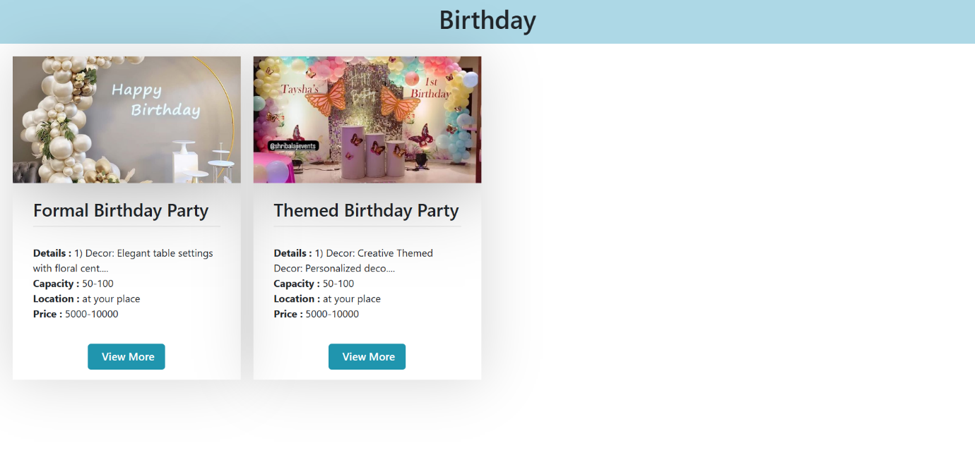

10. TESTING AND IMPLEMENTATION.

System level testing must be conducted prior to installation of any system. It invoices.
- Preparation of realistic test data in according with the system test plan.
- Processing the test data using the new equipment.
- Through checking of the result of all system tests.
- Reviewing the results with future, operators, and of all system personal.
System level testing is an excellent time for training employees in the operation of the new system as well as maintaining it. Typically, it requires 25 to 35 percent of the total implementation effort.
One of the most effective ways to perform system level testing is to perform parallel operations consist of feeding both system the same input data comparing the data files & output result. Despite the fact that the individual program ware tested, related conditions are likely to occur that were not envisioned. Last minute changes to computer programs are necessary to accommodate these new conditions.
  - Implementation:
- User Manual:
- Start the system & run the ‘Software Application’.
- The menu displays as:

- MASTER : It contains the following form’s
- User Registration Form
- User Login Form
- Admin Login Form
- Event Registration Form
- Registration
Use these options to store & access the Customer & its related data. The “Registration Information” form allows entering the personal information of the Customer. It includes Name, Email, Password, Contact etc.

- REPORT : It contains the following report.
- Note: By clicking of report in main form you get the following report as mentioned in below.
- User Register
- User Login Form.
- Admin Login Form.
- Event Registration Form.
- EXIT : To exit from the Main Project.

“IF YOU HAVE ANY TROUBLE/PROBLEM, CONSULT THE SYSTEM ADMINSTRATION”

11. SUGGESTION AND CONCLUSION

LIMITATION OF PACKAGE:

This package is not generalized system. It is useful only for the employee of ‘Event Planning Recommendation System’ For ‘HD Events Planner’ Dhule. All the time user has to alert while communicating the package because there are numerous validations checks that can disturb of irritate the new user.

As we are the student and while developing this package some expectations of Arts, Commerce and B.C.A College Dhule, guide and our teacher’s may not be fulfilled or rest but we are still happy with this Project and can say, though this is not the ‘Complete Package’.

12. BIBLIOGRAPHY

References:

- Mastering Python
Rick van Hattem
- Django Unleashed
Andrew Pinkham
- Database Management Concept

Henry Korth

