**Contents**

1. Introduction………………………………………………… 2
2. Objective…………………………………………………… 6
3. Story Line…………………………………………………... 5
4. Implemented Code………………………………………… 6
5. Snapshots of output ………………………………………. 11
6. Conclusion..………………..……………………………..... 13
7. References ………...………………………………………. 14
8. **Introduction**

**Open Graphics Library (OpenGL)** is a [cross-language](https://en.wikipedia.org/wiki/Language-independent_specification), [cross-platform](https://en.wikipedia.org/wiki/Cross-platform) [application programming interface](https://en.wikipedia.org/wiki/Application_programming_interface) (API) for rendering [2D](https://en.wikipedia.org/wiki/2D_computer_graphics) and [3D](https://en.wikipedia.org/wiki/3D_computer_graphics) [vector graphics](https://en.wikipedia.org/wiki/Vector_graphics). The API is typically used to interact with a [graphics processing unit](https://en.wikipedia.org/wiki/Graphics_processing_unit) (GPU), to achieve [hardware-accelerated](https://en.wikipedia.org/wiki/Hardware_acceleration) [rendering](https://en.wikipedia.org/wiki/Rendering_(computer_graphics)).

[Silicon Graphics](https://en.wikipedia.org/wiki/Silicon_Graphics) Inc., (SGI) started developing OpenGL in 1991 and released it in January 1992; applications use it extensively in the fields of [computer-aided design](https://en.wikipedia.org/wiki/Computer-aided_design)(CAD), [virtual reality](https://en.wikipedia.org/wiki/Virtual_reality), [scientific visualization](https://en.wikipedia.org/wiki/Scientific_visualization), information visualization, [flight simulation](https://en.wikipedia.org/wiki/Flight_simulator), and [video games](https://en.wikipedia.org/wiki/Video_game).

Any visual computing application requiring maximum performance-from 3D animation to CAD to visual simulation-can exploit high-quality, high-performance OpenGL capabilities. These capabilities allow developers in diverse markets such as broadcasting, CAD/CAM/CAE, entertainment, medical imaging, and virtual reality to produce and display incredibly compelling 2D and 3D graphics.

OpenGL specifies a set of "commands" or immediately executed functions. Each command directs a drawing action or causes special effects. A list of these commands can be created for repetitive effects. OpenGL is independent of the windowing characteristics of each operating system, but provides special "glue" routines for each operating system that enable OpenGL to work in that system's windowing environment. OpenGL comes with a large number of built-in capabilities requestable through the API. These include hidden surface removal, alpha blending (transparency), [antialiasing](https://whatis.techtarget.com/definition/antialiasing) , texture mapping, [pixel](https://whatis.techtarget.com/definition/pixel) operations, viewing and modeling transformations, and atmospheric effects (fog, smoke, and haze).

**Developer-Driven Advantages:**

* **Industry standard**
* **Stable**
* **Reliable and portable**
* **Evolving**
* **Scalable**
* **Easy to use**
* **Well-documented**

**API Hierarchy**

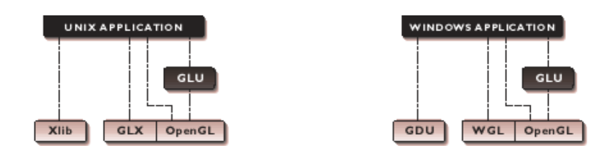

*This diagram demonstrates the relationship between OpenGL GLU and windowing APIs.*

|  |
| --- |
| * OpenGL applications use the window system’s window, input, and event mechanism * GLU supports quadrics, NURBS, complex polygons, matrix utilities, and more |
|  |

1. **Objective**

This project will involve developing simple slides which are linked together using keyboard functions

1. **Story Line**

It was few minutes after midnight. It was her birthday and she told herself that tomorrow is going to be an exciting day and went to bed. When she got up, she expected her parents to be happy and excited too that their baby girl is turning 10 today, but it wasn’t any different from other days when she’d hear her parents fighting over not having a ‘boy child’. She held herself responsible for the fight and went to school without talking to anyone. The girl was emotionally down and in her absent mind she didn’t see a car approaching towards her and was hit. She was severely injured and was taken to the hospital. Meanwhile, her parents were informed about the incident and got worried about their child. At that moment of time when their child was in danger they realized how much they loved her and it didn’t matter whether it’s a girl or boy. The girl gradually recovered from the accident and they started to live a happy life with her.

1. **Implemented Code**

#include<stdio.h>

#include<stdlib.h>

#include<GL/glut.h>

#include<string.h>

#include<math.h>

void circle(GLfloat x, GLfloat y, GLdouble radius) {}

void DrawEllipse_purple(float cx, float cy, float rx, float ry){}

void DrawEllipse_blue(float cx, float cy, float rx, float ry){}

void DrawEllipse_lightblue(float cx, float cy, float rx, float ry){}

void DrawEllipse_black(float cx, float cy, float rx, float ry){}

void DrawEllipse_skin(float cx, float cy, float rx, float ry){}

void DrawEllipse_red(float cx, float cy, float rx, float ry){}  
void DrawEllipse_darkgreen(float cx, float cy, float rx, float ry){}

void DrawEllipse_grey(float cx, float cy, float rx, float ry){}

void drawText(float x, float y, char* str, int size){}

void arc(GLfloat x, GLfloat y, GLdouble radius, GLfloat i, GLfloat j){}

void drawBG1(){}

void drawDad1(){}

void moveDadUP(int x, int y){}

void moveDadDOWN(int x, int y){}

void drawMom1() {}

void moveMomUP(int x, int y){}

void moveMomDOWN(int x, int y) {}

void drawTukku1() {}

void drawBG2() {}

void drawTukku2() {}

void drawBG3() {}

void drawDad3() {}

void moveDad3(int x, int y) {}

void moveMom3(int x, int y) {}

void drawMom3() {}

void drawBG4() {}

void drawDad4() {}

void drawMom4() {}

void drawTukku4() {}

void display1() {

glClear(GL_COLOR_BUFFER_BIT | GL_DEPTH_BUFFER_BIT);

drawBG1();

drawDad1();

drawMom1();

drawTukku1();

glColor3f(0.0f, 0.0f, 1.0f);

drawText(400, 30, "Enter '2' or '3' to move", 2);

drawText(400, 15, "hands up and down", 2);

glFlush();

}

void display2() {

glClear(GL_COLOR_BUFFER_BIT | GL_DEPTH_BUFFER_BIT);

drawBG1();

drawTukku1();

for (int i = 0; i <= 10; i++) {

glClear(GL_COLOR_BUFFER_BIT | GL_DEPTH_BUFFER_BIT);

drawBG1();

drawTukku1();

for (int j = 0; j < 10; j++) {

moveDadUP(0, i);

moveMomUP(0, i);

glFlush();

}

}

glFlush();

}

void display3() {

glClear(GL_COLOR_BUFFER_BIT | GL_DEPTH_BUFFER_BIT);

drawBG1();

drawTukku1();

for (int i = 0; i <= 10; i++) {

glClear(GL_COLOR_BUFFER_BIT | GL_DEPTH_BUFFER_BIT);

drawBG1();

drawTukku1();

for (int j = 0; j < 10; j++) {

moveDadDOWN(0, i);

moveMomDOWN(0, i);

glFlush();

}

}

glColor3f(0.0f, 0.0f, 1.0f);

drawText(400, 30, "Enter '4' to continue ", 2);

glFlush();

}

void display4() {

glClear(GL_COLOR_BUFFER_BIT | GL_DEPTH_BUFFER_BIT);

glClearColor(1.0, 1.0, 1.0, 0.0);

drawBG2();

drawTukku2();

glColor3f(0.0f, 0.0f, 1.0f);

drawText(400, 30, "Enter '5' to continue ", 2);

glFlush();

}

void display5() {

glClear(GL_COLOR_BUFFER_BIT | GL_DEPTH_BUFFER_BIT);

//glClearColor(0.2, 0.7, 1.0, 0.0);

glColor3f(0.0f, 0.0f, 0.0f);

drawText(120, 250, "The girl in her absent mind meets with an accident and gets severely injured.", 2);

glFlush();

glColor3f(0.0f, 0.0f, 1.0f);

drawText(400, 30, "Enter '6' to continue ", 2);

glFlush();

}

void display6() {

glClear(GL_COLOR_BUFFER_BIT | GL_DEPTH_BUFFER_BIT);

//glClearColor(1.0, 1.0, 1.0, 0.0);

drawBG3();

drawDad3();

drawMom3();

glColor3f(0.0f, 0.0f, 1.0f);

drawText(400, 30, "Enter '7' to continue ", 2);

glFlush();

}

void display7() {

glClear(GL_COLOR_BUFFER_BIT | GL_DEPTH_BUFFER_BIT);

glClearColor(1.0, 1.0, 1.0, 0.0);

drawBG3();

drawDad3();

drawMom3();

for (int i = 0; i > -150; i--) {

glClear(GL_COLOR_BUFFER_BIT | GL_DEPTH_BUFFER_BIT);

drawBG3();

for (int j = 0; j < 10; j++) {

moveDad3(i, 195);

moveMom3(i, 196);

glFlush();

}

//glFlush();

}

glColor3f(0.0f, 0.0f, 1.0f);

drawText(400, 30, "Enter '8' to continue ", 2);

glFlush();

}

void display8() {

glClear(GL_COLOR_BUFFER_BIT | GL_DEPTH_BUFFER_BIT);

drawBG4();

drawDad4();

drawMom4();

drawTukku4();

glColor3f(0.0f, 0.0f, 1.0f);

drawText(220, 400, "HAPPY FAMILY ", 2);

drawText(400, 30, "THE END! ", 2);

glFlush();

}

void display0() {

glClearColor(0.0, 0.2, 0.4, 0.0);

glClear(GL_COLOR_BUFFER_BIT | GL_DEPTH_BUFFER_BIT);

glColor3f(1.0, 1.0, 0.2);

//continue option

drawText(380, 90, "Press C to continue", 2);

drawText(380, 60, "At any time, press 1-8 ", 2);

drawText(380, 30, "to switch among slides", 2);

//Team Members

drawText(10, 90, "Team Members:", 2);

drawText(20, 60, "1. Neha Thakur (USN: 1DS15CS064)", 2);

drawText(20, 35, "2. Rashi Verma (USN: 1DS15CS081)", 2);

//guidance

drawText(198, 270, "Under the guidance of:", 2);

drawText(100, 235, "Prof. Shubha Bhat", 2);

drawText(300, 235, "Prof. Ravichandra H", 2);

glColor3f(1.0, 1.0, 1.0);

//Topic

//print(200, 350, "WAR AND PEACE");

drawText(195, 360, "WAR AND PEACE", 3);

drawText(195, 320, "The Unwanted Child", 3);

glFlush();

}

void myKeyboard(unsigned char key, int x, int y)

{

switch (key)

{

case '1':display1();

break;

case '2':display2();

break;

case '3':display3();

break;

case '4':display4();

break;

case '5':display5();

break;

case '6':display6();

break;

case '7':display7();

break;

case '8':display8();

break;

case 'x':display0();

break;

case 'X':display0();

break;

case 'c':display1();

break;

case 'C':display1();

break;

}

}

int main(int argc, char **argv) {

glutInit(&argc, argv);

glutInitDisplayMode(GLUT_RGB | GLUT_DEPTH | GLUT_SINGLE);

glutInitWindowSize(500, 500);

glutCreateWindow("WAR AND PEACE");

glClearColor(1.0, 1.0, 1.0, 0.0);

glMatrixMode(GL_PROJECTION);

glLoadIdentity();

gluOrtho2D(0, 500, 0, 500);

glutDisplayFunc(display0);

glutKeyboardFunc(myKeyboard);

glutMainLoop();

}

1. **Snapshots of output**

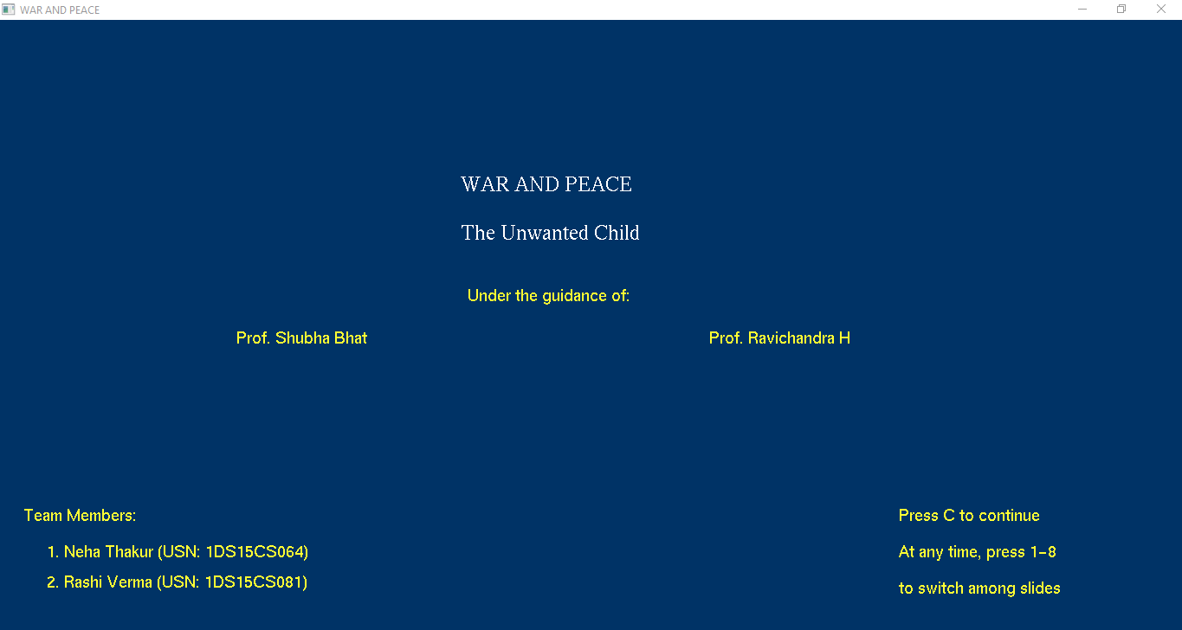

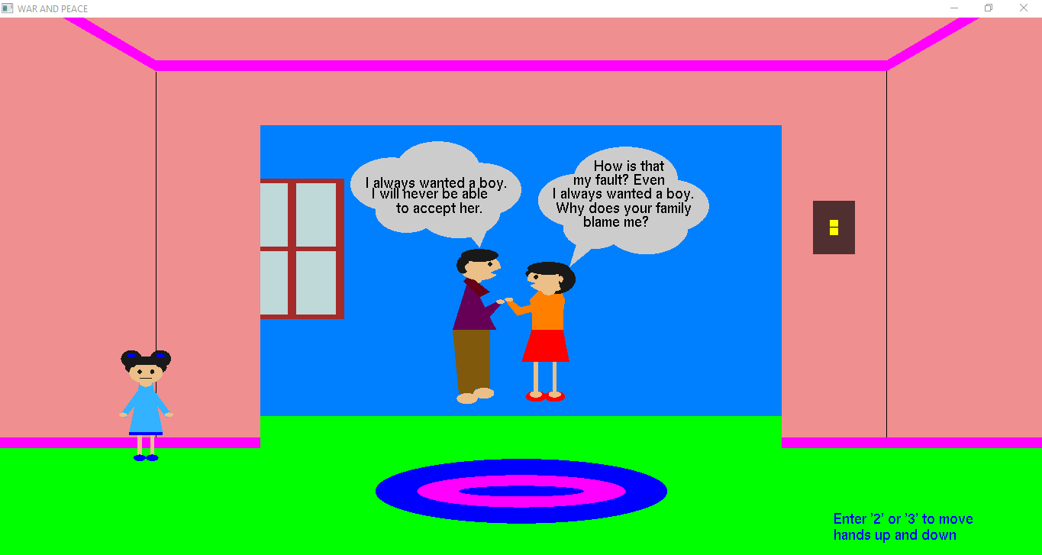

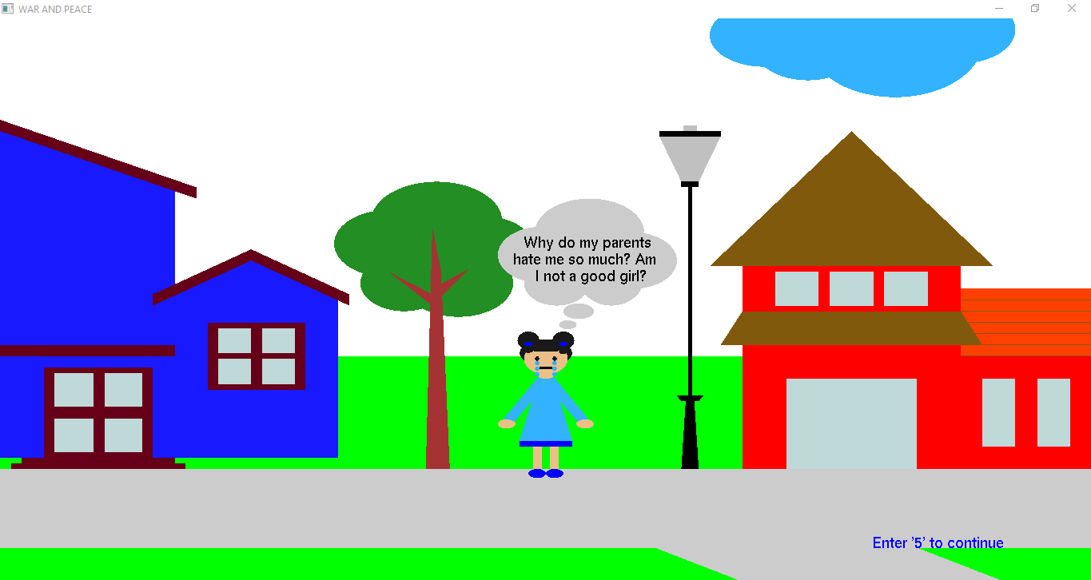

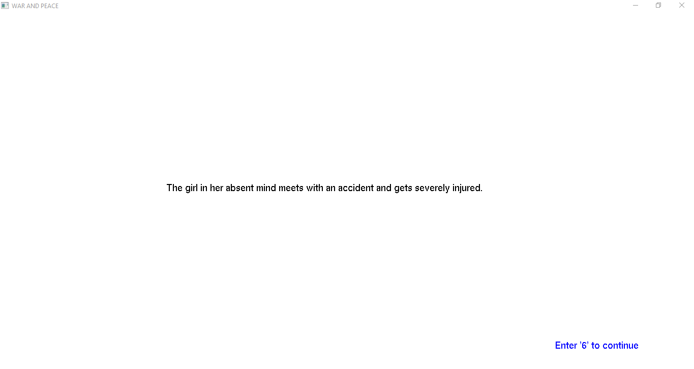

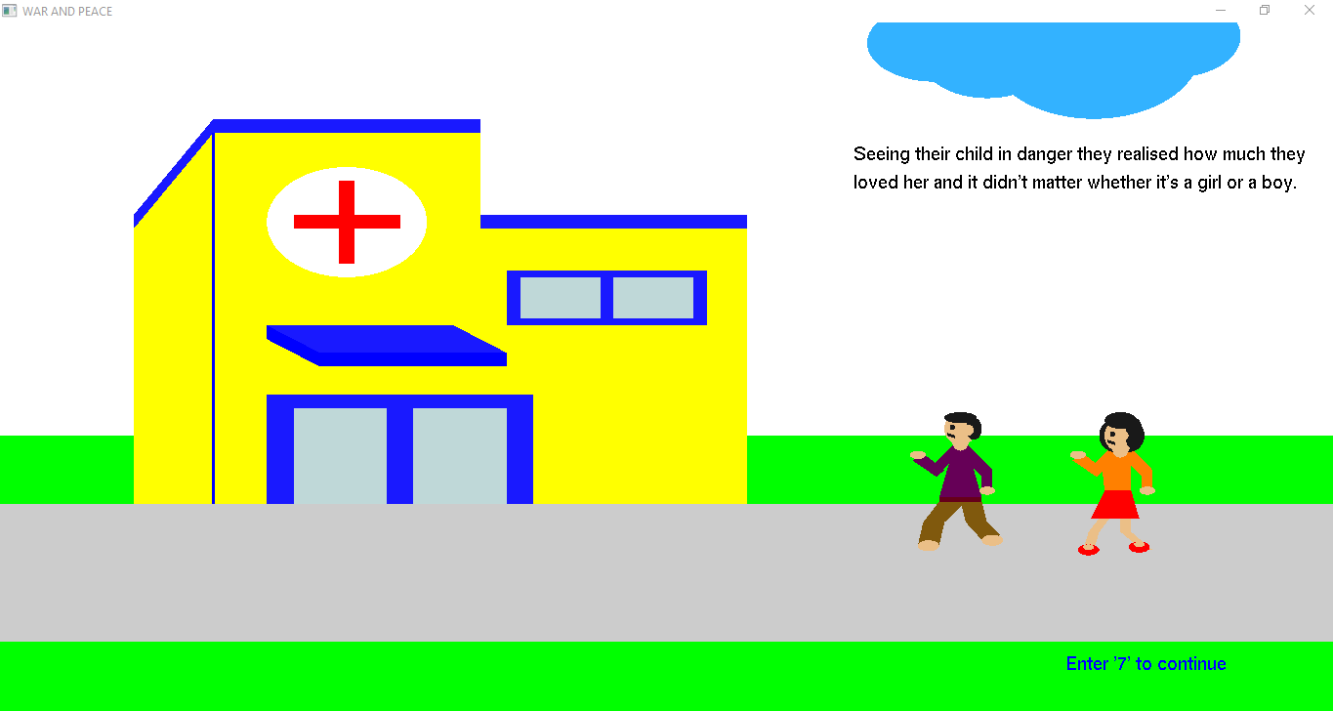

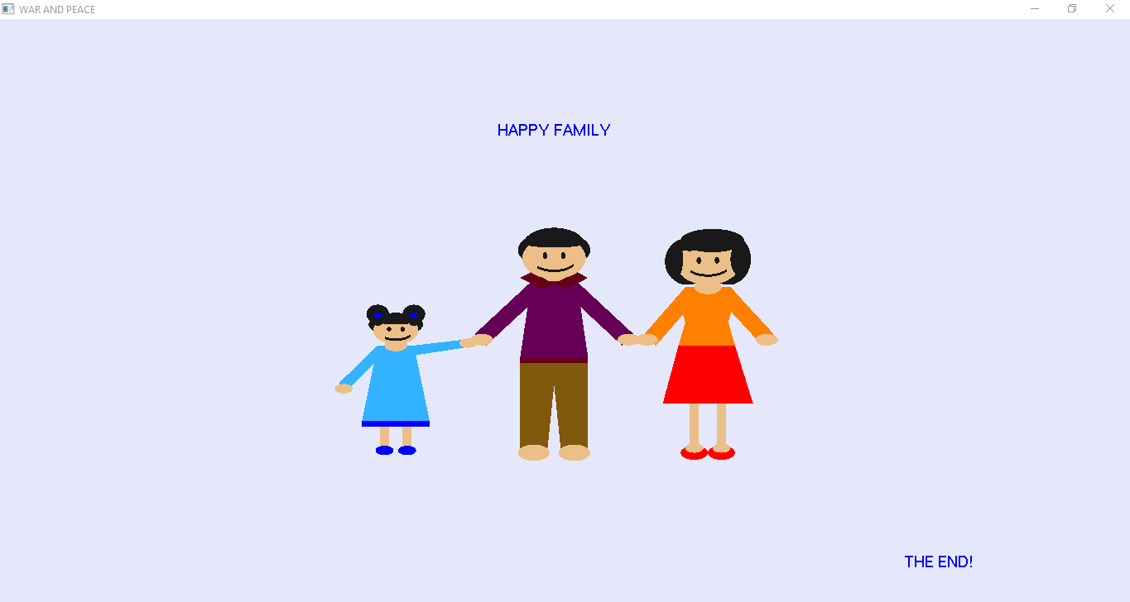

1. **Conclusion**

This project is one of the sample project on Computer Graphics. The project is well suited for designing 2D and 3D objects, as well as for carrying out basic graphics functionalities. However, if implemented on large scale with sufficient resources, it has the potential to become a standard stand-alone GUI based application for Windows Operating System.

Out of many features available, the project demonstrates some popular and commonly used features of OpenGL.

The project on the whole presented a challenge, the course is different from other programming courses offered since there is a subjective parameter that is hard to measure. The team took on many challenges to bring the deliverable to this stage and all are pleased with the effort and the end result. From this very project we were able to achieve various knowledge in computer graphics and also in logical coding. We refresh our knowledge in C Programming. Moreover we also gained an experience of team coordination.

1. **References**
2. https://www.opengl.org
3. <http://www.cs.unm.edu/~angel/>
4. <https://www.openglprojects.in/>
5. math.hws.edu/eck/cs424/downloads/graphicsbook-linked.pdf
6. http://www.sourcecodesworld.com/