CDR: Critical Design Review

Acevedo, Patricia

Benfield, Brooke

Haxton, Mark – Team Lead

Thota, Neha

Alfa Flo Team 12

Evolve or Dissolve

 Table of Contents

U/I Screen mapped to WBS system requirements, features and functions.………………......... 3

System Process Model ……………………….…………………………..…….……………….8

**U/I Screen mapped to WBS system requirements, features and functions.**

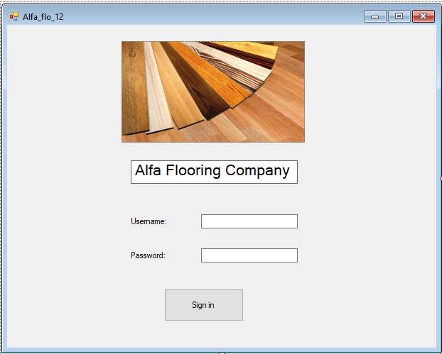

Figure 1

1. Secure User login

1.1. Type in user credentials

1.2. Click “Sign In”

1.3. Customer Information Tab will appear

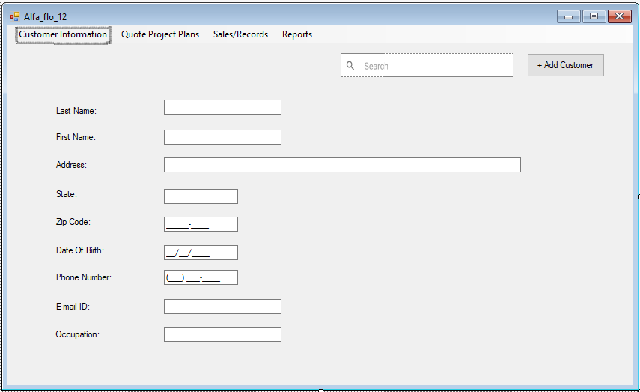

Figure 2

1. Enter new Customer data

2.1. Select Customer Information tab

2.2. Fill out Customer Information Form

2.3. Click on the button "Add customer" located on the upper right side of the screen.

1. Search for existing customer information (Figure 2)

3.1. Select Customer Information tab

3.2. Fill out the "Name" field

3.3. Click on the magnify glass

3.4. Select customer from available customer list

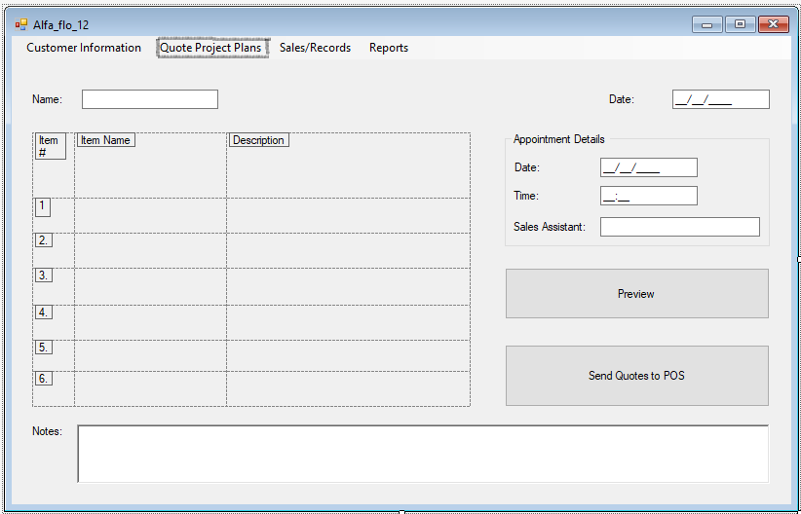

Figure 3

1. Document interactions with sales associates and customers

     4.1. Select Customer information tab

     4.2. Lookup the customer information in search

     4.3. Click on the "Quote Project Plan" tab

     4.4. At the bottom of the screen enter the notes in the "Notes" field.

1. Produce quotes/project plans (Figure 3)

             5.1. Select Customer information tab

 5.2.  Lookup the customer information in search

 5.3. Click on the "Quote Project Plan" tab

 5.4. Enter in product formation in the Quote form

5.5. Click preview

1. Sales associate scheduling options (Figure 3)
   1. Select Customer information tab
   2. Lookup Customer information in search
   3. Click on the "Quote Project Plan" tab
   4. At the right-hand side of the screen, fill out the form for “Appointment Details”

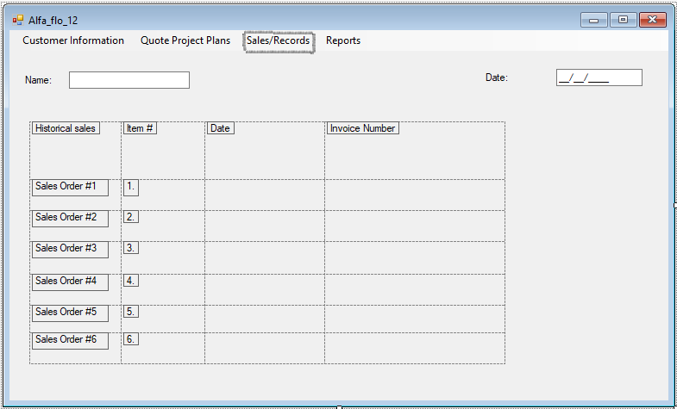

Figure 4

1. Sales/Records

             7.1. Select Customer information tab

 7.2.     Lookup the customer information in search

 7.3. Click on the "sale/records" tab

7.4.  If historical sale orders are available, the sale order number will be displayed on the left-hand side of the screen.

7.5. Click on sales order name, then sale order information will display on the screen

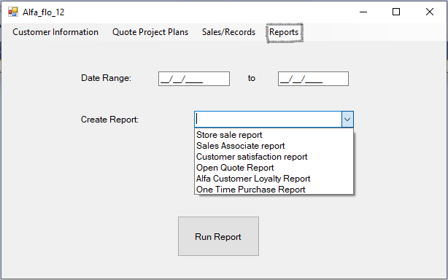

1. Generate report

8.1. Click on the “Reports” tab

8.2. Select the report from the drop list of report options

8.3. Click “Run Report”

**System Process Model**

Process Model IPO’s

1. Secure Log in

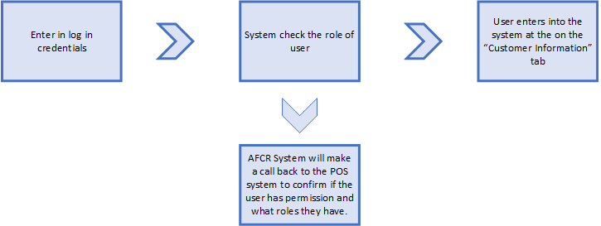

2. Enter new customer data

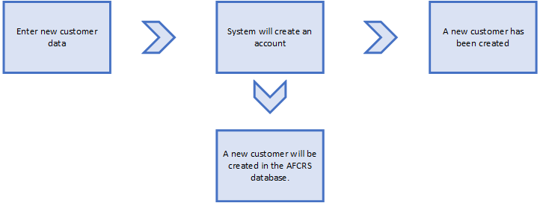

3. Search existing customer

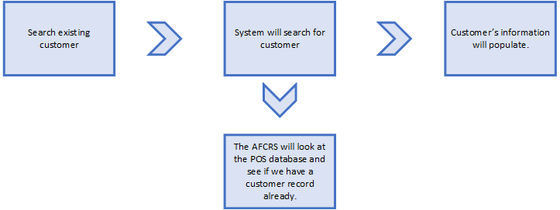

4. Document interaction with sales associates and customers

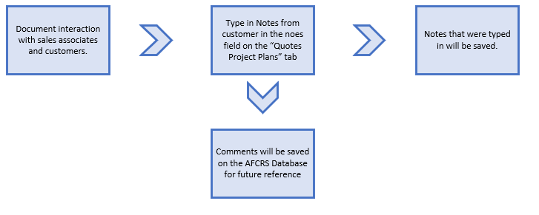

5. Create quotes/project plans

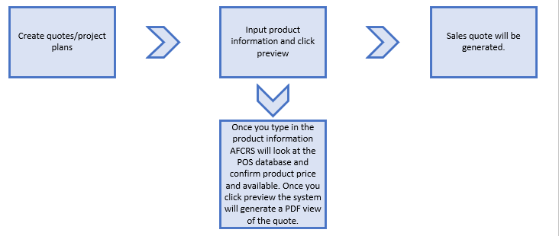

6. Scheduling Appointments with Customers

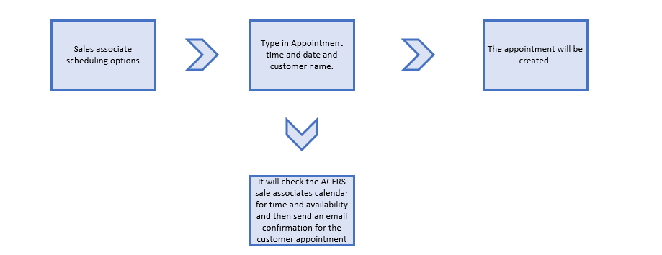

7. Sales and Quote History

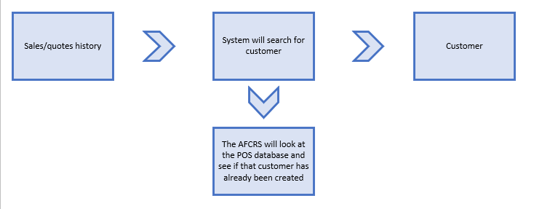

8. Generate reports

