PDR: Preliminary Design Review

Acevedo, Patricia

Benfield, Brooke

Haxton, Mark – Team Lead

Thota, Neha

Alfa Flo Team 12

Evolve or Dissolve

 Table of Contents

Statement of Work …………………………………………………………...………………... 3

Scope ……………………………………………………………………..…….……………….4

Scope Planning…………………………………………………………………………..4

Scope Definition………………………………………………………………................4

Scope Verification ……………………………………...….............................................6

Scope Governance ……………………………………………………...……………….7

**A. Statement of Work**

Alfa Flooring Company is a growing company that is trying to better manage the interactions with both current and potential customers and sales associates. Alfa Flooring knows that if they understand their customers, they will have better knowledge about how to create loyal customers that will generate return customers and referrals. This will make Alfa Flo stand out from the competition and increase the likelihood of a thriving growing business.

To achieve these goals, Alfa flooring company wants to build a single platform for all the customer data in order to facilitate stronger customer relationships. Alfa Flooring’s resolution to this problem is to create a customer relations application to track customers. The system will be referred to as the Alfa Flooring Customer Relation System or AFCRS. Currently Alfa Flooring has minimal customer database on the current point of sale system. The POS also creates and stores invoice data from all sales. The new platform will interact with the POS to assist sales associates to build rapport with new customers and existing customers. This rapport is produced by documenting the company's interactions with the customers. These interactions will produce leads, quotes and final sales. This will help to reach out to customers who have abandoned quotes. This program will also keep track of customer history so we can create loyal customers, by marketing techniques, such as doing follow up on flooring projects, mailing birthday greetings or holiday cards. In addition, it will help generate referrals and predict future customer needs.

The project will be carried out over three phases: Phase one, prerequisites. Determine if software is custom designed or if there is COTS software, which will work. If it is custom developed, who will write the code and what is the cost? Will the hardware be local servers and equipment or will cloud be utilized and what are the associated costs? Phase two, detail design. User stories gathered and analyzed, database structure developed, what is needed to be captured? How will the system interact with the existing POS? Leave the POS intact or import data to AFCRS and make AFCRS do the additional functions of the old POS. The last step in this phase is the requirements of the AFCRS application. Mockups of the application interface will be designed for user acceptance at this step. Phase three, finally is the construction and implementation of the system.

**B. SCOPE**

1. Scope Planning

The scope planning team consists of the Alfa Flo team, Patricia Acevedo, Brooke Benfield, Mark Haxton, and Neha Thota. Meeting dates for the planning are usually Monday evenings at 9:00pm, Friday evening by teleconference at 9:00 pm and ad hoc meetings as required by planning demands to deal with unanticipated issues and to meet timelines. Team members are assigned different planning aspects of the project as needed. Most of the time, the team works together as an integrated group to make decisions.

Requirements, features and functions were identified in the SRR phase of the project and have been revisited several times over the course of meetings and discussions about how best the application can serve the strategic goals of Alfa Flo.

2. Scope Definition

The scope definition, showing the requirements, features and functions are represented in Table 1 below.

|  |  |  |
| --- | --- | --- |
| **Requirements** | **Features** | **Functions** |
| Enter new customer data | Add new customers | Click on "Create new customer"  Fill out customer form. |
| Match customer data with customer relation system purchase information. | Search customer by name | Type customer name in the search field and press enter or click on magnifying glass. |
| Document interaction with sales associates and customers. | Make and store notes of conversations with customers, specifically about flooring needs | Click on “Quotes Project Plans Tab”. and click on the notes field. |
| Create quotes/project plans | Create quotes/project plans from customer interactions | Select Customer Information Tab, type customer information. Select “Quote Project Plans” tab and enter in product information and click on preview. |
| Sales/quotes history | Pull customer’s sales and quotes | Select Customer Information Tab, type customer information. Select “Sales/Records” tab. |
| Generate reports | Create Reports | Select “Sales/Records tab”  Select the report drop down from the following list of reports: Store sale report, Sales Associate report, customer satisfaction report, Open Quotes report, Customer Loyalty report, or One-time Purchase report.  Click “run report”  Report will be downloaded as a csv. spreadsheet. |
| Sales associate scheduling options | Sales Associate schedule appointment | On the “Quote project plan” enter the customer's name and fill out the appointment details on the right hand of the screen. |

Table 1

3. Scope Verification

The scope verification is best represented by the work breakdown structure (WBS) shown in Figure 1. The WBS defines the exact requirements and the sequence of events.

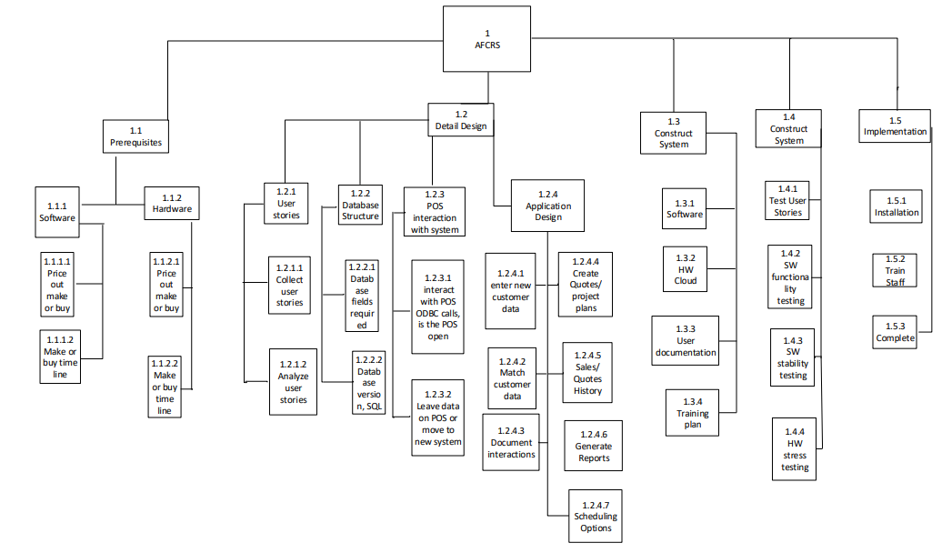

Figure 1- It is the work breakdown structure to the work package level for each of the requirements of the project.

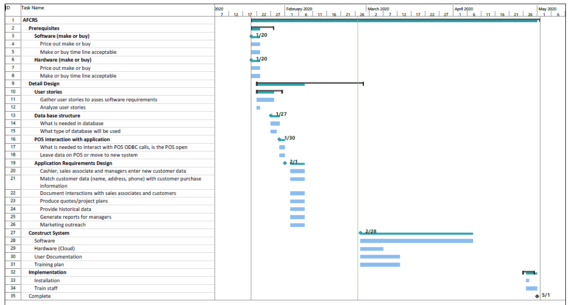Figure 2- The Gantt chart shows the timeline of the project from start to finish.

4. Scope Governance

Scope change governance is the process to keep the scope of the project under control. All changes made to the scope will affect both the cost and schedule and must be scrutinized before allowing the change. These two documents will serve as the monitors and controls. They will control the scope creep and move the project forward. Any additional items, which are requested to be added to the scope and are not on the WBS, must be addressed by an Ad Hoc team meeting. This will include discussion of the criticality of addition and any effects in terms of cost and schedule that the change would create.