1. **The Data**

This data was given by a grocery distributor to study sales and profits of different items.

The columns we have in the data are Country, Region, State, Zip Code, Sales Date, Department Item, Sales, and Profit. First, I filtered them by 2017 year and created a pivot table in order to see the sales by state for each product. Then, I repeated the same process for 2018 year. I could clearly see some sales drop in the some of the states in 2018.

I didn’t have any problem with the data. So, I went ahead and imported the excel worksheet into Tableau. I entered a calculated field, Profit Margin.

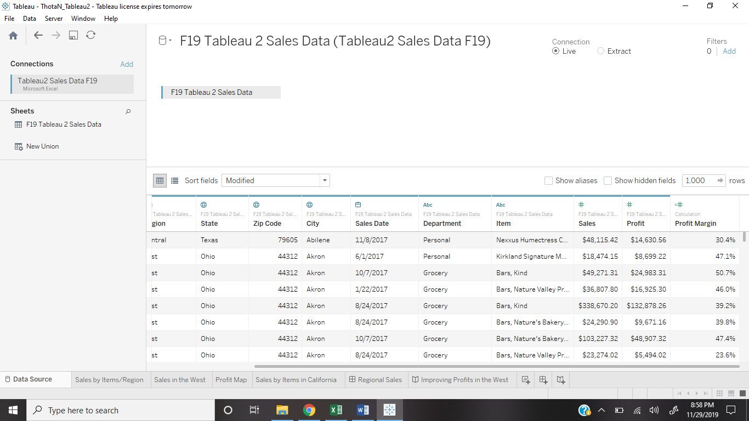

1. **The worksheets**
   * + Worksheet 1- I dragged Sales Date and Item into Columns. I also dragged Region and Sales into Rows in order to study sales by items and regions. Nexxus Humectress Conditioner is clearly a high outlier in 2017, but not in 2018 in all the regions.

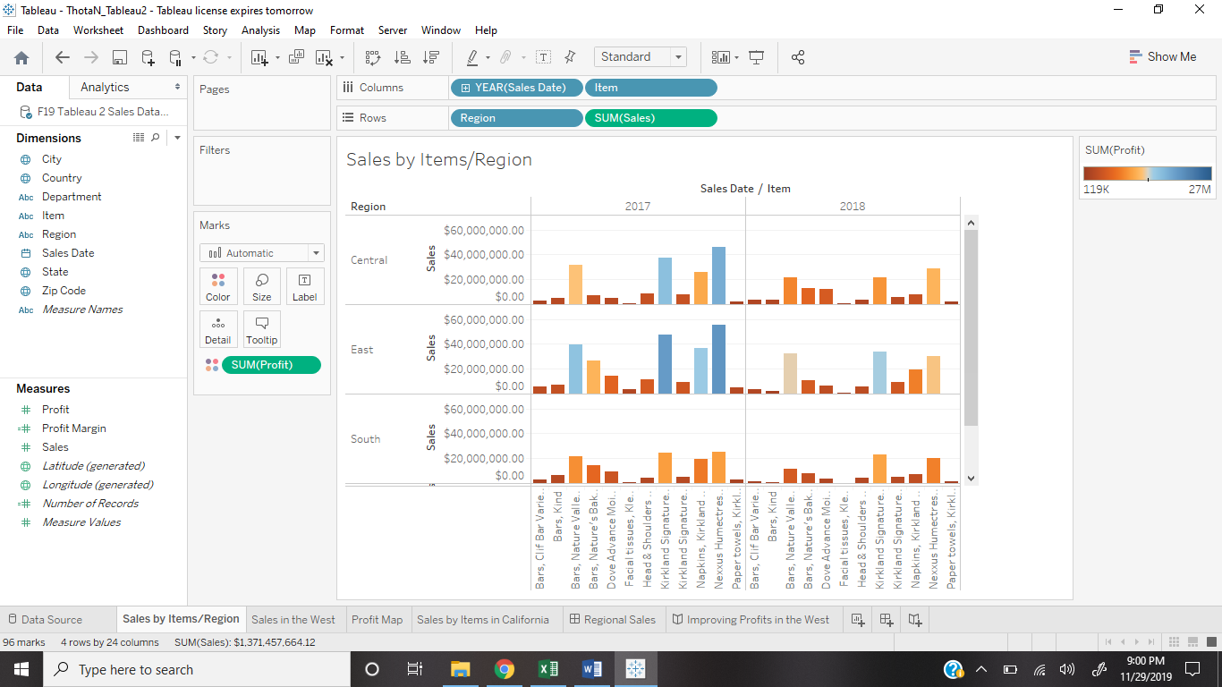

* + - Worksheet 2- I duplicated the first worksheet and filtered Sales Date, Items, and Region to check which region’s sales have dramatically changed from 2017 to 2018 for Nexxus Humectress Conditioner. I observed a dramatic change in the West region. Therefore, in this worksheet, I studied the sales in the West region.

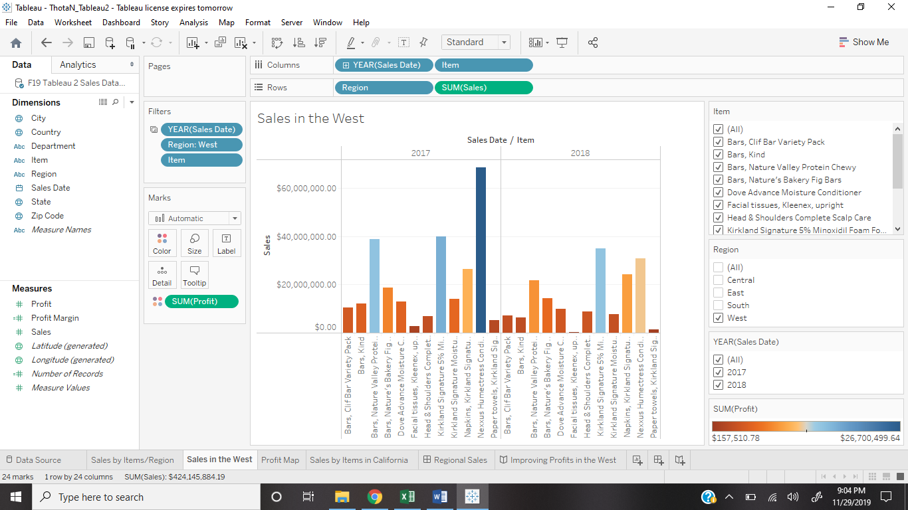

* + - Worksheet 3- I dragged Longitude to Columns and Latitude to Rows. I dragged Profits into both color and label in order to label each state by its profits in red-blue diverging (smallest to highest). I also dragged region, country and state into details for the map to show the exact locations. I also filtered region by West again. The profits in California is extremely high compared to any other state, causing the West sales and profits to be high. I filtered sales date as well and observed a decrease of sales in California from 2017 to 2018.

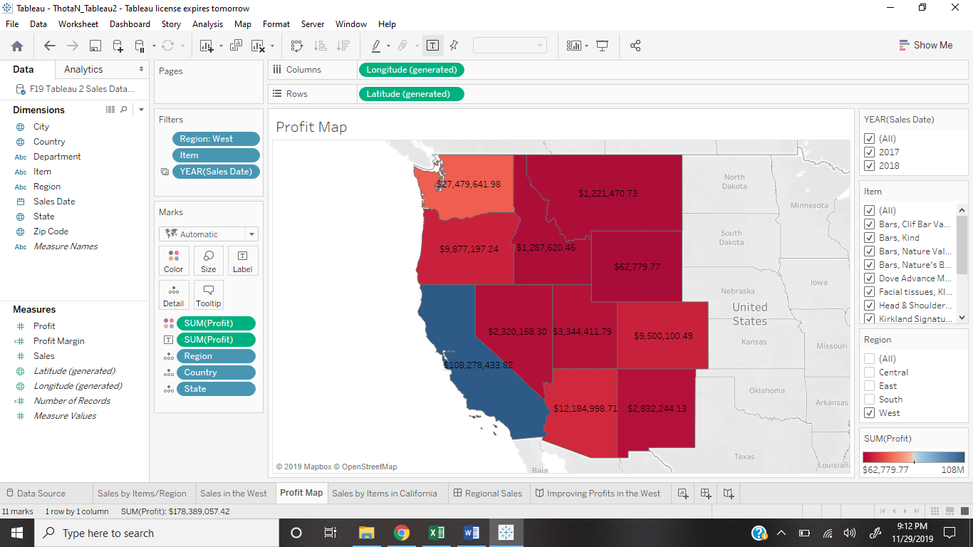

* + - Worksheet 4-

I wanted to know which product caused the sales of California to drop severely. So, I created a pie chart for the state, California and filtered it by sales date. I color coded the pie chart by item and labeled them. I observed a major drop in the profits of Nexxus Humectress Conditioner from 2017 to 2018.

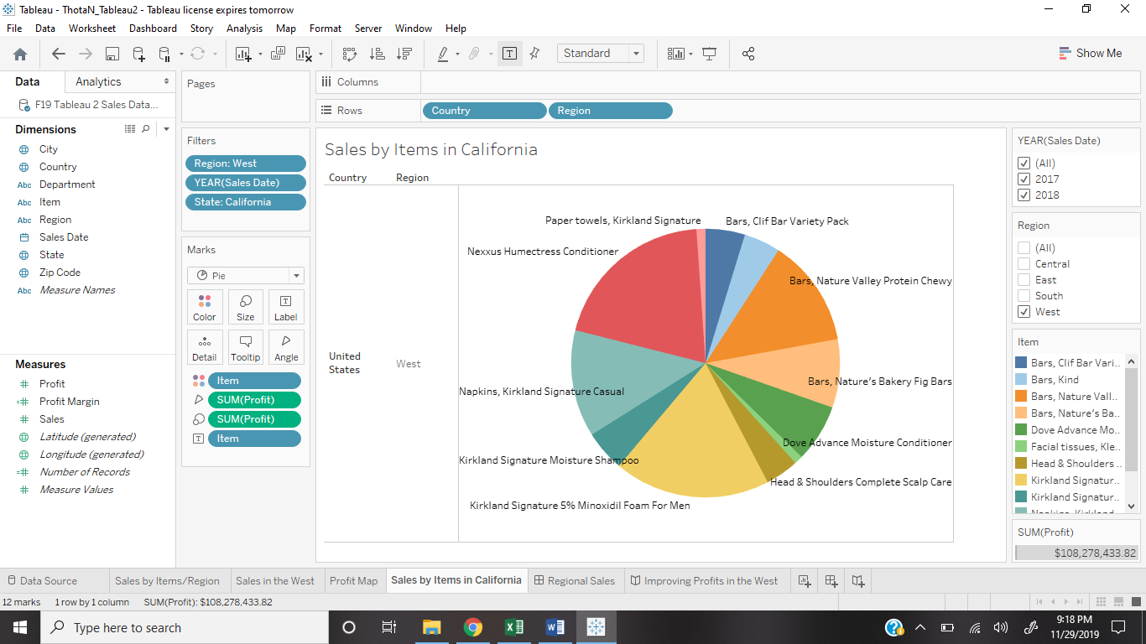

1. **Workbook Dashboard**

I dragged Profit Map and Sales in the West. I rearranged the filter cards, profit legend, slider, etc. I included them in order to study the profits in West from 2017 to 2018 by both map (by each state) and graph (by each item) forms. By putting them together, it is easier to observe the increase and decrease of profits and which products caused these changes the most in each state.

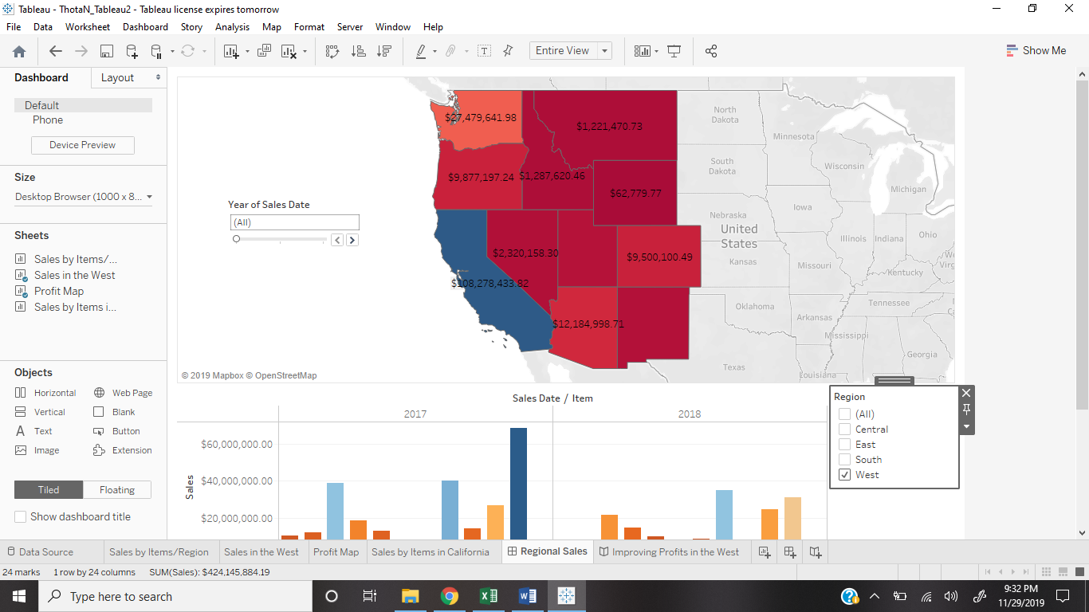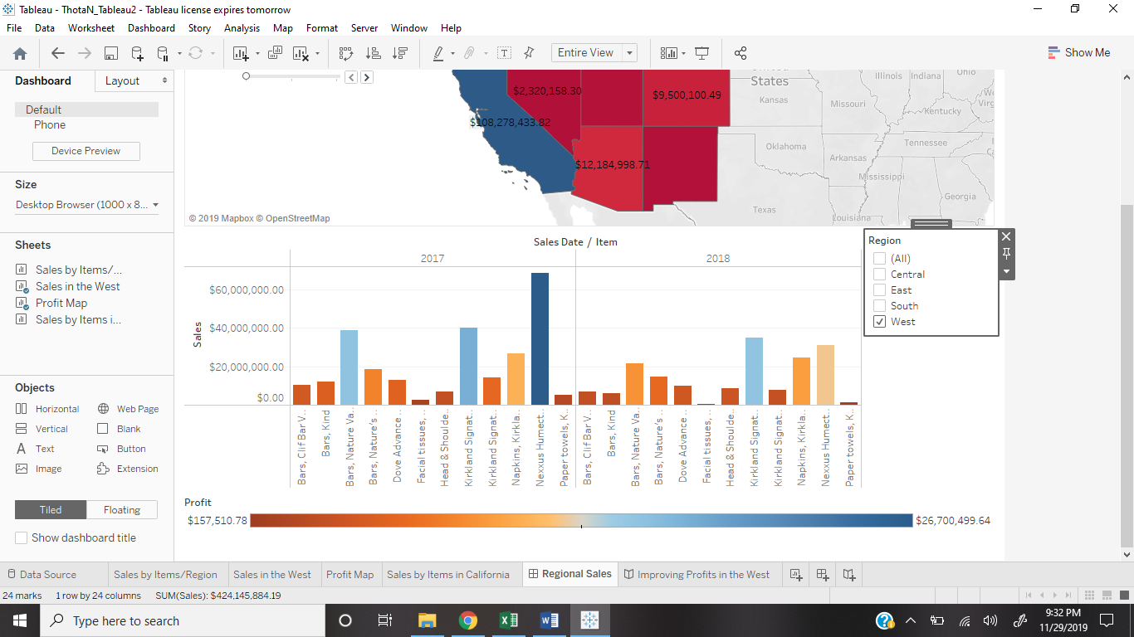

1. **The Story-**

The story begins with the sales and profits in the United States by all four regions. Then I filtered it down to only the West region because there was a high outlier for Nexxus Humectress conditioner. So, I studied the profits for this item in 2017 and 2018, where I saw a drastic drop. I represented this in the form of a map, where I discovered that this drastic change was caused in the state of California. So, I studied sales by item in California, where I observed a loss of nearly 8.5 million $ of profits in only Nexxus Humectress Conditioner in the year, 2018.

1. **Conclusion-**

I have learned a lot about my data and tableau in general. Sometimes, region doesn’t have to be the only reason for decrease in sales. The sales for Nexxus Humectress Conditioner have not only gone down in the West region, but also in the other three regions. This might have caused due to several reasons- the quality being gone down, or higher prices, or alternative product being better. It is necessary to find the reason and then making the product better and more attractive to the customers. However, even though the sales have gone down over the year for Nexxus conditioner, it is still one of the leading products in sales out of all the products sold by the grocery distributor. There is a reason why the sales and profits were high. This means that it has the potential of being a good product and therefore, it must not be wasted.

Tableau is one of the best software for analyzing any kinds of sales data and discovering in which areas we are lagging. It helps filter data by state, region, city, etc. making it easier to study each product’s sales and profits every year. This data can be represented in the forms of graphs, charts, maps, etc. Dashboard can be used to group different worksheets and studied together. Story can help us summarize our findings and provide a conclusion to several problems relating to sales and profits.