|  |  |
| --- | --- |
| Feasibility Analysis of Solar Power Plant in New England territory  …Mitigate Power Tariff | **Team-1 - Arun, Mazhar, Neha, Partha**  OPIM-5641-BDM |

# Executive Summary

Sources indicate that in the New England Territory, Connecticut is one of the states which pays the highest average tariff of 17$. Through our project, we try to mitigate the high tariff rate involved in the Connecticut region by performing a feasibility study of setting up a solar power plant for generation of electricity. We consider solar energy as it is a renewable source of energy which can have a positive impact on the environment as compared to other non-renewable sources of energy. By setting up the power plant we also look at the profit involved after having sold electricity at a lower tariff.

## Results:

* Tariff, Specific productivity and EPCC cost are the most contributing factors to net profit, whereas Tariff, Specific productivity and Inflations influence the NPV.
* For a 100MW power plant with an PPA of 50 years, the lowest tariff at which power can be sold is 0.10 cents/kwhr
* The plant should remain functional for at least 24 years and maximum of 87 years for optimal profit
* With an uncertainty in tariff and specific productivity and plant lifetime of 87years, there is 4.1% chances of losing the business

Problem description

Considering the existing Electric Power Monthly Report by the US Energy Information Administration, US pays an average electricity tariff of 10.53 cents per kilowatt hour. New England territory ranks as the highest in US mainland in terms of the tariff paid with an average electricity tariff of 15.95 cents per kilowatt hour. In this territory, Connecticut pays the highest average electricity tariff of 17.63 cents per kilowatt hour, approximately 70% higher than US average. The data about the average electricity tariff shown in *Exhibit1* is as of June 2016.

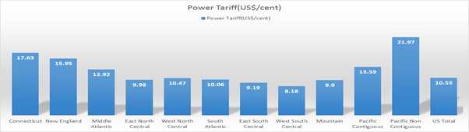

*Exhibit 1:* Avg. Electricity Tariff across the territories in the US and in Connecticut

In the New England territory, the total electricity demand growth during peak periods is higher compared to non-peak periods. When the demand increases, plants fueled by gas are used to generate the power. More increase in demand expand the need for power import from other states with an association of transmission cost.

When other states on an average rely more on coal as generating fuel, New England rely heavily on natural gas. Environmental norms and other legal implications prevent New England from coal based power plants. Relying more on natural gas and importing power are the major facts that lead to higher power prices in New England territories.

To encounter this problem, we look for an alternative source to replace the conventional power generation with renewable and more reliable source of energy-SOLAR POWER.

This project is aimed to find out the economic and technological feasibility of private owned Solar plant at New England by using revenue parameters like Net Profit, Internal Rate of Return(IRR), Net Present Value (NPV). We based our decision on various parameters like installation cost, maintenance cost, funds available, space available and inflation, to analyze how the market price of power will be influenced with the implementation of solar power.

# Analysis

The project has a twofold objective

* Decrease the tariff paid by the New England territory
* Maximize the profit made by setting up the solar power plant

To gain an insight about all those factors that are high in both their impact and uncertainty on the objective variable, the Tornado Diagram in *Exhibit 2* and *Exhibit 3* uniquely identifies those factors. This insight gets us focused on the right factors for further discussion.

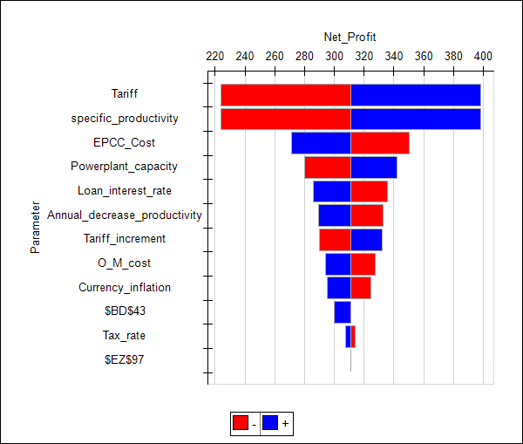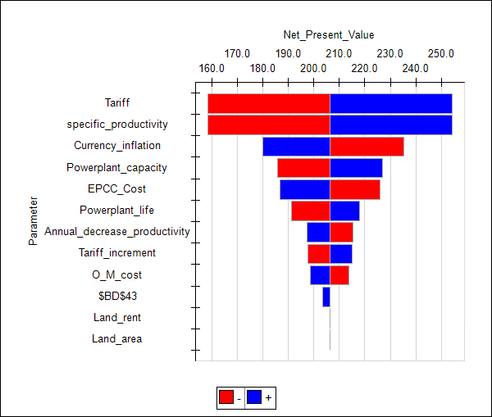

*Exhibit 2*: Tornado Chart (Net Profit) *Exhibit 3*: Tornado Chart (NPV)

From the above analysis, it can be inferred that Tariff, Specific Productivity and EPCC cost greatly influence the Net Profit of this project. Whereas Tariff, Specific Productivity and Currency inflation greatly influence the Net Present Value(NPV).

The project with a capacity of 100MW, will not sustain any loss, if it is runs at least 24 years with a minimum tariff of 0.10 cents/kwhr. Also, the project make optimal profit if executed for 87 years. Please refer sensitivity analysis on *Life time* and *Tariff* of the power plant in *Exhibit4* and *Exhibit5* respectively.

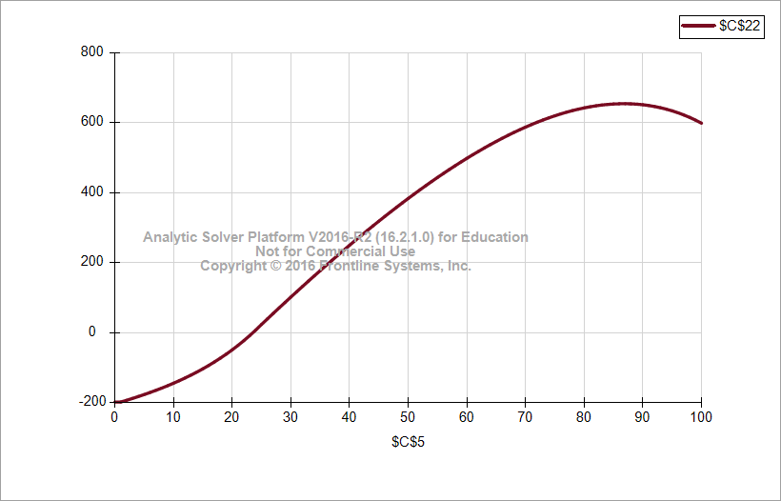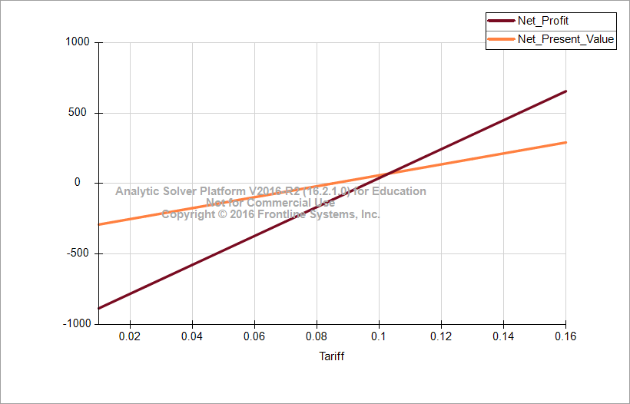

*Exhibit 4:* Sensitivity Analysis (Life Time) *Exhibit 5:* Sensitivity Analysis (Tariff)

For a 100MW power plant with a lifetime of 87 years, the project is most likely to have 252.7mn $ and 552mn $ as NPV and Net Profit respectively. In the worst case, net profit will be restricted to 244mn$. Refer *Exhibit 6* for detailed Scenario analysis on tariff.

*Exhibit 6*: Scenario Analysis(Tariff)

Net profit degrades with an increase in O&M cost and Annual decrease in Productivity rate. However, O&M cost can be improved by means of automation and technology changes. Similarly Decrease in productivity rate can be improved with research and innovations in the field of photovoltaic cells. Please refer *Appendix C.3.4* and *Appendix C.3.5* for sensitivity analysis report of Net Profit w.r.t *Decrease in productivity rate* and *O&M Cost*.

Specific productivity decides the efficiency of a plant to harness solar radiation and transform it into electricity. It depends on geographical factors and type of panels used. Unit increase in specific productivity contributes around 1.2mn $ to the net profit (refer *Appendix C.4.2*). Selection of proper location and high end solar panels significantly increase the net profit. In New England territory, the specific productivity varies between 900 units*and 1300 units*, with a most likely value of 1100units*. Similarly, the average Decrease in Productivity is 1% with a standard deviation of 0.20%. And for the business to sustain the tariff can be varied between 0.12 cents/kwh and 0.16 kw/hr. Simulating the Net Profit with all the above uncertainties, it can be inferred that the mean net profit value of the project will be 229mn $ and there will be only 4.1% chances to lose the business. Also, the project should run for 80 years to obtain optimal profit with all uncertainties in parameters (Refer *Appendix C.5*). Had the inflation rate in new England is uncertain, then there is 30% chances of losing the business.

# Conclusion

1) The project should run for a time period of 24 years to recover the overall investment

2) To attain a maximum, profit the power plant must operate for 87 years

3) Minimum Tariff at which we can sell electricity for the project to get breakeven is between 9.5 to 10 $cents

4) If the selling tariff is varied between 12 to 16 cents throughout the lifetime of power plant there is only 4.1% chance to make loss in the business.

# Appendix

## **Appendix A:**

**Problem formulation**

* **Objective:**

The main objective of our model is to maximize the profit by optimizing the other major influencing variables as formulated below.

* **Decisions:**
* Power plant Life time
* Power Plant Capacity
* **Output Variable:**
* Profit
* Net Profit Value(NPV)
* Internal Rate of Return(IRR)
* **Parameters:**
* Available Area - area available to setup the power plant
* Specific productivity - Energy produced per kilowatt installed per year
* Annual decrease in productivity through power plant lifetime
* EPCC cost($/Kw) -Engineering, Procurement, and Construction" (EPC)
* O&M cost per Kw installed capacity -Operations and Maintenance cost required to run the power plant
* Interest rate - Rate at which bank/green investors lend the money for the project
* Power Plant Life (yr.)-period till which the power plant will function profitably
* Tariff in $ per kwhr -Selling price of power
* Land Rent ($/acre/year)– Remuneration paid towards land occupied
* Land Area(acre/MW)- Area required to set up unit MegaWatt Power plant
* Inflation
* **Constraints:**
* New Tariff by using Solar Energy < Existing Tariff for Natural gas as a source of energy
* Total Cost <= Budget

* **Calculations:**
* Gross Profit= Revenue- total cost
* Net Profit=Gross profit -Tax
* Tax= Gross profit*Tax rate
* Total cost= Capital investment + Operations and Maintenance Cost
* Capital investment= (EPCC cost per KW * Power plant capacity(KW))
* Operations and Maintenance Cost= O&M Cost per KW * Power plant capacity(KW)*(1+inflation rate) + Land rent + Debt cost
* Land Rent= Land Area (in square meter) * Rent per square meter
* Revenue= Tariff* Power Generated
* Power Generated= Specific Productivity * Power Plant capacity (1- Annual decrease in productivity) ^Number of years
* **Concerns**

The major concerns in developing the model would be the collection and optimization of the precise input data parameters regarding

● Technology: Performance of the power plant

● Cost: land rent, engineering, procurement, construction, and commissioning cost

● Finance: Predicting inflation and interest rate

## **Appendix B:**

**Base case model**

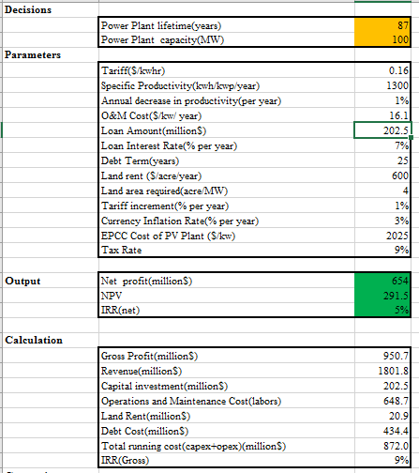

## **Appendix C: Analysis**

### Appendix C.1-Tornado Charts

*Appendix C.1.1-Sensitivity Analysis using Tornado Chart on Net Profit*



*Appendix C.1.2-Sensitivity Analysis using Tornado Chart on Net Present Value*



### Appendix C.2-Scenario Analysis

*Appendix C.2.1-Scenario analysis of Net Profit and NPV in different situations of EPCC cost*

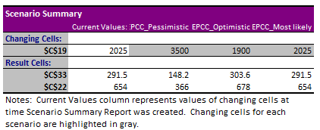

*Appendix C.2.2-Scenario analysis of Net Profit and NPV in different situations of Inflation*

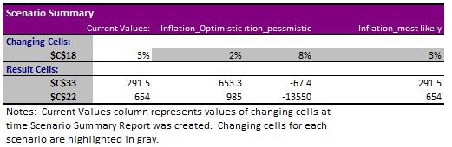

*Appendix C.2.3-Scenario analysis of Net Profit and NPV in different situations of Tariff*

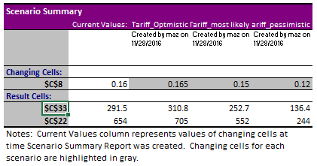

### Appendix C.3-Sensitivity Analysis

*Appendix C.3.1-Parametric Sensitivity Analysis of Tariff*

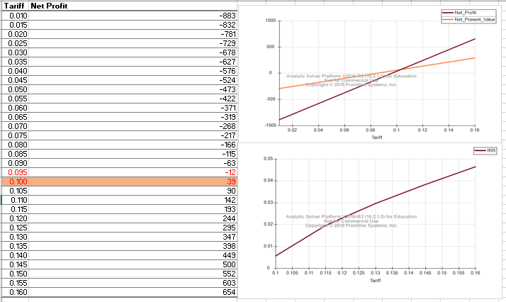

*Appendix C.3.2-Parametric Sensitivity Analysis on plant life time*



*Appendix C.3.3-Parametric Sensitivity Analysis on Inflation*

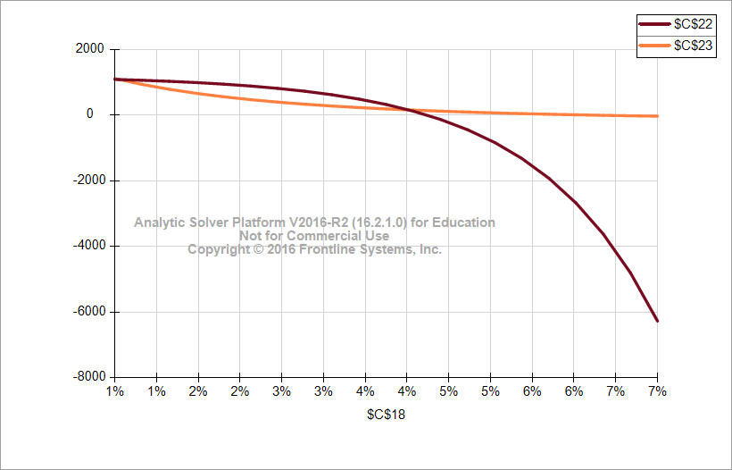

*Appendix C.3.4-Parametric Sensitivity Analysis on Annual decrease in productivity*

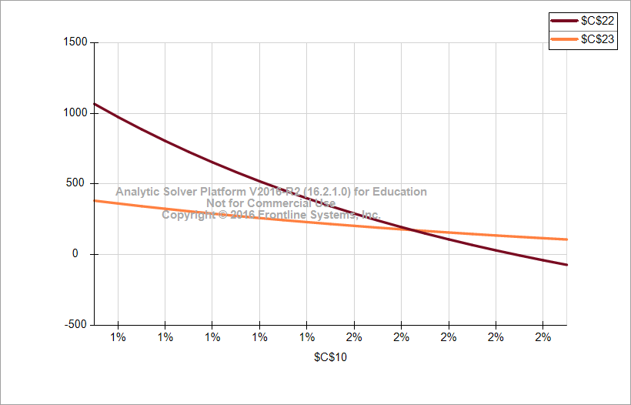

*Appendix C.3.5-Parametric Sensitivity Analysis on Operations and maintenance cost*

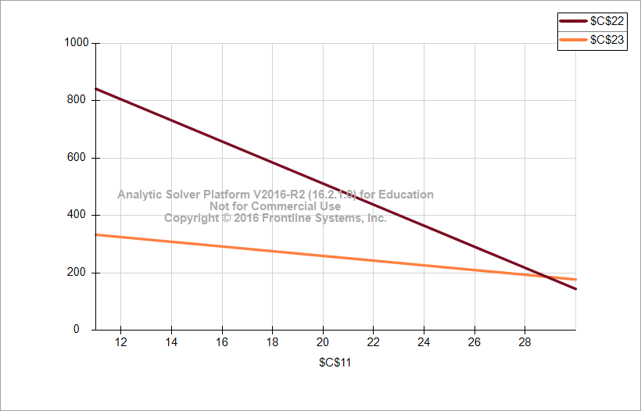

*Appendix C.3.6-Parametric Sensitivity Analysis on Tax Rate*

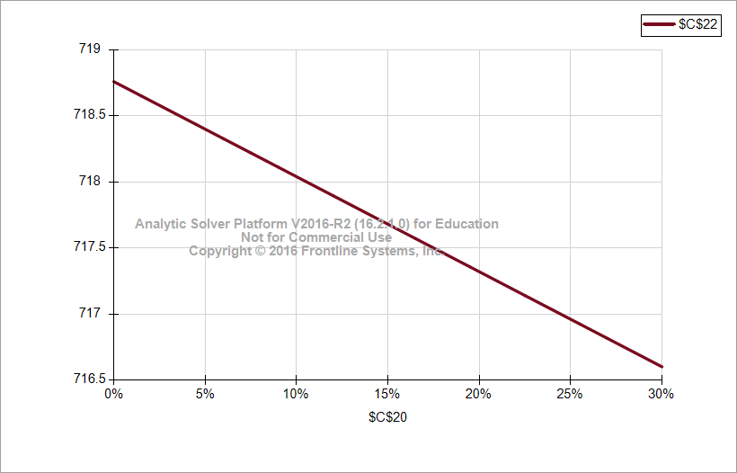

*Appendix C.3.7-Parametric Sensitivity Analysis on Land Rent*

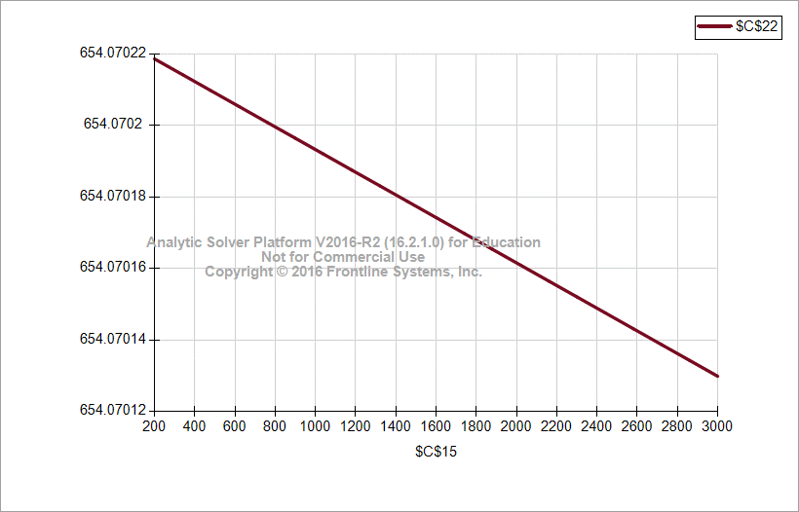

*Appendix C.3.8-Two Parametric sensitivity analysis w.r.t EPCC and Specific Productivity*

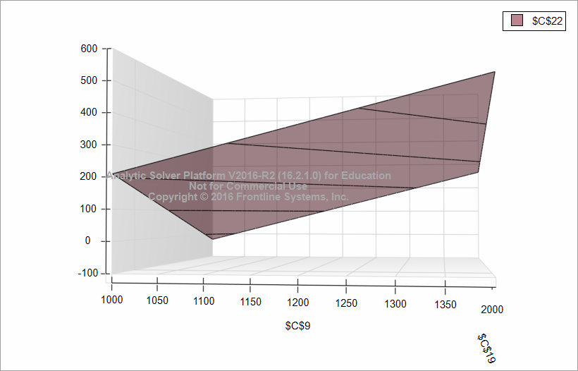

*Appendix C.3.9-Two Parametric sensitivity analysis w.r.t Tariff and Inflation*

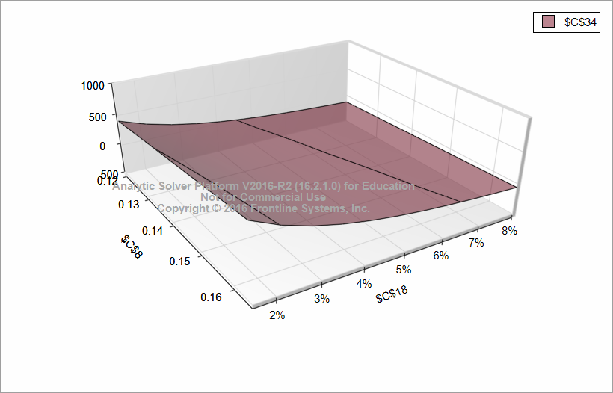

### Appendix C.4-Optimisation Analysis

*Appendix C.4.1- Sensitivity of Net Profit w.r.t Tariff in Non linear Optimisation Model*

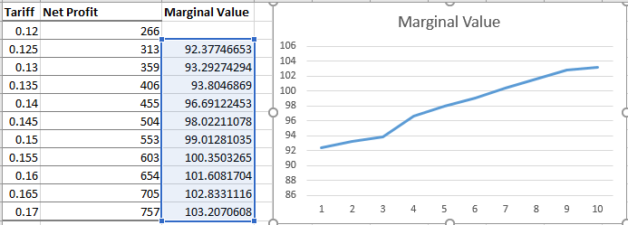

*Appendix C.4.2-Sensitivity of Net Profit w.r.t Specific Productivity*

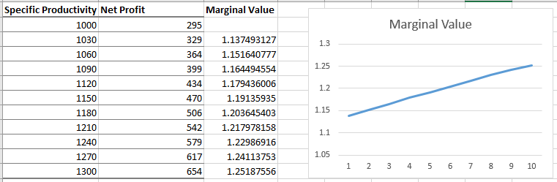

### Appendix C.5-Simulation Analysis

*Appendix C.5.1-Simulation of Profit with uncertainties*

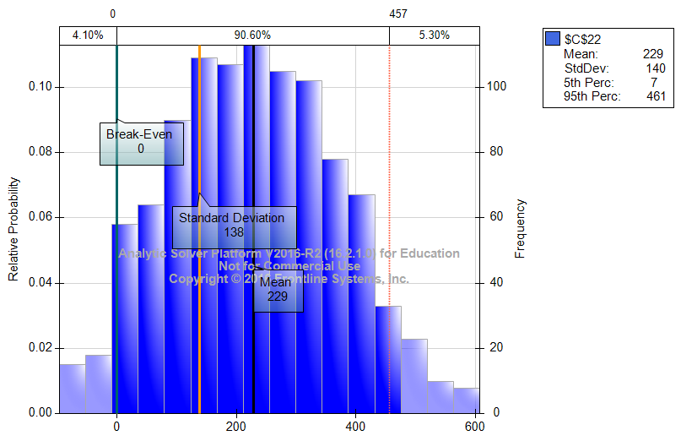

*Appendix C.5.2- Simulation sensitivity w.r.t lifetime*

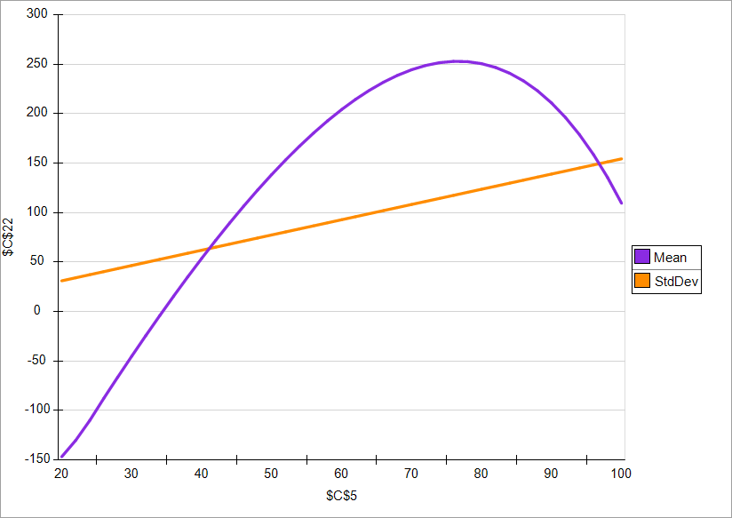

*Appendix C.5.3-Simulation with uncertainty in Inflation*

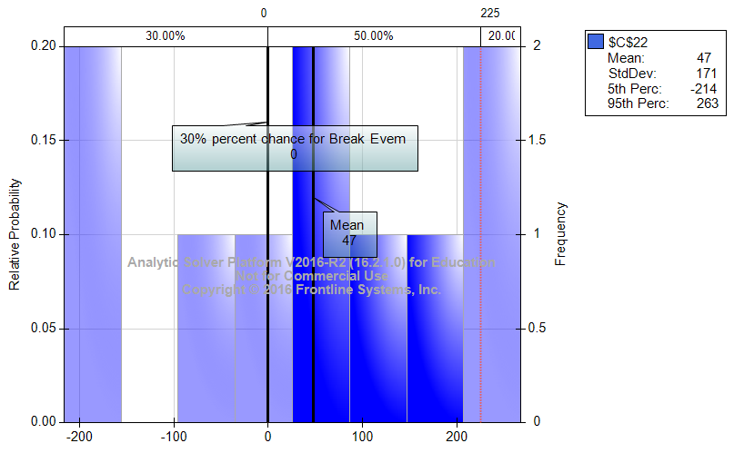

### Appendix C.6-Business Value w.r.t Plant Life time

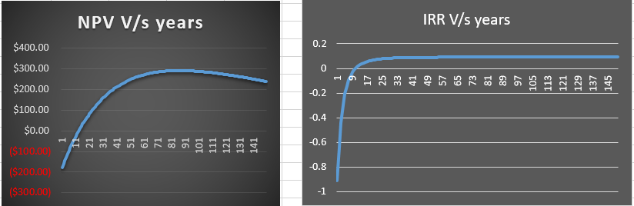

### Appendix C.7-Sensitivity of Net Profit w.r.t Geographical impact

*Appendix C.7.1-Arizona*

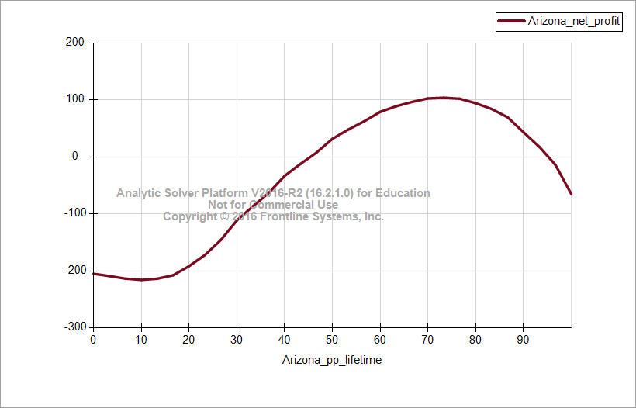

*Appendix C.7.2-Washington*

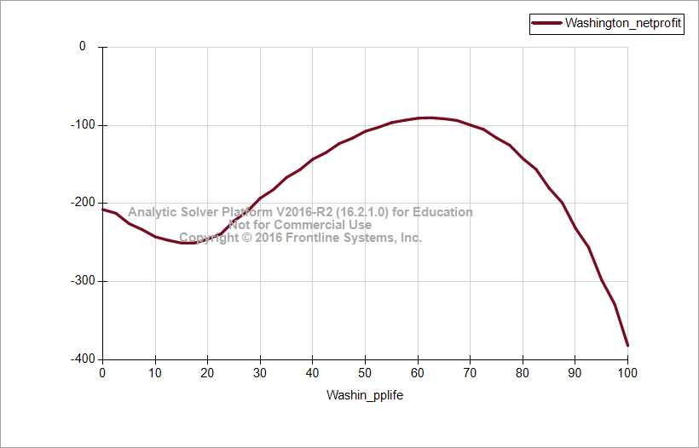

*Appendix C.7.3-Florida*

