**CLOUD COMPUTING PRACTICAL 1**

**LAUNCH INSTANCE**

**Neha T Mathew A069**

**For UBUNTU:**

1. Sign in to your AWS account and search EC2

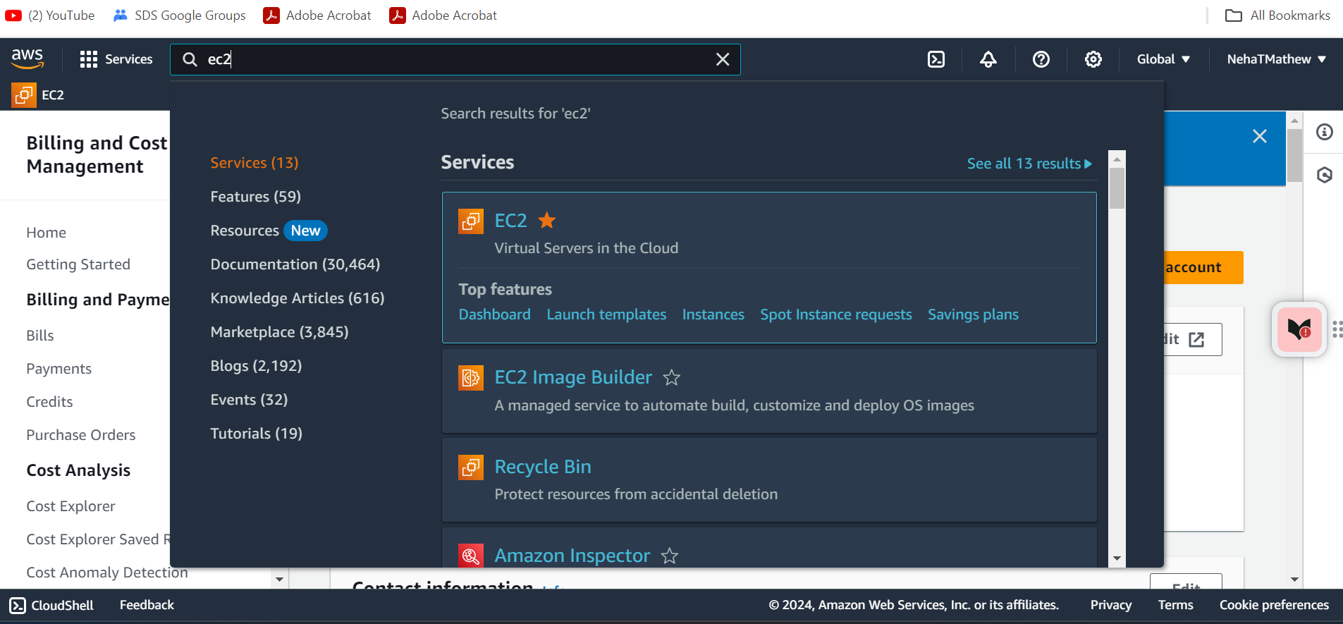

1. Select the Launch Instance in the EC2 dashboard

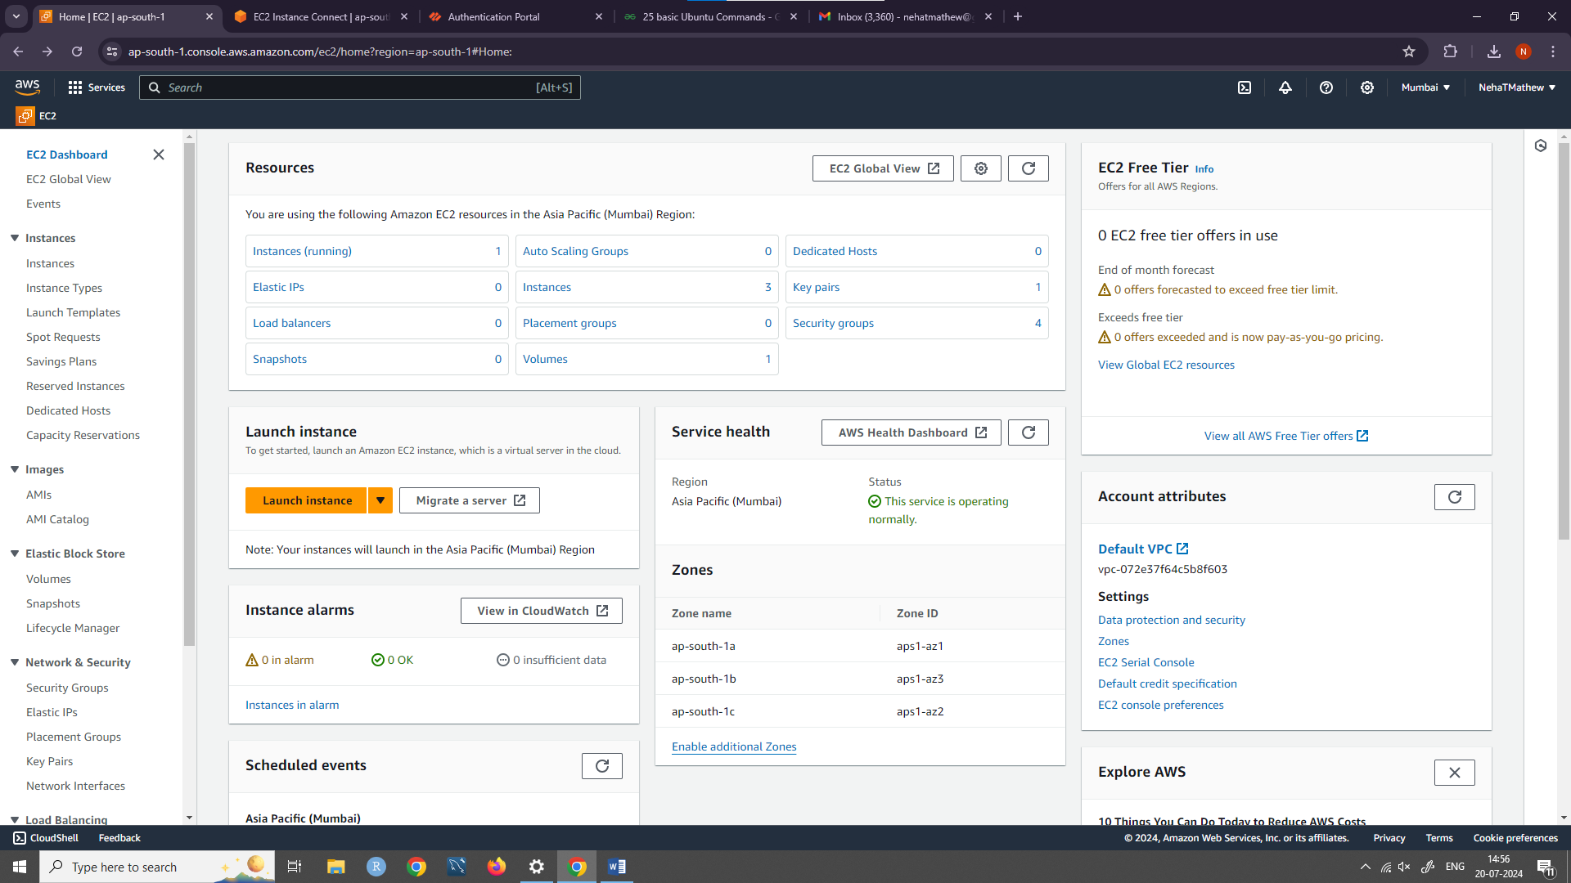

1. Named instance as ”day1_cc” and Select ubuntu under Quick start.

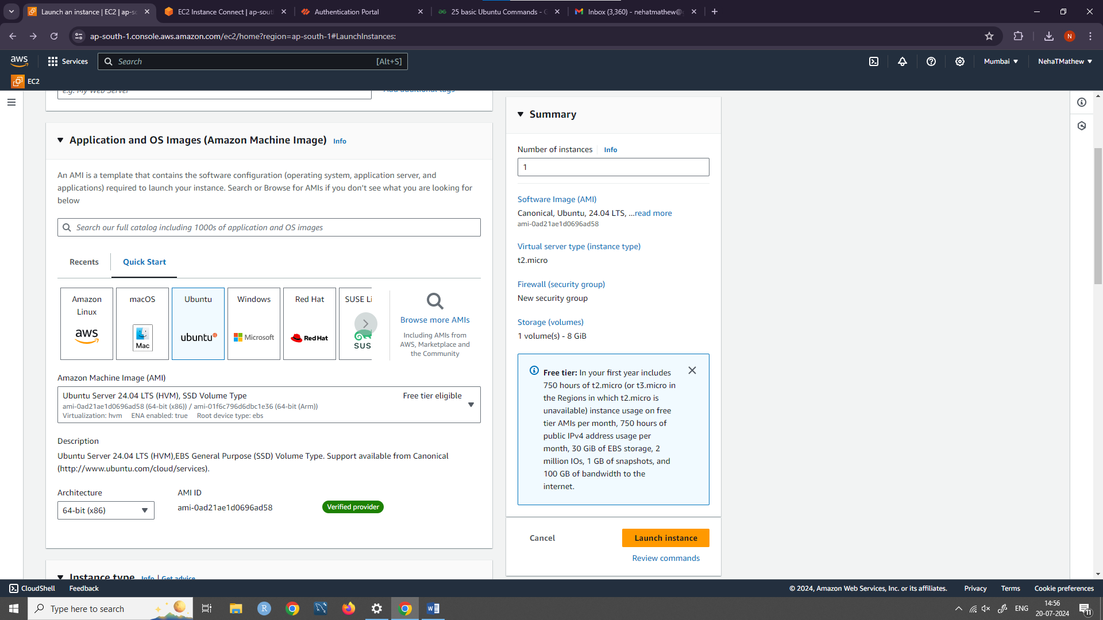

1. Create a new key pair name and select the private key format as .pem . Then launch the instance

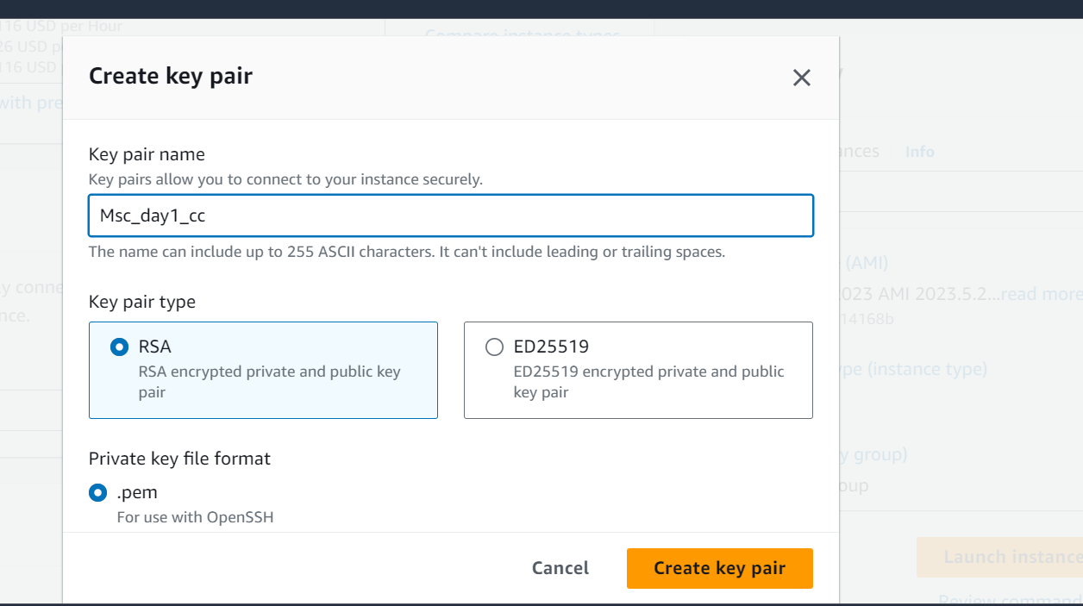

1. Once that instance status is shown as running click on the instance ID

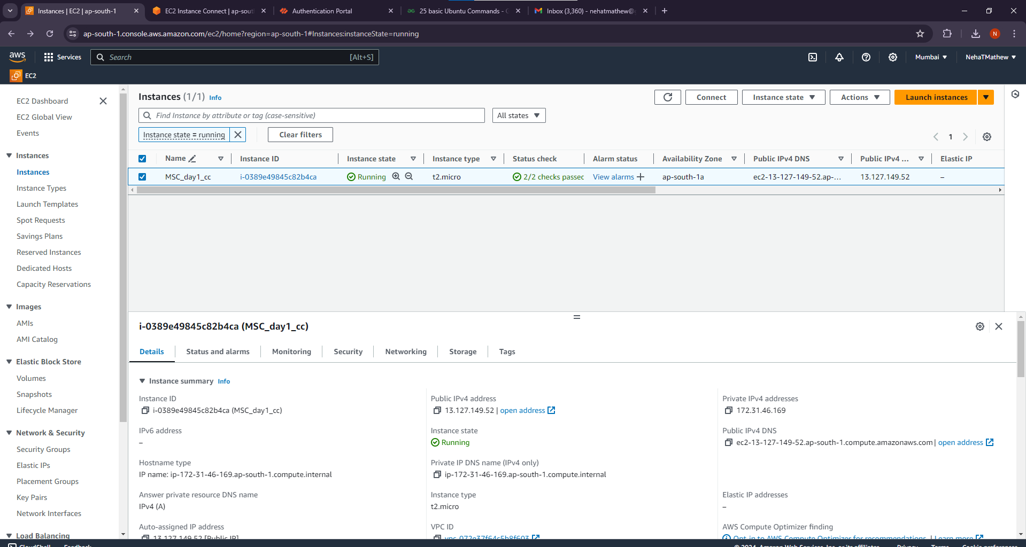

1. Click on Connect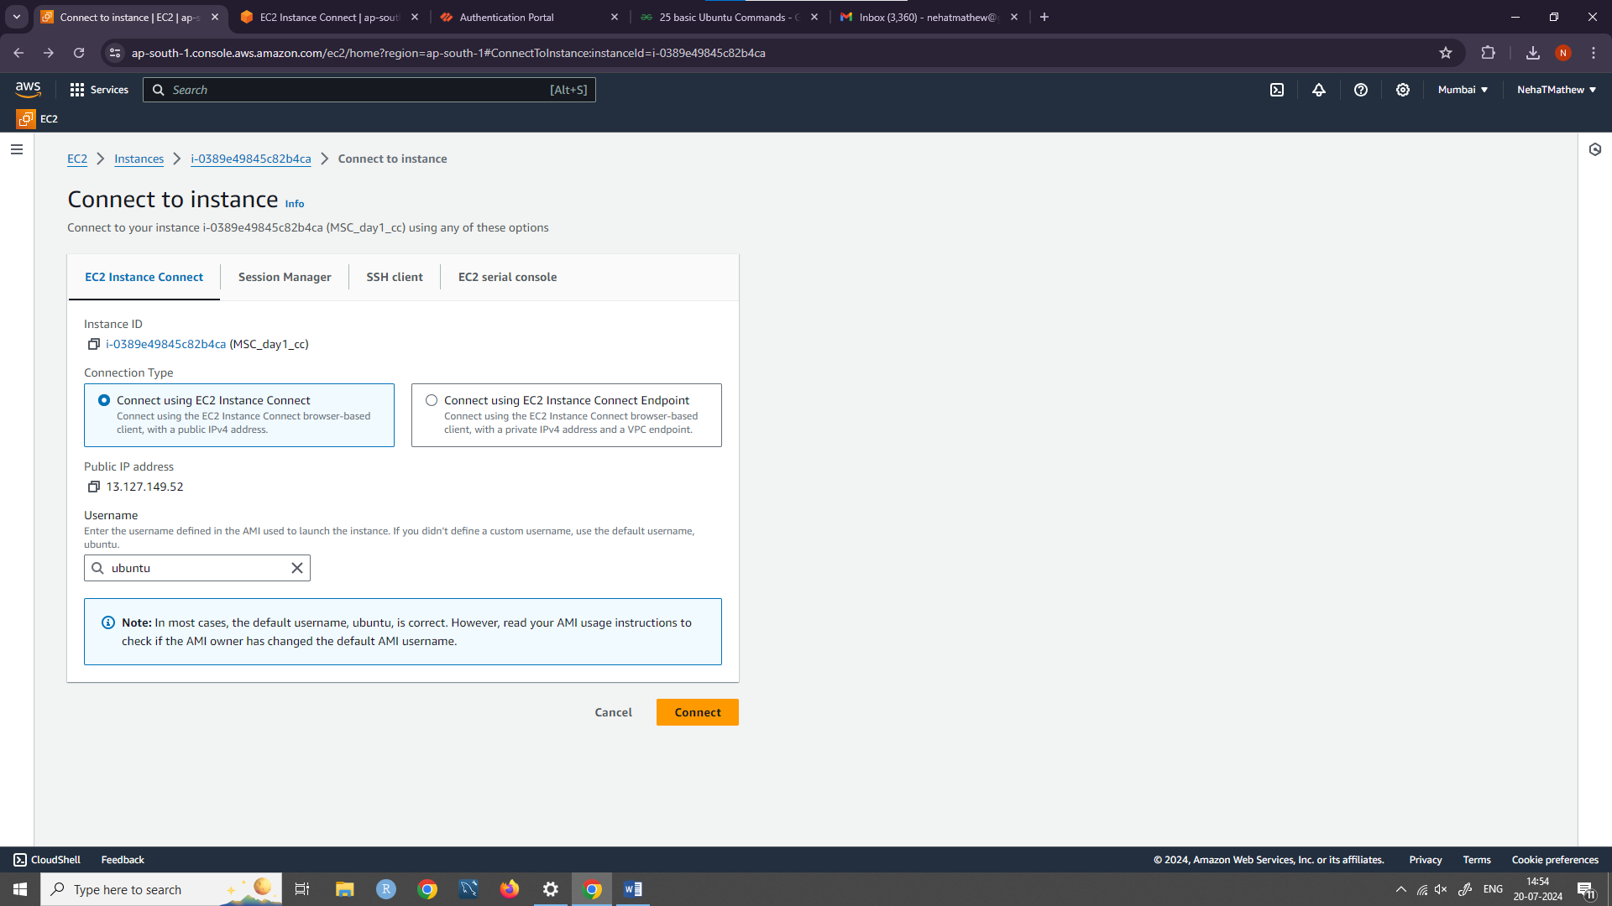
2. Once the instance summary page show up click on Connect

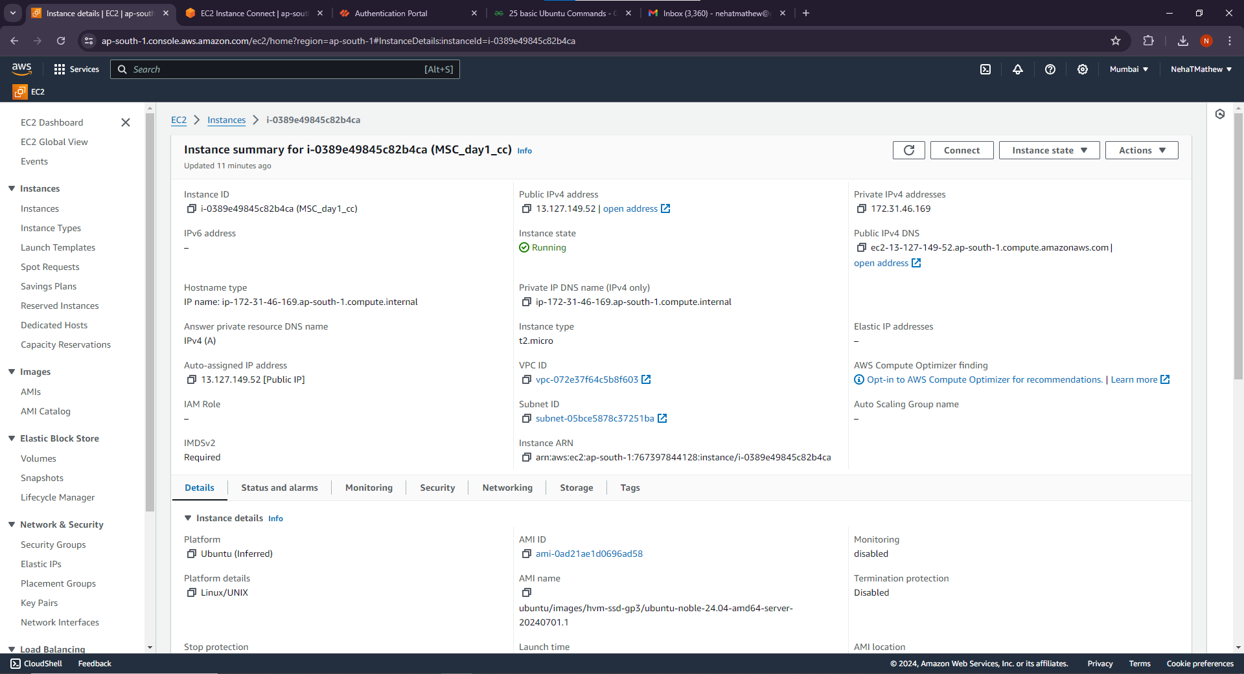8.Run any 5 basic Ubuntu commands and we are done !

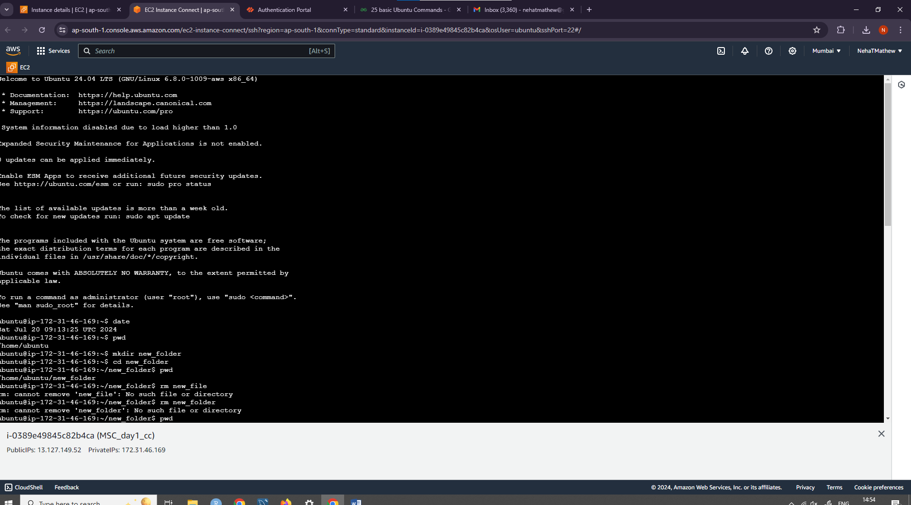

**For Windows:**

1.Create a name “msc_windows_day1” and click on windows under Quick Start

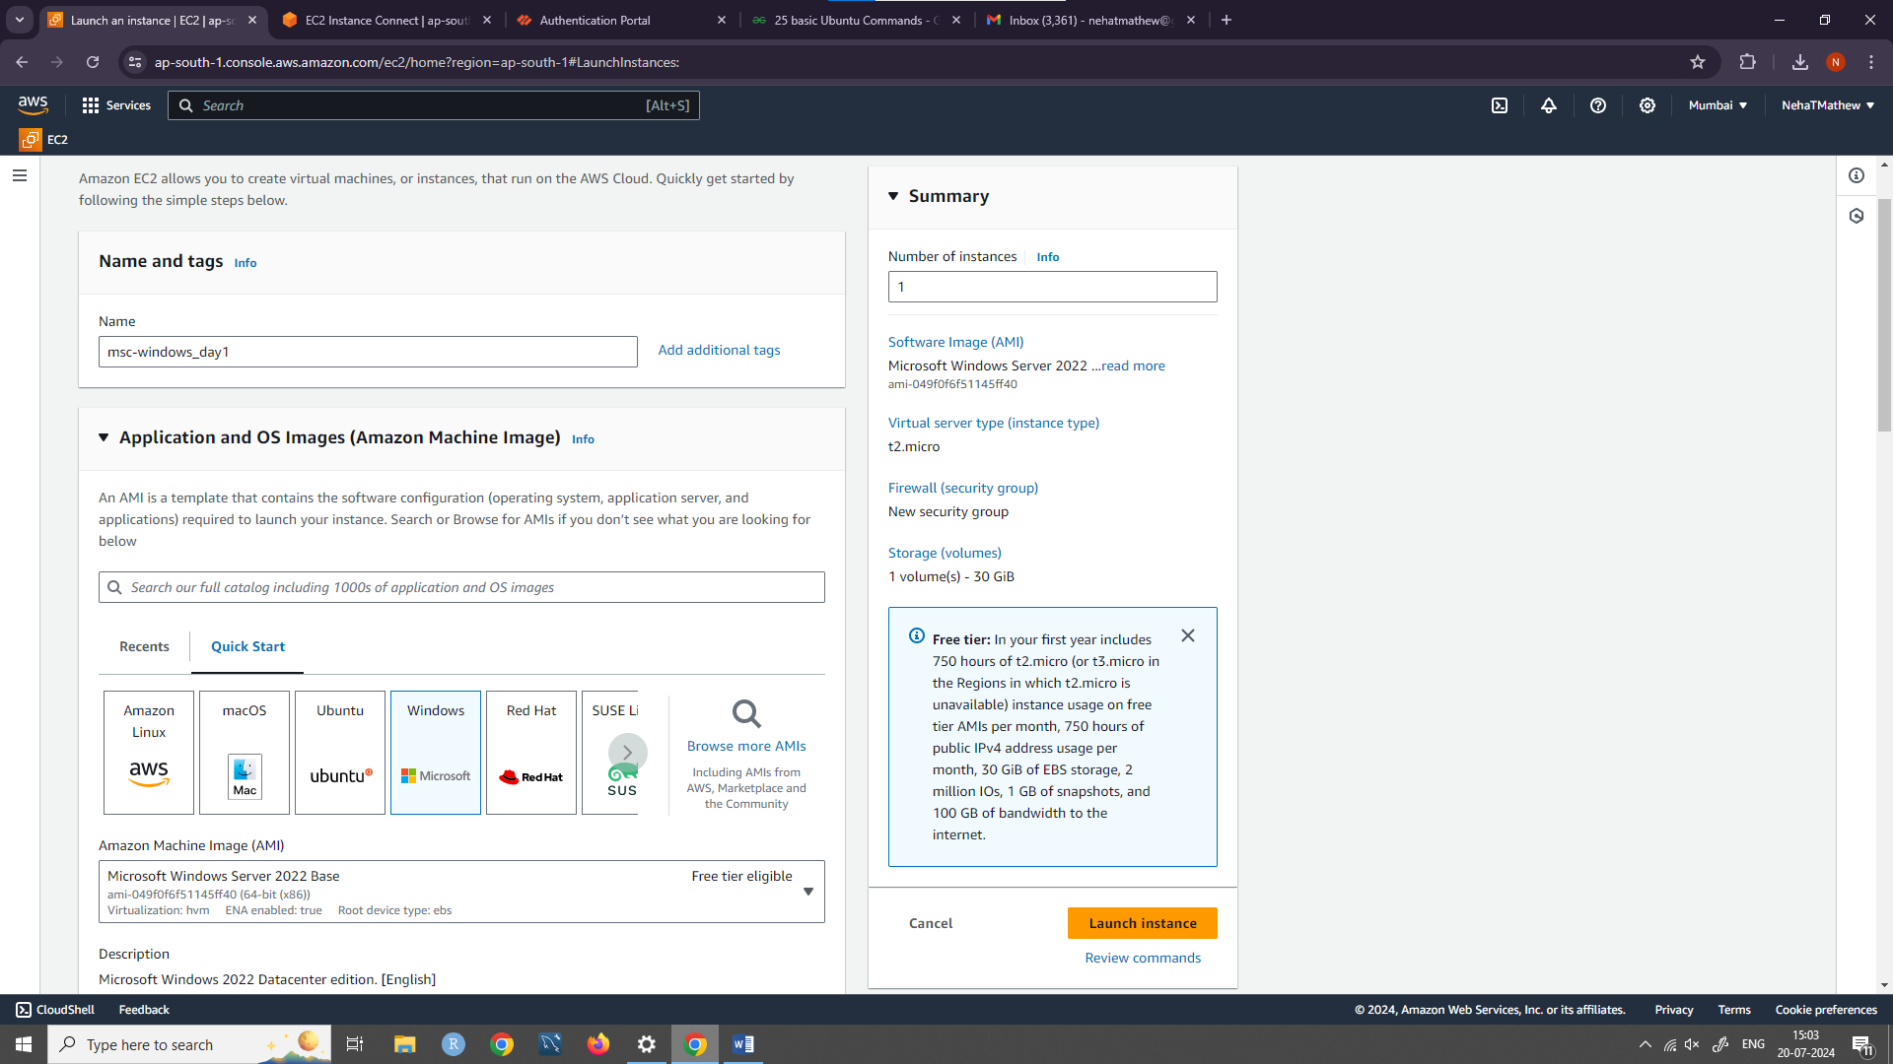

2.Create a new key pair name “window_day11”

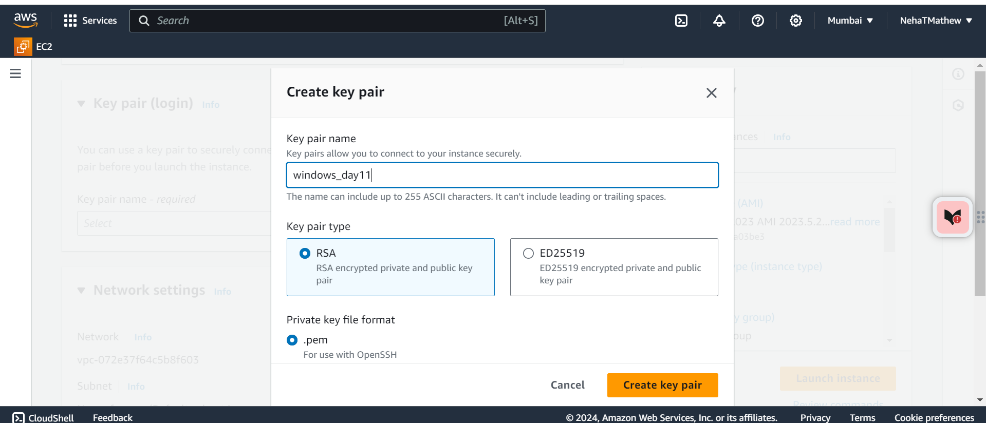

3.After creating a new key pair launch the instance

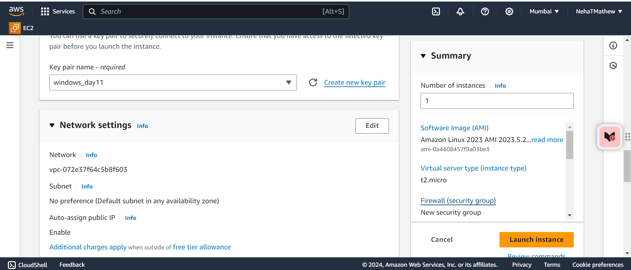

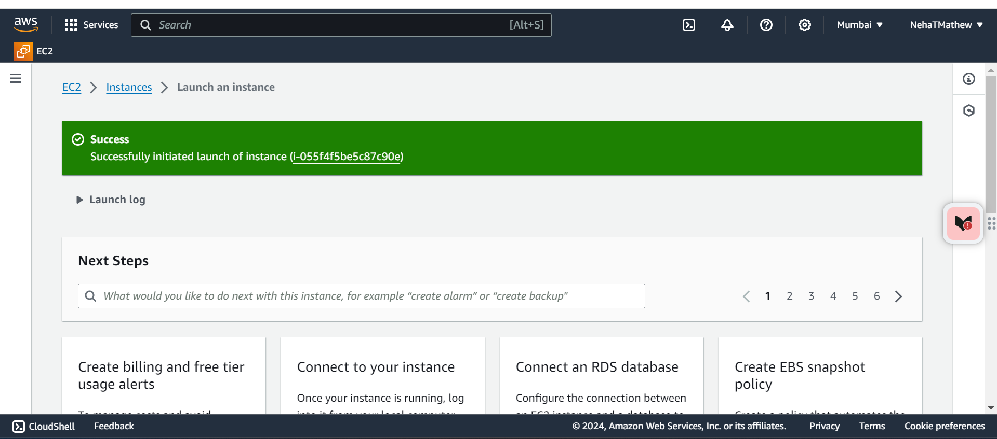

4.Once it is successfully launched click on the Instance ID

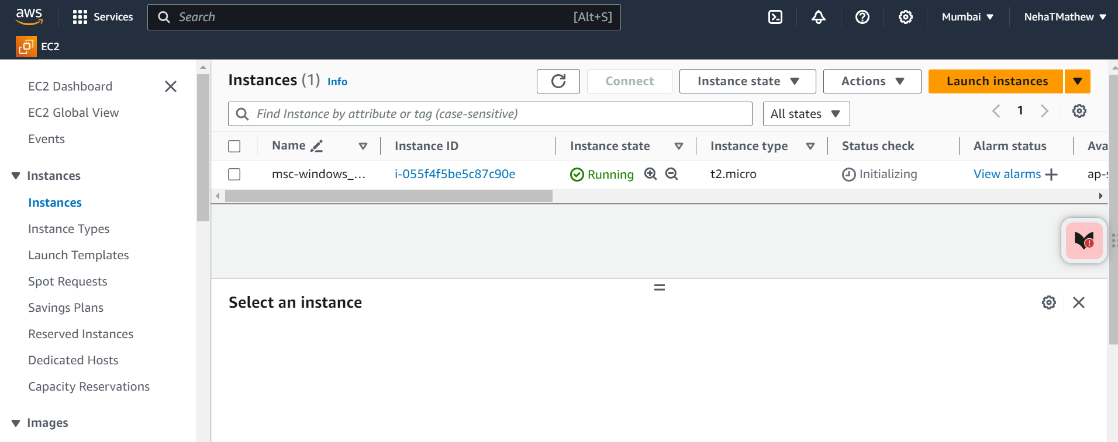

5.In the instance summary page click on connect

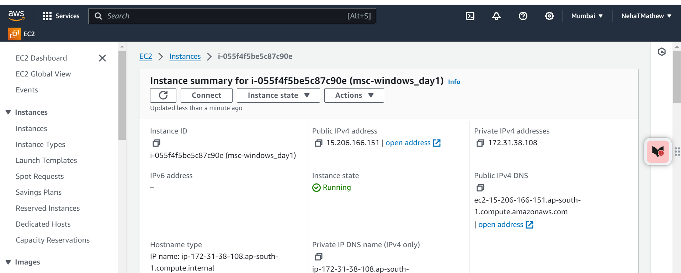

6.Click on connect

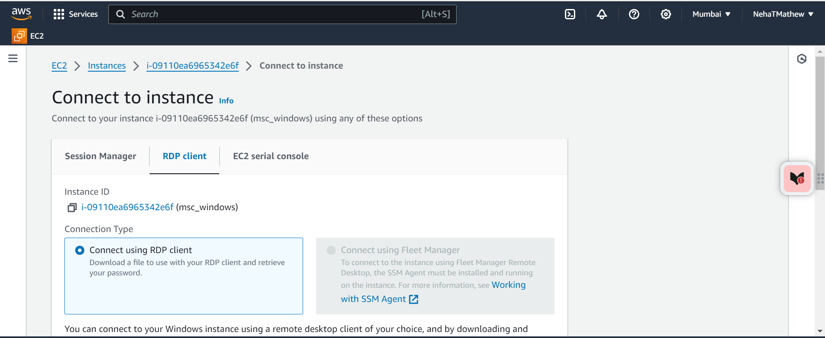

7.Click on download remote desktop file and click on get password

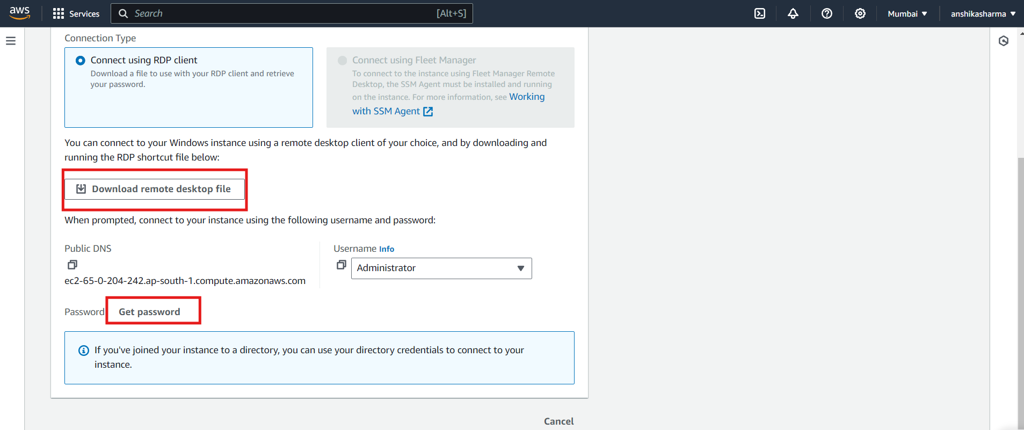

8.Click on Upload the private key and upload the .pem file

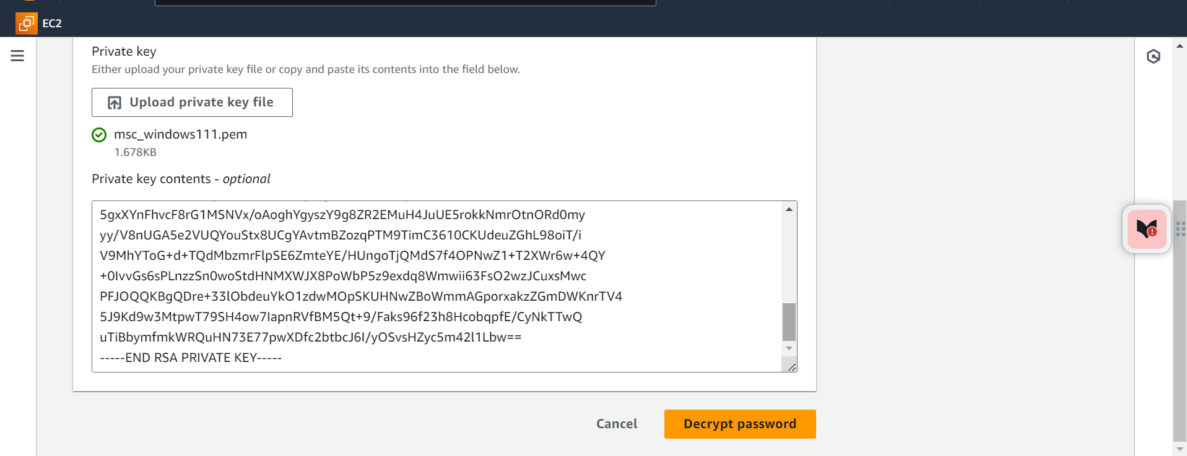

9.Copy the password and paste the password in the remote desktop file that we downloaded earlier .

Now a new windows system will appear on your screen

