**EARTHQUAKE PREDICTION: USING DEEP LEARNING TECHNIQUES**

A DISSERTATION SUBMITTED TO

SVKM’S NMIMS (DEEMED TO BE UNIVERSITY)

IN PARTIAL FULFILLMENT FOR THE DEGREE OF

**MASTER OF SCIENCE**

**IN**

**STATISTICS AND DATA SCIENCE**

BY

**Sumaiya Khan (86062300030)**

**Shreya Sane (86062300009)**

**Anshika Sharma (86062300034)**

**Neha T Mathew (86062300018)**

UNDER THE SUPERVISION OF

Dr Pradnya Khandeparkar



NILKAMAL SCHOOL OF MATHEMATICS, APPLIED STATISTICS AND ANALYTICS

SVKM’s Narsee Monjee Institute of Management Studies

(Deemed-To-Be-University)

V.L. Mehta Rd, Vile Parle (West), Mumbai – 400056

November 2023

**TABLE OF CONTENTS**

1. Acknowledgment

2. Abstract

3. Objectives

4. Introduction

5. Literature Review

6. Data Preparation: About the data

7. Data Cleaning

8. Methodology

8.1. Model Building

8.2. Model-Based Statistical Analysis

9. Results and Discussion

10. Conclusion

11. Limitations

12. Future Scope

11. References

**ACKNOWLEDGEMENT**

First and foremost, we would like to express our heartfelt gratitude towards the Program chairperson of M.Sc. Statistics and Data Science, Prof. (Dr.) Dr. Pradnya Khandeparker, for your constant support and guidance throughout this project on earthquake prediction using Deep Learning techniques. Your encouragement and feedback have been instrumental in helping us achieve our goals and complete this project successfully.

We express our sincere gratitude to NMIMS for affording us the invaluable opportunity to undertake and conduct this research project. The support and resources provided by NMIMS have played a pivotal role in facilitating the progression and completion of our scholarly endeavors.

We would like to express my appreciation to other faculty members, our friends, and family members who have supported us throughout this project with their words of encouragement and motivation.

**ABSTRACT**

The research paper mainly focuses on the analysis of seismic activities along with the prediction of earthquake interrogating deep learning (DL) techniques. Knowing the disastrous effects of earthquakes and threats to communities all over the world, understanding and estimating these events are important for efficient risk reduction approaches. South Asia, which is an active region seismically, contributes as a Strategic location of the Integrated tectonic behaviors leading to frequent tremors. Integrating DL techniques like LSTM, Hybrid models and Artificial neural network (ANN) has shown promising results in analyzing seismic data and Improving forecasting abilities. However, there are various challenges and problems that still exists such as capturing temporal dynamics and spatial dependencies which highlights the need of further research and development in this field. This paper draws insights from key investigations to emphasize the need of utilizing advanced computational methods and algorithms for revealing the challenges of seismic events and improving earthquake prediction methodologies.

**OBJECTIVES**

1. To predict Earthquakes using deep learning techniques in South Asia.
2. To compare various techniques employed for earthquake prediction and determine which approach provides the most effective performance.
3. To analyse limitations of DL techniques and enhance accuracy.

**INTRODUCTION**

Some natural things that happen are earthquakes. They cause a lot of destruction in the communities where they occur, as well as in the structures and landscapes on which they happen. Earthquakes also trigger different types of natural disasters such as floods and tsunamis. The truth is that understanding earthquakes has become very critical due to extensive studies conducted all over the world in relation to their increasing rate and probable tremendous negative impacts which may take place.

It is likely that South Asia experiences a high number of tremors brought about by intricate tectonic interactions since this region lies in an earthquake-prone zone. This happens because most large tectonic plates meet here, for example, collisions between Indian Plate and Eurasian Plate result into vigorous geological activities. Many scientists have found out that there are areas prone to earthquakes in Asia, especially Southeast Asia.

Geologists have strong evidence to suggest that this region is highly vulnerable to powerful and destructive earthquakes in the near future because of its tectonic activity.

We only need to think about the devastating earthquakes that happened in Nepal in 2015, Japan in 2011, Aceh and Thailand coastlines in 2004, as well as Kashmir and New Orleans in 2005. These events resulted in significant loss of life and damage to property. By taking appropriate precautionary measures and being able to predict earthquakes well in advance, we can potentially reduce the impact of such disasters even more.

In the recent past, seismic science has had its understanding of seismic activity and predictive capabilities tremendously improved by infusing machine learning and deep learning techniques. Application of ML algorithms such as neural networks, Regression analysis, Decision tree, Random Forest, KNN methods have become popular in earthquake prediction because they can handle highly complex and dynamic dataset. These techniques are usually based on parameters like magnitude, depth and geological features to improve the accuracy of earthquake predictions. However, these ML techniques in earthquake prediction faces challenges in capturing temporal dynamics and spatial dependencies while also being sensitive to noise. This limits interpretability and its applicability outside the training data thus making it ineffective in this context.

Machine learning techniques may struggle to forecast earthquakes of significant magnitude due to their infrequent occurrence compared to other events. ML models might prioritize learning patterns from the most powerful and prevalent seismic events. Additionally, the classical design of ML algorithms poses constraints in effectively modelling time series data characterized by high levels of complexity and nonlinearity.

Different disciplines have employed Deep Learning (DL) techniques more and more, giving an unprecedented edge in data analytics. These models are great at bringing to the surface something otherwise hidden or not obvious in data and this gives rise to results that will be very much appreciated. On the other hand, traditional machine learning uses explicit feature engineering unlike deep learning which automatically selects relevant features from input data thus avoiding such calculations. This quality is a distinguishing factor that shows how powerful DL can be for advanced data analysis as it allows analytical insights that were impossible before. Their ability to undertake complex data analysis and extract secret patterns without having to engage in explicit feature computation makes deep learning relevant to earthquake forecasting purposes.

Long Short-Term Memory models, a type of recurrent neural networks, are designed to understand long-term connections in data sequences, unlike traditional RNNs. They are particularly effective in handling relationships over time, which makes them well-suited for tasks such as analysing time-series data, natural language processing, and speech recognition. LSTM models, whether one-dimensional or two-dimensional, have been successfully applied to predicting earthquakes. These models take into account various parameters like earthquake magnitude, depth, time, latitude, and longitude to forecast trends. Despite their potential, current deep learning methods for earthquake prediction are still in the early stages of development, posing a challenge for researchers.

The study investigates an attention-driven LSTM model created to predict the timing, magnitude, and location of an upcoming major earthquake.

In the field of machine learning, a hybrid model refers to a computational framework that combines different algorithms or approaches from various domains to address complex problems or improve overall performance. These models integrate elements from both traditional machine learning (ML) techniques and advanced deep learning (DL) architectures, along with other methodologies. For instance, a hybrid model might use deep learning to extract features from raw data, and then employ conventional ML algorithms for classification or prediction tasks.

Hybrid models bring together different machine learning methods, such as recurrent neural networks (RNNs) like LSTM or GRU, with alternative models such as random forest or convolutional neural networks (CNNs).

They want to improve the forecasting accuracy and robustness in multiple ways, including greater generalization, better control of high-dimensional datasets, and more interpretability than that offered by standalone model.

The paper explores how Deep Learning (DL) is playing a vital role in earthquake analysis and prediction. It looks at key studies that have used advanced algorithms to better understand and predict seismic events.

**LITERATURE REVIEW**

Based on some geographical parameters related to different seismic datasets, many researchers have worked on various papers. They have used different machine learning and deep learning algorithms like K-Means Clustering, Random Forest (RF), Support Vector Regression (SVR), Long Short Memory (LSTM) and Gated Recurrent Unit (GRU) for earthquake prediction.

(Bhargava & Pasari, 2022) suggested the use of Artificial Neural Networks for earthquake magnitude prediction. Here, they have used temporal information and Seismic Electric Signals to improve accuracy. On the other hand, (Tang et al., 2021) suggested convolutional neural networks for seismological event detection.

To monitor seismic activity in specific regions (Kumar et al., 2018) proposed a seismic activity identification method using the STA/LTA algorithm whereas (Bui & van der Baan, 2020) evaluated power spectral density techniques for seismic event identification. Also, to enhance earthquake detection efficiency (Liao et al., 2022) proposed a template-Matching Algorithm.

(Tang et al., 2021) introduced convolutional neural networks for seismological event detection, focusing on earthquake signal detection in the temporal domain and spectral feature utilization for wave differentiation. Also, for improved accuracy, (Bhargava & Pasari, 2022) suggested the use of Artificial Neural Networks to predict the magnitude.

Overall, to predict the earthquakes, different people suggested a variety of techniques which helped in enhancing the forecasting accuracy and efficiency.

**DATA PREPARATION**

**About The Data:**

The following seismic data is obtained from the **earthquake.usgs.gov** and covers certain parts of South Asia.

The raw dataset:

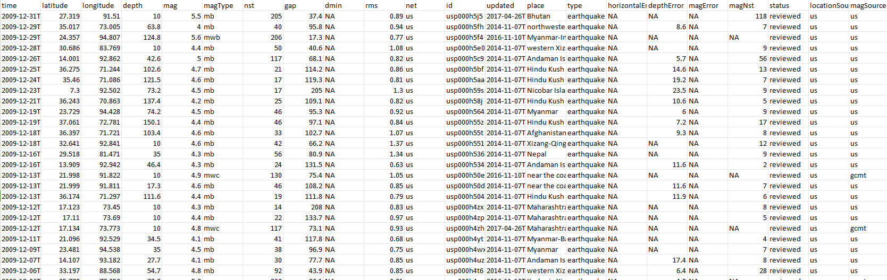

1. There are a total of 22 variables in our raw dataset.
2. There are a total of 3130 rows.

**DATA CLEANING**

The time feature is transformed to a more representable feature called “Timestamp” that represents the date and time in seconds. This is done to incorporate the time pattern in simple information instead of complex information such as date (year, month, day) and time (hour, minute, second) .The pd.to_dataframe() of the pandas library is used to convert strings, datetime objects, or numeric values to pandas Timestamp objects and the same is used here.

After calculating the percentage of missing values in every variable, rows containing null values were dropped. The variables that had more than 50 % missing values were also dropped.

**Geographical Clustering:**

The location at which earthquakes are bound to happen is a very crucial factor since it helps us to keep track of patterns in where earthquakes occur. It is important to note that areas close to the tectonic plates experience different kinds of earthquakes than the places that are far away. This is done using K means algorithm to discover and divide the data set into geographic clusters that share the same seismic characteristics in each studied area.K means algorithm is a machine learning grouping technique used to group n observations into K cluster where each observation belong to the cluster with the nearest average. By taking k=5 we have divided the data set into 5 clusters and performed K means clustering to produce a location-dependent prediction.This produced a new variable “cluster” that denotes the location cluster associated with each event.

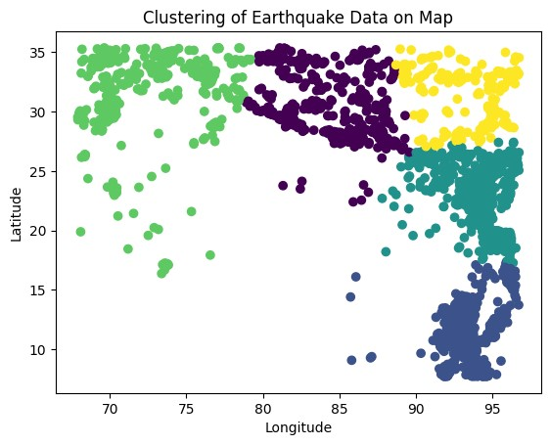

**Encoding:**

To ensure integrity of the data and to make it more usable and efficient, we have converted 2 categorical variables “country” and “magType” to numerical variables using label encoding. This assigns a distinctive numerical value to each category. Then mappings are created that are stored in dictionaries which is used to display the correspondence between the original categories and their numerical representations.

**Magnitude clustering:**

Using clustering the data is divided into two clusters based on the magnitude strength as “medium” and “Large” and are plotted.

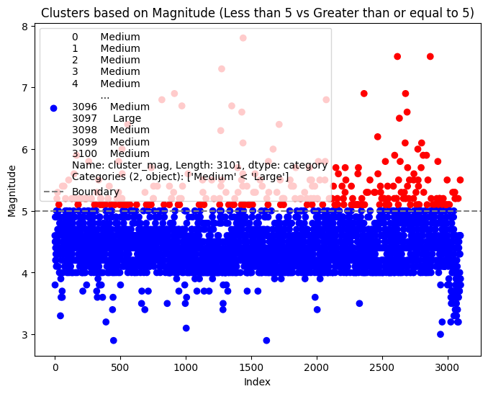

**Normalization:**

Since the seismic data is represented on a different scale it is crucial to normalize so that our results aren't biased.This is done to improve the performance and accuracy of our results.There are different methods to normalize the variables such as Z-score normalization,Standard deviation Normalization and min-max scaler. The approach we have chosen to go ahead with is Min-Max scaler which is calculated by the formula:

**z = x -min(x) /max(x)- min(x)**

Min -Max scaler converts the data to the range between 0 and 1.

**DATA PRE-PROCESSING**

**Train Test Split:**

The main aim of supervised learning is to build a model that performs well on new data. Train-Test split is a model validation method to see how well our model is performing on unseen data .For that we have divided our dataset into two parts called train and test .In the train part of data we fit our models and the test portion is used to make predictions and to evaluate the working of the model.The data has been partitioned using an 80-20 split, where 80% of the data is allocated for training and 20% for testing. Given that the dataset is in descending order based on the occurrence of earthquakes, with the most recent events appearing at the beginning of the dataset, the complete dataset has been reversed. This reordering ensures that the most recent earthquake occurrences are included in the training set. Following that, a slicing operation is applied to extract the initial 80% of the inversed dataset for training, while the remaining 20% is used for testing purposes.

**Parameterization:**

The process of selecting various parameters to work on has a colossal effect on the end results. Parameters such as the number of neurons in LSTM model, batch size, activation function,optimizer,dropout function plays a crucial role. For activation function we have used Rectified linear function. Adam optimizer is used as Optimizer for all models since it performs better than theoretical models. Depending on the prediction model we tune several values for dense layer,batch size and number of neurons and select the most optimal value

**Model building**

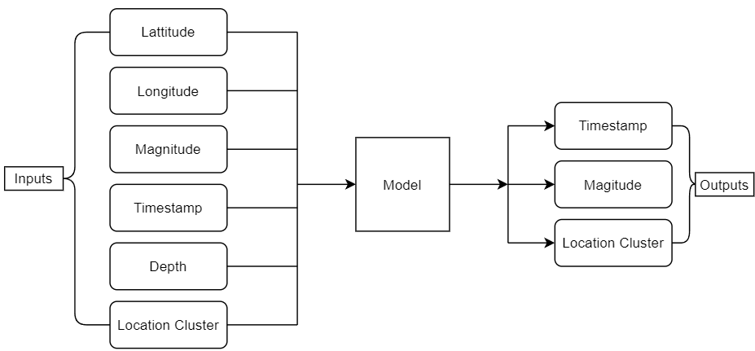

**LSTM:**

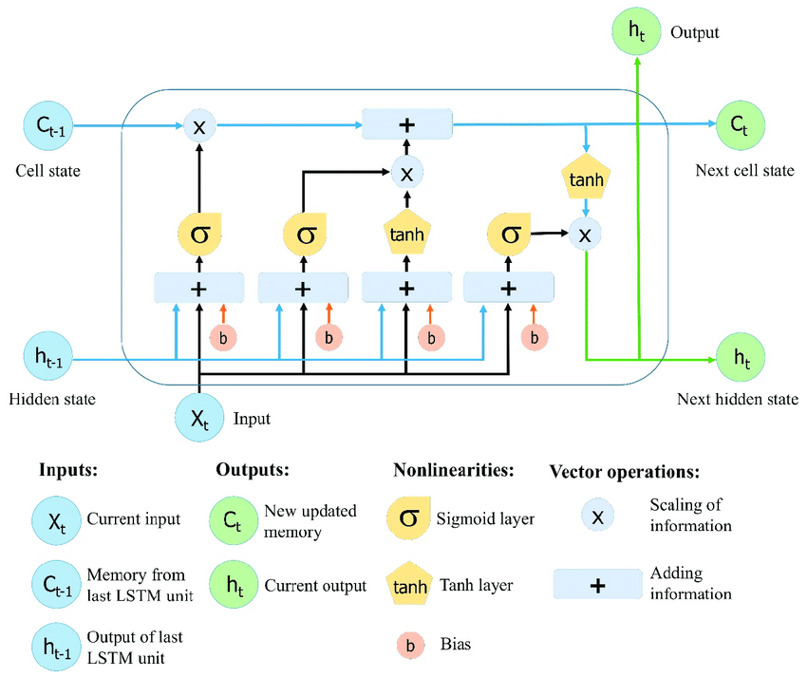

**Key components and features of an LSTM:**

1**.Memory Cells:** LSTMs have a memory cell that can maintain information over time steps. This allows them to capture dependencies in sequential data.

**2.Gates:** LSTMs use different gates to control the flow of information into and out of the memory cell. These gates are:

Forget Gate: Decides what information to discard from the cell state.

Input Gate: Decides which new information to store in the cell state.

Output Gate: Decides what to output based on the current input and memory of the cell.

**3.Cell State:** The cell state runs straight down the entire chain of LSTM units with only minor linear interactions. This means information can be carried unchanged across many time steps, reducing the vanishing gradient problem.

A multi-output LSTM is a recurrent neural network that is used to make predictions on multiple outputs. Long Short-Term Memory (LSTM) neural network model is applied here to predict three output variables (cluster, mag, time_seconds) based on a set of input features (latitude, longitude, depth, mag, time_seconds, cluster).After scaling using Min-Max scaler the data is split into train and test. We have defined and trained LSTM model comprising of a single LSTM layer with 1500 units and also a dense output layer on the training data. Subsequently the model’s performance is evaluated using MSE.

Here the activation function used is “leaky-reLu” instead of the “reLu”. This is due to that fact that reLu addresses a zero gradient value for negative inputs that could deactivate some neurons,whereas the leaky-reLu multiplies the negative inputs by a small value instead of zero

**LSTM with Shared input Layer:**

A shared layer LSTM model utilizes LSTM layers with shared parameters to process multiple related inputs or tasks efficiently, leveraging common representations and patterns across different parts of the network. Shared layers are layer instances that are reused multiple times in the same model. They learn features corresponding to multiple paths in the layer graph.

In a neural network model, sharing layers refers to using the same layer (with the same set of parameters) across different parts of the network. This can be beneficial when dealing with related tasks or multiple input modalities where certain features or representations are common.

We have implemented a shared input layer connected to three LSTM models.The first one predicts the magnitude, the second predicts the time and the last one predicts the location cluster.Since all of these three models are connected to the same input layer they are also trained and tested with the same values of the data.By attaching each branch to this shared input layer,the models learn to extract relevant features from the input day interdependently for each prediction task(magnitude,timestamp, and location), while still sharing the initial representation of the input data.After defining the three models we compiled them with their appropriate loss function and metrics. Then with validation split for evaluation, each model is trained and finally each model's performance is evaluated on the testing data using metrics like loss, mean absolute error (MAE), and root mean squared error (RMSE).

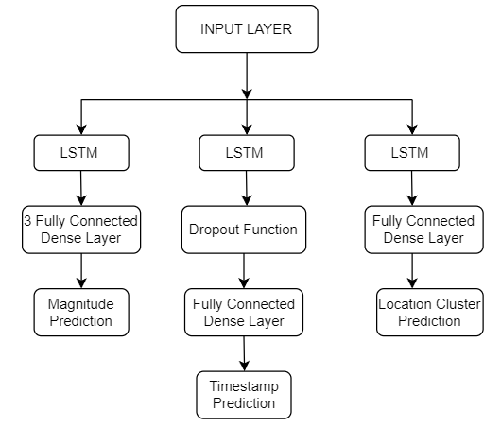

**Artificial neural network(ANN)**

Artificial Neural Networks (ANNs) are a fundamental component of modern machine learning and artificial intelligence. Inspired by the structure and functioning of the human brain, ANNs are computational models composed of interconnected nodes (neurons) organized in layers. Each neuron processes information received from its input connections, applies an activation function, and passes the result to neurons in the next layer. Through a process of learning from training data, ANNs can generalize and make predictions or classifications on new, unseen data.

First the data is split into two train and test using index slicing and concatenation of train and test datasets. The input features are standardized using StandardScaler and then the ANN model is constructed using Keras Sequential API, comprising three Dense layers with rectified linear unit (ReLU) activation function.

1.The first layers contains reLu activation function with 64 neurons where input shape is equal to number of scaled features.

2.The second layer also utilizes reLu activation function with 32 neurons

3.The output layer does not have an activation function and we have considered the neurons equal to the number of output variables

The model is finally compiled with the “Adam” optimizer and we have considered Mean squared error(MSE) as the loss function

**RESULTS AND DISCUSSION**

In this section we first examine the performance of LSTM model for the seismic dataset from South Asia (majorly including India) using the performance metric mentioned below. Then results are compared with the baseline method such as ANN and a variant of LSTM i.e. Shared Layer model.

**Analysis of performance metrics**

The statistical metrics are presented in this section to evaluate the results. The below tables shows the MSE, RMSE and MAE of different models. The results displayed are for train and test sets . R squared is another performance indicator that can be used to evaluate the model and describe how good the model fit is.

**1. LSTM**

|  |  |  |  |  |
| --- | --- | --- | --- | --- |
| **Performance metric** | **MSE** | **RMSE** | **MAE** | **R2** |
| Train | 0.000021 | 0.004583 | 0.003258 | 0.999277 |
| Test | 0.000110 | 0.010488 | 0.007563 | 0.978858 |

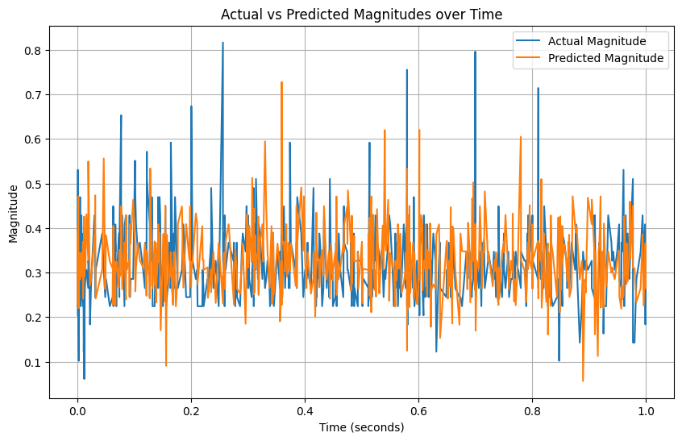

**2. ANN**



|  |  |  |  |  |
| --- | --- | --- | --- | --- |
| **Performance metric** | **MSE** | **RMSE** | **MAE** | R2 |
| Train | 0.0019057 | 0.011583 | 0.007714 | 0.994659 |
| Test | 0.0019057 | 0.043654 | 0.035591 | 0.791964 |

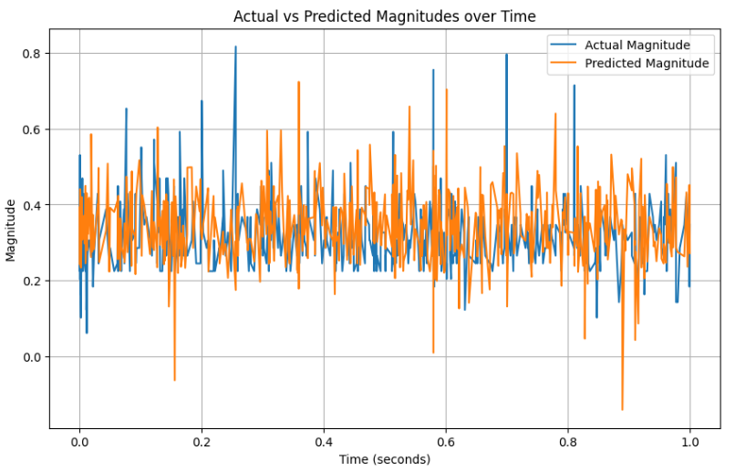

**3. Shared Layer LSTM**



|  |  |  |  |  |  |
| --- | --- | --- | --- | --- | --- |
| **Performance metric** | | **MSE** | **RMSE** | **MAE** | R2 |
| Magnitude | Train | 0.0080 | 0.0897 | 0.0649 | 0.0157 |
| Test | 0.0377 | 0.1941 | 0.1666 | 0.98777 |
| Timestamp | Train | 0.0119 | 0.1090 | 0.0952 | 0.7663 |
| Test | 0.7264 | 0.8523 | 0.8499 | 0.78654 |

|  |  |  |  |
| --- | --- | --- | --- |
|  | | Model Loss | Accuracy |
| Location | Train | 0.3141 | 0.9685 |
| Test | 1.6238 | 0.1562 |

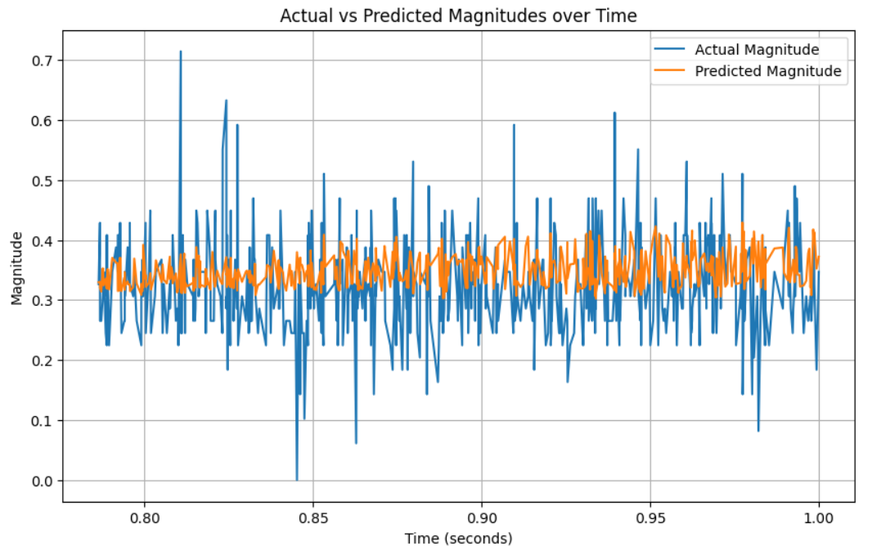

Overall based on this evaluation metrics LSTM model is working well on our data in predicting the next magnitude, location and time of the earthquake. The above figures illustrate the curves of the actual and predicted magnitude over time.

The data points for the predicted magnitude seems to closely follow the same pattern as of the actual magnitude indicating LSTM model is successful at predicting the magnitude of the earthquake over time.

**Comparison with the baseline method**

To compare our work with the selected baseline method, using the same dataset as the baseline method which belongs to South Asian Continent. The below table shows the results of our work, the baseline method, and the usefulness of LSTM, ANN and a variant of LSTM to the same dataset.

**CONCLUSION**

Based on the evaluation results, the LSTM model emerges as the preferred choice among the models evaluated for earthquake prediction. The combination of lower MSE, RMSE, and MAE values along with a high R2 value for the LSTM model provides compelling evidence of its superiority in earthquake prediction tasks, highlighting its capability to deliver accurate and meaningful predictions for earthquake magnitude, location and time.

Based on the evaluation metrics obtained for the earthquake prediction models, including Mean Squared Error (MSE), Root Mean Squared Error (RMSE), Mean Absolute Error (MAE), and R2 (coefficient of determination), the following conclusions can be drawn:

1**. Lower MSE, RMSE, and MAE for LSTM Model:**

* The LSTM model for earthquake prediction demonstrates lower values of MSE, RMSE, and MAE compared to the baseline models (ANN and shared layer LSTM).
* Lower MSE, RMSE, and MAE indicate that the LSTM model's predictions are closer to the actual earthquake magnitude and time values on average.
* This suggests that the LSTM model captures the underlying patterns and relationships in the earthquake data more effectively than the baseline models, resulting in more accurate predictions.

**2. High R2 Value for LSTM Model:**

* The R2 value for the LSTM model is high, indicating a strong correlation between the predicted and actual earthquake values.
* A high R2 value (close to 1) suggests that the LSTM model explains a significant proportion of the variance in the earthquake data, demonstrating good predictive performance.
* The high R2 value further validates the effectiveness of the LSTM model in capturing the complex temporal dependencies and patterns inherent in earthquake data.

**3.Capability for Accurate and Meaningful Predictions:**

* The LSTM model's ability to deliver accurate and meaningful predictions for earthquake magnitude, location, and time is highlighted by the combination of lower error metrics (MSE, RMSE, MAE) and a high R2 value. This indicates that the LSTM model is reliable and can provide valuable insights into earthquake occurrences, potentially aiding in effective earthquake prediction and mitigation efforts.

The LSTM model is considered superior for earthquake prediction tasks compared to other models evaluated. Its strong performance in accuracy, precision, and predictive capability makes it a compelling choice for applications requiring reliable earthquake forecasting.

**LIMITATIONS**

No matter how promising or advanced any earthquake prediction models may seem but every model comes with its set of limitations. So, despite of having this much accuracy our model also has some limitations.

1. **Uncertain Precursors:**

Sometimes, predicting earthquake relies on some factors like changes in groundwater levels or animal behaviour. But these precursors are often inconsistent and not reliably predictive. In some cases, changes in groundwater levels have been observed before earthquakes, but this isn't always the case. Therefore, relying solely on uncertain precursors can make earthquake prediction unreliable.

1. **Variability in Earthquake Patterns:**

Earthquakes vary in their characteristics such as magnitude (how strong they are), depth (how far below the surface they occur), and location (where they happen).They occur unpredictably and in different places. For example, while some regions may experience frequent small earthquakes, others may have infrequent but devastating ones. This variability makes it difficult to develop models that accurately predict when and where earthquakes will occur, as each event is unique in its characteristics.

1. **Lack of Historical Data:**

Earthquake prediction becomes difficult due the lack of historical data, especially in regions where earthquakes occur infrequently. Without sufficient data on past earthquakes and their characteristics, such as magnitude, depth, and location, it's difficult to develop accurate prediction models. For example, regions with low earthquake frequency might have fewer recorded instances to analyze, making it challenging to develop accurate prediction models.

1. **Technological Limitations:**

Detecting subtle changes in seismic activity requires advanced technology, and current systems may not be sophisticated enough to capture all relevant data. For instance, while seismometers can detect ground movement associated with earthquakes, they may not be sensitive enough to detect smaller, precursor signals. Additionally, monitoring systems may be limited by factors such as budget constraints or geographical coverage, further hampering their effectiveness in predicting earthquakes accurately.

1. **False Positives:**

Even with advanced monitoring systems in place, there's always a risk of false alarms. These false positives can lead to unnecessary panic, evacuation efforts, and economic costs. For example, if a monitoring system incorrectly signals an imminent earthquake, it could trigger widespread fear and disruption, even if no earthquake occurs. Balancing the need for timely warnings with the risk of false alarms is a significant challenge in earthquake prediction efforts.

**FUTURE SCOPE**

1. **Non-Seismic Data Integration:**

Integrating non-seismic data, such as satellite imagery and geological surveys, into earthquake prediction models presents a promising avenue for improving accuracy and reliability. These additional data sources can provide valuable insights into factors like tectonic plate movements, ground composition, and surface changes, which can contribute to a more comprehensive understanding of seismic activity patterns.

1. **Real-Time IoT Monitoring:**

The implementation of IoT (Internet of Things) devices and sensors in earthquake-prone areas offers the potential for real-time monitoring of ground motion and structural integrity. These devices can continuously collect and transmit data on seismic activity, ground deformation, and building responses, allowing for early detection of anomalies and timely interventions to mitigate risks and minimize damage.

1. **Early Warning App:**

Developing smartphone applications for earthquake early warning systems represents a proactive approach to enhancing public safety and preparedness. These apps can leverage real-time data from seismic sensors to provide personalized alerts and safety recommendations to users in affected areas, enabling individuals to take timely actions to protect themselves and their communities. Additionally, these apps can facilitate communication and coordination among emergency responders and citizens during crisis situations.

**DRIVE LINK FOR DATASET AND CODES:**

<https://drive.google.com/drive/folders/18-fdcl96QeNKzIinhgiinRi9omf1ygni>

**REFERENCES**

Abhiraj, Rathor, A., Yadav, A. K., & Ranvijay. (2024). *Earthquake Magnitude and Depth Prediction Based on Hybrid GRU-BiLSTM Model*. 303–315. https://doi.org/10.1007/978-981-99-7962-2_24

Berhich, A., Belouadha, F. Z., & Kabbaj, M. I. (2022). A location-dependent earthquake prediction using recurrent neural network algorithms. *Soil Dynamics and Earthquake Engineering*, *161*. https://doi.org/10.1016/j.soildyn.2022.107389

Berhich, A., Belouadha, F. Z., & Kabbaj, M. I. (2023). An attention-based LSTM network for large earthquake prediction. *Soil Dynamics and Earthquake Engineering*, *165*, 107663. https://doi.org/10.1016/J.SOILDYN.2022.107663

Bhargava, B., & Pasari, S. (2022). Earthquake Prediction Using Deep Neural Networks. *8th International Conference on Advanced Computing and Communication Systems, ICACCS 2022*, 476–479. https://doi.org/10.1109/ICACCS54159.2022.9785011

Bhatia, M., Ahanger, T. A., & Manocha, A. (2023). Artificial intelligence based real-time earthquake prediction. *Engineering Applications of Artificial Intelligence*, *120*, 105856. https://doi.org/10.1016/J.ENGAPPAI.2023.105856

Bommer, J. J. (2022). Earthquake hazard and risk analysis for natural and induced seismicity: towards objective assessments in the face of uncertainty. *Bulletin of Earthquake Engineering 2022 20:6*, *20*(6), 2825–3069. https://doi.org/10.1007/S10518-022-01357-4

Bui, H., & van der Baan, M. (2020). Event detection using a fast matched filter algorithm-An efficient way to deal with big microseismic data sets. *SEG Technical Program Expanded Abstracts*, *2020-October*, 1325–1329. https://doi.org/10.1190/SEGAM2020-3420645.1

Jain, R., Nayyar, A., Arora, S., & Gupta, A. (2021). A comprehensive analysis and prediction of earthquake magnitude based on position and depth parameters using machine and deep learning models. *Multimedia Tools and Applications*, *80*(18), 28419–28438. https://doi.org/10.1007/S11042-021-11001-Z/METRICS

Kumar, S., Vig, R., & Kapur, P. (2018). Development of Earthquake Event Detection Technique Based on STA/LTA Algorithm for Seismic Alert System. *Journal of the Geological Society of India*, *92*(6), 679–686. https://doi.org/10.1007/S12594-018-1087-3/METRICS

Kuyuk, H. S., & Susumu, O. (2018). Real-Time Classification of Earthquake using Deep Learning. *Procedia Computer Science*, *140*, 298–305. https://doi.org/10.1016/J.PROCS.2018.10.316

Liao, W. Y., Lee, E. J., Chen, D. Y., Chen, P., Mu, D., & Wu, Y. M. (2022). RED-PAN: Real-Time Earthquake Detection and Phase-Picking With Multitask Attention Network. *IEEE Transactions on Geoscience and Remote Sensing*, *60*. https://doi.org/10.1109/TGRS.2022.3205558

Liu, Y., Wang, Y., & Zhang, J. (2012). New machine learning algorithm: Random forest. *Lecture Notes in Computer Science (Including Subseries Lecture Notes in Artificial Intelligence and Lecture Notes in Bioinformatics)*, *7473 LNCS*, 246–252. https://doi.org/10.1007/978-3-642-34062-8_32/COVER

Puthran, R. (2023). Spatio-Temporal Analysis of Hybrid CNN-GRU Model for Prediction of Earthquake for Disaster Management. *International Journal of Intelligent Systems and Applications in Engineering*, *12*(3s), 270–281. https://ijisae.org/index.php/IJISAE/article/view/3705

Sarker, I. H. (2021). Deep Learning: A Comprehensive Overview on Techniques, Taxonomy, Applications and Research Directions. *SN Computer Science*, *2*(6), 1–20. https://doi.org/10.1007/S42979-021-00815-1/FIGURES/11

Shah, A. A., Qadri, T., & Khwaja, S. (2018). Living with earthquake hazards in South and South East Asia. *ASEAN Journal of Community Engagement*, *2*(1), 15. https://doi.org/10.7454/ajce.v2i1.105

Sherstinsky, A. (2018). Fundamentals of Recurrent Neural Network (RNN) and Long Short-Term Memory (LSTM) Network. *Physica D: Nonlinear Phenomena*, *404*. https://doi.org/10.1016/j.physd.2019.132306

Tang, S., Wang, J., & Tang, C. (2021). Identification of Microseismic Events in Rock Engineering by a Convolutional Neural Network Combined with an Attention Mechanism. *Rock Mechanics and Rock Engineering*, *54*(1), 47–69. https://doi.org/10.1007/S00603-020-02259-0/METRICS