Industrial Internship Report on

Food Delivery Application
Prepared by
Nehavarshini S

Executive Summary
This report provides details of the Industrial Internship provided by upskill Campus and The IoT Academy in collaboration with Industrial Partner UniConverge Technologies Pvt Ltd (UCT).
This internship was focused on a project/problem statement provided by UCT. We had to finish the project including the report in 6 weeks’ time.

My project was (My project was "Food Delivery Application", a web-based platform developed using HTML, CSS, JavaScript, Node.js, and Express.js. The application serves as a bridge between restaurants and customers by allowing users to browse restaurants, view food items, add items to a cart, make payments, track orders, and view order history. Restaurant owners can manage food items and process customer orders through a dedicated dashboard. The application also includes features such as favorites management, delivery tracking, order management, and restaurant administration. This project helped me understand the complete software development lifecycle, including frontend design, backend development, API integration, testing, and deployment).
This internship gave me a very good opportunity to get exposure to Industrial problems and design/implement solution for that. It was an overall great experience to have this internship.

TABLE OF CONTENTS
- Preface Error! Bookmark not defined.
- Introduction 4
  - About UniConverge Technologies Pvt Ltd Error! Bookmark not defined.
  - About upskill Campus Error! Bookmark not defined.
  - Objective Error! Bookmark not defined.
  - Reference Error! Bookmark not defined.
  - Glossary Error! Bookmark not defined.
- Problem Statement 7
- Existing and Proposed solution 8
- Proposed Design/ Model Error! Bookmark not defined.
  - High Level Diagram (if applicable) Error! Bookmark not defined.
  - Low Level Diagram (if applicable) Error! Bookmark not defined.
  - Interfaces (if applicable) 11
- Performance Test 18
  - Test Plan/ Test Cases Error! Bookmark not defined.
  - Test Procedure Error! Bookmark not defined.
  - Performance Outcome Error! Bookmark not defined.
- My learnings 20
- Future work scope 21

Preface
This internship program provided me with an excellent opportunity to gain practical exposure to industry-oriented projects and understand the software development process. Over the span of six weeks, I worked on the design and development of a Food Delivery Application using HTML, CSS, JavaScript, Node.js, and Express.js. The project enabled me to apply theoretical concepts learned during academics to a real-world application.

Internships play a vital role in career development as they help students gain practical knowledge, improve technical skills, and understand industry expectations. Through this internship, I was able to enhance my problem-solving abilities, programming skills, and project management experience.

The problem statement assigned to me was to develop a Food Delivery Application that acts as a bridge between restaurants and customers. The application allows users to browse restaurants, order food, manage carts, make payments, track deliveries, and view order history. Restaurant owners can manage food items and process customer orders through a dedicated dashboard.

This opportunity was provided by upskill Campus (USC) in collaboration with UniConverge Technologies (UCT) and The IoT Academy. The internship was carefully planned with weekly learning modules, project milestones, mentor guidance, and regular assessments to ensure continuous learning and project progress.

Throughout these six weeks, I learned frontend and backend web development, API integration, local storage management, GitHub repository management, debugging techniques, and software documentation practices. This experience has significantly improved my confidence in developing complete web applications.

I would like to express my sincere gratitude to upskill Campus (USC), UniConverge Technologies (UCT), The IoT Academy, mentors, trainers, faculty members, and everyone who directly or indirectly supported me during this internship. Their guidance and encouragement helped me successfully complete the project.

My message to juniors and peers is to make the most of internship opportunities by actively learning, experimenting with new technologies, and building real-world projects. Consistent effort, curiosity, and practical implementation are the keys to professional growth and career success.

Introduction

The rapid growth of internet technologies and online services has transformed the way people order food. Food delivery applications have become an essential part of modern lifestyles by providing customers with a convenient platform to browse restaurants, order meals, and receive deliveries at their preferred locations. These applications help restaurants expand their customer base while offering users a seamless ordering experience.

The objective of this project is to develop a Food Delivery Application that serves as a bridge between restaurants and customers. The application enables users to register, browse nearby restaurants, view food items, add products to a cart, make payments, track orders, and view order history. Restaurant owners can manage menus, food prices, and customer orders through a dedicated dashboard.

The application was developed using HTML, CSS, JavaScript, Node.js, and Express.js. It provides an interactive user interface and a simple backend API for handling restaurant data. Additional features such as favorites, reviews, delivery tracking, restaurant management, and order history have been incorporated to improve user experience.

This project demonstrates the practical implementation of web development technologies and provides valuable insights into designing and developing a real-world application. It also highlights the importance of user-friendly interfaces, efficient data management, and seamless communication between customers, restaurants, and delivery personnel.

    - objectives

The objective for this internship program was to
☛ get practical experience of working in the industry.
☛ to solve real world problems.
☛ to have improved job prospects.
☛ to have Improved understanding of our field and its applications.
☛ to have Personal growth like better communication and problem solving.

      - 1.2 Reference

- HTML Documentation – https://developer.mozilla.org/en-US/docs/Web/HTML

- Node.js Documentation – https://nodejs.org/docs/latest/api/

- Express.js Documentation – https://expressjs.com/

1.3 Glossary

Terms | Acronym
HyperText Markup Language | HTML
Cascading Style Sheets | CSS
JavaScript | JS

Terms | Acronym
Node Package Manager | NPM
Application Programming Interface | API
Local Storage | LS
User Interface | UI
User Experience | UX
Express Framework | Express.js
Food Delivery Application | FDA

2 .Problem Statement
In the assigned problem statement

The food delivery industry has grown significantly with the increasing demand for online ordering services. Traditional methods of ordering food through phone calls are time-consuming, lack transparency, and provide limited order tracking capabilities. Customers often face difficulties in discovering nearby restaurants, comparing menu options, and tracking the status of their orders.

The objective of this project is to develop a Food Delivery Application that acts as a bridge between restaurants and consumers. The application allows restaurant owners to register and manage food items with pricing details, while customers can browse restaurants, view menus, place orders, make payments, and track deliveries.

The system also provides restaurant management features such as order processing, menu management, and delivery assignment. Customers can maintain favorite restaurants, review food items, view order history, and receive order status updates. The overall goal is to provide a user-friendly, efficient, and reliable platform that improves the food ordering and delivery experience for both customers and restaurant owners.

Existing and Proposed solution
    - Existing Solutions

Many food delivery platforms are available in the market that allow customers to order food online. Traditional food ordering systems mainly rely on phone calls and manual order processing. While modern food delivery applications provide online ordering services, some limitations still exist such as limited customization, dependency on third-party platforms, complex restaurant management, and restricted learning opportunities for students developing similar systems.

Limitations of existing solutions:

      - Manual food ordering can be time-consuming and prone to errors.
      - Customers may not receive real-time updates about their orders.
      - Restaurant owners have limited control over third-party delivery platforms.
      - Some systems lack personalized features such as favorites, reviews, and order history.
      - High service charges and platform fees can affect restaurants and customers.

    - Proposed Solution

The proposed solution is a Food Delivery Application that acts as a bridge between restaurants and customers. The application provides a simple and user-friendly platform where customers can browse restaurants, search for food items, add items to a cart, make payments, track orders, and manage favorites. Restaurant owners can manage food items, prices, and customer orders through a dedicated dashboard.

    - Value Addition

The developed application offers several additional features:

      - Restaurant listing with food images and ratings.
      - Search functionality for restaurants.
      - Shopping cart and payment management.
      - Order history tracking.
      - Favorite restaurants feature.
      - Customer reviews and ratings.
      - Delivery tracking with ETA updates.
      - Restaurant dashboard for menu management.
      - Delivery status management.
      - Responsive and user-friendly interface.

    - 3.1 Code Submission (GitHub Link)

GitHub Repository Link:
https://github.com/nehavarshinis453-sys/upskillcampus/ food-delivery.zip

    - 3.2 Report Submission (GitHub Link)

Report PDF Link:

https://github.com/nehavarshinis453-sys/upskillcampus/blob/main/FoodDelivery.zip_Neha_USC_UCT.pdf

Proposed Design / Model
The Food Delivery Application follows a client-server architecture where users interact with the web application through a browser. Customers can browse restaurants, add food items to the cart, place orders, make payments, and track deliveries. Restaurant owners can manage food items and process orders through a dashboard. The backend server handles restaurant data and communication between different modules of the application.

High Level Diagram
+ +
| Customer |
+ +
| v
+ +
| Web Interface |
| (HTML/CSS/JS) |
+ +
| v
+ +
| Node.js + Express|
| Server |
+ +
| v
+ +
| Restaurant Data |
| & Order Details |
+ +
| v
+ +
| Delivery Module |
+ +

Figure 1: High Level Diagram of the System

Low Level Diagram
Customer Login
| v
Restaurant Listing
| v
Select Food Item
|
v
Add To Cart
| v
Payment Processing
| v
Order Confirmation
| v
Order History
| v
Delivery Tracking
| v
Order Delivered

Figure 2: Low Level Diagram of the System

Working Flow
- User logs into the application.
- Restaurants and food items are displayed.
- User selects food items and adds them to the cart.
- User proceeds to payment.
- Order details are stored and displayed in order history.
- Restaurant processes the order.
- Delivery status and ETA are updated.
- Customer tracks the order until delivery completion.

3.1 Interfaces

The Food Delivery Application consists of multiple user-friendly interfaces that allow customers, restaurant owners, and delivery personnel to interact with the system efficiently.

Login Interface

The login page allows users to enter their username and password to access the application securely.

Login Page Screenshot
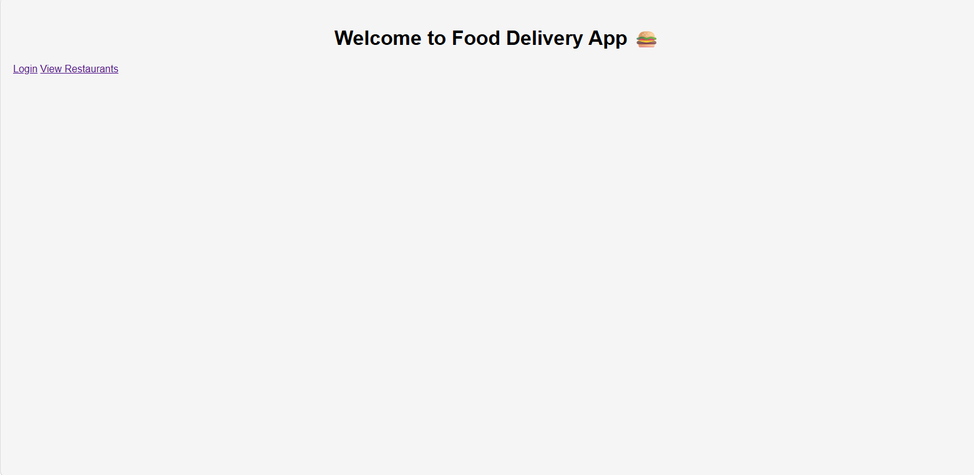

Restaurant Listing Interface

This page displays all available restaurants along with food images, ratings, and prices. Users can search for restaurants and place orders.

Restaurant Listing Screenshot

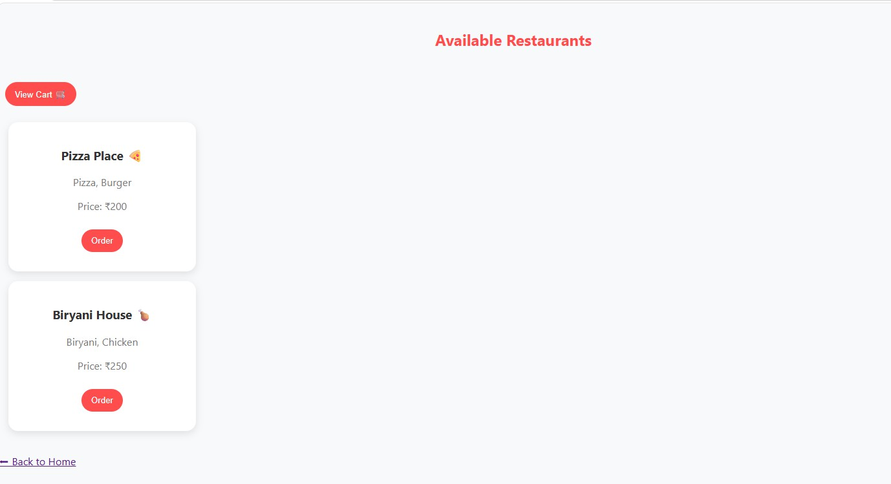

Cart Interface
The cart page displays selected food items, quantities, prices, and the total amount payable. Users can remove items before proceeding to payment.

Cart Page Screenshot

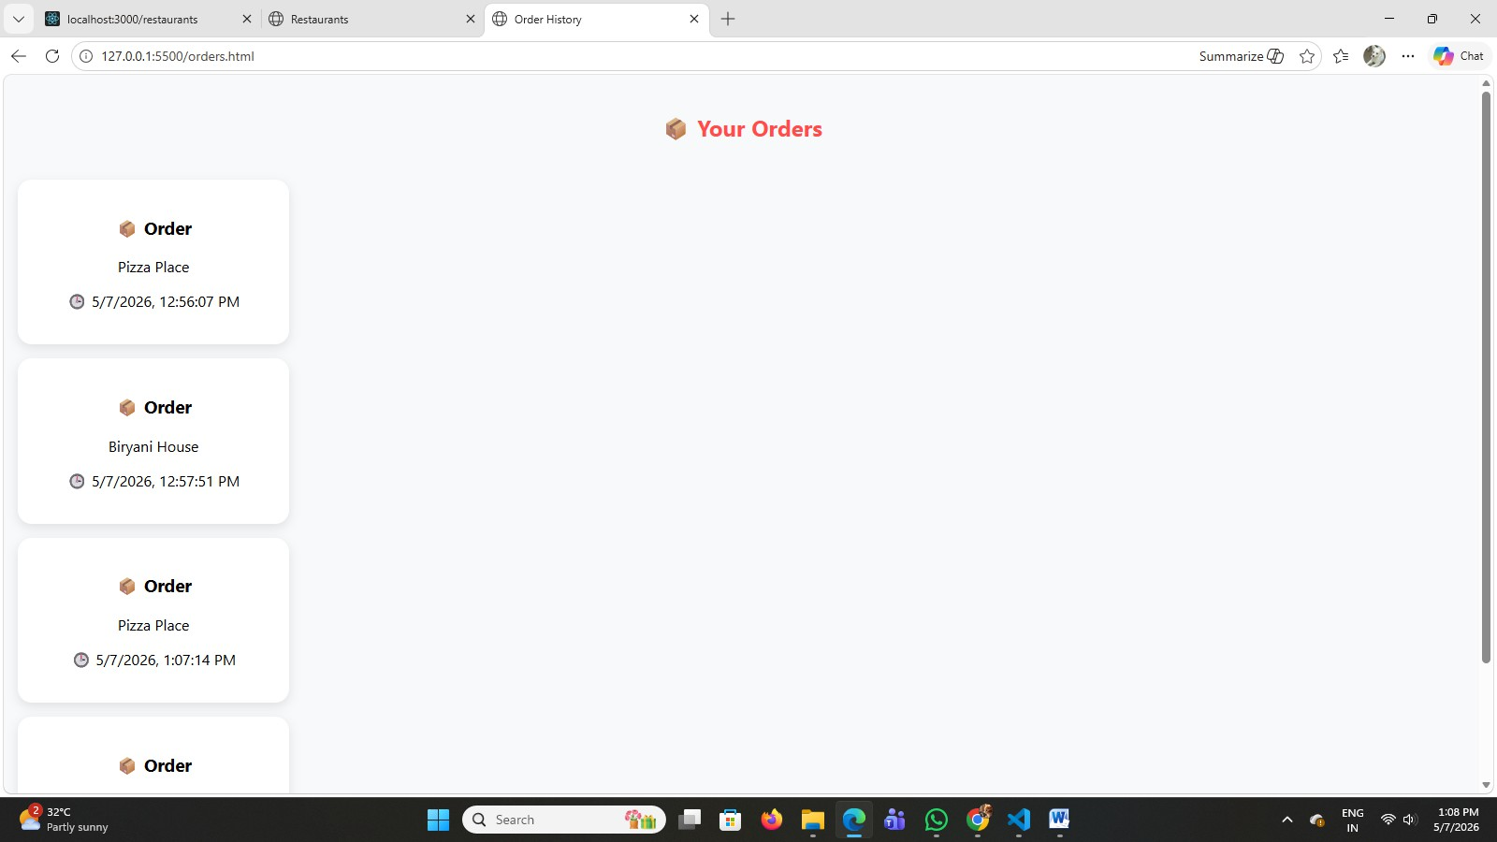

Payment Interface

The payment page allows users to enter payment details and complete their food order. Payment Page Screenshot

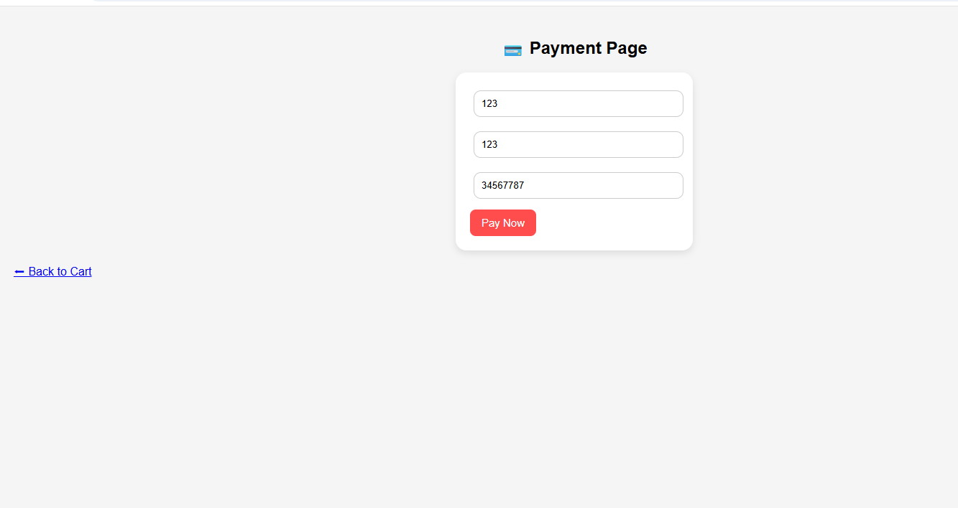

Order History Interface
This page displays previously placed orders along with order dates and details. Order History Screenshot
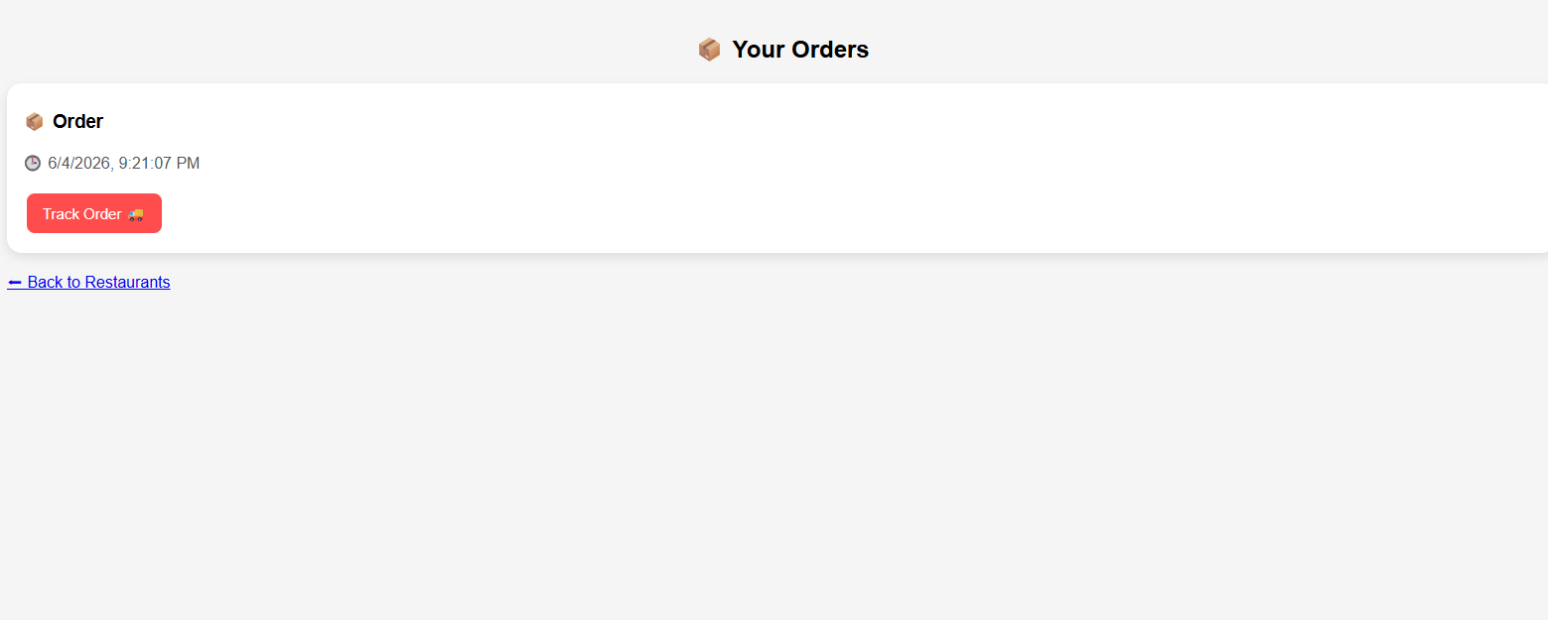

Order Tracking Interface
Users can track the status of their orders and view delivery updates and estimated arrival time (ETA).

Tracking Page Screenshot
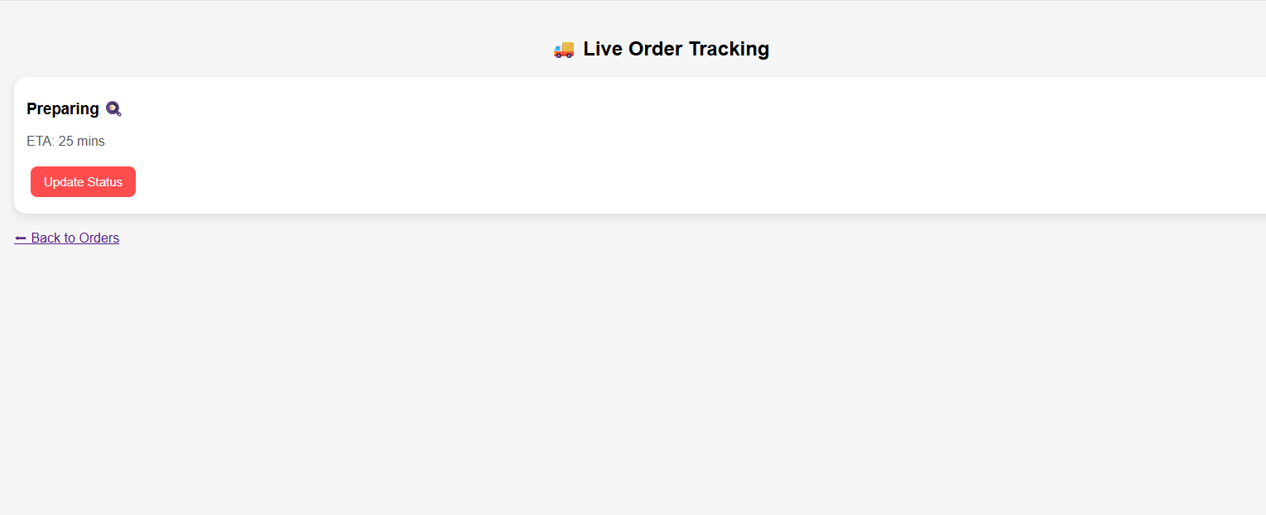

Favorites Interface
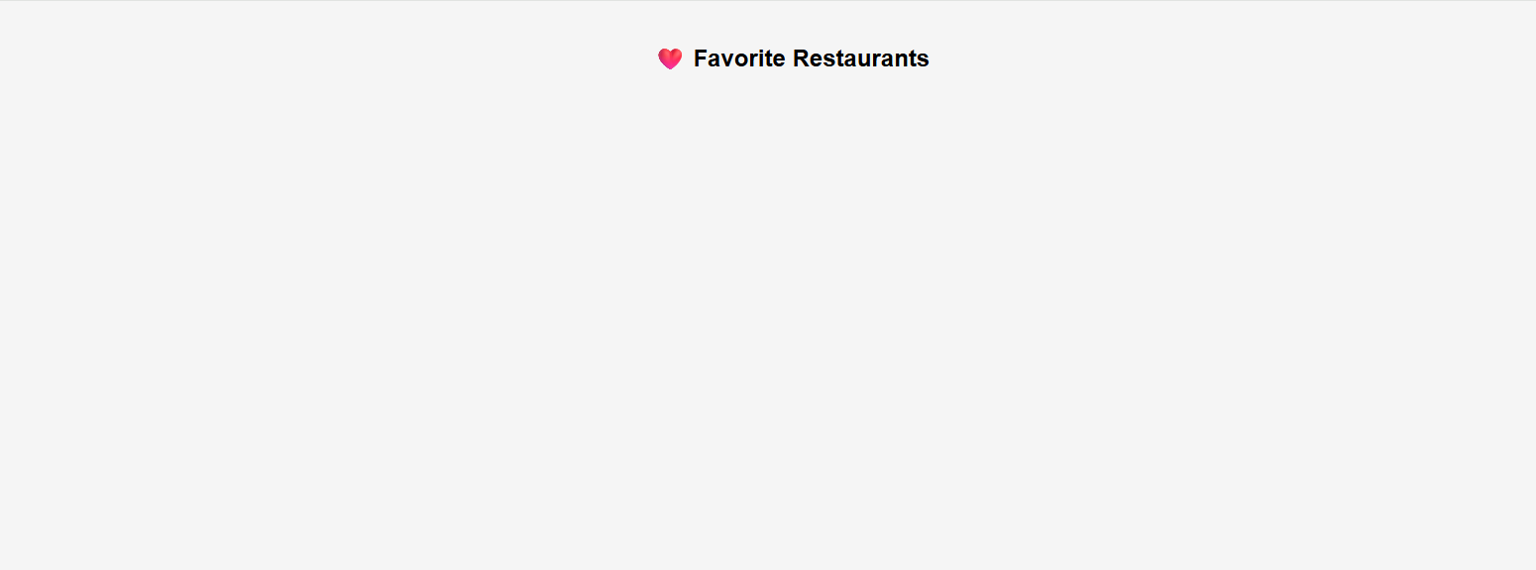
Customers can save their favorite restaurants for quick access in future visits. Favorites Page Screenshot

Restaurant Dashboard Interface

Restaurant owners can add food items, manage menus, and process customer orders through the dashboard.

The delivery interface allows delivery personnel to update pickup and delivery status.

Delivery Page Screenshot

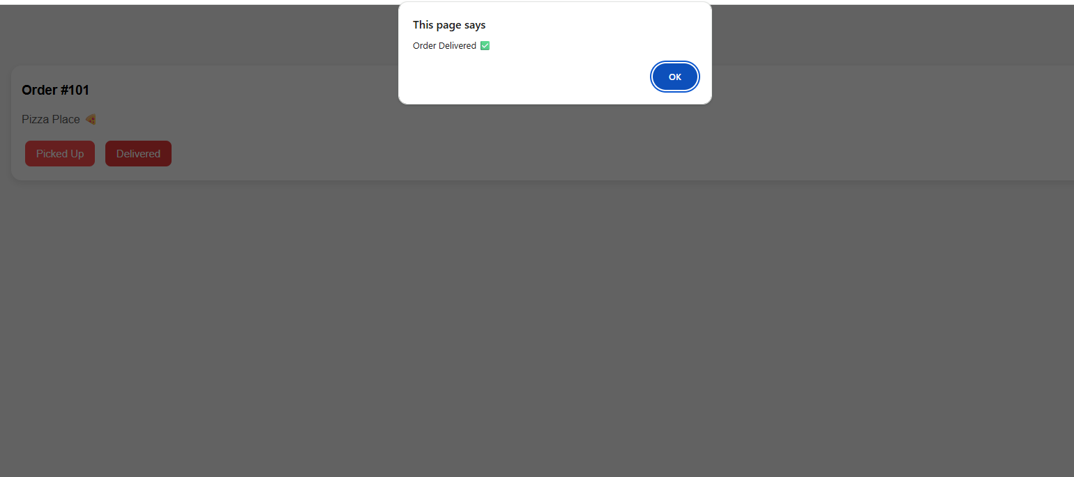

4.Performance Test

The performance testing phase was conducted to evaluate the reliability, responsiveness, and functionality of the Food Delivery Application. Since the application is web-based, important constraints such as response time, data storage, user interaction, and system reliability were considered during development.

    - Identified Constraints

      - Response Time – Restaurant data should load quickly without noticeable delays.
      - Data Storage – User cart, favorites, and order history should be stored efficiently using Local Storage.
      - System Reliability – The application should function correctly even after page refreshes.
      - User Experience – Navigation between pages should be smooth and intuitive.
      - Scalability – The design should support adding more restaurants and food items in the future.

    - Handling of Constraints

- Local Storage was used to maintain cart items, favorites, and order history.
- JavaScript functions were optimized to load data dynamically.
- Node.js and Express.js were used to provide fast API responses.
- Modular page design improved maintainability and scalability.
- Validation checks were added for login and payment forms.

    - 4.1 Test Plan / Test Cases

Test Case ID | Test Description | Expected Result | Status
TC-01 | User Login | User successfully logs in | Pass
TC-02 | Load Restaurants | Restaurant list displayed | Pass
TC-03 | Search Restaurant | Matching restaurants displayed | Pass
TC-04 | Add Item to Cart | Item added successfully | Pass
TC-05 | Remove Item from Cart | Item removed successfully | Pass
TC-06 | Payment Processing | Payment completed successfully | Pass

Test Case ID Test Description Expected Result Status TC-07 Order History Orders displayed correctly Pass TC-08 Add Favorite Restaurant saved to favorites Pass TC-09 Track Order Order status updated correctly Pass TC-10 Add Food Item Restaurant dashboard updates menu Pass
    - 4.2 Test Procedure

      - Start the Node.js server and launch the application.
      - Login using sample user credentials.
      - Browse available restaurants and search for specific restaurants.
      - Add food items to the cart and verify total calculation.
      - Proceed to payment and complete the order.
      - Verify that order details appear in Order History.
      - Test delivery tracking and status updates.
      - Add restaurants to Favorites and verify storage.
      - Use the Restaurant Dashboard to add new food items.
      - Refresh the application and confirm data persistence.

    - 4.3 Performance Outcome

The application performed successfully during testing. Restaurant data loaded quickly through the Express.js API. Cart operations, payment processing, favorites management, and order history functionality worked as expected. Delivery tracking and dashboard features responded correctly. Local Storage effectively preserved user data across page refreshes. Overall, the application met all functional requirements and provided a smooth user experience with reliable performance.

5.My learnings
This internship provided me with valuable practical experience in web application development and helped me understand the complete software development lifecycle. Through the development of the Food Delivery Application, I gained hands-on knowledge of frontend technologies such as HTML, CSS, and JavaScript, as well as backend technologies including Node.js and Express.js.

I learned how to design user-friendly interfaces, develop dynamic web pages, create APIs, manage application data, and implement features such as cart management, payment processing, order tracking, favorites, and restaurant dashboards. I also gained experience in debugging, testing, and improving application performance.

The internship enhanced my problem-solving skills, logical thinking, project planning, and documentation abilities. Additionally, I learned the importance of version control and project hosting through GitHub. These technical and professional skills will help me in future academic projects, internships, and software development careers.

Overall, this internship was a highly rewarding experience that improved my confidence in developing real-world web applications and strengthened my interest in full-stack development.

6.Future work scope

Although the Food Delivery Application successfully meets the project requirements, several enhancements can be implemented in the future to improve functionality and user experience.

Future improvements include:

      - Integration of a real database such as MongoDB or MySQL for permanent data storage.
      - User authentication with secure login and registration mechanisms.
      - Real-time order tracking using Google Maps API and GPS services.
      - Integration of online payment gateways such as Razorpay, Stripe, or PayPal.
      - Push notifications for order updates and promotional offers.
      - AI-based recommendation systems for personalized food suggestions.
      - Advanced analytics dashboards for restaurants to analyze customer behavior and sales performance.
      - Mobile application development for Android and iOS platforms.
      - Loyalty and reward programs for frequent customers.
      - Multi-language support and improved accessibility features.

These enhancements would make the application more scalable, secure, and suitable for deployment in real-world commercial environments.

