**PRACTICAL-6**

**Reading Data**

A SqlDataReader is a type that is good for reading data in the most efficient manner possible. You can not use it for writing data. SqlDataReaders are often described as fast-forward firehose-like streams of data. You can read from SqlDataReader objects in a forward-only sequential manner. Once you’ve read some data, you must save it because you will not be able to go back and read it again.

Program:

using System;

using System.Collections.Generic;

using System.Linq;

using System.Web;

using System.Web.UI;

using System.Web.UI.WebControls;

using System.Data;

using System.Data.SqlClient;

public partial class Default2 : System.Web.UI.Page

{

protected void Page_Load(object sender, EventArgs e)

{

SqlConnection con = new SqlConnection(“Data Source=.\\SQLEXPRESS;AttachDbFilename=”+Server.MapPath(“App_Data\\Database.mdf”)+”;Integrated Security=True;User Instance=True”);

SqlCommand cmd = new SqlCommand(“Select * from Table1”,con);

con.Open();

SqlDataReader dr = cmd.ExecuteReader();

GridView1.DataSource = dr;

GridView1.DataBind();

con.Close();

}

}

Output:

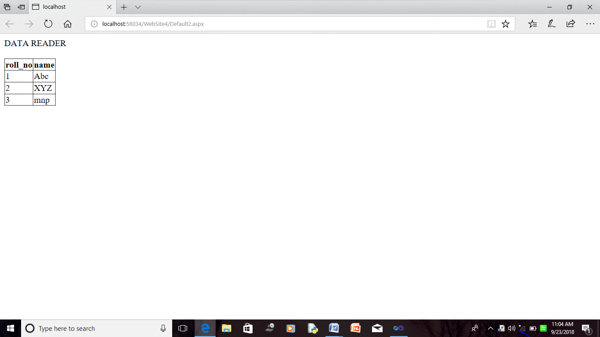

**PRACTICAL-7**

**Stored Procedure**

Program:

using System;

using System.Collections.Generic;

using System.Linq;

using System.Web;

using System.Web.UI;

using System.Web.UI.WebControls;

using System.Data;

using System.Data.SqlClient;

public partial class Default3 : System.Web.UI.Page

{

protected void Page_Load(object sender, EventArgs e)

{

SqlConnection con = new SqlConnection("Data Source=.\\SQLEXPRESS;AttachDbFilename=" + Server.MapPath("App_Data\\Database.mdf") + ";Integrated Security=True;User Instance=True");

SqlCommand cmd = new SqlCommand("StoredProcedure", con);

cmd.CommandType = CommandType.StoredProcedure;

SqlDataAdapter da = new SqlDataAdapter();

da.SelectCommand = cmd;

DataSet ds = new DataSet();

da.Fill(ds, "StoredProcedure");

this.GridView1.DataSource = ds;

this.GridView1.DataBind();

}

}

Output:

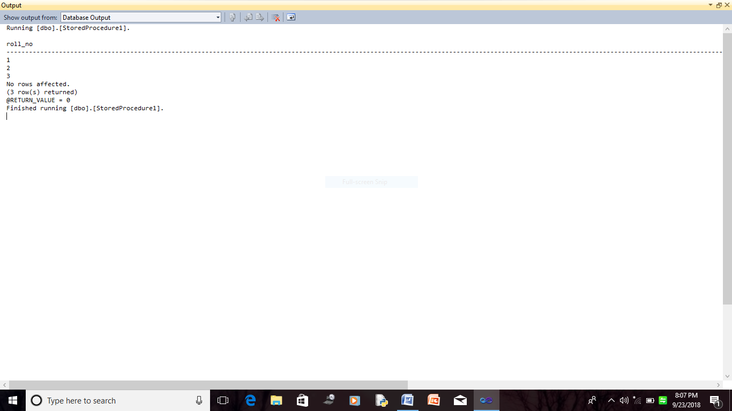

**PRACTICAL-8**

**Using Parameters with Queries**

Using a parameter in a query is as easy as creating a query that uses criteria. You can design a query to prompt you for one piece of information, such as a part number, or for more than one piece of information, such as two dates. For each parameter, a parameter query displays a separate dialog box that prompts you for a value for that parameter.

Program:

using System;

using System.Collections.Generic;

using System.Linq;

using System.Web;

using System.Web.UI;

using System.Web.UI.WebControls;

using System.Data;

using System.Data.SqlClient;

public partial class Default4 : System.Web.UI.Page

{

protected void Page_Load(object sender, EventArgs e)

{

SqlConnection con = new SqlConnection("Data Source=.\\SQLEXPRESS;AttachDbFilename=" + Server.MapPath("App_Data\\Database.mdf") + ";Integrated Security=True;User Instance=True");

con.Open();

}

protected void Button2_Click(object sender, EventArgs e)

{

TextBox1.Text = "";

TextBox2.Text = "";

}

protected void Button1_Click(object sender, EventArgs e)

{

try

{

SqlConnection con = new SqlConnection("Data Source=.\\SQLEXPRESS;AttachDbFilename=" + Server.MapPath("App_Data\\Database.mdf") + ";Integrated Security=True;User Instance=True");

con.Open();

SqlCommand com = new SqlCommand("insert into Table1 values(@a,@b)", con);

com.Parameters.AddWithValue("@a",TextBox1.Text);

com.Parameters.AddWithValue("@b", TextBox2.Text);

com.ExecuteNonQuery();

Response.Redirect("Default4.aspx");

}

catch(Exception ex)

{

Label3.Text = ex.Message;

}

}

}

Program: (.aspx file)

<%@ Page Language="C#" AutoEventWireup="true" CodeFile="Default4.aspx.cs" Inherits="Default4" %>

<!DOCTYPE html PUBLIC "-//W3C//DTD XHTML 1.0 Transitional//EN" "http://www.w3.org/TR/xhtml1/DTD/xhtml1-transitional.dtd">

<html xmlns="http://www.w3.org/1999/xhtml">

<head runat="server">

<title></title>

</head>

<body>

<form id="form1" runat="server">

<div></div>

<asp:Label ID="Label1" runat="server" Text="Roll_No"></asp:Label>

<asp:TextBox ID="TextBox1" runat="server" style="margin-left: 31px"></asp:TextBox>

<p>

<asp:Label ID="Label2" runat="server" Text="Name"></asp:Label>

<asp:TextBox ID="TextBox2" runat="server" style="margin-left: 44px"></asp:TextBox>

</p>

<asp:Button ID="Button1" runat="server" onclick="Button1_Click" Text="Insert"

Width="64px" />

<asp:Button ID="Button2" runat="server" onclick="Button2_Click"

style="margin-left: 36px" Text="Clear" Width="62px" />

<p>

<asp:Label ID="Label3" runat="server"></asp:Label>

</p>

<asp:GridView ID="GridView1" runat="server" AutoGenerateColumns="False"

DataSourceID="SqlDataSource1">

<Columns>

<asp:BoundField DataField="roll_no" HeaderText="roll_no"

SortExpression="roll_no" />

<asp:BoundField DataField="name" HeaderText="name" SortExpression="name" />

</Columns>

</asp:GridView>

<asp:SqlDataSource ID="SqlDataSource1" runat="server"

ConnectionString="<%$ ConnectionStrings:ConnectionString %>"

SelectCommand="SELECT * FROM [Table1]"></asp:SqlDataSource>

</form>

</body>

</html>

Output:

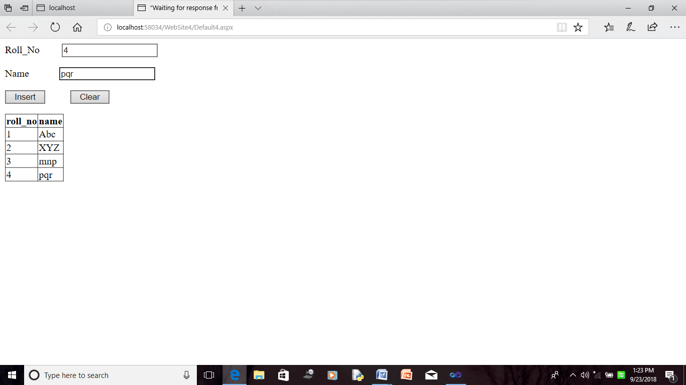

**PRACTICAL-9**

**Insert,Update,Delete Queries**

Program: (apx.cs file)

using System;

using System.Collections.Generic;

using System.Linq;

using System.Web;

using System.Web.UI;

using System.Web.UI.WebControls;

using System.Data;

using System.Data.SqlClient;

public partial class Default5 : System.Web.UI.Page

{

protected void Page_Load(object sender, EventArgs e)

{

SqlConnection con = new SqlConnection("Data Source=.\\SQLEXPRESS;AttachDbFilename=" + Server.MapPath("App_Data\\Database.mdf") + ";Integrated Security=True;User Instance=True");

con.Open();

}

protected void Button1_Click(object sender, EventArgs e)

{

try

{SqlConnection con = new SqlConnection("Data Source=.\\SQLEXPRESS;AttachDbFilename=" + Server.MapPath("App_Data\\Database.mdf") + ";Integrated Security=True;User Instance=True");

con.Open();

SqlCommand com = new SqlCommand("insert into Table1 values(@a,@b)", con);

com.Parameters.AddWithValue("@a", TextBox1.Text);

com.Parameters.AddWithValue("@b", TextBox2.Text);

com.ExecuteNonQuery();

Response.Redirect("Default5.aspx");

Label4.Visible = true;

Label4.Text = "Inserted..";

}

catch (Exception ex)

{

Label3.Text = ex.Message;

}

}

protected void Button2_Click(object sender, EventArgs e)

{

try

{

SqlConnection con = new SqlConnection("Data Source=.\\SQLEXPRESS;AttachDbFilename=" + Server.MapPath("App_Data\\Database.mdf") + ";Integrated Security=True;User Instance=True");

con.Open();

SqlCommand com = new SqlCommand("delete from Table1 where roll_no=' "+ TextBox1.Text+ " ';" ,con);

com.ExecuteNonQuery();

GridView1.DataBind();

con.Close();

Label4.Visible = true;

Label4.Text = "Deleted..";

TextBox1.Text = "";

TextBox2.Text = "";

}

catch (Exception ex)

{

Label3.Text = ex.Message;

}

}

protected void Button3_Click(object sender, EventArgs e)

{

try

{

SqlConnection con = new SqlConnection("Data Source=.\\SQLEXPRESS;AttachDbFilename=" + Server.MapPath("App_Data\\Database.mdf") + ";Integrated Security=True;User Instance=True");

con.Open();

SqlCommand com = new SqlCommand("update Table1 set name=@a1 where roll_no= @a2", con);

com.Parameters.AddWithValue("a1", TextBox2.Text);

com.Parameters.AddWithValue("a2", Convert.ToInt16(TextBox1.Text));

com.ExecuteNonQuery();

GridView1.DataBind();

con.Close();

Label4.Visible = true;

Label4.Text = "Updated..";

TextBox1.Text = "";

TextBox2.Text = "";

}

catch (Exception ex)

{

Label3.Text = ex.Message;

}}}

Program: (.aspx file)

<%@ Page Language="C#" AutoEventWireup="true" CodeFile="Default5.aspx.cs" Inherits="Default5" %>

<!DOCTYPE html PUBLIC "-//W3C//DTD XHTML 1.0 Transitional//EN" "http://www.w3.org/TR/xhtml1/DTD/xhtml1-transitional.dtd">

<html xmlns="http://www.w3.org/1999/xhtml">

<head runat="server">

<title></title>

</head>

<body>

<form id="form1" runat="server">

<div>

</div>

<asp:Label ID="Label1" runat="server" Text="Roll_No"></asp:Label>

<asp:TextBox ID="TextBox1" runat="server" style="margin-left: 47px"></asp:TextBox>

<p>

<asp:Label ID="Label2" runat="server" Text="Name"></asp:Label>

<asp:TextBox ID="TextBox2" runat="server" style="margin-left: 60px"></asp:TextBox>

</p>

<asp:Button ID="Button1" runat="server" onclick="Button1_Click" Text="Insert"

Width="59px" />

<asp:Button ID="Button3" runat="server" onclick="Button3_Click"

style="margin-left: 38px" Text="Update" Width="70px" />

<asp:Button ID="Button2" runat="server" onclick="Button2_Click"

style="margin-left: 36px" Text="Delete" Width="62px" />

<p>

<asp:Label ID="Label3" runat="server"></asp:Label>

<asp:Label ID="Label4" runat="server"></asp:Label>

</p>

<asp:GridView ID="GridView1" runat="server" AutoGenerateColumns="False"

DataSourceID="SqlDataSource1" style="margin-top: 35px">

<Columns>

<asp:CommandField ShowSelectButton="True" />

<asp:BoundField DataField="roll_no" HeaderText="roll_no"

SortExpression="roll_no" />

<asp:BoundField DataField="name" HeaderText="name" SortExpression="name" />

</Columns>

</asp:GridView>

<asp:SqlDataSource ID="SqlDataSource1" runat="server"

ConnectionString="<%$ ConnectionStrings:ConnectionString %>"

SelectCommand="SELECT * FROM [Table1]"></asp:SqlDataSource>

</form>

</body>

</html>

Output:

**Insertion**

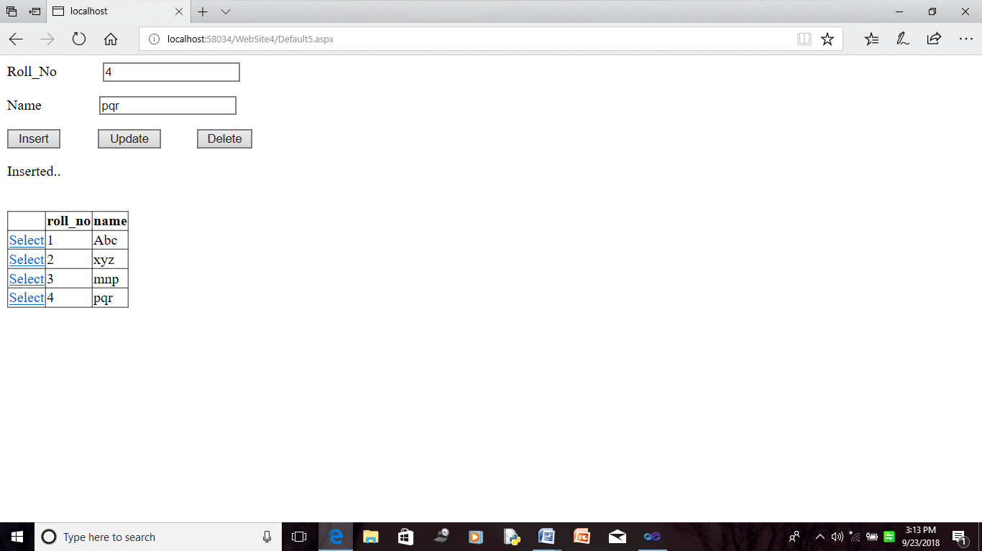

**Updation**

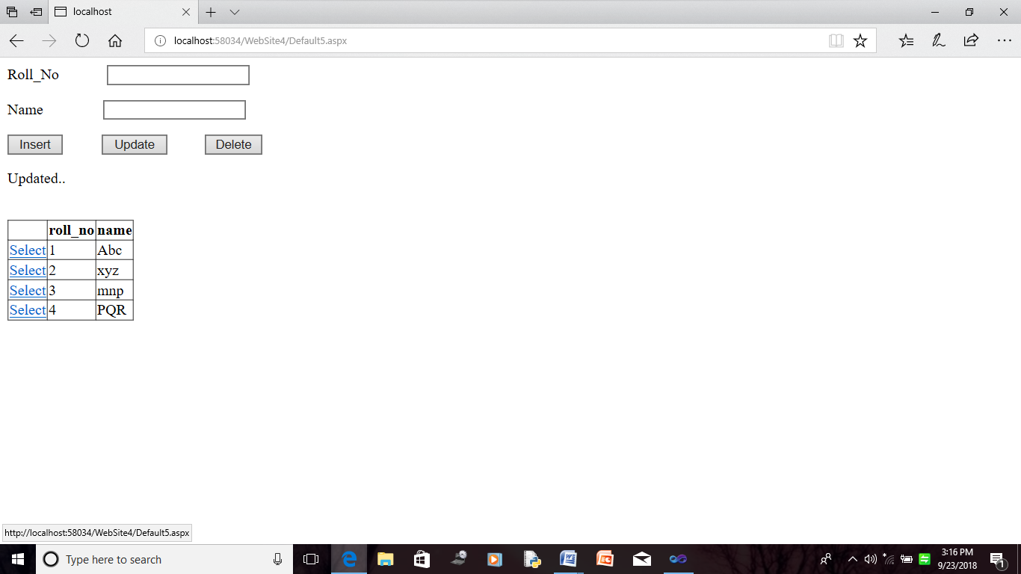

**Deletion**

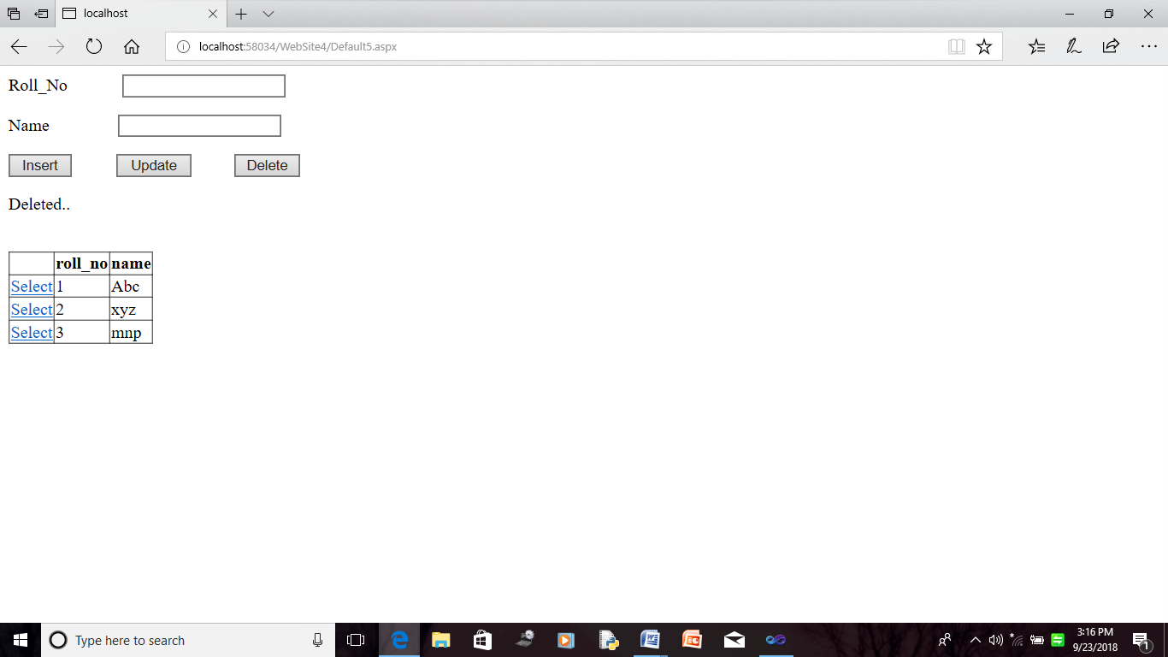s