LAB ASSIGNMENT – 11
Task Description #1 – Stack Implementation
Task: Use AI to generate a Stack class with push, pop, peek, and is_empty
methods.
Sample Input Code:
class Stack:
pass
Expected Output:
• A functional stack implementation with all required methods and
docstrings.
Use this prompt:
Prompt:
"Generate a Python `Stack` class using a list to store elements. Implement the methods `push()`, `pop()`, `peek()`, and `is_empty()`. Add clear docstrings for the class and every method. Handle popping or peeking from an empty stack appropriately. Include a short example demonstrating all four methods."
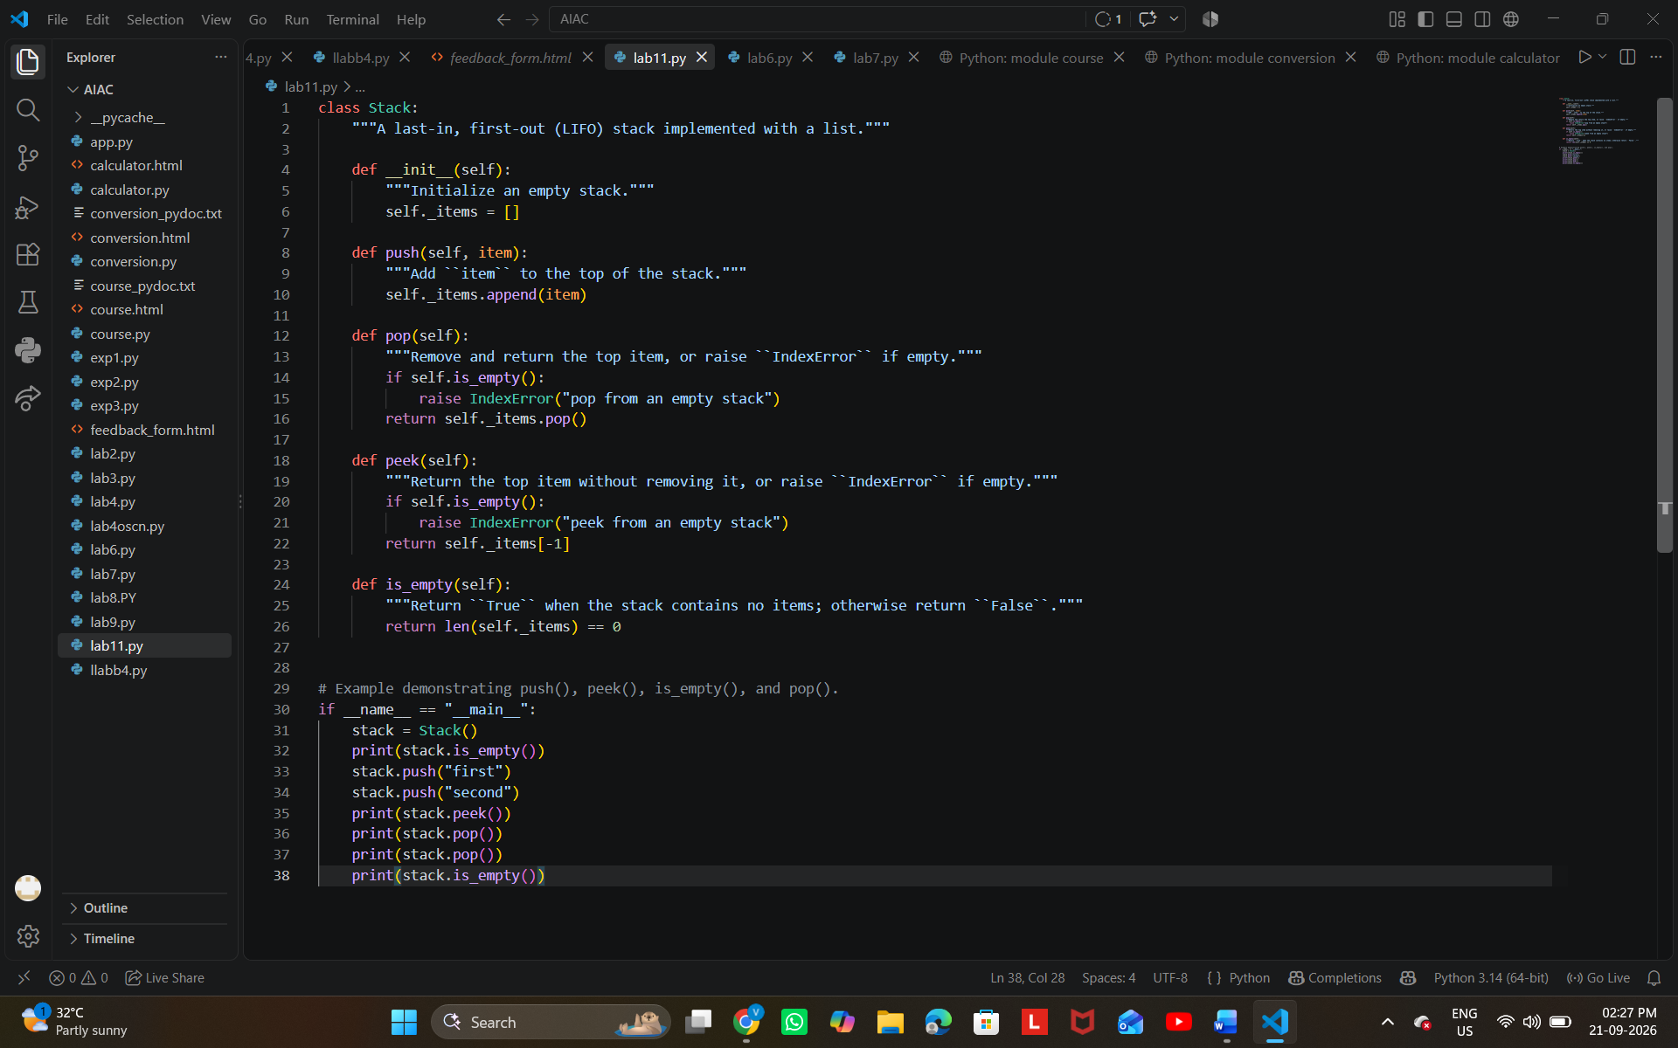

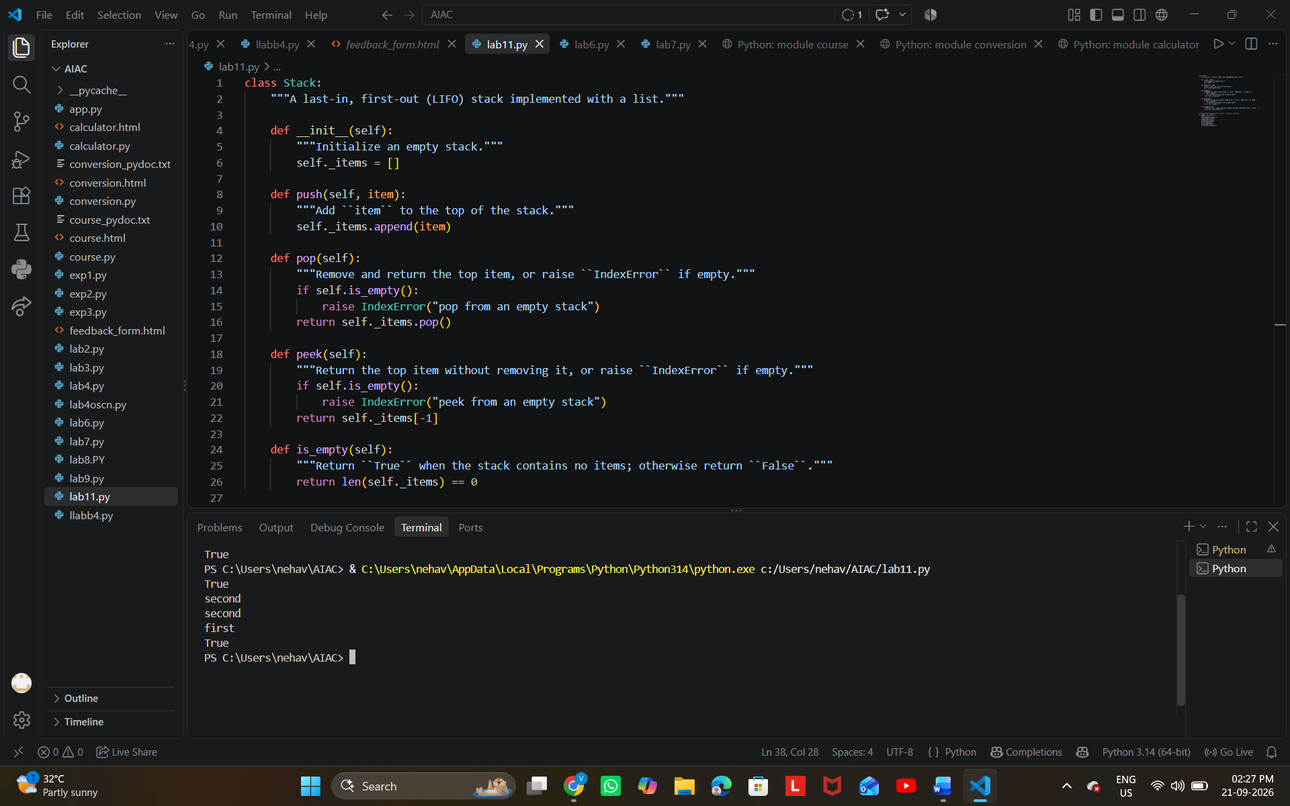
Task Description #2 – Queue Implementation
Task: Use AI to implement a Queue using Python lists.
Sample Input Code:
class Queue:
pass
Expected Output:
• FIFO-based queue class with enqueue, dequeue, peek, and size
methods.
Prompt:
"Write a Python program to implement a Queue class using a list following the FIFO (First-In, First-Out) principle. Include `__init__()`, `enqueue()`, `dequeue()`, `peek()`, `size()`, and `is_empty()` methods with docstrings. Handle empty-queue cases and demonstrate the queue by adding 10, 20, and 30, then display the queue, front element, removed element, and queue size."

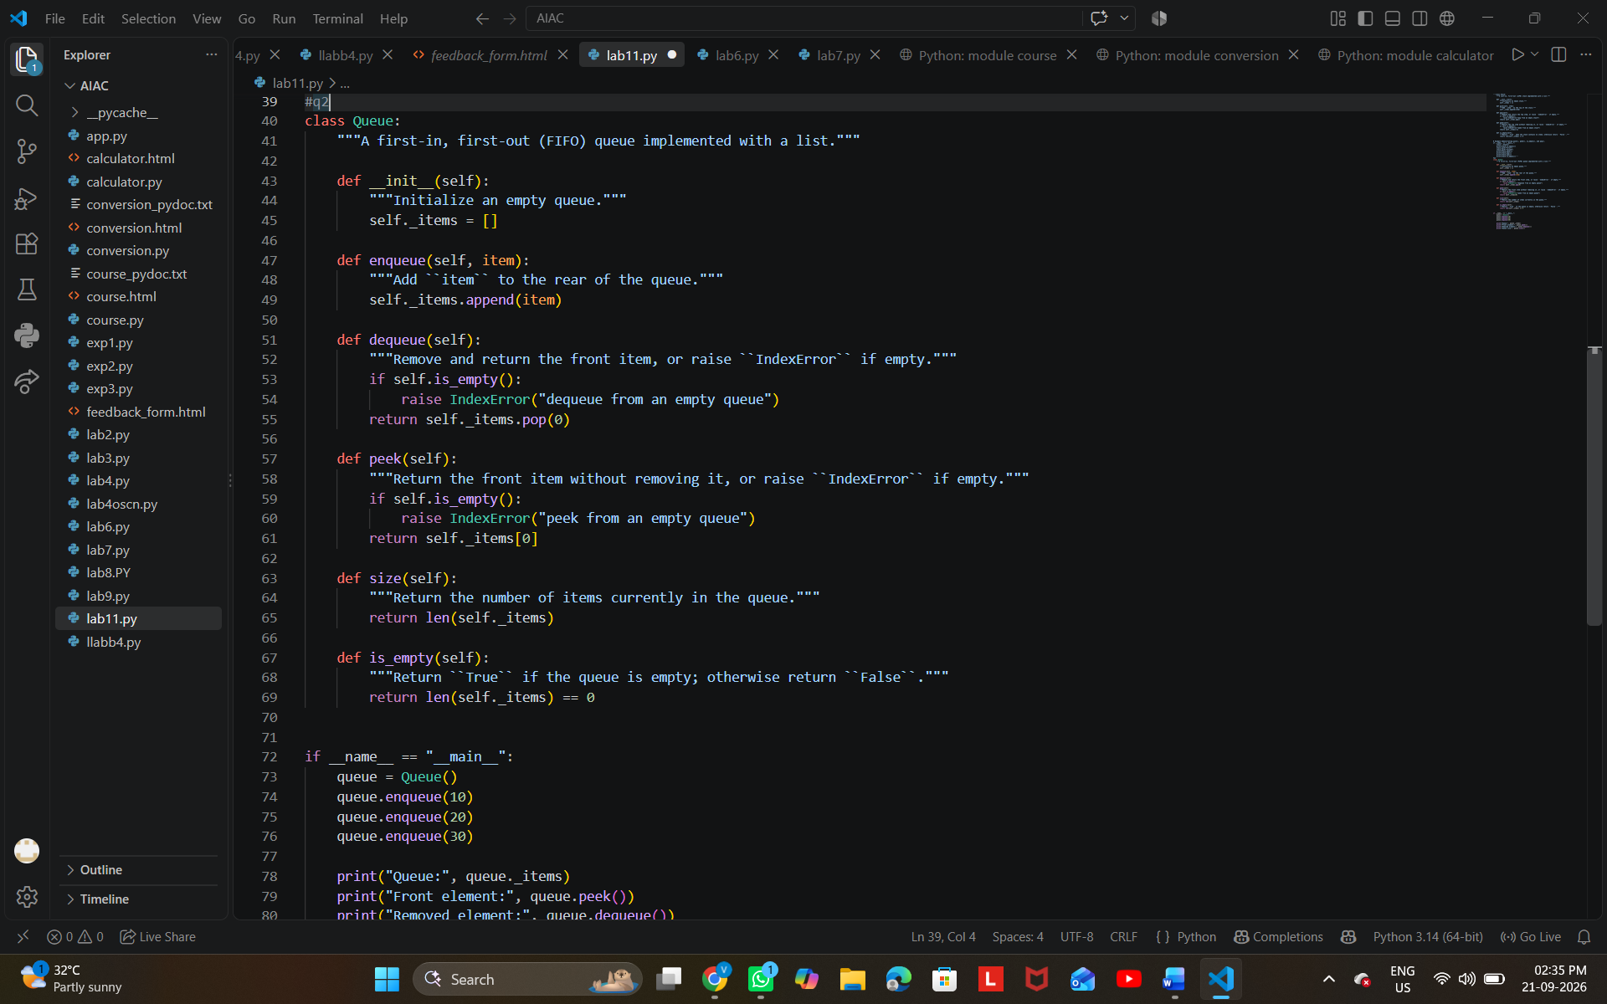
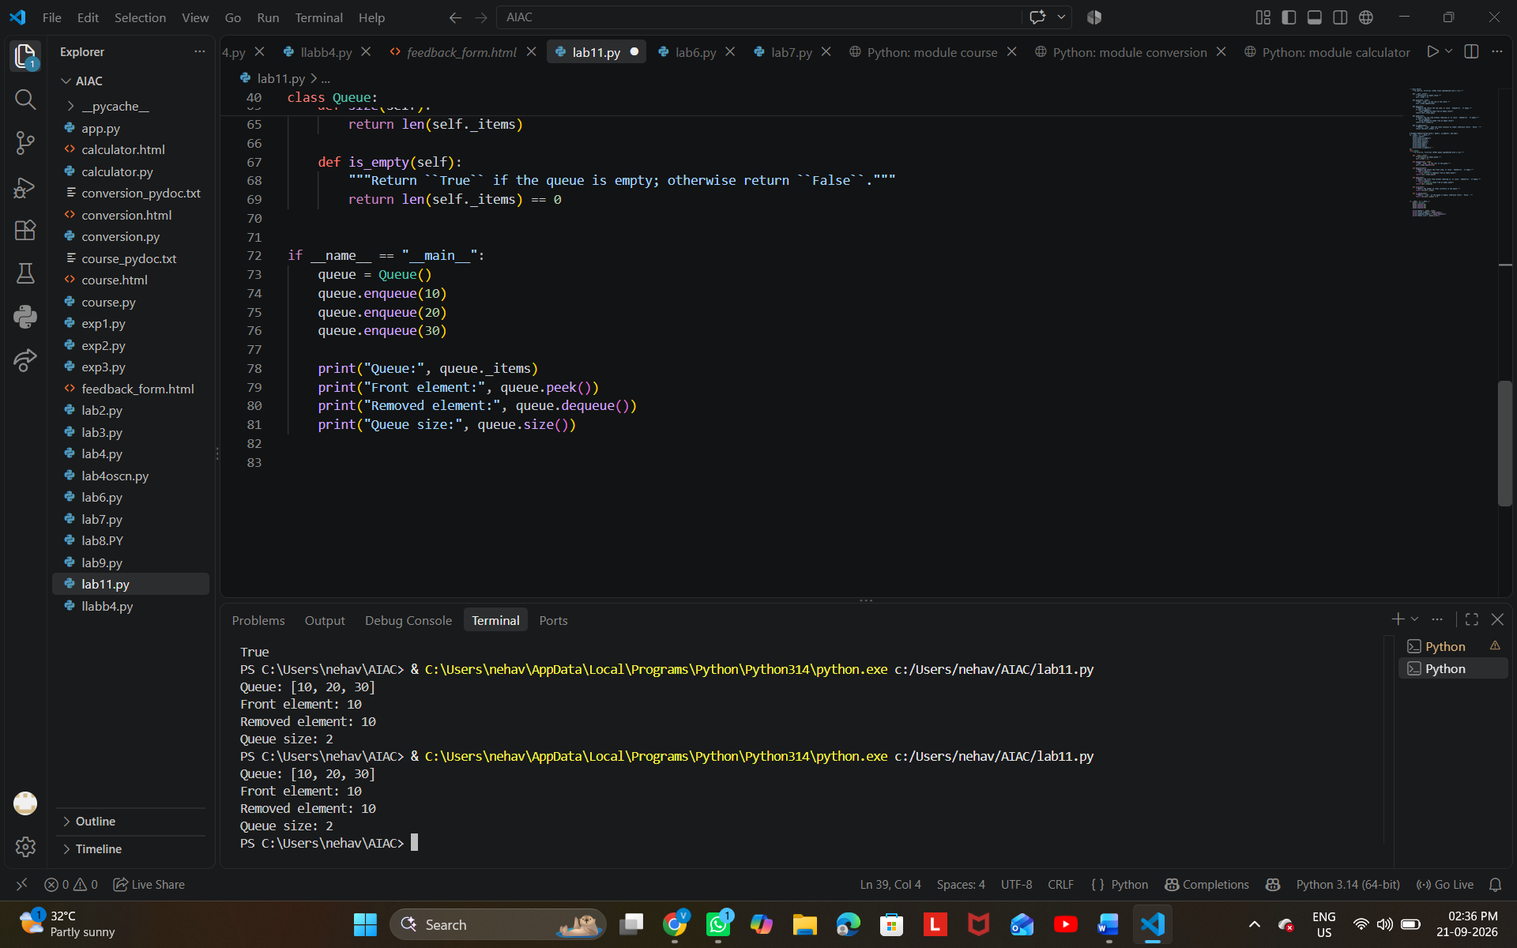

Task Description #3 – Linked List
Task: Use AI to generate a Singly Linked List with insert and display
methods.
Sample Input Code:
class Node:
pass
Week6 -
Monday
class LinkedList:
pass
Expected Output:
• A working linked list implementation with clear method
documentation.
**Prompt:**
"Generate a Python program to implement a Singly Linked List using two classes: `Node` and `LinkedList`. The `Node` class should store data and a reference to the next node. The `LinkedList` class should include `insert()` and `display()` methods. Add clear docstrings and comments explaining the code. Include an example that inserts a few elements and displays the linked list."
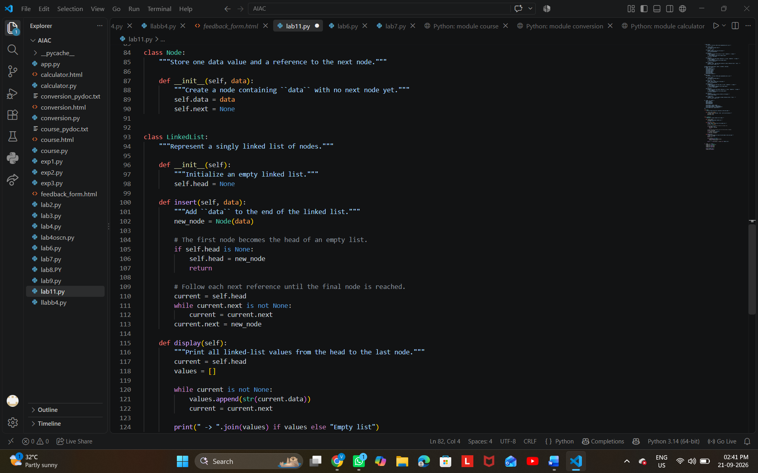
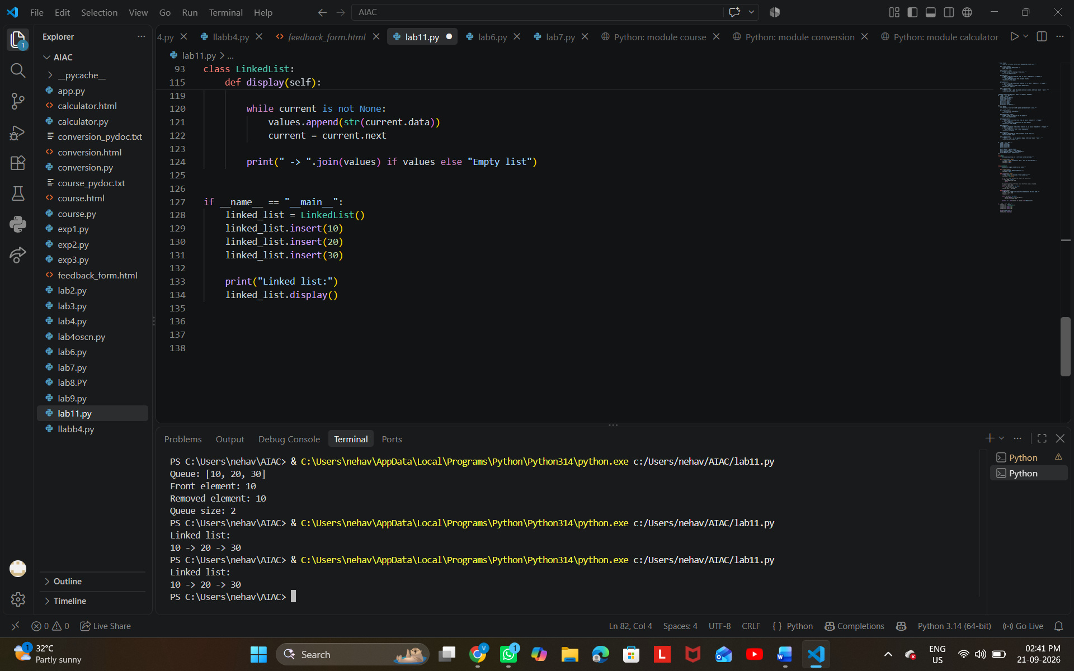
Task Description #4 – Binary Search Tree (BST)
Task: Use AI to create a BST with insert and in-order traversal methods.
Sample Input Code:
class BST:
pass
Expected Output:
• BST implementation with recursive insert and traversal methods.
**Prompt:**
"Generate a Python program to implement a Binary Search Tree (BST) using a `BST` class. Include a recursive `insert()` method to add elements and a recursive `inorder()` traversal method to display the elements in sorted order. Handle the root node properly and include clear comments/docstrings. Provide a short example
demonstrating insertion and in-order traversal."

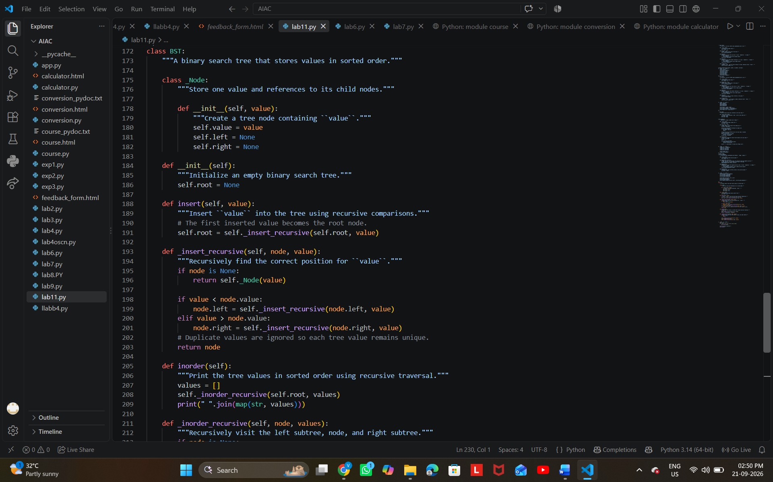
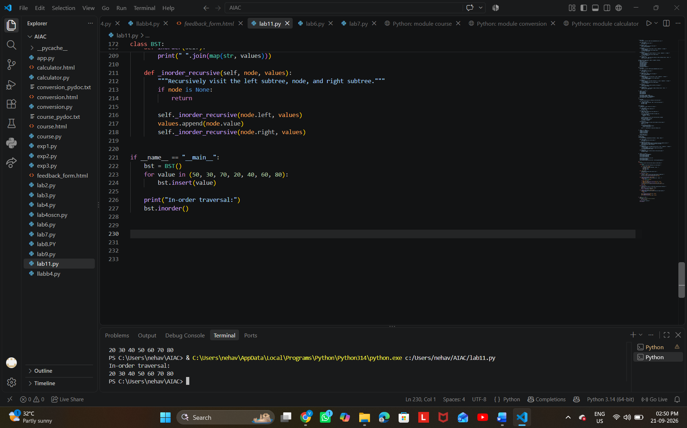

Task Description #5 – Priority Queue
Task: Use AI to implement a priority queue using Python’s heapq
module.
Sample Input Code:
class PriorityQueue:
pass
Expected Output:
• Implementation with enqueue (priority), dequeue (highest priority),
and display methods.
prompt
Implement a Python Priority Queue using `heapq` with `enqueue(priority)`, `dequeue()` for the highest-priority item, and `display()` methods. Use the starter class `PriorityQueue: pass`. Include simple comments, method documentation, and sample input/output.
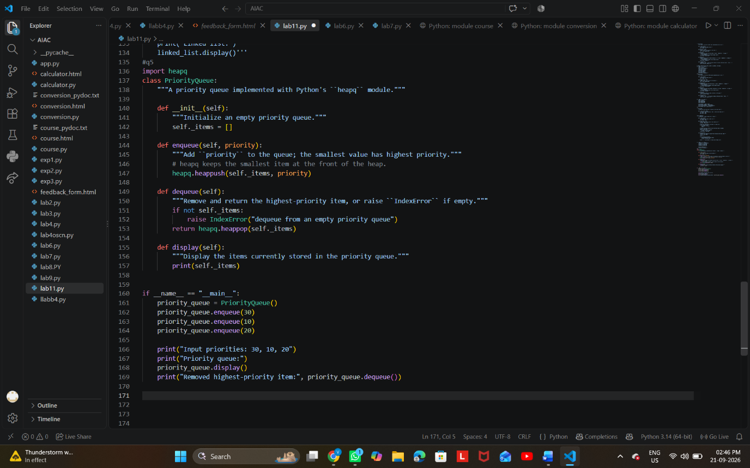

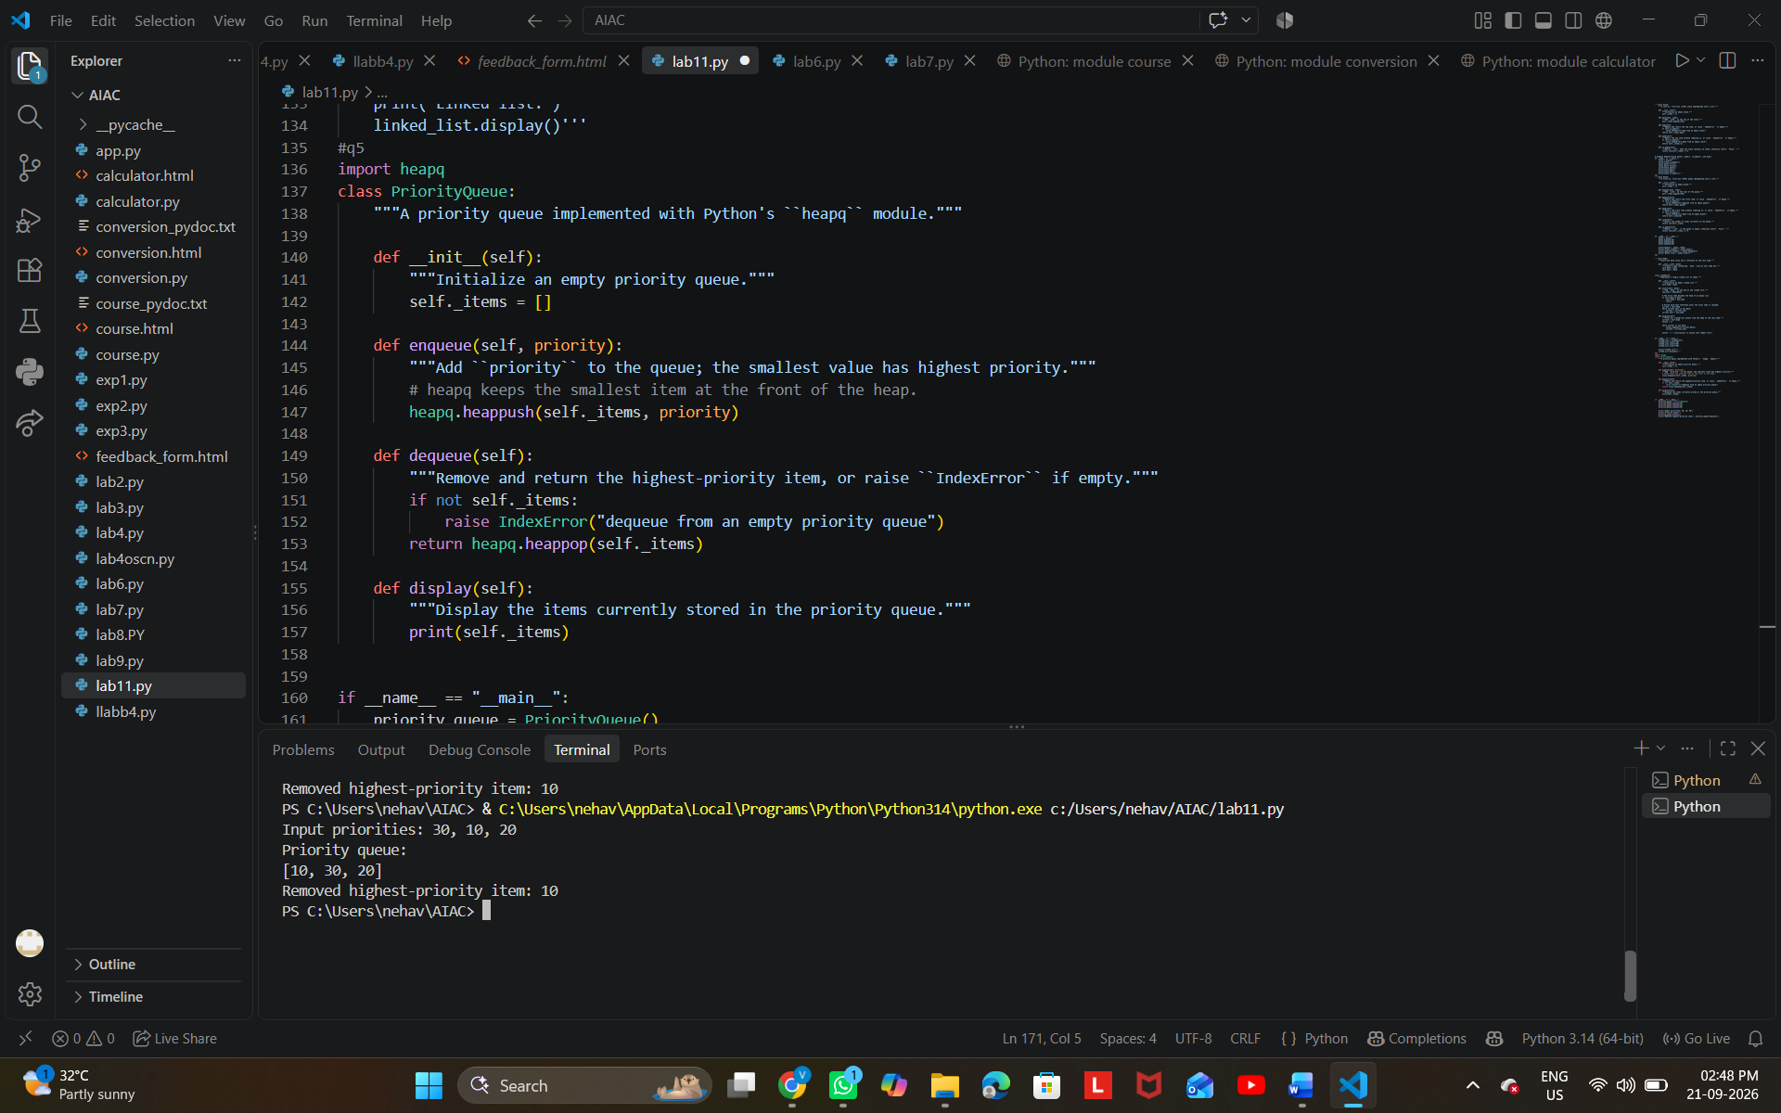
Task Description #6 – Deque
Task: Use AI to implement a double-ended queue using
collections.deque.
Sample Input Code:
class DequeDS:
pass
Expected Output:
• Insert and remove from both ends with docstrings.
PROMPT:-
Implement a Python Deque using collections.deque with methods to insert and remove elements from both ends. Use the starter class DequeDS: pass. Include simple docstrings, comments, and sample input/output.

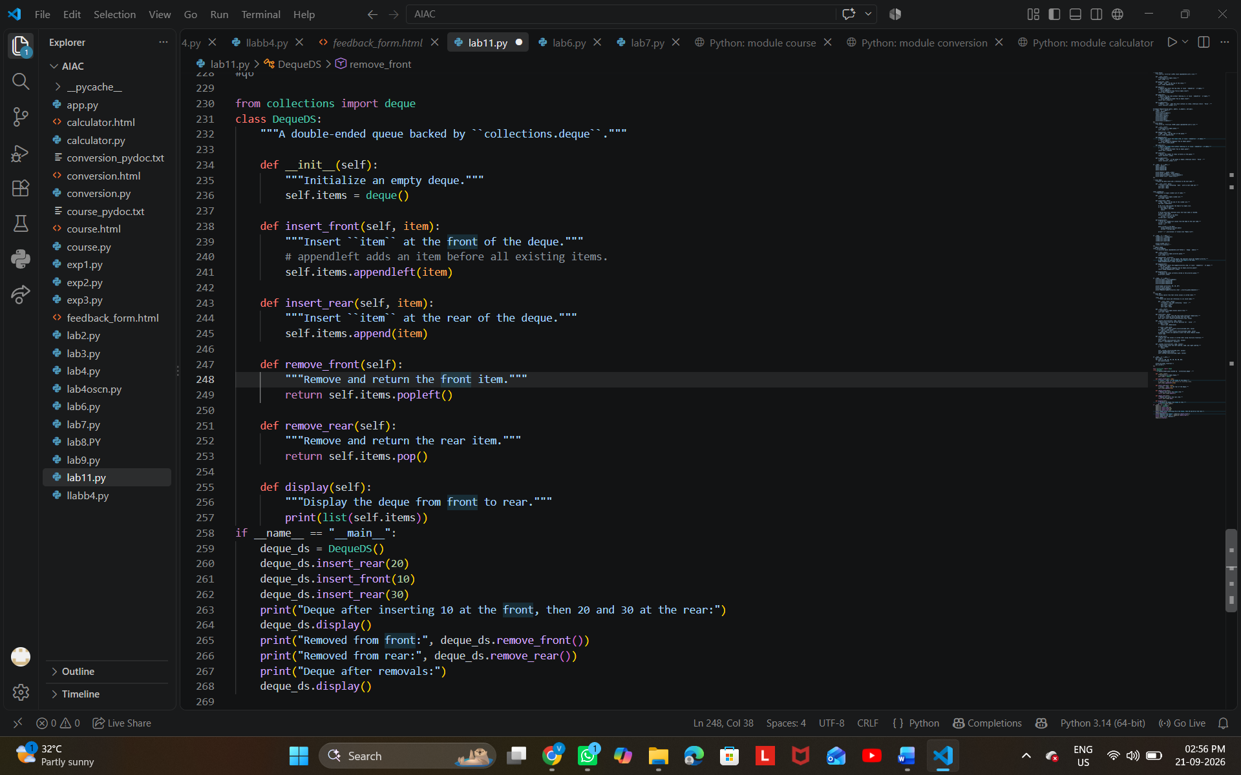
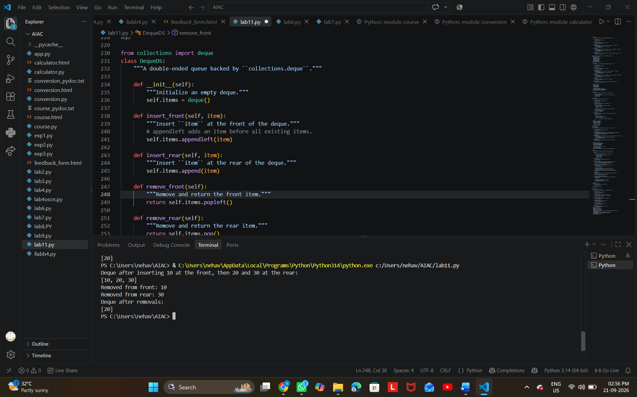

Task Description #7 Real-Time Application Challenge – Choose the
Right Data Structure
Scenario:
Your college wants to develop a Campus Resource Management System
that handles:
1. Student Attendance Tracking – Daily log of students
entering/exiting the campus.
2. Event Registration System – Manage participants in events with
quick search and removal.
3. Library Book Borrowing – Keep track of available books and their
due dates.

4. Bus Scheduling System – Maintain bus routes and stop
connections.
5. Cafeteria Order Queue – Serve students in the order they arrive.
Student Task:
• For each feature, select the most appropriate data structure from
the list below:
o Stack
o Queue
o Priority Queue
o Linked List
o Binary Search Tree (BST)
o Graph
o Hash Table
o Deque
• Justify your choice in 2–3 sentences per feature.
• Implement one selected feature as a working Python program with
AI-assisted code generation.
Expected Output:
• A table mapping feature → chosen data structure → justification.
• A functional Python program implementing the chosen feature
with comments and docstrings.
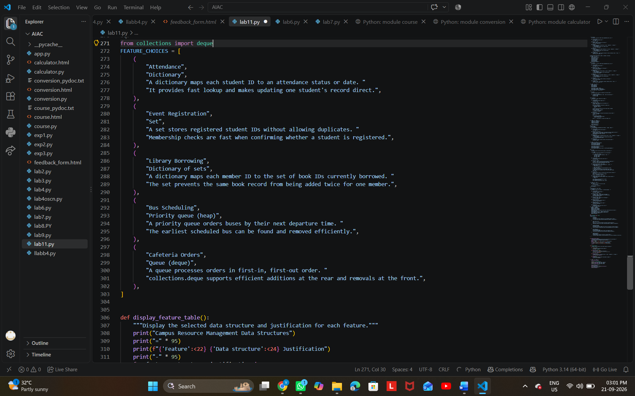
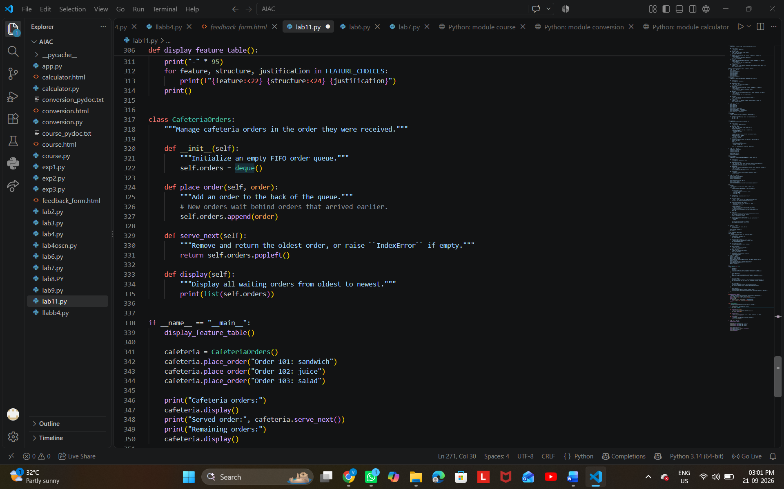

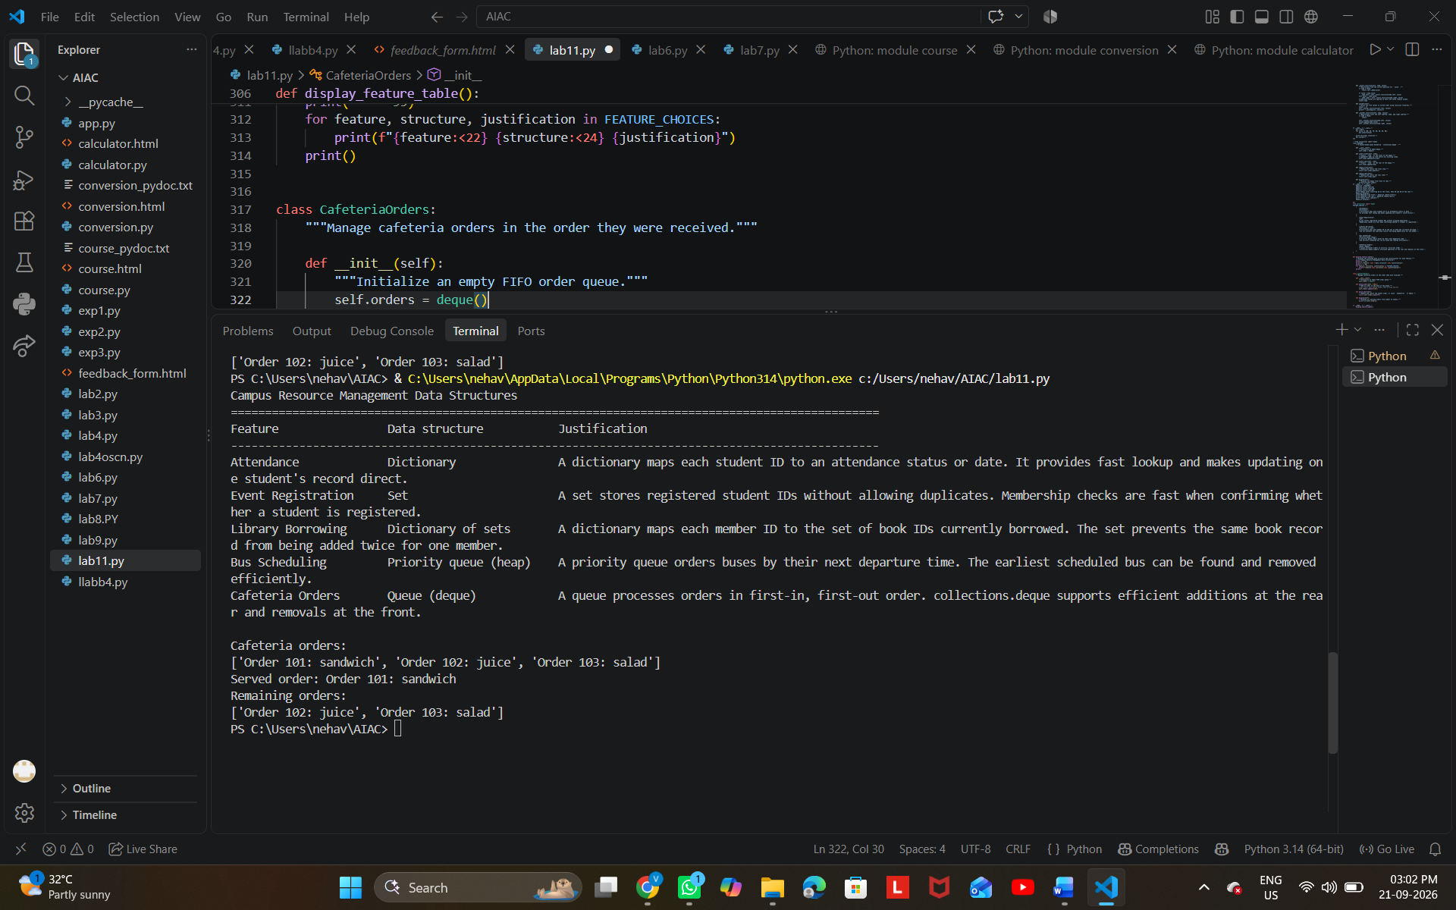
Task Description #8: Smart E-Commerce Platform – Data Structure
Challenge
An e-commerce company wants to build a Smart Online Shopping System
with:
1. Shopping Cart Management – Add and remove products
dynamically.
2. Order Processing System – Orders processed in the order they are
placed.
3. Top-Selling Products Tracker – Products ranked by sales count.

4. Product Search Engine – Fast lookup of products using product ID.
5. Delivery Route Planning – Connect warehouses and delivery
locations.
Student Task:
• For each feature, select the most appropriate data structure from
the list below:
o Stack
o Queue
o Priority Queue
o Linked List
o Binary Search Tree (BST)
o Deque
• Justify your choice in 2–3 sentences per feature.
• Implement one selected feature as a working Python program with
AI-assisted code generation.
Expected Output:
• A table mapping feature → chosen data structure → justification.
• A functional Python program implementing the chosen feature
with comments and docstrings.
PROMPT:-
Use AI to select the most appropriate data structure for each e-commerce feature: Shopping Cart, Order Processing, Top-Selling Products, Product Search, and Delivery Route Planning. Use only Stack, Queue, Priority Queue, Linked List, BST, and Deque. Create a table with a 2–3 sentence justification for each choice, then implement one selected feature in Python with comments, docstrings, and working code.
