Task Description #1 (Privacy & Security in File Handling)
Task: Use an AI tool to generate a Python script that stores user data (name, email, password) in a file.
Analyze: Check if the AI stores sensitive data in plain text or without encryption.
Expected Output:
Identified privacy risks.
Revised version with encrypted password storage (e.g., hashing).

PROMPT:- Create a Python program that stores a user’s name, email, and password in a file. Analyze the privacy and security risks of storing the password in plain text, then provide a revised version that securely stores the password using hashing and explain the improvements.
Code:-
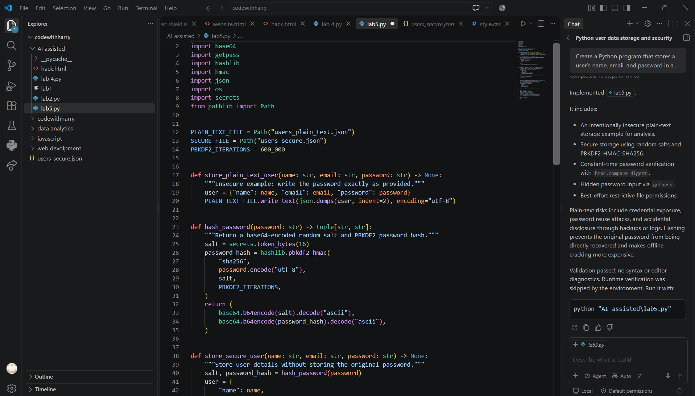
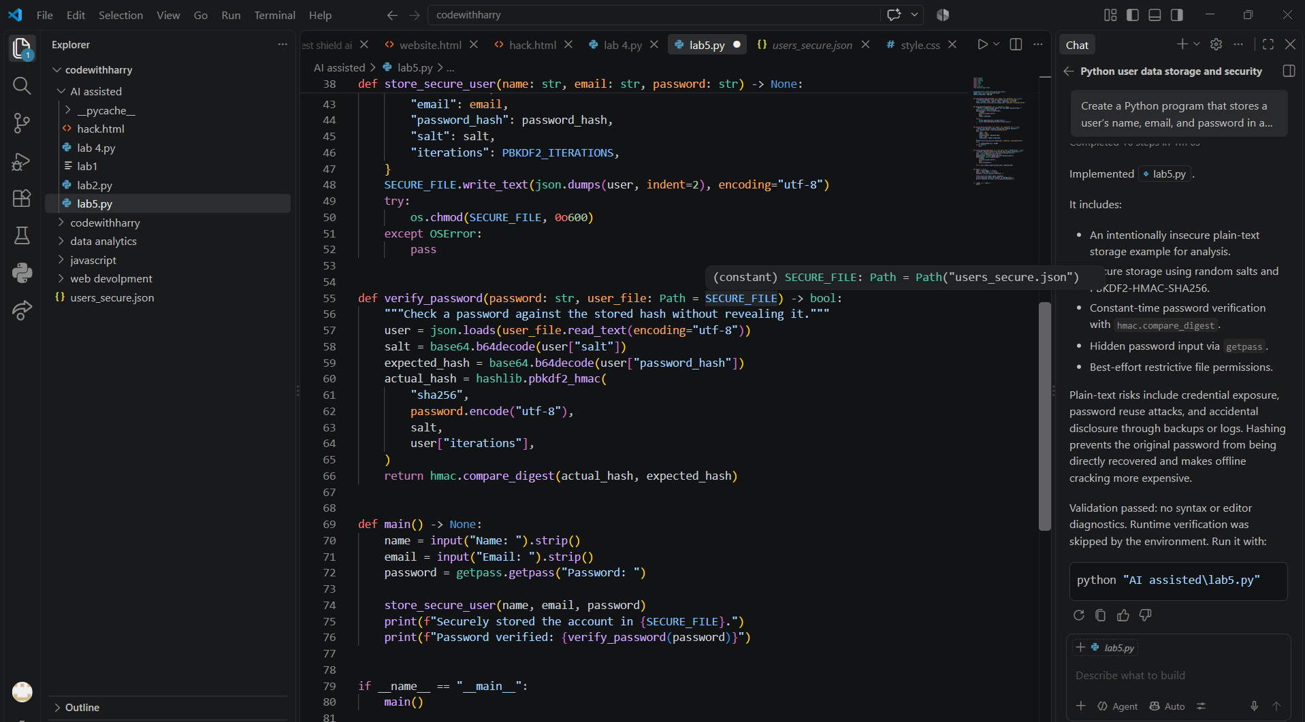
RESULT:-
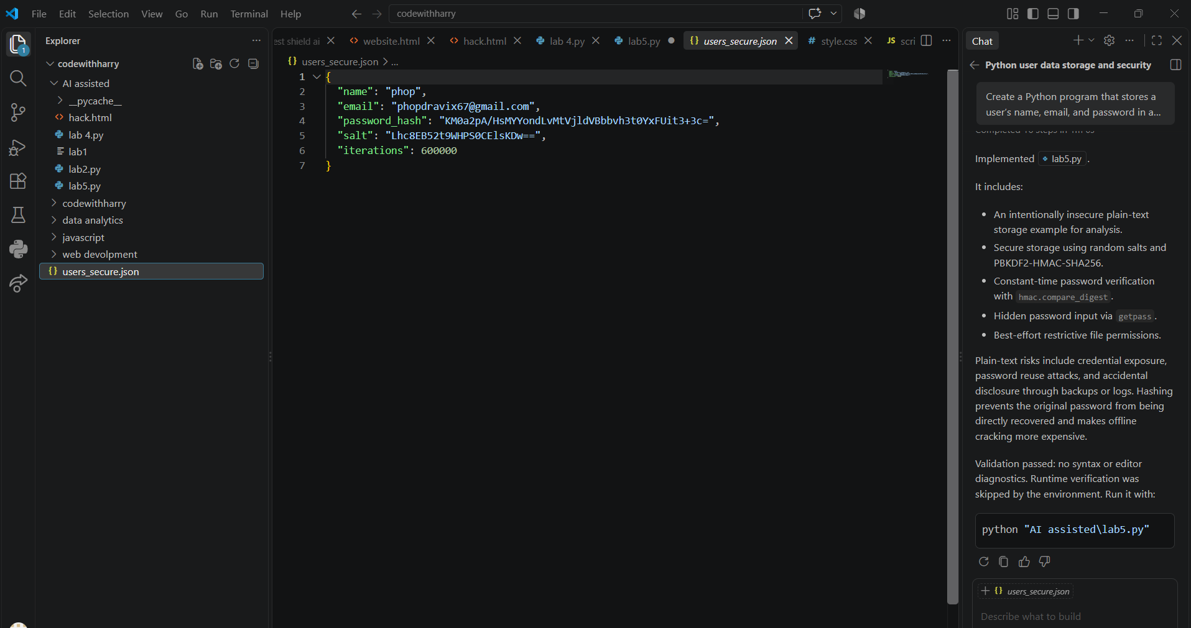
Task Description #2 – Fair Decision Logic
Task: Prompt an AI tool to generate a scholarship eligibility checker based on academic score, family income, and location. Examine whether the logic unfairly favors or disadvantages any group.
Expected Output-2:
Code snippet with observations on fairness. Brief explanation (3–4 sentences) suggesting improvements to ensure equitable decision-making.
Prompt:- Create a scholarship eligibility checker based on academic score, family income, and location. Generate a code snippet that takes these three factors as input and determines whether a student is eligible for the scholarship using clear and transparent rules. After generating the code, examine the decision logic for fairness and identify whether it unfairly favors or disadvantages students from any group, particularly based on income or location. Provide observations on at least two possible sources of bias and suggest improvements to ensure equitable decision-making. Keep the fairness improvement explanation to 3–4 sentences.
CODE:-
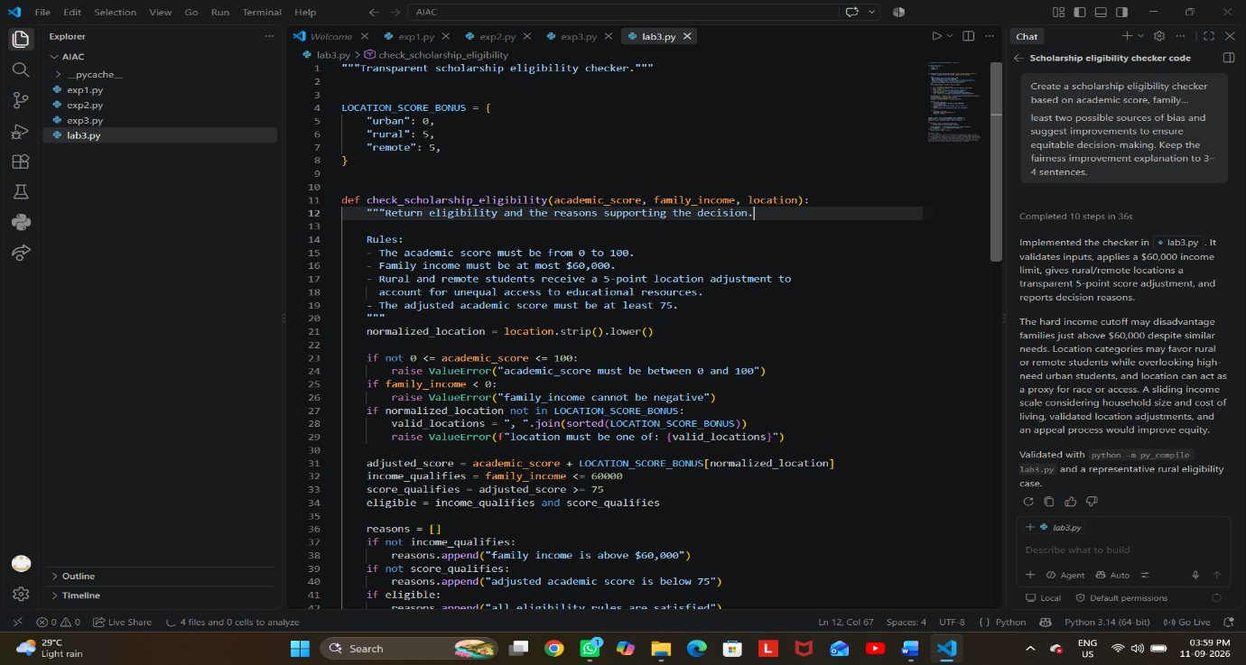
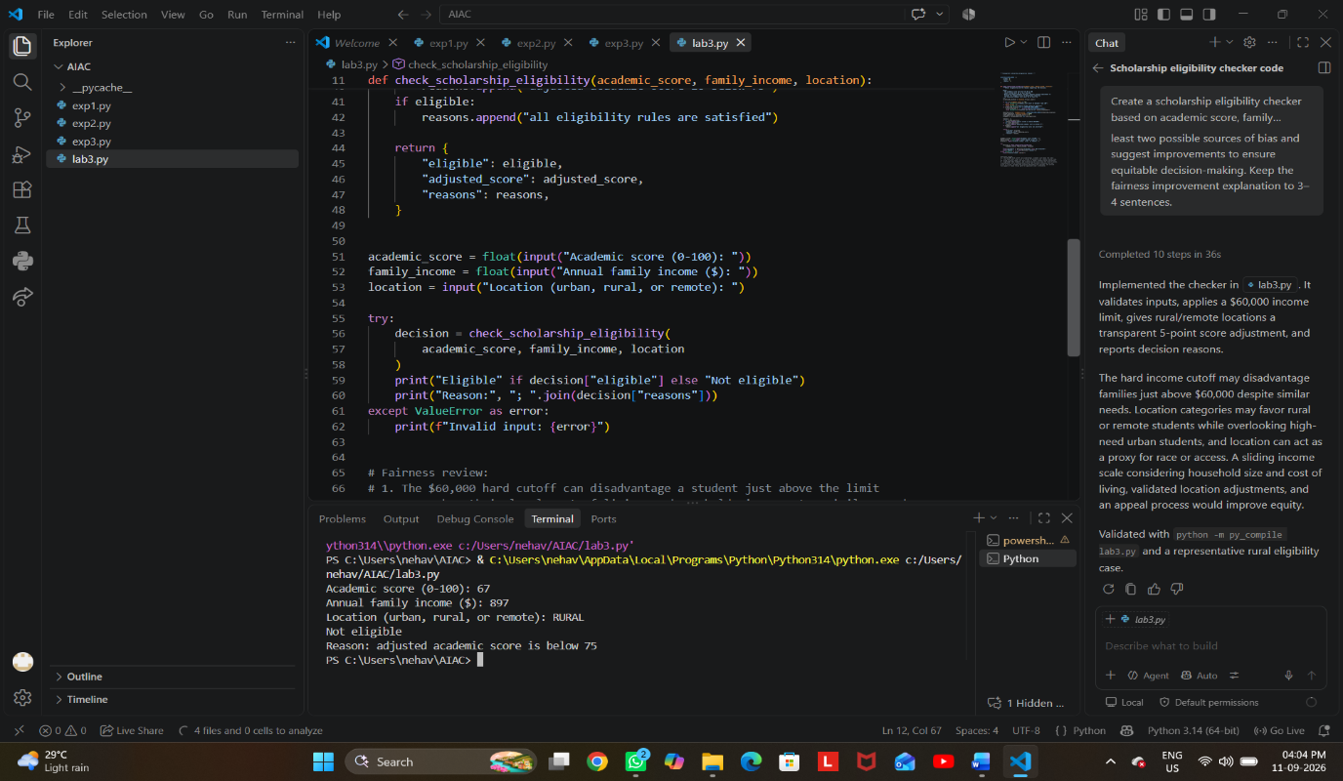
Task Description #3 (Transparency in AI-Based Admission System)
Task: Use an AI tool to generate a Python program that predicts whether a student should be selected or rejected for admission based on factors such as entrance exam score, academic marks, and other relevant admission criteria.
Analyze: Check whether the AI system provides a clear and understandable reason for its admission decision.
Expected Output:
- Identified transparency risks.
- Example of an admission decision where the AI gives no explanation.
- Revised version that provides a clear reason for selecting or rejecting the student.
- Example output showing the important factors that influenced the AI's decision.
PROMPT:- Create a beginner-friendly Python AI-based admission system using entrance exam score, academic marks, and interview score. Show a decision with no explanation identify the transparency risks, then revise the program to clearly explain the selection/rejection reason, show each factor’s weight and contribution, and display the important factors influencing the decision with sample output
CODE:-
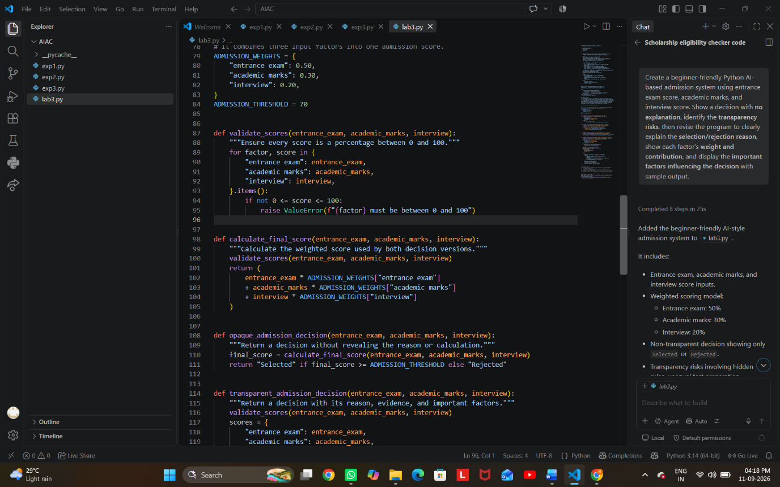

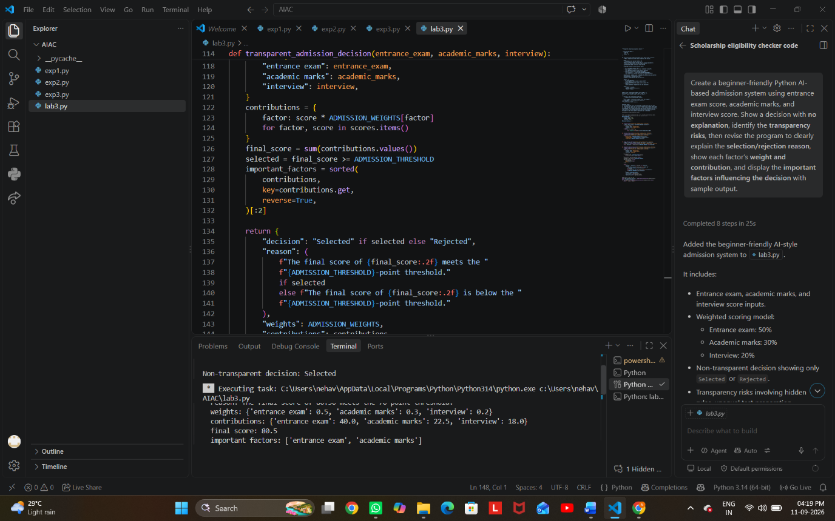
Task Description #4 – Ethical Scoring System
Task: Generate an employee performance evaluation system using inputs such as project completion rate, teamwork score, and attendance. Analyze the scoring logic for any unethical weighting or hidden bias.
Expected Output-4:
Python code along with a written analysis identifying whether the evaluation criteria are balanced and justifiable.
PROMPT:- Create a beginner-friendly Python employee performance evaluation system using project completion rate, teamwork score, and attendance. Analyze the scoring weights for unfair or biased criteria, explain whether the evaluation is balanced and justifiable, and suggest improvements to make the scoring system more ethical and fair. Include the Python code and a short written analysis.

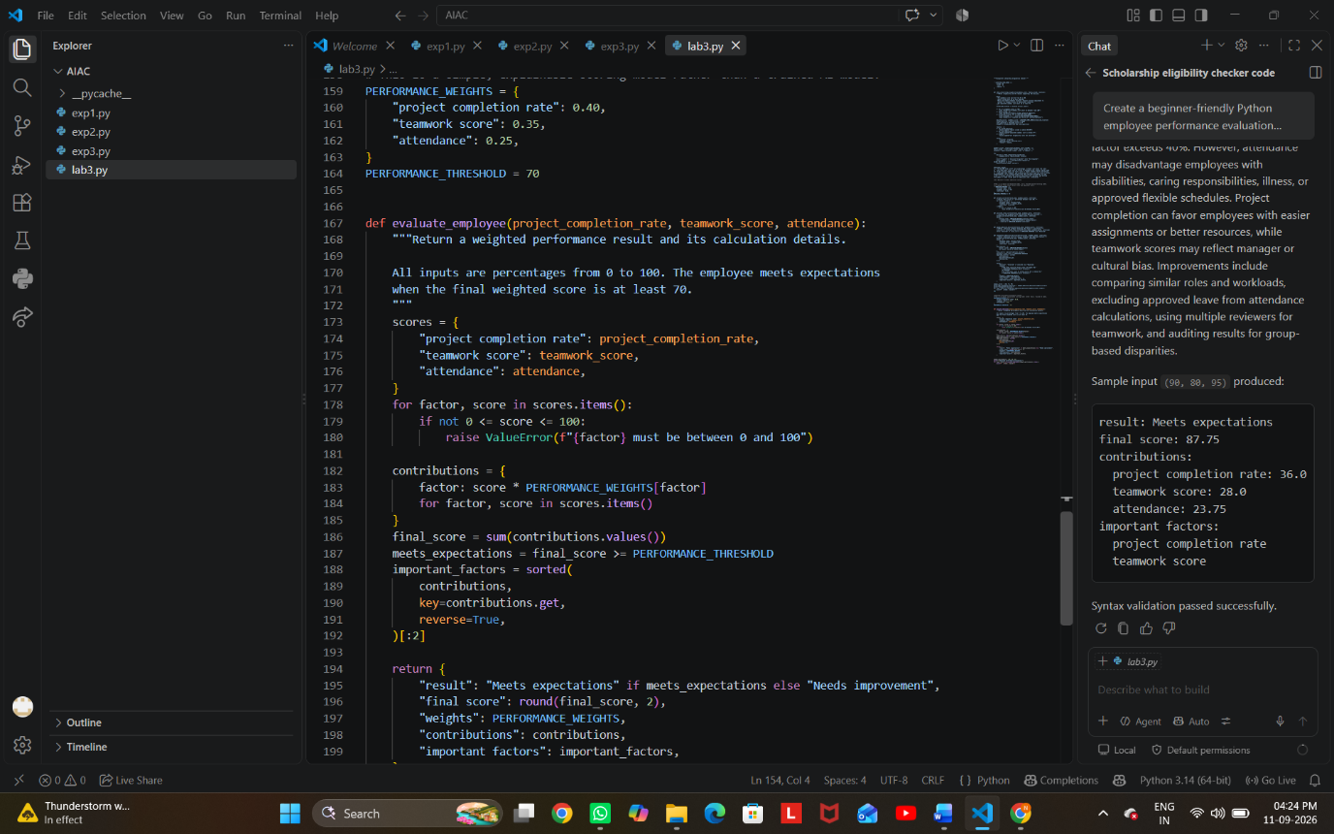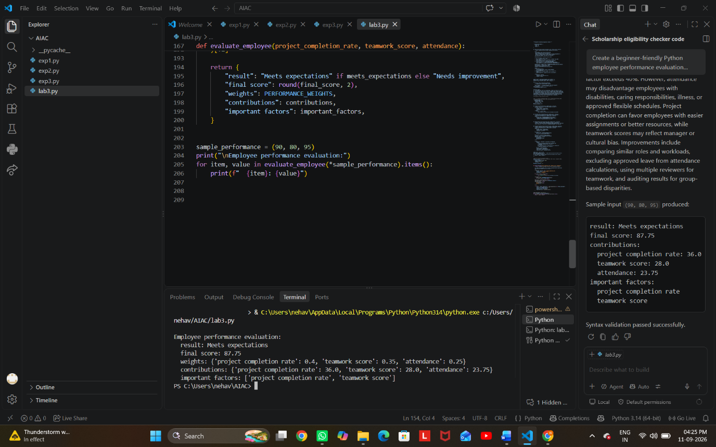
Task Description #5 – Accessibility and Inclusiveness
Task: Use an AI tool to generate a user feedback form application. Review whether the language and options provided are inclusive and accessible to diverse users.
Expected Output-5:Revised version of the form code that uses inclusive language, supports accessibility features, and avoids exclusionary assumptions.
PROMPT:- Create a beginner-friendly user feedback form application using HTML, CSS, and JavaScript. Review the form for accessibility and inclusiveness, including language, input options, labels, keyboard navigation, and screen-reader support. Identify any exclusionary assumptions, then provide a revised version of the form code using inclusive language, accessible features, and flexible options for diverse users.
CODE:-
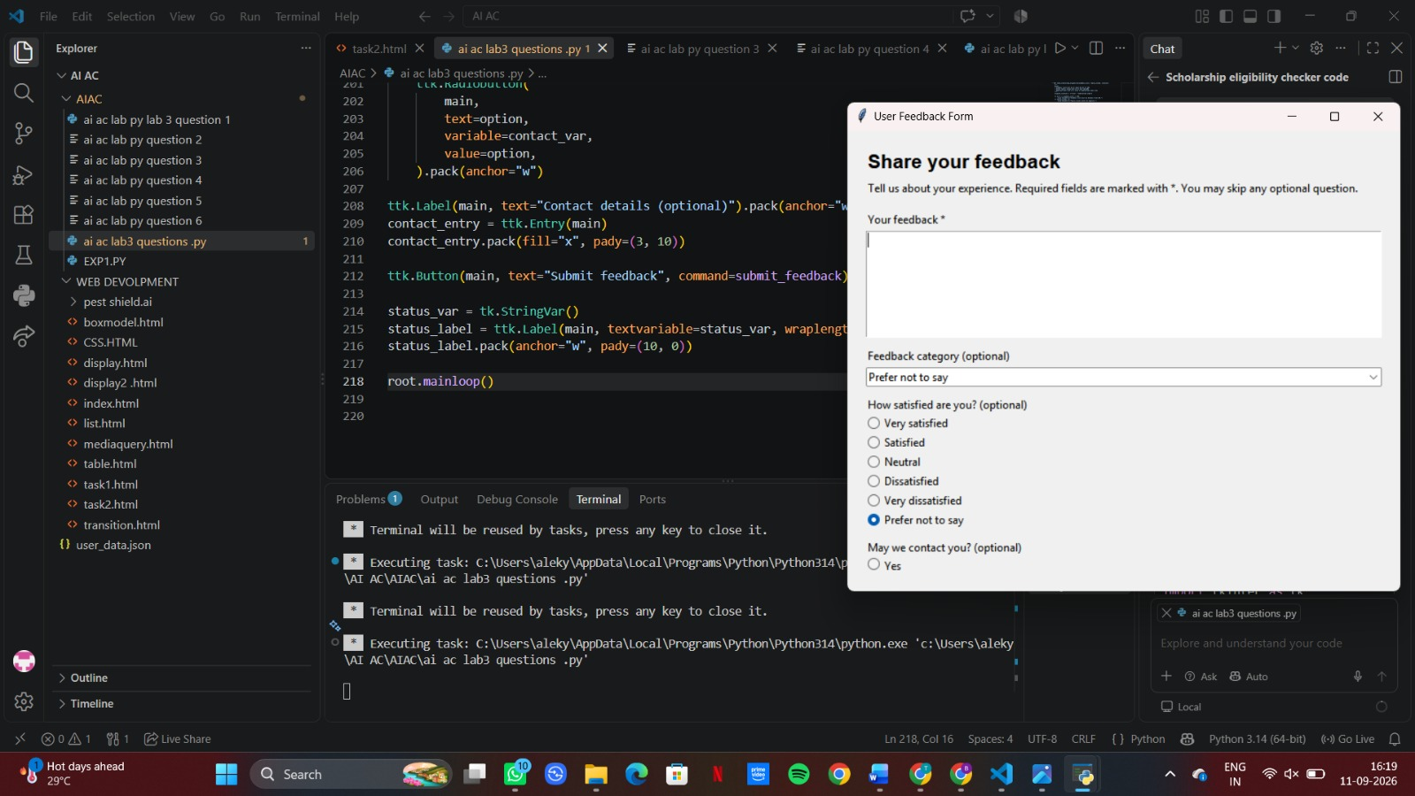
Task Description #6 (Fairness in Loan Approval System)
Task: Use an AI tool to generate a Python program that predicts whether a person should be approved or rejected for a loan based on information such as income, age, employment status, credit score, and loan amount.
Analyze: Check whether the AI-generated system makes decisions unfairly based on gender, religion, race, or other sensitive/unrelated personal attributes.
Expected Output:
- Identified fairness and discrimination risks.
- Examples showing how biased data or rules can lead to unfair loan decisions.
- Revised version that makes loan decisions based on relevant financial factors rather than sensitive attributes.
Brief explanation of how the revised system improves fairness
PROMPT:- Generate a Python loan approval system using income, age, employment status, credit score, and loan amount. Analyze whether it makes unfair decisions based on gender, religion, race, caste, or other sensitive attributes. Give examples of possible bias and then provide a revised version that uses only relevant financial factors and treats applicants fairly. Briefly explain how the revised system improves fairness.

