Hypothesis Testing – Lecture Notes

1. Null and Alternate Hypothesis
- Null Hypothesis (H₀):
Assumes no effect or no difference. It is the default assumption.
Example: A new drug has no effect on blood pressure.
- Alternate Hypothesis (H₁ or Ha):
Assumes there is an effect or a difference.
Example: The new drug lowers blood pressure.

2. Confidence Interval (CI)
- A range of values within which we are fairly confident the true population parameter lies.
- A 95% CI means: “We are 95% confident that the true mean lies in this interval.”
- CI is tied to alpha (α):
CI = 1 - α
➤ So, for α = 0.05, CI = 95%

Insert the bell curve image here (title: Normal Distribution with Confidence Interval and Alpha Regions)
🟩 Green area = 95% Confidence Interval
🟥 Red tails = 5% Significance Level (α = 0.05, split as 2.5% on each side)
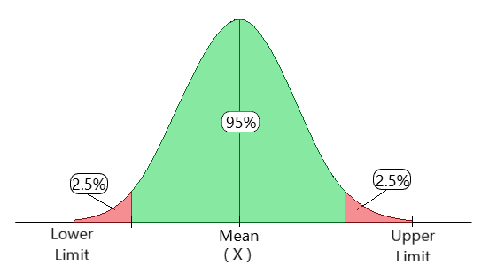

3. Significance Level (α)
- α (alpha) is the probability of making a Type I error (rejecting H₀ when it’s actually true).
- Common values: 0.05, 0.01, 0.10
- If p-value < α → Reject H₀
- If p-value ≥ α → Fail to reject H₀

4. P-value
- The probability of getting results as extreme as the sample data, assuming H₀ is true.
- Lower p-value = stronger evidence against H₀.
Decision Rule:
- p ≤ α: Reject H₀
- p > α: Fail to reject H₀

5. Types of Statistical Tests
Z Test: Known population variance, large sample (n>30)
T Test: Small sample (n<30)
- One Tale: A one-sample t-test is used to determine if the mean of a single sample is significantly different from a known or hypothesized population mean.
- Two Tale: A two-sample t-test is used to compare the means of two independent samples to determine if they are significantly different from each other.

Chi-Square Test: The chi-square test is a statistical test used to assess the independence (or association) between two categorical variables. It helps determine whether there is a significant relationship between the variables or if they are independent.

ANOVA: ANOVA is a statistical technique used to compare means among multiple groups or treatments. It assesses whether there are any statistically significant differences between the means of the groups.

- One-Way ANOVA: One-way ANOVA is used when there is one categorical independent variable (with two or more levels or groups) and one continuous dependent variable. It tests whether there are any significant differences between the means of the groups.
- Two-Way ANOVA: Two-way ANOVA is used when there are two categorical independent variables (factors) and one continuous dependent variable. It assesses the interaction effect between the two factors and whether they have a significant influence on the dependent variable.

6. Solved Examples
What is Degrees of Freedom (df)?
Degrees of freedom represent the number of values in a calculation that are free to vary while still satisfying a given constraint (like a known mean or total).
Think of it like this:
If you know the average of 3 numbers is 10, and you already know 2 of them, the third one is fixed. So, only 2 were free to vary.
Summary Table
Test Type | df Formula | Example Result
One-Sample T-Test | n - 1 | 19
Two-Sample T-Test | n₁ + n₂ - 2 | 58
ANOVA | (k - 1, N - k) | (2, 6)
Chi-Square Test | k - 1 | 4

Example 1: One-Sample T-Test (Real-life)
Scenario:
A startup claims their employees work an average of 9 hours per day. You suspect they might be overworking employees and take a sample of 20 employees.
- Sample mean = 9.5 hours
- Sample standard deviation = 1.2 hours
- Sample size = 20
- α = 0.05

Hypotheses:
- H₀: μ = 9 → Employees work 9 hours/day
- H₁: μ > 9 → Employees work more than 9 hours/day

T-test formula:
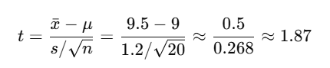
- Degrees of freedom = 19
- Critical t-value for one-tailed test (α = 0.05) ≈ 1.729

Conclusion:
1.87 > 1.729 → Reject H₀
Employees are likely working more than 9 hours per day.
(1.87 is t calculate.
1.729 is t critical.
If calculated > critical then Reject Null Hypothesis)

For p and α analysis:
from scipy.stats import t
# Given values
t_value = 1.87
df = 19 # degrees of freedom

# One-tailed p-value
p_value_one_tailed = 1 - t.cdf(t_value, df)

# Two-tailed p-value (if the test is two-sided)
p_value_two_tailed = p_value_one_tailed * 2

p_value_one_tailed, p_value_two_tailed

Example 2: Chi-Square Goodness of Fit Test (Real-life)
Scenario:
A restaurant owner thinks each weekday gets an equal number of customers.
She tracks customer count for a week:
Day | Observed Customers
Monday | 80
Tuesday | 90
Wednesday | 100
Thursday | 110
Friday | 120
Expected = (80+90+100+110+120)/5 = 100 per day

Hypotheses:
- H₀: All weekdays have equal customer traffic
- H₁: At least one day has different traffic

χ² formula:
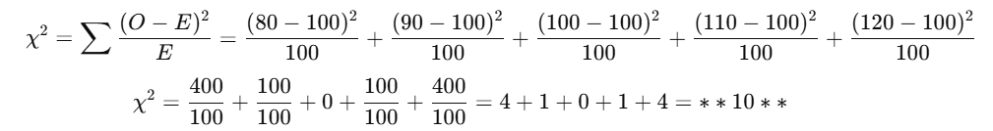
- Degrees of freedom = 5 - 1 = 4
- Critical χ² value at α = 0.05 and df = 4 ≈ 9.49

Conclusion:
10 > 9.49 → Reject H₀
Customer traffic is not equally distributed across weekdays.

Example 3: Two-Sample T-Test (Real-life)
Scenario:
You want to check if students from two different colleges (College A and College B) score differently on a standardized test.
Group | Sample Size (n) | Mean Score | Standard Deviation
A | 30 | 75 | 10
B | 30 | 80 | 12
Hypotheses:
- H₀: μ₁ = μ₂ → No difference in average scores
- H₁: μ₁ ≠ μ₂ → There is a difference
α = 0.05
T-test formula for independent samples:
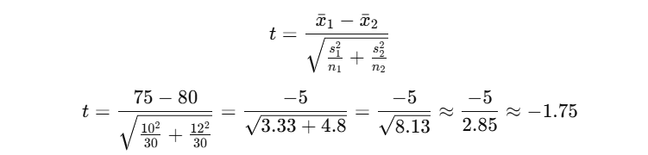
Degrees of Freedom: ~ 58
Critical t-value (two-tailed, α = 0.05): ±2.001
Conclusion:
-1.75 > -2.001 → Fail to reject H₀
No significant difference in scores between College A and B.

Example 4: ANOVA (Real-life)
Scenario:
A manager wants to compare average monthly sales of three stores (Store A, B, C).
Store | Monthly Sales (in ₹’000)
A | 80, 85, 78
B | 90, 88, 92
C | 75, 70, 72
Hypotheses:
- H₀: μ₁ = μ₂ = μ₃ → All stores have same average sales
- H₁: At least one store mean is different
Using ANOVA (calculated or via software):
- F-statistic = 10.45
- Critical F (α = 0.05, df1 = 2, df2 = 6): ≈ 5.14
Conclusion:
10.45 > 5.14 → Reject H₀
At least one store has significantly different average sales.

Example 5: Z-Test (Real-life)
Scenario:
A packaging machine is supposed to fill bags with 500 grams of sugar. You take a sample of 100 bags.
Sample mean = 495g, population standard deviation = 10g
Hypotheses:
- H₀: μ = 500g
- H₁: μ ≠ 500g
- α = 0.05
Z-test formula:
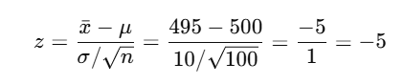
Critical z-values (α = 0.05, two-tailed): ±1.96
Conclusion:
-5 < -1.96 → Reject H₀
The machine is not filling the correct amount.

