Amazon Sales Analytics
Project Documentation

Prepared by:
Neha Yadav
MBA – Business Analytics

Tools Used
Excel | SQL | Power BI

Project Type
End-to-End Business Analytics Project

Project Overview
Project Objective
The objective of this project is to analyze Amazon sales data and identify important business insights using Excel, SQL, and Power BI. The project helps understand sales performance, customer behavior, product performance, delivery status, and regional revenue trends. The final dashboard supports data-driven business decisions.

Dataset Information
Dataset Details
- Dataset Name: Amazon Sales Data
- Total Records: 128,976
- Total Columns: 24
- Tools Used: Excel, SQL, Power BI
Main Columns
- Order ID
- Order Date
- Ship State
- City
- Category
- Product
- Quantity
- Amount
- Order Status
- Courier Status
- B2B
- Fulfilment
Excel Process
Data Cleaning
The raw dataset was first imported into Microsoft Excel. The data was cleaned to improve quality and prepare it for analysis.
The following tasks were performed:
- Removed duplicate records.
- Checked and handled missing values.
- Corrected data formatting.
- Standardized column values.
- Verified data accuracy before analysis.

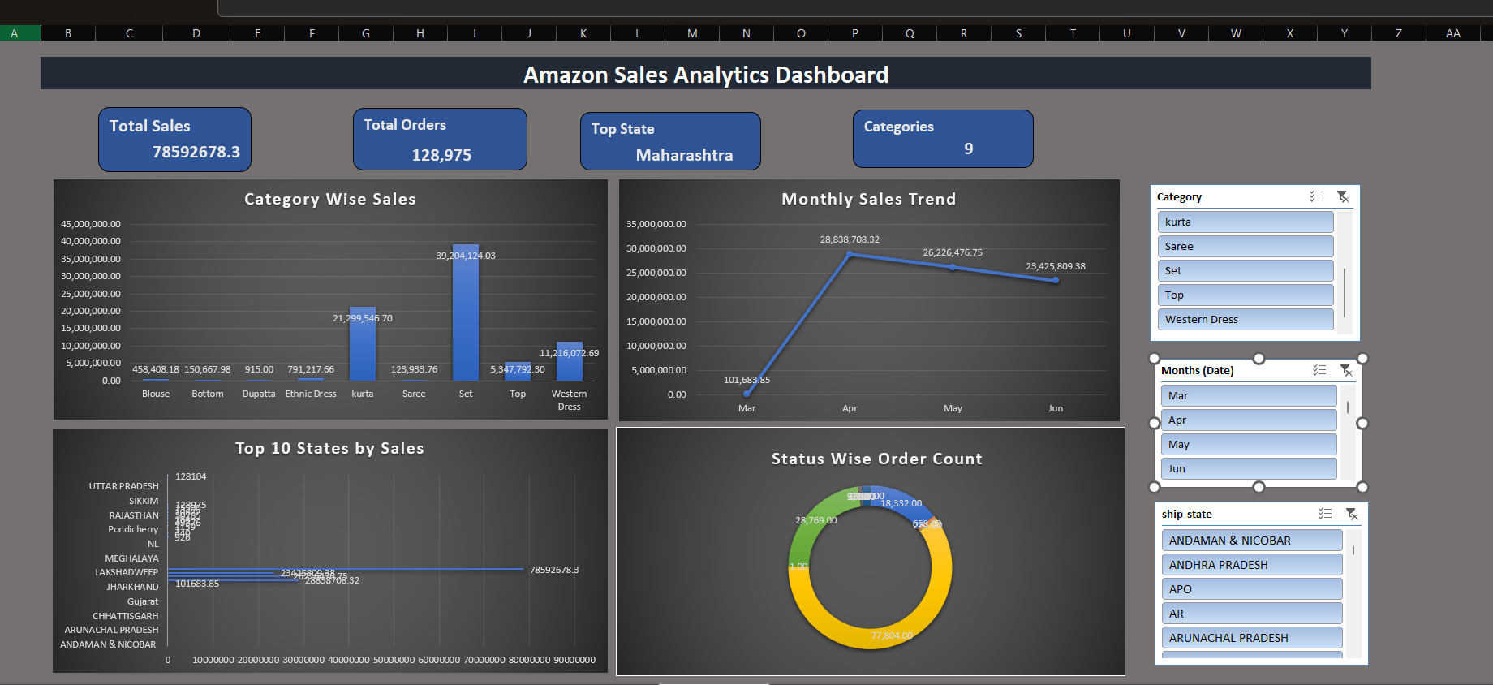
Figure 1: Final Excel Dashboard

Data Analysis
After cleaning the data, Pivot Tables were created to summarize the information.
The following analyses were performed:
- Revenue Trend Analysis
- Revenue by Category
- Top Revenue-Generating Cities
- Order Status Analysis
- Revenue by Ship State
Dashboard Development
An interactive Excel dashboard was created using:
- Pivot Tables
- Pivot Charts
- KPI Cards
- Slicers
- Professional Formatting

SQL Process
Database Creation
The cleaned Amazon Sales dataset was imported into PostgreSQL to perform data analysis using SQL.
Data Preparation
The following steps were completed:
- Created a database.
- Created a table.
- Imported the cleaned CSV file.
- Verified the imported data.

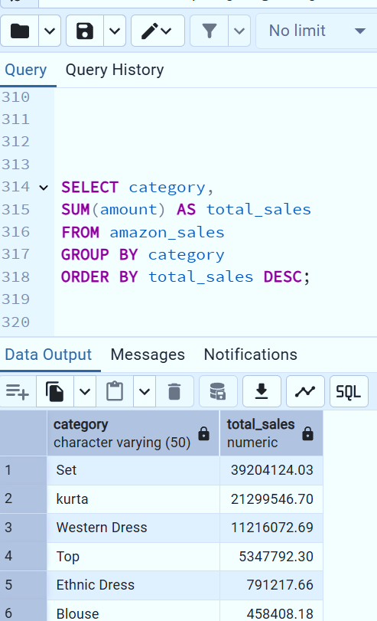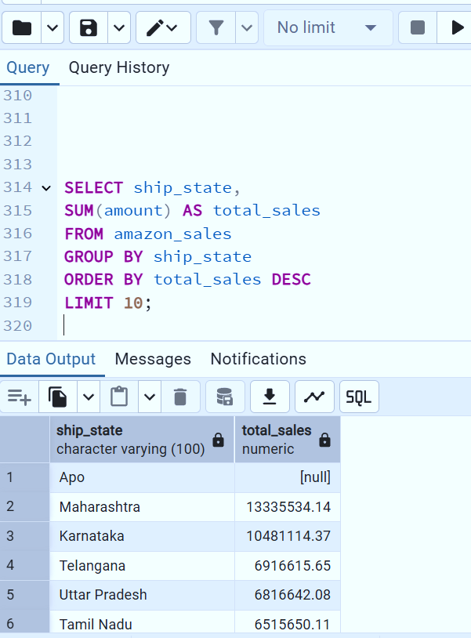
Figure 2: SQL Query Figure 3: SQL Query

SQL Analysis
SQL queries were used to analyze the dataset and answer business questions.
The following analyses were performed:
- Total Revenue
- Total Orders
- Revenue by Category
- Revenue by State
- Monthly Sales Trend
- Top Products by Revenue
- Order Status Analysis
- B2B vs B2C Analysis
Result
SQL helped extract meaningful business information from the dataset and supported the creation of the Power BI dashboard.

Power BI Process
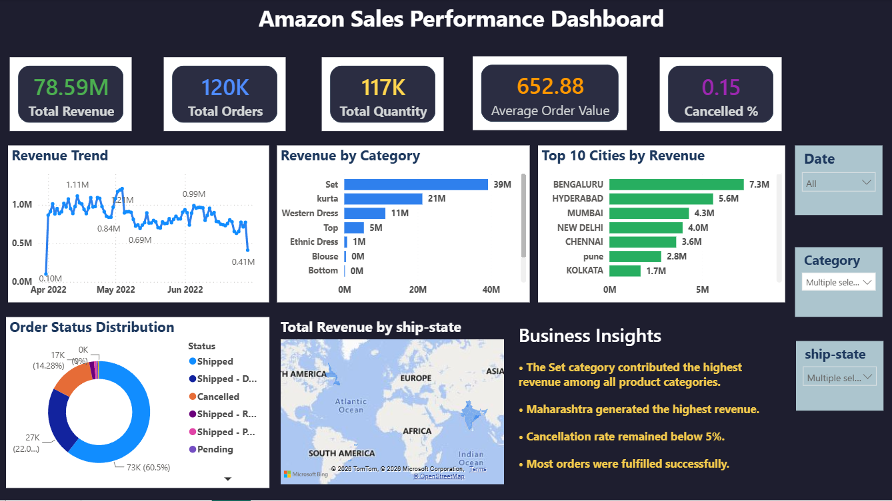Figure 5: Power BI Dashboard – Page 1

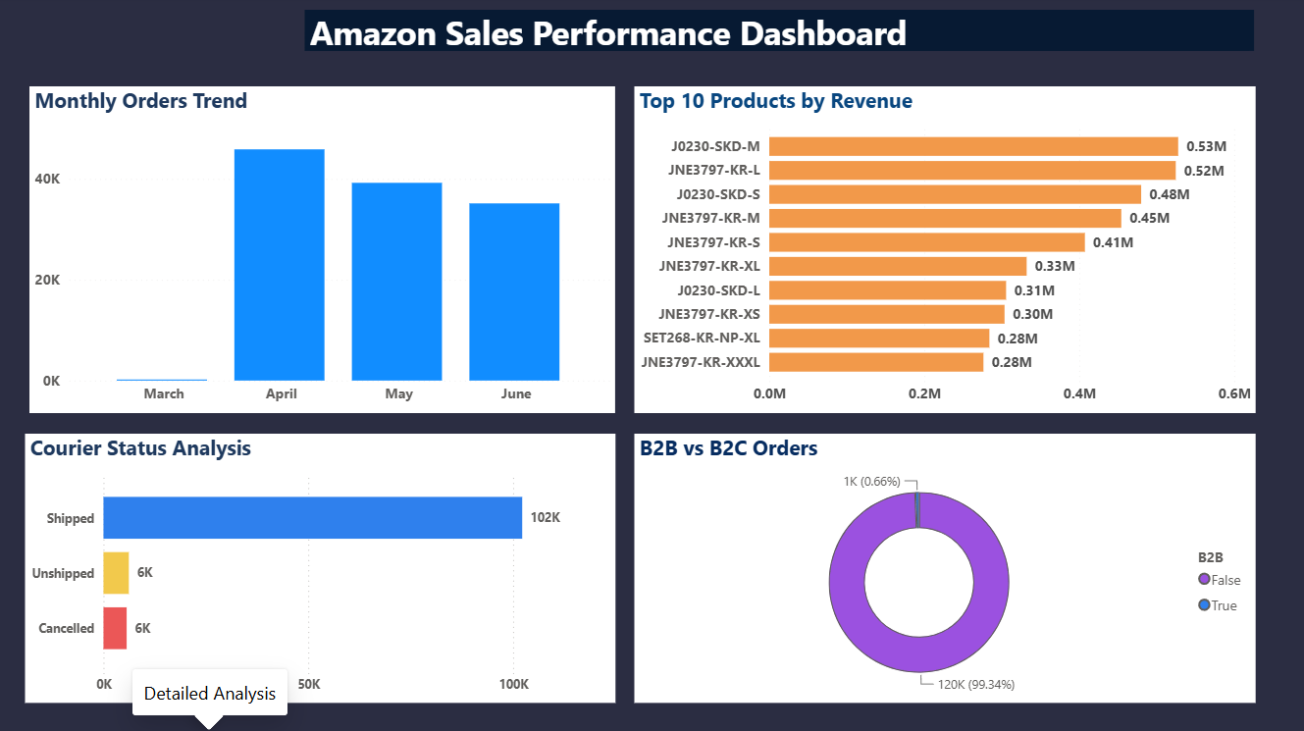
Figure 6: Power BI Dashboard – Page 2

Data Import
The cleaned Amazon Sales dataset was imported into Power BI for visualization and business analysis.
Data Modeling
The following data modeling tasks were completed:
- Created a Calendar table.
- Established relationships between tables.
- Added calculated columns for Month Name and Month Number.
- Sorted Month Name by Month Number for correct chronological order.
DAX Measures
DAX measures were created to calculate important business metrics, including:
- Total Revenue
- Total Orders
- Average Order Value
- Cancellation Rate
Dashboard Development
An interactive Power BI dashboard was developed with multiple visualizations, including:
- Revenue Trend
- Revenue by Category
- Top 10 Cities by Revenue
- Order Status Distribution
- Revenue by Ship State
- Monthly Orders Trend
- Top 10 Products by Revenue
- Courier Status Analysis
- B2B vs B2C Orders
Dashboard Features
The dashboard includes:
- KPI Cards
- Interactive Slicers
- Dynamic Charts
- Professional Layout
- Business Insights

Dashboard KPIs
The dashboard includes the following Key Performance Indicators (KPIs):
- Total Revenue
- Total Orders
- Average Order Value
- Cancellation Rate
- Revenue by Category
- Revenue by Ship State
- Monthly Revenue Trend
- Top Products by Revenue
- Courier Status Analysis
- B2B vs B2C Orders

Conclusion
The Amazon Sales Analytics project successfully analyzed sales performance, customer behavior, product performance, and delivery status using Excel, SQL, and Power BI. The dashboard provides clear business insights that can support better decision-making. The recommendations presented in this project can help improve revenue, customer satisfaction, and overall business performance.

End Note
This project demonstrates practical Business Analytics skills, including data cleaning, SQL analysis, dashboard development, and business insight generation. The project reflects a complete end-to-end analytics workflow from raw data to business recommendations.

