

THE UNIVERSITY OF ZAMBIA
SCHOOL OF NATURAL SCIENCES
DEPARTMENT OF COMPUTING AND INFORMATICS

MINI-PROJECT ASSIGNMENT

GROUP No: 30
COURSE CODE: CSC 4792
COURSE NAME: Data Mining and Warehousing
DATE: 14th September, 2026.

DATA IN BRIEF — RESEARCH DATA ARTICLE
Dataset on the Digital Footprint, Ward Development Structures, Council Documents, and Constituency Development Fund (CDF) Allocations of Lusangazi Town Council
Department of Computer Science, School of Natural Sciences, The University of Zambia, Lusaka, Zambia
* Corresponding author.
Guba Siachalinga, Group 30 (CSC 4792)
Nehemiah Kalikenka, Group 30 (CSC 4792)
Buumba Chinjila, Group 30 (CSC 4792)
Henry Madzima, Group 30 (CSC 4792)
Naleli Kabika, Group 30 (CSC 4792)

ABSTRACT
This paper presents a multi-source open-government dataset capturing the digital footprint, administrative organization, Ward Development Committees (WDC), document metadata, budget and Constituency Development Fund (CDF) allocations of Lusangazi Town Council in Eastern Province, Zambia. The data were extracted via a custom Python data engineering pipeline using HTML web scraping (BeautifulSoup) and PDF document parsing (PyMuPDF) targeting official public council domains. The final dataset comprises seven standardized, pipe-delimited (|) CSV files spanning CDF projects, council documents, ward/WDC structures, administration, historical financial statements, the 2026 Output-Based Budget, and Integrated Development Plan (IDP) priorities, designed to enhance civic transparency, public resource auditing, and spatial-administrative research across local governance in Zambia.

KEYWORDS
Open government data; civic data mining; local governance; Constituency Development Fund; council budgets; Zambia

SPECIFICATIONS TABLE
Subject Area | Computer Science / Data Engineering / Open Government Data
More specific subject area | Civic Data Mining, Public Sector Analytics, Local Government Transparency
Type of data | Tables (CSV format)
How data was acquired | Programmatic web scraping (requests, BeautifulSoup4) and PDF document extraction (PyMuPDF/fitz) from official municipal web portals.
Data format | Processed, pipe-delimited (|) CSV files
Parameters for data collection | Target site: Lusangazi Town Council web portal (https://www.lusangazicouncil.gov.zm). Text attributes normalized to lowercase, trimmed of redundant whitespace, and deduplicated.
Description of data collection | Automated HTTP requests fetched public pages and PDF publications. Text and HTML table elements were extracted, parsed, mapped to defined relational schemas, and exported as pipe-delimited CSVs.
Data source location | Lusangazi District, Eastern Province, Zambia
Data accessibility | Repository name: GitHub & Kaggle  GitHub URL: CSC4792_Group_30_Lusangazi_Town_Council_Data_Mining  Kaggle URL: Lusangazi Town Council Dataset
License | Creative Commons Attribution 4.0 International (CC BY 4.0)

VALUE OF THE DATA
- Civic Transparency & Public Accountability: Provides structured, machine-readable access to CDF project allocations, council budgets, and development priorities for Lusangazi District.
- Academic & Data Science Research: Enables researchers and software engineers to analyze resource distribution models, civic text mining, and local governance digital footprints in rural Zambian councils.
- Public Policy & Monitoring: Policy analysts and civil society organizations (CSOs) can utilize these relational datasets to track CDF project execution statuses across wards.
- Financial Transparency & Budget Tracking: The historical financials, 2026 Output-Based Budget, and IDP priority files together allow revenue, expenditure, and planned-investment trends to be tracked across multiple financial years.
- Replicable Open Data Pipeline: Serves as a standard benchmark for open-data extraction methodologies targeting local council websites built on standard Content Management Systems (CMS).

DATA DESCRIPTION
The dataset is hosted as a single multi-file collection on Kaggle and GitHub comprising seven pipe-delimited (|) CSV files formatted under the naming convention db-unza26-csc4792-[DESCRIPTION].csv. Figure 1 summarizes the overall health of the extraction pipeline across all source files.
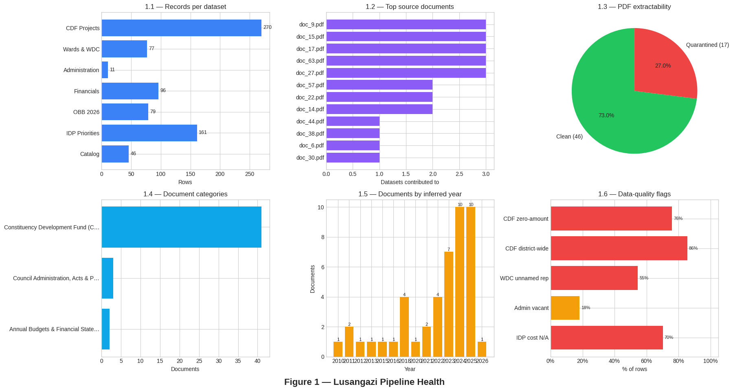
1. File: db-unza26-csc4792-lusangazi_cdf_projects.csv
Contains granular details of Constituency Development Fund (CDF) projects allocated across Lusangazi District.
Column Name | Data Type | Description | Example
project_id | String / PK | Unique identifier for the CDF project | CDFLUS-2024-001
project_name | String | Official title/description of the approved project | 1x3 Classroom Block
ward | String | Local electoral ward where project is sited | Ukwimi Ward
sector | String | Functional sector classification | Education
allocated_amount_zmw | Float | Approved project budget in Zambian Kwacha (ZMW) | 450000.00
status | String | Implementation status | Ongoing
year | Integer | Financial year of funding allocation | 2024

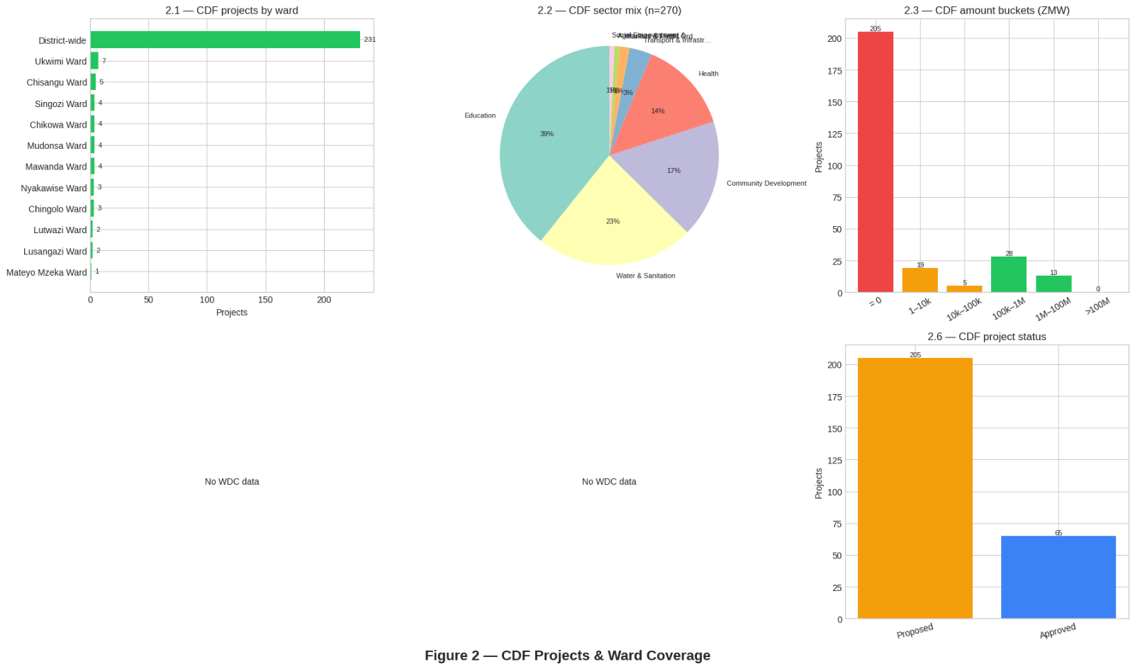
2. File: db-unza26-csc4792-lusangazi_council_documents.csv
Contains metadata and structural audits of scraped council PDF publications, Integrated Development Plans (IDPs), and financial statements.
Column Name | Data Type | Description | Example
document_id | String / PK | Unique identifier for the mined document | DOC-LUS-001
title | String | Official title of the document or report | Integrated Dev Plan
document_type | String | Categorization of the publication | Development Plan
publication_year | Integer | Year the document was officially released | 2022
source_url | String | Direct web hyperlink to the original PDF asset | https://.../idp.pdf
page_count | Integer | Total page count extracted via PyMuPDF | 142

3. File: db-unza26-csc4792-lusangazi_wards_wdc.csv
Structures the administrative ward boundaries, Ward Development Committee (WDC) zones, and community leadership priorities.
Column Name | Data Type | Description | Example
ward_id | String / PK | Standardized ward identifier code | WARD-LUS-01
ward_name | String | Official name of the electoral ward | Mwanjawanthu
wdc_chairperson | String | Name of the sitting WDC executive leader | John Banda
zones_count | Integer | Number of administrative zones within the ward | 6
key_priority | String | Primary civic infrastructure focus listed by WDC | Water & Sanitation

4. File: db-unza26-csc4792-lusangazi_administration.csv
Documents the operational department structures, key executive officers, and contact channels for Lusangazi Town Council.
Column Name | Data Type | Description | Example
dept_id | String / PK | Unique administrative department code | DEPT-LUS-01
department_name | String | Official title of the council department | Engineering Dept
head_of_department | String | Designation/Name of the leading officer | Council Engineer
contact_email | String | Official public communication channel | info@...gov.zm

5. File: db-unza26-csc4792-lusangazi_financials_budget.csv
Contains historical, line-item financial records (revenue and expenditure entries) for Lusangazi Town Council, extracted from council financial statements spanning multiple financial years. Each record captures a single budget line together with its classification as revenue or expenditure and, where applicable, its revenue stream. The file holds 96 records.
Column Name | Data Type | Description | Example
financial_id | String / PK | Unique identifier for the financial record | LUS-FIN-001
council_name | String | Name of the reporting council | Lusangazi Town Council
financial_year | Integer | Financial year the record pertains to | 2016
category_code | String | Budget category/line-item code (sparsely populated in source documents) | —
description | String | Narrative description of the budget line item | Personal levy
amount_zmw | Float | Recorded amount in Zambian Kwacha (ZMW) | 10410.00
revenue_or_expenditure | String | Classification of the line item | Revenue
revenue_stream | String | Revenue category/stream classification (revenue rows only) | Local Taxes / Rates
source_doc | String | Filename of the source PDF the record was mined from | doc_1.pdf

6. File: db-unza26-csc4792-lusangazi_obb_budget_2026.csv
Contains Output-Based Budget (OBB) records for the 2026 financial year, mined from the council's OBB publication. Each row represents a revenue or expenditure line item and, uniquely among the dataset's files, carries multi-year projections (2024 through 2028), enabling year-on-year budget trend analysis. The file holds 79 records.
Column Name | Data Type | Description | Example
record_type | String | Type of budget record | revenue
financial_year | Integer | Reference financial year of the OBB publication | 2026
revenue_section | String | Section/category heading under which the line item is grouped | Local taxes/rates
section_code | Float | Numeric code identifying the budget section | 1.0
category_code | String | Numeric code identifying the specific budget category | 1
description | String | Narrative description of the budget line item | Personal levy
amount_zmw | Float | Budgeted amount for the reference financial year (2026), in ZMW | 8925.00
amount_2027_zmw | Float | Projected amount for financial year 2027, in ZMW | 9639.00
amount_2028_zmw | Float | Projected amount for financial year 2028, in ZMW | 10410.00
revenue_or_expenditure | String | Classification of the line item | Revenue
source_doc | String | Filename of the source PDF the record was mined from | doc_1.pdf
amount_2024_zmw | Float | Actual/approved amount for financial year 2024, in ZMW (where reported) | 8434297.00
amount_2025_zmw | Float | Actual/approved amount for financial year 2025, in ZMW (where reported) | 8050193.00

7. File: db-unza26-csc4792-lusangazi_idp_priorities.csv
Captures the strategic development priorities of Lusangazi District as recorded in the council's Integrated Development Plan (IDP). Each record corresponds to a single strategic objective, mapped to a sector, a target ward (or a district-wide scope), an estimated implementation cost, and an implementation period. The file holds 161 records.
Column Name | Data Type | Description | Example
idp_id | String / PK | Unique identifier for the IDP priority record | IDP-LUS-001
sector | String | Development sector classification | Water & Sanitation
strategic_objective | String | Narrative description of the planned intervention | Drilling of borehole at Masosi village
target_ward | String | Electoral ward targeted by the objective, or “District-wide” | Chingolo Ward
estimated_cost_zmw | Float | Estimated implementation cost in ZMW (sparsely populated in source documents) | 1500400.00
implementation_period | String | Planned implementation timeframe | 2024-2026
source_doc | String | Filename of the source PDF the record was mined from | doc_6.pdf

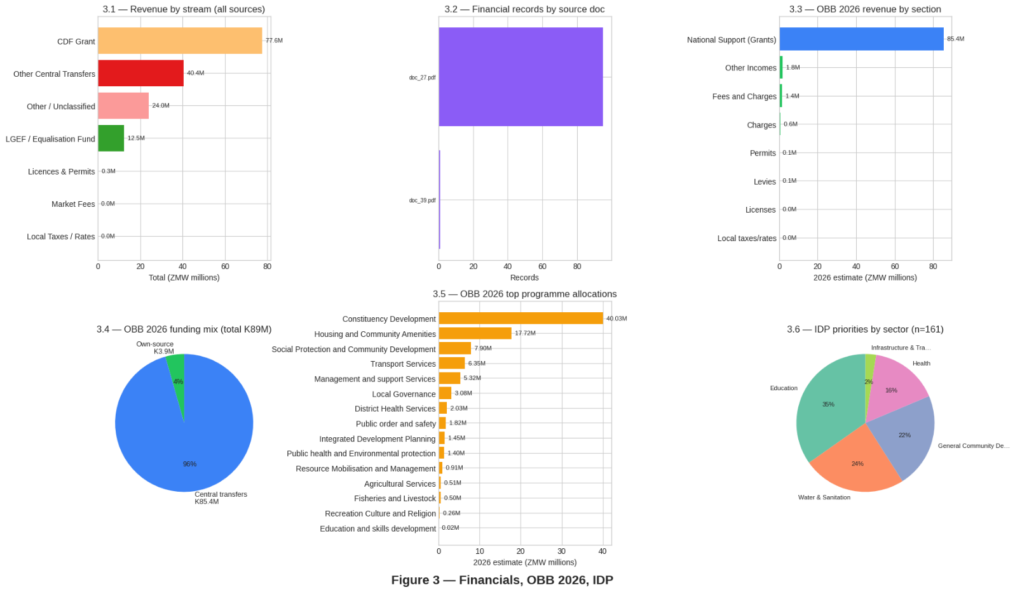

EXPERIMENTAL DESIGN, MATERIALS, AND METHODS
[Council Web Portal & Linked PDFs]
│
▼
[Stage 1: Discovery] ──► (Recursive crawl; PDF, table & text-fallback discovery)
│
▼
[Stage 2: Selection] ──► (PDF extractability triage; topic allow/deny lists; ward allow-list)
│
▼
[Stage 3: Cleaning] ──► (MD5 dedup; whitespace/encoding; hardened numeric parsing)
│
▼
[Stage 4: Structured Extraction] ──► (Multi-path regex/table parsing; sector taxonomy; pipe-delimited CSV)
│
▼
[Stage 5: Validation & EDA] ──► (Health-check assertions; full-suite profiling; figures)
│
▼
[Stage 6: Hosting] ──► (GitHub & Kaggle publication; CC BY 4.0)
The dataset was produced through a six-stage data engineering pipeline — discovery, selection, cleaning, structured extraction, and validation — implemented entirely in Python (requests, BeautifulSoup4, PyMuPDF, pdfplumber, pandas) inside a single reproducible Jupyter notebook (CSC4792-Group-30-Lusangazi-Town-Council-Data-Mining.ipynb). Representative code excerpts for each stage are given below; the full implementation, including all extraction rules and the exploratory analysis suite, is available in the notebook committed to the GitHub repository.
Stage 1: Data Discovery — Site Crawling and Resource Identification
The pipeline was seeded with the official council portal (https://www.lusangazicouncil.gov.zm/) and recursively crawled to build a structural registry of internal pages before any content was extracted.
- Seed crawl: an HTTP GET request against the base URL was parsed with BeautifulSoup4, every anchor href resolved to an absolute URL via urljoin(), and a domain-matching filter (urlparse().netloc) discarded outbound/external links, leaving a deduplicated set of internal URLs.
- Target expansion: the crawled URL set was merged with a small list of known high-value subpages (e.g. the CDF tracker and administration/ward pages) identified by their page_id query parameters, ensuring pages not reachable from the homepage navigation were still scanned.
- Resource discovery: each target page was scanned for (i) anchors whose href contained ".pdf", captured as absolute PDF URLs; (ii) embedded HTML <table> elements, parsed with pandas.read_html(); and (iii) fallback page text (BeautifulSoup .get_text()) for pages with no structured markup.
def get_internal_links(base_url):
response = requests.get(base_url, headers={"User-Agent": "Mozilla/5.0"},
timeout=30, verify=False)
soup = BeautifulSoup(response.text, "html.parser")
links = set()
for a in soup.find_all("a", href=True):
url = urljoin(base_url, a["href"])
if urlparse(url).netloc == urlparse(base_url).netloc:
links.add(url)
return list(links)
internal_urls = get_internal_links(BASE_URL)
# PDF discovery on every crawled + known target page
for a in soup.find_all("a", href=True):
href = a["href"].strip()
if ".pdf" in href.lower():
pdf_urls.add(urljoin(url, href))
Listing 1. Recursive internal-link crawl and PDF-link discovery (Steps 2–3).
Stage 2: Data Selection — Filtering Relevant Documents and Records
Of the documents reached by the crawl, only those relevant to CDF, finances, IDP or administration were retained, and low-quality PDFs were quarantined before any content-level parsing began.
- Content-based PDF triage: every downloaded PDF was scored on extractable alpha character count and distinct-word count after stripping scanner watermarks; files falling below threshold (empty text layer or near-empty after cleaning) were classified as scanned/noise and physically moved to scanned_pdfs_quarantine/ with a manifest recording the reason and a suggested action (OCR vs. manual review). This step alone removed 17 of 63 downloaded PDFs (27%) from the clean corpus (Figure 1.3).
- Topic allow/deny keyword lists: each extraction target (CDF projects, IDP priorities, financials) defined an explicit allow-list of URL/filename keywords (e.g. "community-projects", "cdf-2nd-edition") and a deny-list to exclude adjacent but irrelevant statutes and forms (e.g. "local-government-act", "food-safety", "job-advert") that would otherwise match on loose keyword overlap.
- Ward allow-list: a fixed vocabulary of the 11 official Lusangazi wards was used to reject place names that are chiefdoms or the parent constituency (e.g. Sandwe, Nyamphande, Msanzala) rather than wards, preventing them from being mis-recorded as ward-level records.
def extractability_check(raw_text, min_alpha_chars=200, min_unique_words=20):
if not raw_text or not raw_text.strip():
return 0, 0, True, "empty text (no text layer at all)"
cleaned = raw_text
for pat in WATERMARK_PATTERNS: # e.g. r'(?i)camscanner'
cleaned = re.sub(pat, ' ', cleaned)
alpha_chars = sum(c.isalpha() for c in cleaned.strip())
unique_words = len(set(re.findall(r'[a-zA-Z]{3,}', cleaned.lower())))
if alpha_chars < min_alpha_chars:
return alpha_chars, unique_words, True, f"only {alpha_chars} real alpha chars"
if unique_words < min_unique_words:
return alpha_chars, unique_words, True, f"only {unique_words} distinct words"
return alpha_chars, unique_words, False, "ok"
def normalize_ward(raw: str):
"""Return canonical ward label, or None if not one of the 11 official wards."""
s = re.sub(r"\s+", " ", re.sub(r"\s+WARD$", "", str(raw).upper().strip()))
if s in WARD_ALIASES: # chiefdoms/constituency -> None
mapped = WARD_ALIASES[s]
return mapped.title() if mapped else None
return s.title() if s in LUSANGAZI_WARDS else None
Listing 2. PDF-extractability triage and ward allow-list normalization (Steps 4.5–4.6).
Stage 3: Data Cleaning — Deduplication, Normalization and Value Sanitization
Surviving documents were deduplicated and their extracted values sanitized before being mapped to the relational schema.
- Content-hash deduplication: each retained PDF was hashed with MD5; files sharing a hash (re-published or re-linked copies of the same document) were collapsed to one record, with the duplicate URLs preserved as provenance rather than discarded.
- Encoding and whitespace normalization: extracted strings were UTF-8 encoded and stripped of trailing carriage returns and redundant internal whitespace; the pipe character (|) was enforced as the field separator across all CSV exports to avoid collisions with commas inside monetary values and project titles.
- Hardened numeric parsing: a dedicated parse_amount() function rejects scientific-notation artefacts, digit-concatenation errors, and 4-digit values that are plausibly years (1990–2035) rather than currency amounts, before accepting a value as a ZMW figure.
- NaN-vs-zero semantics: unavailable disbursement/usage figures are left as NaN rather than coerced to 0, so that "not published" is never misread downstream as "nothing was disbursed/used".
def parse_amount(val, max_plausible=5e8):
"""Hardened amount parser: rejects sci-notation, digit-concatenation, years."""
if val is None or (isinstance(val, float) and pd.isna(val)):
return 0.0
s = str(val).replace("\n", " ").replace(",", "").strip()
if "e+" in s.lower() or "e-" in s.lower():
return 0.0
nums = re.findall(r"\d+(?:\.\d+)?", s)
candidates = []
for n in nums:
if len(n.replace(".", "")) > 9: # concatenated-digit artefact
continue
f = float(n)
if 1990 <= f <= 2035 and f == int(f): # looks like a year, not ZMW
continue
if f < 100 or f > max_plausible:
continue
candidates.append(f)
return candidates[-1] if candidates else 0.0
# Disbursement/usage: preserve NaN rather than assume zero
for col in ["disbursement_zmw", "usage_zmw"]:
cdf_fix[col] = pd.to_numeric(cdf_fix[col], errors="coerce") # missing stays NaN
Listing 3. Hardened numeric parsing and explicit NaN-vs-zero handling (Steps 6, 9, 12).
Stage 4: Structured Extraction — Multi-Path Parsing and Schema Mapping
Because source documents mix free-text prose, ad hoc tables and semi-structured line blocks, each target dataset used up to three complementary parsing paths applied in sequence, with results merged and re-indexed: (1) a header-anchored parser that locates fixed section headers such as “APPROVED COMMUNITY PROJECTS” and reads the following S/N | Name | Sector | Amount block; (2) a line-block parser that segments prioritised ward-level project lists using numeric line boundaries and a controlled sector vocabulary; and (3) a pdfplumber table-extraction fallback for pages with genuine embedded tables. Every record produced by any path was passed through a keyword-driven sector taxonomy for consistent categorization.
def categorize_sector(text):
t = str(text).lower()
if any(k in t for k in ["road","bridge","culvert","crossing","feeder","grader"]):
return "Transport & Infrastructure"
if any(k in t for k in ["borehole","water","well","piped","dam","sanitation"]):
return "Water & Sanitation"
if any(k in t for k in ["school","classroom","desk","teacher","education"]):
return "Education"
if any(k in t for k in ["clinic","health","maternity","hospital","ambulance"]):
return "Health"
if any(k in t for k in ["bursary","skills","empowerment",
"grant","loan","youth","women"]):
return "Social Empowerment & Skills"
if any(k in t for k in ["agriculture","farming","dip tank",
"livestock","irrigation"]):
return "Agriculture & Livestock"
return "Community Development"
APPROVED_HEADER_RE = re.compile(r"APPROVED\s+COMMUNITY\s+PROJECTS", re.I)
# ... header-anchored parser reads S/N | Name | Sector | Amount rows
# following this header; a look-ahead window of up to 4 lines locates
# the ZMW amount associated with each project row.
Listing 4. Keyword-driven sector taxonomy and header-anchored block parsing (Step 6).
Stage 5: Data Quality Validation and Exploratory Analysis
After extraction, an automated health-check pass asserted structural invariants on every output file — e.g. that the CDF file contains a plausible minimum of non-zero amounts, that no row's “project name” is actually a ward name (a common table-alignment failure mode), that no IDP record leaked in unrelated budget/financial line items, and that every ward value in the wards file belongs to the 11 official wards — flagging the run as failed if any invariant did not hold. A separate full-suite exploratory analysis pass then profiled every dataset (row/column counts, dtypes, categorical distributions, numeric summary statistics) and generated the multi-panel pipeline-health, CDF/ward-coverage and financial figures reported in the Data Description section.
# Post-extraction structural invariants (excerpt, CDF file)
cdf = pd.read_csv("db-unza26-csc4792-lusangazi_cdf_projects.csv", sep="|")
n_nonzero = (pd.to_numeric(cdf["amount"], errors="coerce").fillna(0) > 0).sum()
garbage = cdf["project_name"].str.upper().isin(
{w.upper() for w in LUSANGAZI_WARDS}).sum() # ward mistaken for project
huge = (pd.to_numeric(cdf["amount"], errors="coerce").fillna(0) > 5e8).sum()
assert n_nonzero >= 8, "unexpectedly few non-zero CDF allocations"
assert garbage == 0, "ward name leaked into project_name column"
assert huge == 0, "implausible CDF amount (>500M ZMW) detected"
# Full-suite EDA (excerpt, run per file)
for col in df.columns:
if df[col].dtype == "object" and df[col].nunique() < 15:
print(df[col].value_counts().head(10)) # categorical distribution
display(df.select_dtypes(include=["float64","int64"]).describe()) # numeric summary
Listing 5. Post-extraction health-check assertions and EDA profiling (Steps 10.5–11.5).
Stage 6: Dataset Hosting and Accessibility
The compiled CSV datasets and the accompanying Jupyter execution notebook (CSC4792-Group-30-Lusangazi-Town-Council-Data-Mining.ipynb) were committed to a public GitHub repository under the Creative Commons Attribution 4.0 International (CC BY 4.0) license. The dataset was simultaneously published on Kaggle as a unified open-data asset, with each file retaining the db-unza26-csc4792-[DESCRIPTION].csv naming convention and pipe-delimited format used throughout the pipeline.

DECLARATIONS
Ethics Statement
The data compiled in this work was gathered exclusively from publicly accessible open-government websites and publications. No private, confidential, or personally identifiable information (PII) beyond publicly designated civil service titles was collected. This work did not involve human or animal subjects, and no experiments were performed.
Declaration of Competing Interest
The authors declare that they have no known competing financial interests or personal relationships that could have appeared to influence the work reported in this paper.
CRediT Author Statement
Guba Siachalinga: Conceptualization, Methodology, Data curation, Writing – original draft, Project administration. Nehemiah Kalikenka: Software, Data curation, Validation, Writing – review & editing. Buumba Chinjila: Methodology, Formal analysis, Investigation. Henry Muzundwi: Software, Visualization, Data curation. Naleli Kabika: Validation, Resources, Writing – review & editing.

CITING THIS WORK
Group 30. (2026). Dataset on the Digital Footprint, Ward Development Structures, Council Documents, and Constituency Development Fund (CDF) Allocations of Lusangazi Town Council. University of Zambia Open Data Repository / Kaggle.

REFERENCES
Republic of Zambia. (2019). Local Government Act No. 2 of 2019. ZambiaLII. https://zambialii.org/akn/zm/act/2019/2/eng@2019-04-11
Republic of Zambia. (2023). Local Government (Amendment) Act, 2023 (Act No. 28 of 2023). ZambiaLII. https://zambialii.org/akn/zm/act/2023/28/eng@2023-12-26
Republic of Zambia. (2026). Local Government (Amendment) Act, 2026 (Act No. 76 of 2026). ZambiaLII. https://zambialii.org/akn/zm/act/2026/76/eng@2026-06-12
Republic of Zambia, Ministry of Local Government and Rural Development. (n.d.). Ministry of Local Government and Rural Development. https://www.mlgrd.gov.zm
Phiri, L. (2026). A Multi-Source Dataset for CS1 Failure Prediction [Dataset]. Kaggle. https://www.kaggle.com/lightonphiri/a-multisource-dataset-forcs1-failure-prediction

