Copyedit Review of: Neherlab COVID-19 Scenarios
Issue #687, part 1: Restructuring, Organizing, and Editing “About” Page
Samantha Hamilton
26 July 2020

About COVID-19 Scenarios
This web application serves as an interactive planning tool for COVID-19 outbreaks in communities across the world. It implements a simple Susceptible-Infected-Recovered (SIR) model with additional categories for individuals exposed to the virus that are not yet infectious, severely sick people in need of hospitalization, people in critical condition, and a fatal category.

The source code of this tool is freely available at github.com/neherlab/covid19_scenarios and we welcome contributions in any form: comments, suggestions, or help with development. We also welcome you to join our General Discussion Thread. A preprint describing covid19-scenarios.org is now available on medrxiv (doi: 10.1101/2020.05.05.20091363v2).

Basic assumptions
The model works as follows:

- Susceptible individuals are exposed/infected through contact with infectious individuals. Each infectious individual causes on average [R0] secondary infections while they are infectious.
  - Transmissibility of the virus could have seasonal variation (as discussed below in Seasonality). This is parameterized with the parameter "seasonal forcing" (amplitude) and "peak month" (month of most efficient transmission).

- Exposed individuals progress to a symptomatic/infectious state after an average latency. This progression happens in three stages to ensure the distribution of times spent in the exposed compartment is more realistic than a simple exponential model.

- Infectious individuals recover or progress to severe disease. The ratio of recovery to severe progression depends on age.

- Severely sick individuals either recover or deteriorate and turn critical. Again, this depends on the age.

- Critically ill individuals either get admitted to ICU (if space is available) or are placed in an overflow compartment. Younger age-groups are given preferential access to ICU.

- Critically ill individuals either return to regular hospital or die. Again, this depends on the age and on whether they receive intensive care or not.

The individual parameters of the model can be changed to allow exploration of different scenarios.

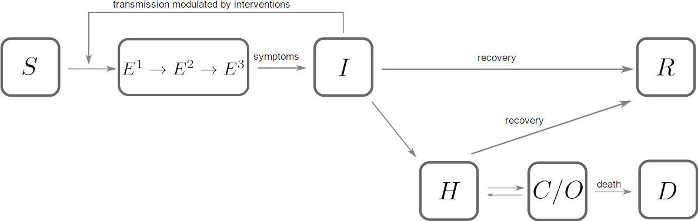
Figure 1. A schematic illustration of the underlying model. S corresponds to the 'susceptible' population, E is 'exposed', I is 'infectious', R 'recovered', H 'severe' (hospitalized), C 'critical in (ICU)', O 'critical not in ICU/overflow', and D are fatalities.
Re-worded suggestion... Figure 1. A schematic illustration of the underlying model. Variables include the susceptible population (S), exposed (E), infectious (I), recovered (R), severe and/or hospitalized (H), critical and/or in the ICU (C), those critical but not in ICU or overflow (O), and fatalities (D).
COVID-19 is much more severe in the elderly, so proportion of elderly in a community is therefore an important determinant of the overall burden on the health care system and the death toll. We collected age distributions for many countries from data provided by the UN and make those available as input parameters. Furthermore, we use data provided by the epidemiology group of the Chinese CDC (alternative link) to estimate the fraction of severe and fatal cases by age group.

Seasonality
We don’t yet know how seasonality will affect COVID-19 transmission; that said, many respiratory viruses such as influenza, common cold viruses (including other coronaviruses) have a pronounced seasonal variation in incidence, in part driven by climate variation through the year. We model this seasonal variation using a sinusoidal function with an annual period. This is a simplistic way to capture seasonality.

For further information on the possible effects of seasonality, see Remaining parameters below.

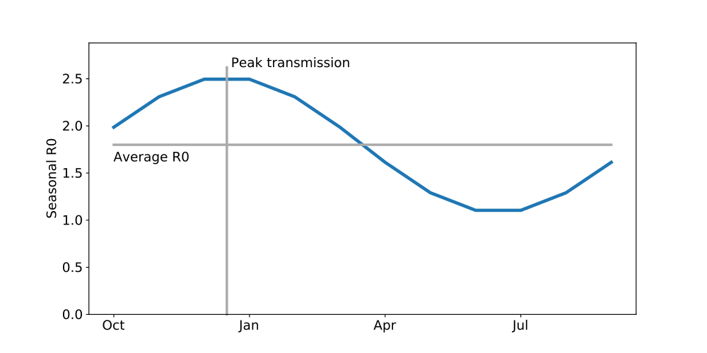
Figure 2. Seasonal variation in transmission rate is modeled by a cosine. The model allows to specify the average R0, the amplitude of the cosine (seasonal forcing), and the month of peak transmission.

Transmission reduction
The tool allows one to explore temporal variation in the reduction of transmission by infection control measures. This is implemented as a curve through time that can be dragged by the mouse to modify the assumed transmission. The curve is read out and used to change the transmission relative to the base line parameters for R0 and seasonality.

Several studies attempt to estimate the effect of different aspects of social distancing and infection control on the rate of transmission. A report by Wang et al. estimates a step-wise reduction of R0 from above 3 to around 1 and then to around 0.3 due to successive measures implemented in Wuhan. This study by Litvinova et al. investigates the effect of school closures on influenza transmission.

Details of the model
Qualitatively we model the epidemic dynamics with the following subpopulations:

- Susceptible individuals [S] are exposed to the virus by contact with an infected individual.
- Exposed individuals [E] progress towards a symptomatic state on average time tl.
- Infected individuals [I] infect an average of R0 secondary infections. On a time-scale of ti, infected individuals either recover or progress towards hospitalization.
- Hospitalized individuals [H] either recover or worsen towards a critical state on a time-scale of th.
- Critical individuals [C] model ICU usage. They either return to the hospital state or die [D] on a time-scale of tc.
D
- Recovered individuals [R] cannot be infected again.
Subpopulations are delineated by age classes, indexed by [a], to allow for variable transition rates dependent upon age. Quantitatively, we solve the following system of equations to estimate hospital usage:

~equations here~
​
The parameters of this model fall into three categories: (1) A time dependent infection rate [β(t)] time scales of transition to a different subpopulation [tl], [ti], [th], [tc], and age specific parameters [ma], [ca], and [fa], that determine relative rates of different outcomes; (2) The latency time from infection to infectiousness is [tl], the time an individual is infectious after which he/she either recovers or falls severely ill is [ti], the time a sick person recovers or deteriorates into a critical state is [th], and the time a person remains critical before dying or stabilizing is t[c]; (3) The fraction of infectious that are asymptomatic or mild is [ma], the fraction of severe cases that turn critical is [ca], and the fraction of critical cases that are fatal is [fa].
One aspect of the model is not reflected in the above system of equations: If the number of critically ill patients exceeds the capacity of ICU, they are placed in an overflow category [O]. Individuals in this category die at a higher rate. Otherwise, the flow is the same as for category [Ca]. Patients are allocated to the overflow category in a manner that gives priority to younger patients.
The transmission rate [βa(t)] is given by:

~equation here~
​
where [ζa] is the degree to which particular age groups are isolated from the rest of the population, [M(t)] is the time course of mitigation measures, [ε] is the amplitude of seasonal variation in transmissibility, and [tmax] is the time of the year of peak transmission.

Parameter estimation
With the prevalence of COVID-19 data for many regions, we now estimate a few select parameters for independent regions that provide public data. Specifically, we estimate the following default scenario parameters:

- R0 value
- The date and initial size of the epidemic start
- Fraction of cases caught by the region's testing infrastructure
These parameters are estimated from both the cumulative number of COVID-19 cases and COVID-19 related fatalities reported. The estimation is accomplished by the minimization of the least squared difference between our model predictions and the empirical data. Specifically:

- We define an objective function that:
  - Takes as input a set of model parameters to simulate.
  - Integrates the equations of motion described above.
  - Returns the sum of squared residuals between the given empirical data and the result of ODE integration.
  - Weights the residuals to the cumulative fatalities relative to case data to account for the difference in magnitudes.

- The objective function is minimized with respect to the above variable parameters using the Nelder Mead algorithm.
- Scenarios are populated with these individualized parameters.

Remaining parameters
- Many estimates of R0 are in the range of 2-3 with some estimates pointing to considerably higher values.
- The serial interval--that is, the time between subsequent infections in a transmission chain--was initially estimated to be 7-8 days. More recent research now suggests a serial interval of 5-6 days (see Ganyani et al.).
- The China CDC compiled extensive data on severity and fatality of more than 40 thousand confirmed cases. In addition, we assume that a substantial fraction of infections, especially in the young, go unreported. This is encoded in the columns "Confirmed [% of total]".
- Seasonal variation in transmission is common for many respiratory viruses but the strength of seasonal forcing for COVID19 is uncertain. For more information, see a study by us and by Kissler et al.

References

