CLOUD COMPUTING-CSA1554

EXP-1: SaaS Application

Aim
To create a simple cloud-based application and provide it as Software as a Service (SaaS) using Zoho Creator.

Algorithm
- Login to Zoho Creator
- Create a new application
- Create a form (Task Form)
- Add required fields (Title, Description, Date, etc.)
- Save the form
- Create report to view data
- Deploy and share the application

Input
User enters task details
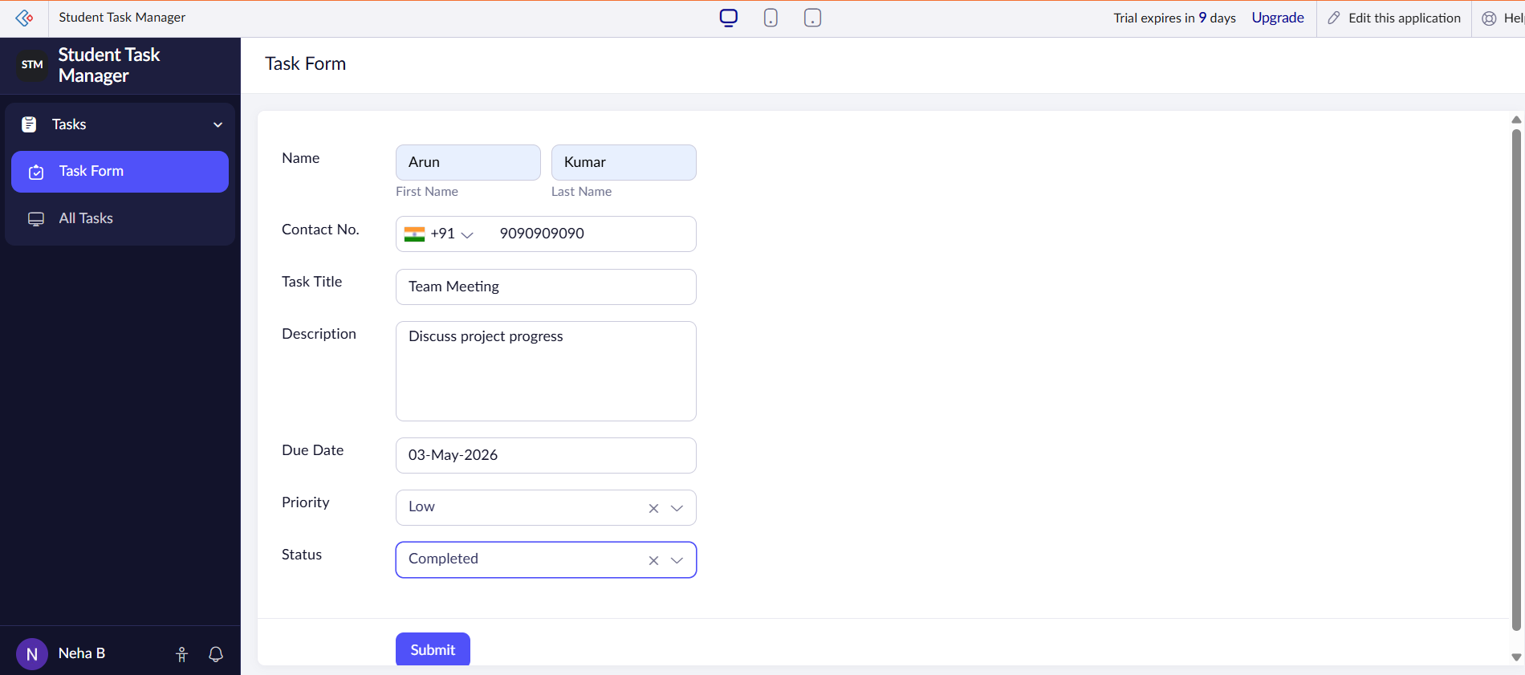

Output
Task details stored and displayed in cloud

