CLOUD COMPUTING-CSA1554

EXP-6: Hospital Management System

Aim
To create a cloud-based Hospital Management System and provide it as Software as a Service (SaaS) using Zoho Creator.

Algorithm
- Login to Zoho Creator
- Create a new application
- Create a form (Patient Form)
- Add fields (Patient Name, Age, Gender, Doctor Name, etc.)
- Save the form
- Create report to view patient records
- Deploy and share the application

Input
Patient details
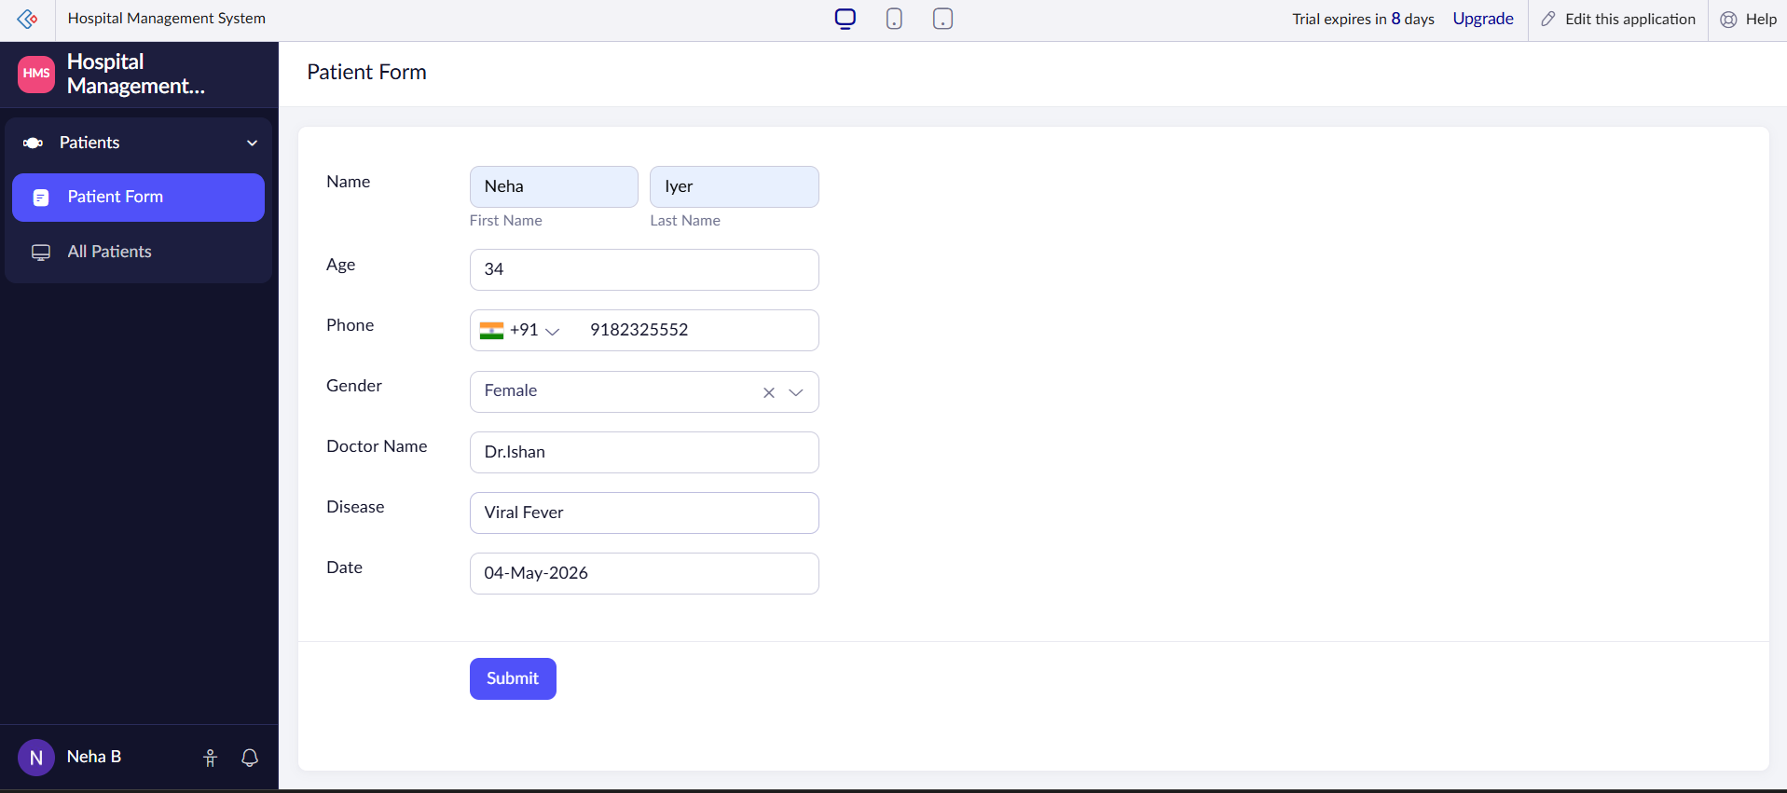

Output
Patient records stored and displayed in cloud
