CLOUD COMPUTING-CSA1554

EXP-2: Flight Reservation System

Aim
To develop a cloud-based Flight Reservation System and provide it as SaaS.

Algorithm
- Login to Zoho Creator
- Create a new application
- Create a form (Booking Form)
- Add fields (Passenger Name, From, To, Date, etc.)
- Save the form
- Generate report for bookings
- Deploy and share application

Input
User enters flight booking details
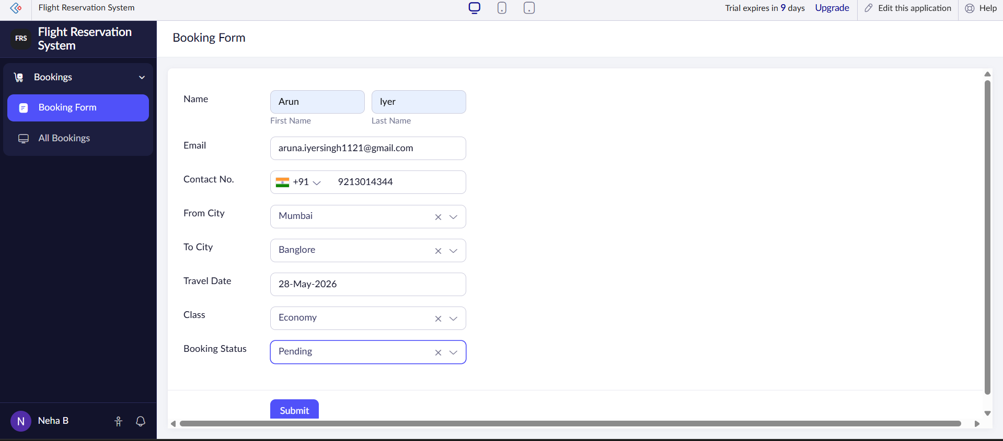

Output
Flight booking details displayed and stored

