CLOUD COMPUTING-CSA1554

EXP-3: Property Buying & Rental System

Aim
To create a cloud-based Property Buying and Rental system for Chennai city using SaaS.

Algorithm
- Login to Zoho Creator
- Create new application
- Create form (Property Form)
- Add fields (Owner Name, Location, Price, Type, etc.)
- Save the form
- Create report for properties
- Deploy and share application

Input
User enters property details
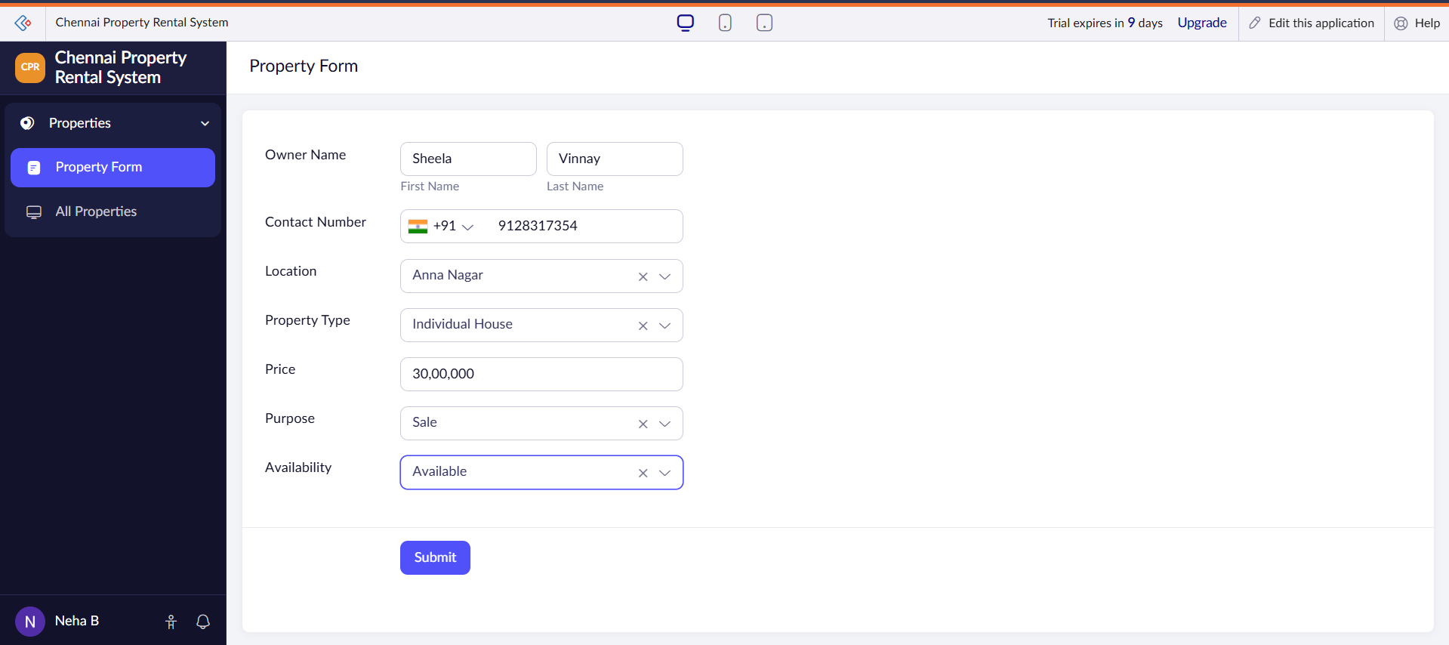

Output
Property listings stored and displayed

