CLOUD COMPUTING-CSA1554

EXP-4: Car Booking Reservation System

Aim
To develop a cloud-based Car Booking Reservation System using SaaS.

Algorithm
- Login to Zoho Creator
- Create new application
- Create form (Car Booking Form)
- Add fields (Customer Name, Car Type, Date, etc.)
- Save the form
- Create report for bookings
- Deploy and share application

Input
User enters car booking details
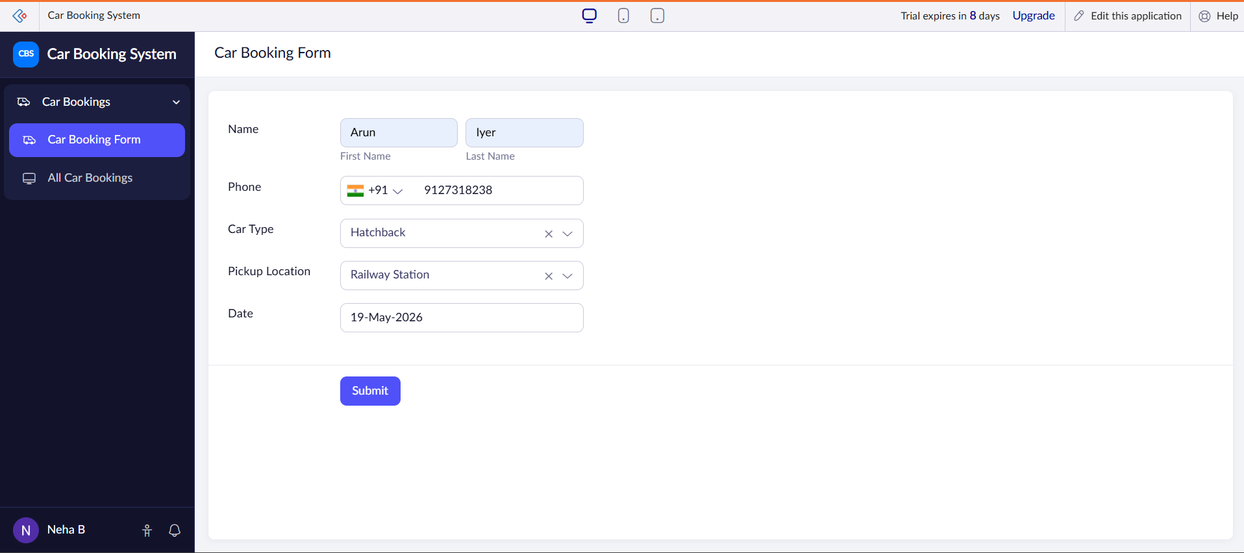

Output
Car booking data stored and displayed
