CLOUD COMPUTING-CSA1554

EXP-5: Library Book Reservation System

Aim
To create a cloud-based Library Book Reservation system for SIMATS using SaaS.

Algorithm
- Login to Zoho Creator
- Create new application
- Create form (Library Form)
- Add fields (Student Name, Book Name, Issue Date, etc.)
- Save the form
- Create report for reservations
- Deploy and share application

Input
User enters book reservation details
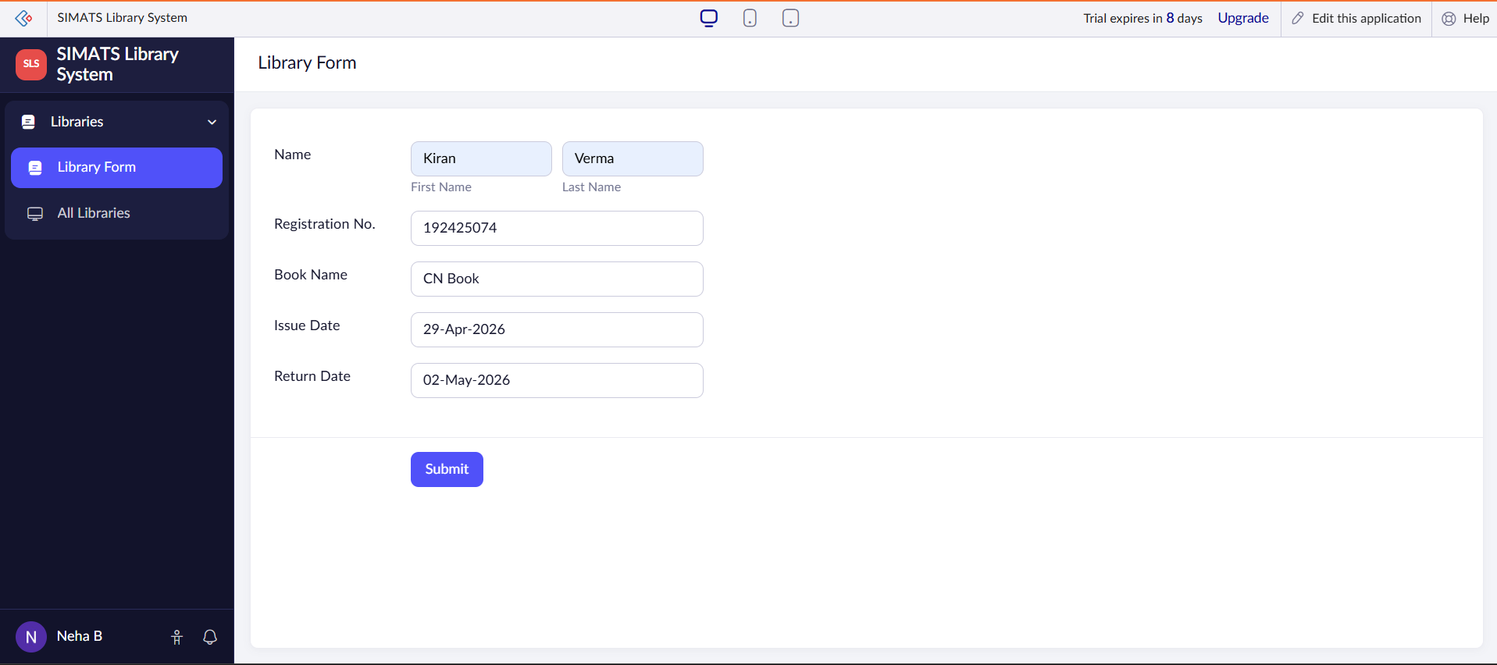

Output
Book reservation details stored and displayed
