Disaster Recovery Implementation Plan for IBM Cloud Foundry Project

**Table of Contents**

1. Introduction

2. Project Overview

3. Risk Assessment

4. Replication set up

5. Backup and Restoration Plan

6. Recovery Testing

7. Conclusion

**1. Introduction**

The Disaster Recovery Implementation Plan outlines the measures and procedures for maintaining the continuity of our technology project hosted on IBM Cloud Foundry in the event of a disruptive incident. This document aims to ensure the integrity, availability, and resilience of our systems against potential disasters.

**2. Project Overview**

Describe the project hosted on IBM Cloud Foundry, including its architecture, components, and dependencies. This section should provide a clear understanding of the technology stack and the importance of maintaining its availability.

**3. Risk Assessment**

Identify potential risks and threats that may impact the availability and functionality of the project. Assess the likelihood and potential impact of each risk, considering factors such as hardware failure, data corruption, cyber attacks, and natural disasters.

A code snippet for designing a map is shown below:

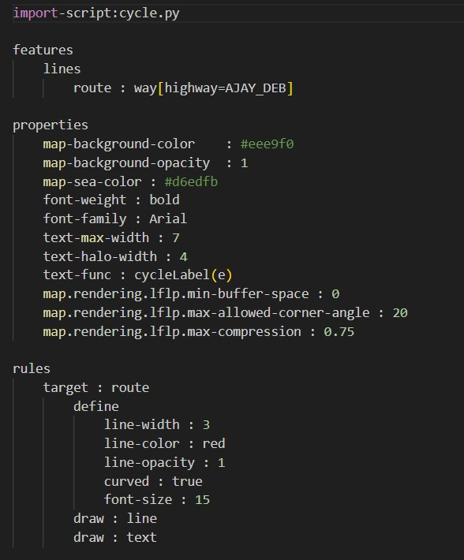

**4. Replication set up:**

IBM Cloud Object Storage:

IBM Cloud Object Storage offers data replication features, allowing you to create multiple copies of your data in different geographic regions. This redundancy ensures data availability and durability.

Create IBM Cloud Object Storage Instances:

Sign in to your IBM Cloud account and create at least two IBM Cloud Object Storage instances, one in your primary location and another in your secondary location (disaster recovery site).

Select Regional and Cross-Region Options:

IBM Cloud Object Storage offers regional and cross-region options for data replication. Choose the appropriate option based on your disaster recovery requirements.

Configure Replication Policy:

Within each IBM Cloud Object Storage instance, configure replication policies to specify which data should be replicated and the replication destination. These policies can be set to replicate data within the same region or to a different geographical region for disaster recovery.

Data Replication: Depending on your chosen replication policy:

For Regional Replication: Data is replicated to multiple data centers within the same region.

For Cross-Region Replication: Data is replicated to another IBM Cloud Object Storage instance in a different geographic region.

Data Classification and Lifecycle Policies:

Implement data classification and lifecycle policies to manage the retention and expiration of data based on your disaster recovery strategy.

Monitoring and Alerts:

Set up monitoring and alerts to track the status of data replication and to be notified of any issues.

Data Validation:

Periodically validate the replicated data to ensure its integrity and consistency between the primary and secondary locations.

Encryption and Security:

Ensure that data in transit and at rest is encrypted and follows security best practices.

Test Failover Procedures:

Regularly conduct tests to validate the failover process from the primary to the secondary location. This ensures that you can seamlessly switch to the secondary site in the event of a disaster.

Documentation and Training:

Document your replication setup, policies, procedures, and failover process. Provide training to your team members involved in recovery efforts.

Compliance and Legal Considerations:

Ensure that your replication setup and disaster recovery procedures comply with industry-specific regulations and legal requirements.

Regular Maintenance and Testing:

Continuously assess and improve your data replication and disaster recovery plan based on feedback and lessons learned from testing and real-world incidents. Regularly test the entire disaster recovery process to ensure its effectiveness.

Replicating data in IBM Cloud Object Storage ensures that your data remains available and durable even in the face of regional disasters or other unexpected disruptions. Regular testing and maintenance are key to ensuring that your disaster recovery plan functions as intended.

**5. Backup and Restoration Plan**

Detail the procedures for regular data backups, including the frequency, storage location, and encryption methods. Specify the restoration process, highlighting the steps involved in recovering data and system configurations from the backups.

**6. Recovery Testing**

Recovery testing is a critical component of your disaster recovery plan, especially when using IBM Cloud or any other cloud-based infrastructure. It helps ensure that your recovery procedures work as expected and that you can successfully restore your systems and data in the event of a disaster. Here are the steps to perform recovery testing for your disaster recovery plan in an IBM Cloud environment:

1. Scenario Selection : Identify specific disaster scenarios to test.

2. Test Environments : Create separate test environments resembling the production setup.

3. Objectives and Plan : Define test objectives and develop detailed recovery test plans.

4. Data and Application Recovery : Test data and application recovery procedures.

5. Network and Failover : Validate network configurations and perform failover tests.

6. Performance and User Experience : Evaluate performance and user experience in the recovery environment.

7. Automation and Monitoring : Test automation scripts and monitoring/alerting systems.

8. Documentation and Training : Review documentation, provide training, and ensure team awareness.

9. Data Validation : Validate data integrity after recovery.

10. Evaluation and Iteration : Assess test results, identify improvements, and adjust the recovery plan.

11. Regular Testing : Schedule and conduct regular recovery tests to maintain preparedness.

Recovery testing helps ensure that your disaster recovery plan is effective, and your systems and data can be successfully restored during unforeseen disasters.

**7. Conclusion**

Summarize the key points of the disaster recovery implementation plan and emphasize the critical role of IBM Cloud Foundry in maintaining the resilience and reliability of the project. Highlight the importance of continuous monitoring and improvement of the disaster recovery strategies..