**Disaster Recovery Implementation Plan**

**for IBM Cloud Foundry Project**

**Problem Statement:**

Considering the increasing dependency on the IBM Cloud Foundry Project for critical business operations, there exists a significant vulnerability in the event of unforeseen disasters or system failures. Currently, the absence of a structured and comprehensive Disaster Recovery Plan poses a substantial risk to the continuity and resilience of the services provided by the IBM Cloud Foundry environment.

**Documentation:**

The documentation for a Disaster Recovery Implementation Plan for an IBM Cloud Foundry Project should be comprehensive, providing a clear guide for the recovery procedures, responsibilities, and actions to be taken in case of a disaster or system failure.

Information on the document version, change history, and responsible personnel for updates and revisions. Summary of potential risks and threats to the IBM Cloud Foundry Project. Assessment of the impact these risks can have on the project's operations. Defined Recovery Time Objectives (RTO) and Recovery Point Objectives (RPO). Detailed plans for each type of disaster scenario, including hardware failure, system crashes, natural disasters, cyber-attacks, etc.

Detailed list of responsibilities for different team members and their roles during a disaster recovery situation. Security protocols and encryption methods used to protect data during backup, replication, and transfer processes. Comprehensive documentation of the disaster recovery plan. Training materials and resources for staff to ensure understanding and readiness. Plans for regular review, testing, and updates to the Disaster Recovery Plan. Supportive materials, references, and additional information relevant to the Disaster Recovery Plan. Space for designated authorities to review, approve, and sign-off on the documentation.

**Technical Implementation:**

**Understand the Business Needs:**

The first step involves understanding the critical aspects of the business, identifying the most essential systems, applications, and data, and assessing the potential risks and impact of various disasters.

**Define Disaster Recovery Requirements:**

Based on the business needs and risks, define the specific requirements for disaster recovery, including Recovery Time Objectives (RTO) and Recovery Point Objectives (RPO).

**Identify Cloud Services:**

Choose the appropriate cloud services and platforms (e.g., AWS, Azure, GCP) based on the business's needs, budget, and technical requirements.

**Design the Disaster Recovery Plan**:

Create a detailed plan that outlines the disaster recovery strategy, backup configuration, data replication, and recovery testing procedures.

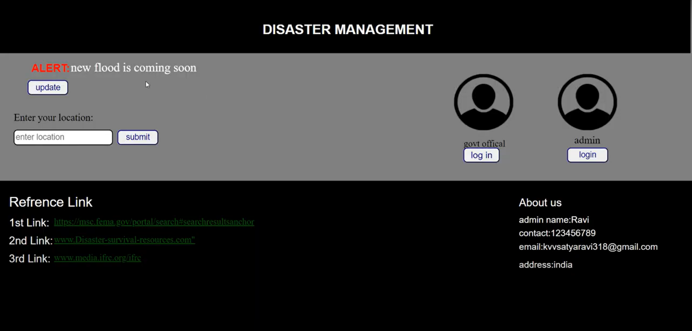**Home Page:**

**Government Employee Login Page:**



**Tasks done by the government employee:**



**Alert updating details:**



**Create location details:**

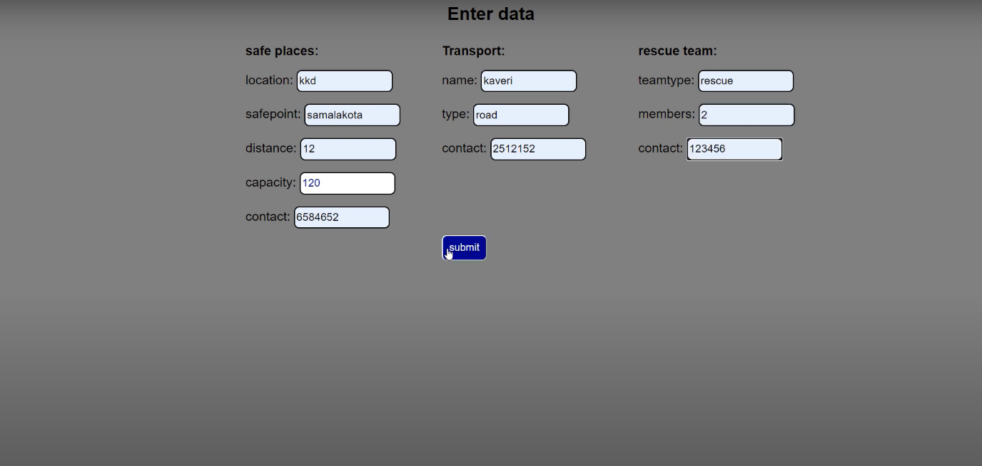

**Show location details:**

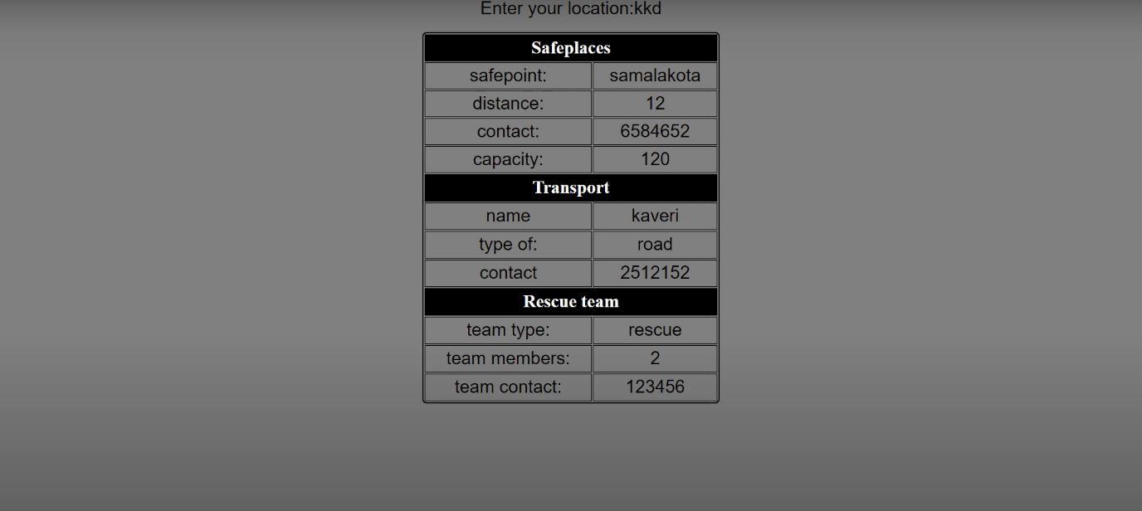

**Conclusion:**

Disaster Recovery Implementation Plan for an IBM Cloud Foundry project is an essential component of your overall risk management strategy. By taking a proactive and systematic approach to disaster recovery, you can minimize downtime, protect critical data, and ensure the continuity of your operations in the face of unexpected disruptions. Regularly update and test your plan to maintain its effectiveness and keep your organization resilient in the face of adversity.