Architecture Proposal
Google ADK + MCP Server Integration
Data Commons Auto-Schematization Pipeline
February 2026

Executive Summary

Problem Statement
The current PVMAP generation pipeline is a monolithic Python script (~1,500 lines) that handles all processing phases sequentially. While functional, this architecture limits scalability, testing, and extensibility.
- Single script handles discovery, sampling, schema selection, generation, and validation
- Gemini-only LLM support limits flexibility and vendor independence
- No real-time connection to Data Commons knowledge graph
- Difficult to unit test individual components
- Error feedback loop is tightly coupled to generation logic

Proposed Solution
We propose migrating to an agent-based architecture using Google ADK (Agent Development Kit) with MCP (Model Context Protocol) server integration for real-time Data Commons queries.
- Modular agent pipeline with 6 specialized agents orchestrated by SequentialAgent
- LoopAgent-based retry mechanism for automatic error recovery with structured feedback
- MCP server enables real-time StatVar discovery before generation
- Multi-LLM support (Gemini, Claude) via abstracted agent interfaces
- Each agent is independently testable, debuggable, and replaceable

Expected Benefits
- Improved accuracy through pre-generation StatVar discovery (reduces hallucination)
- Better maintainability with modular, single-responsibility agents
- Faster development cycles via isolated testing and debugging
- Enhanced extensibility for future features (new agents, tools, LLMs)
- Real-time validation against Data Commons schema

Google ADK Architecture

How ADK Improves the Pipeline
ADK enables us to break the monolithic pipeline into specialized agents, each handling one task. This modular design allows independent testing, easier debugging, and the ability to swap or upgrade individual components without affecting others.

ADK Components Used
- LlmAgent: Used for Discovery, Sampling, Schema Selection, DC Query, and Evaluation agents - each with focused instructions and tools
- SequentialAgent: Coordinates the pipeline flow (Discovery → Sampling → Schema Selection → Generation → Evaluation)
- LoopAgent: Powers the PVMAP retry mechanism - automatically retries generation with error feedback until validation passes (max 3 attempts)
- Session State: Passes data between agents (dataset info, sampled data, discovered StatVars, generated PVMAP)

Agent Pipeline Overview
The pipeline consists of 6 specialized agents orchestrated by a SequentialAgent coordinator. Each agent has a single responsibility and communicates via session state.
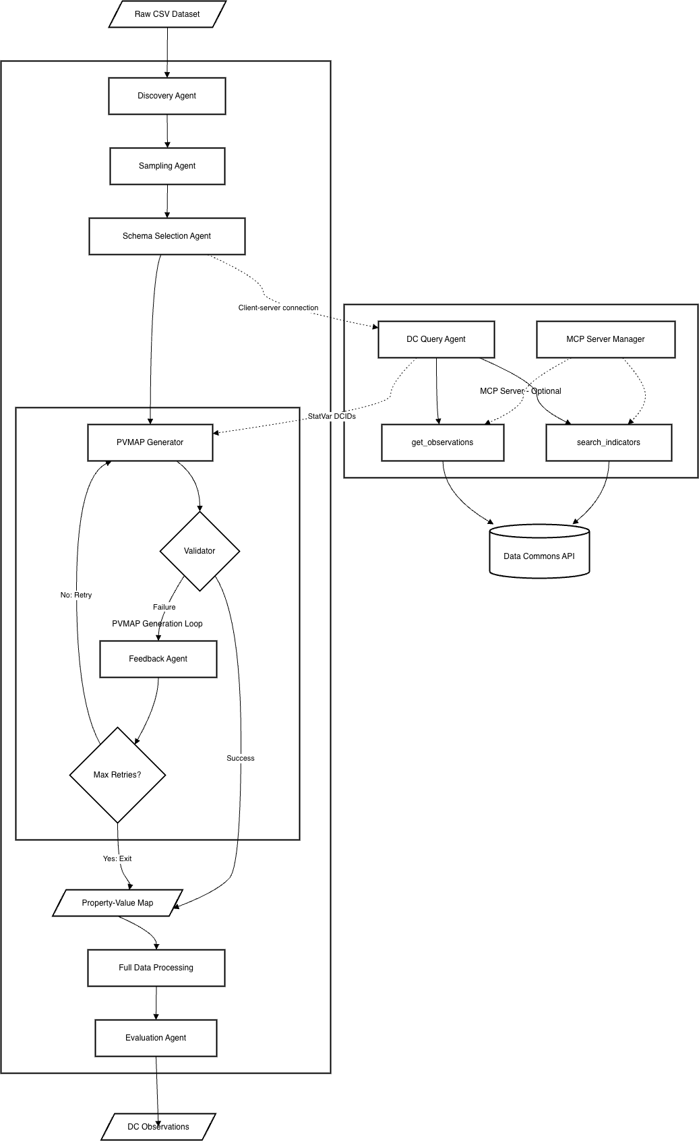
Figure 1: ADK + MCP Architecture Diagram
Agent | Type | Responsibility
Discovery Agent | LlmAgent | Scans input directory for CSV datasets, validates required files (metadata, input data), and registers datasets for processing
Sampling Agent | LlmAgent | Extracts representative rows (max 100) ensuring coverage of all categorical values and numeric ranges - reduces LLM context while preserving data diversity
Schema Selection | LlmAgent | Analyzes dataset content to select the best-matching schema category (Demographics, Economy, Health, etc.) and loads corresponding examples
DC Query Agent | LlmAgent + MCP | (Optional) Queries Data Commons API to find existing StatVar DCIDs matching dataset columns - reduces hallucination by providing real DCIDs to generator
PVMAP Generation | LoopAgent | Generates PVMAP, validates against full dataset using stat_var_processor, and automatically retries with error feedback on failure (max 3 attempts). Samples error logs (~300 lines) for efficient feedback.
Evaluation Agent | LlmAgent | Compares generated PVMAP against ground truth files, calculates PV accuracy and Node accuracy metrics, generates detailed diff reports

MCP Server Integration

How MCP Improves Accuracy
MCP enables real-time queries to Data Commons before PVMAP generation. Instead of guessing StatVar names, the pipeline can discover actual DCIDs from the knowledge graph, significantly reducing hallucination.

MCP Server Architecture
The MCP server runs as a subprocess managed by MCPServerManager. It exposes Data Commons API endpoints as tools that agents can invoke.

MCPServerManager Lifecycle
- Startup: Launches MCP server as subprocess on localhost:3000
- Health Check: Verifies server is responsive before returning
- Context Manager: Uses Python's context manager pattern for safe resource cleanup
- Shutdown: Gracefully terminates subprocess on pipeline completion

Available MCP Tools
The MCP server exposes two primary tools for Data Commons integration:
Tool | Parameters | Returns
search_indicators | query: string  places: string[] | StatVars and topics matching query (DCIDs, names, descriptions)
get_observations | variable_dcid: string  place_dcid: string | Statistical observations (date, value, unit) for the variable at the place

DC Query Agent Integration
The DC Query Agent is an LlmAgent that uses MCP tools to discover StatVars before PVMAP generation. This pre-generation discovery is the key innovation for reducing hallucination.

Pre-Generation StatVar Discovery Workflow
- DC Query Agent receives dataset metadata and column names from Schema Selection Agent
- Agent formulates search queries based on column names (e.g., "population count", "unemployment rate")
- Calls search_indicators() MCP tool to find matching StatVars in Data Commons
- Optionally calls get_observations() to validate that StatVars have data for relevant places
- Discovered StatVar DCIDs are stored in session state and passed to PVMAP Generator

Reducing Hallucination
Without MCP integration, the LLM must guess StatVar names based on training data, leading to hallucinated DCIDs. With real-time Data Commons queries:
- Generator receives actual DCIDs from Data Commons, not guessed names
- Validation can confirm StatVars exist before PVMAP generation
- Prompt includes discovered StatVars as "preferred" options, guiding generation
- Reduces retry loops by providing accurate context upfront

Key Benefits & Comparison

Architectural Benefits
Benefit | Description
Modularity | Each agent is independently testable and replaceable. Changes to one agent do not affect others. Easier debugging with isolated failure points.
Extensibility | New agents can be added without modifying existing code. Supports plugin architecture for custom processing steps.
Real-time Integration | MCP enables live Data Commons queries, reducing guesswork and hallucination. StatVars are validated before use.
Multi-LLM Support | Architecture supports Gemini, Claude, and future LLM providers via abstracted interfaces. No vendor lock-in.
Automatic Retry | LoopAgent handles retry logic with structured error feedback, improving success rates. Configurable max attempts.

Before vs After Comparison
Aspect | Before | After
Architecture | Monolithic (~1500 lines) | 6 modular agents
LLM Support | Gemini only | Gemini + Claude + others
DC Integration | None (offline) | Real-time via MCP
Retry Mechanism | Embedded in script | LoopAgent (ADK)
Testability | Integration tests only | Unit + integration

Conclusion
The proposed Google ADK + MCP architecture provides significant improvements over the current monolithic pipeline:
- Modular Design: 6 specialized agents with single responsibilities, enabling independent testing and development
- Real-time Integration: MCP server enables live Data Commons queries for StatVar discovery
- Improved Accuracy: Pre-generation StatVar discovery reduces hallucination of non-existent DCIDs
- Automatic Retry: LoopAgent handles validation failures with structured error feedback
- Future-proof: Multi-LLM support and extensible plugin architecture
The backward compatibility layer ensures existing workflows continue to function during the transition period.

See the architecture diagram in Figure 1 above, or refer to complete_architecture_diagram.md for the Mermaid version (importable into draw.io).

