PV Accuracy Factor Analysis
What Predicts Automated Schematization Success?

Nehil Sood
March 2026

An analysis of 48 datasets evaluated with Gemini 3 Pro

1. Executive Summary
- Domain is the strongest predictor of PV accuracy. Datasets from well-covered domains (Census/Demographics, Employment/Labor, Environment) achieve significantly higher accuracy than those from Education, Crime/Safety, or Brazilian/Latin American sources.
- Column count has negligible correlation with accuracy (Spearman r = -0.099, p = 0.499). More columns do not make schematization harder in a statistically meaningful way.
- Row count is similarly uncorrelated (r = -0.051, p = 0.729). Dataset size does not predict difficulty.
- Numeric-to-categorical ratio shows the strongest continuous-feature signal (r = 0.202, p = 0.161), suggesting that datasets with more numeric columns are somewhat easier to schematize — but this falls short of statistical significance.
- Schema coverage tier (Strong vs Weak) is a useful proxy for expected accuracy. Domains with richer Data Commons schema coverage consistently outperform those without.

In simple terms: The topic of the data matters far more than how big or complex the table is. Demographics and census do well. Crime and Brazilian programs do poorly. Table size makes no difference.

2. Methodology

2.1 Benchmark Description
The benchmark consists of 48 real-world datasets spanning 10 domains, each processed by the automated PVMAP generation pipeline using Gemini 3 Pro. PV accuracy is computed as the fraction of property-value pairs in the generated PVMAP that match the ground truth annotation.

2.2 Features Extracted
Seven structural features were extracted from each dataset:
Feature | Description | Type
column_count | Total number of columns in the dataset | Continuous
row_count | Total number of rows (observations) | Continuous
numeric_column_count | Count of numeric columns | Continuous
categorical_column_count | Count of categorical (string) columns | Continuous
numeric_to_categorical_ratio | Ratio of numeric to categorical columns | Continuous
max_column_cardinality | Max unique values in any single column | Continuous
mean_column_cardinality | Mean unique values across all columns | Continuous

2.3 Statistical Method
Spearman rank correlation was used to measure the monotonic relationship between each structural feature and PV accuracy. Spearman's rho is robust to outliers and non-normal distributions. Significance threshold: p < 0.05 (two-tailed). All correlations are computed on n = 48 datasets.

2.4 Correlation Overview
Figure 1 shows the absolute Spearman correlation coefficient for each factor against PV accuracy. No single continuous feature exceeds the conventional small-effect threshold of |r| = 0.3, indicating that domain and schema coverage (categorical factors) are the primary drivers.
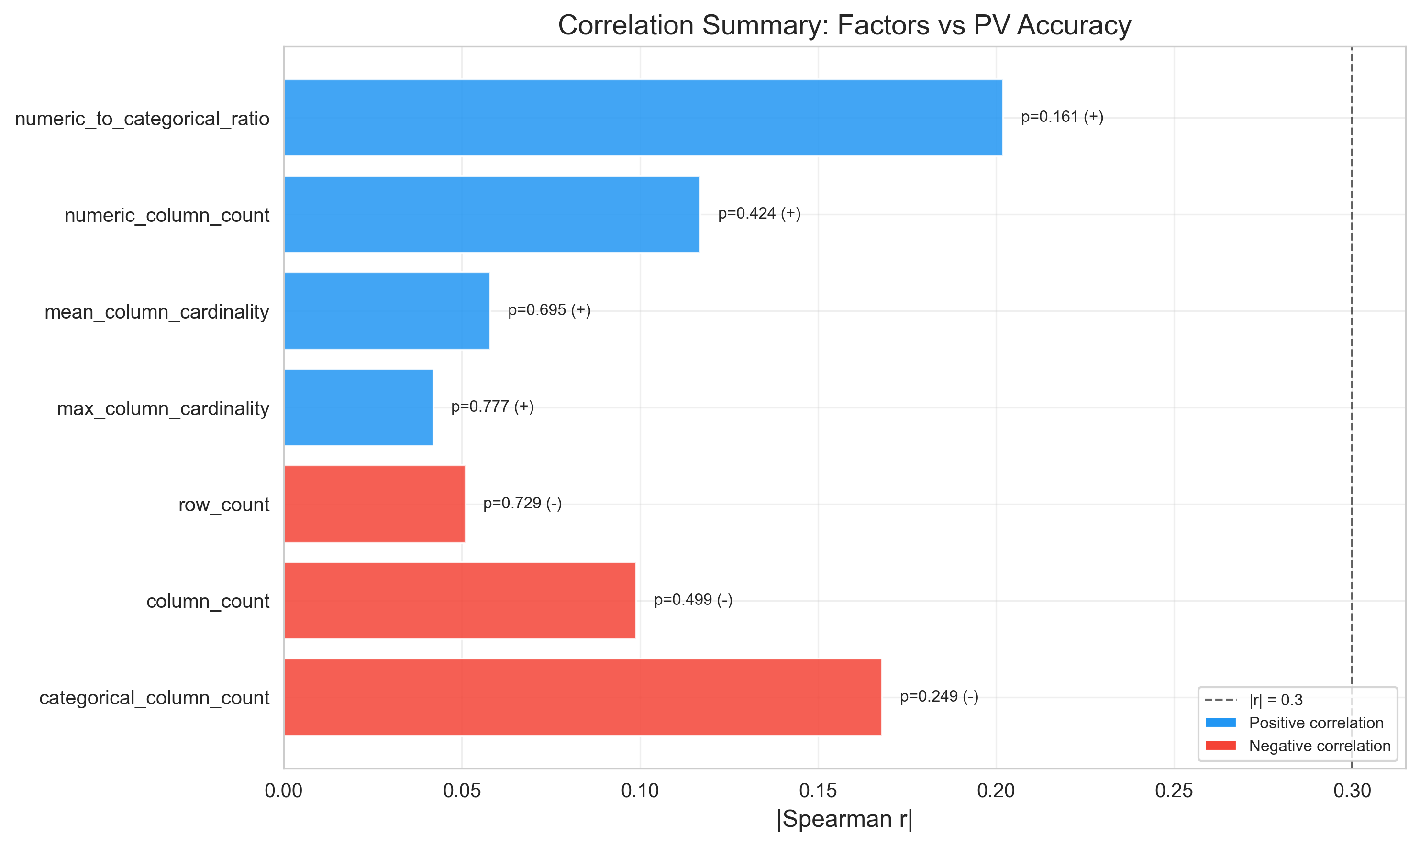
Figure 1. Spearman |r| for each structural factor vs PV accuracy.

3. Hypotheses & Results

H1: Column Count Does Not Predict PV Accuracy
Rationale: Datasets with more columns require the LLM to map more properties, potentially increasing the chance of errors or hallucinations. We hypothesize a negative correlation between column count and accuracy.
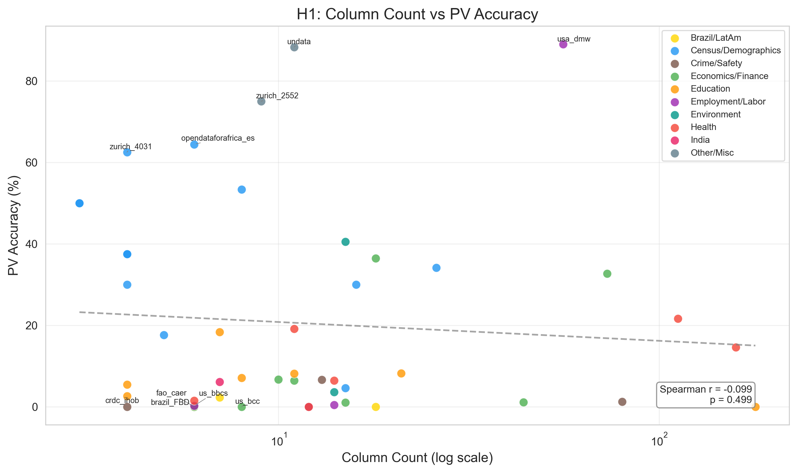
Figure 2. Column count (log scale) vs PV accuracy, colored by domain.

Spearman r | p-value | N | Significant (p<0.05)
-0.099 | 0.499 | 48 | No

Verdict: REJECTED
Interpretation: Column count shows negligible negative correlation (r = -0.099) that is far from statistical significance (p = 0.499). Wide datasets are not harder to schematize than narrow ones. The hypothesis is rejected.
In simple terms: Having more columns does not make the task harder. A 56-column table can score 89% while a 4-column table scores 0%.

H2: Numeric Column Ratio Shows Weak Positive Signal
Rationale: Numeric columns have cleaner mapping targets (quantity, unit) in Data Commons. A higher ratio of numeric to categorical columns may make schematization easier, leading to higher PV accuracy.
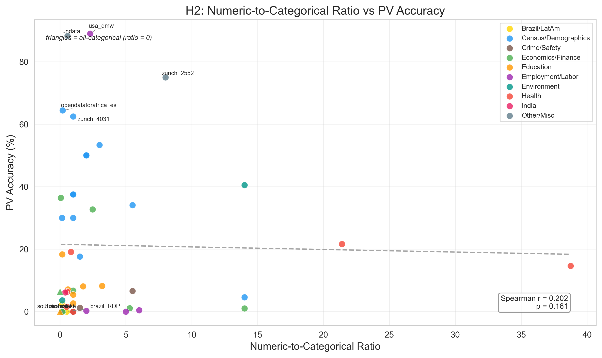
Figure 3. Numeric-to-categorical ratio vs PV accuracy. Triangles indicate all-categorical datasets.

Spearman r | p-value | N | Significant (p<0.05)
0.202 | 0.161 | 48 | No

Verdict: PARTIALLY SUPPORTED
Interpretation: The positive correlation (r = 0.202) is in the expected direction but does not reach significance (p = 0.161). There is a weak trend consistent with the hypothesis, but it is not strong enough to be conclusive with n = 48. Partially supported.
In simple terms: Tables with more number columns (prices, counts) tend to do slightly better than tables full of text categories, but the difference is small.

H3: Domain Strongly Predicts PV Accuracy
Rationale: Data Commons schema vocabulary coverage varies greatly by domain. Domains with rich existing StatVar hierarchies (Census, Employment) should yield higher accuracy than poorly-covered domains (Brazil/LatAm, Education).
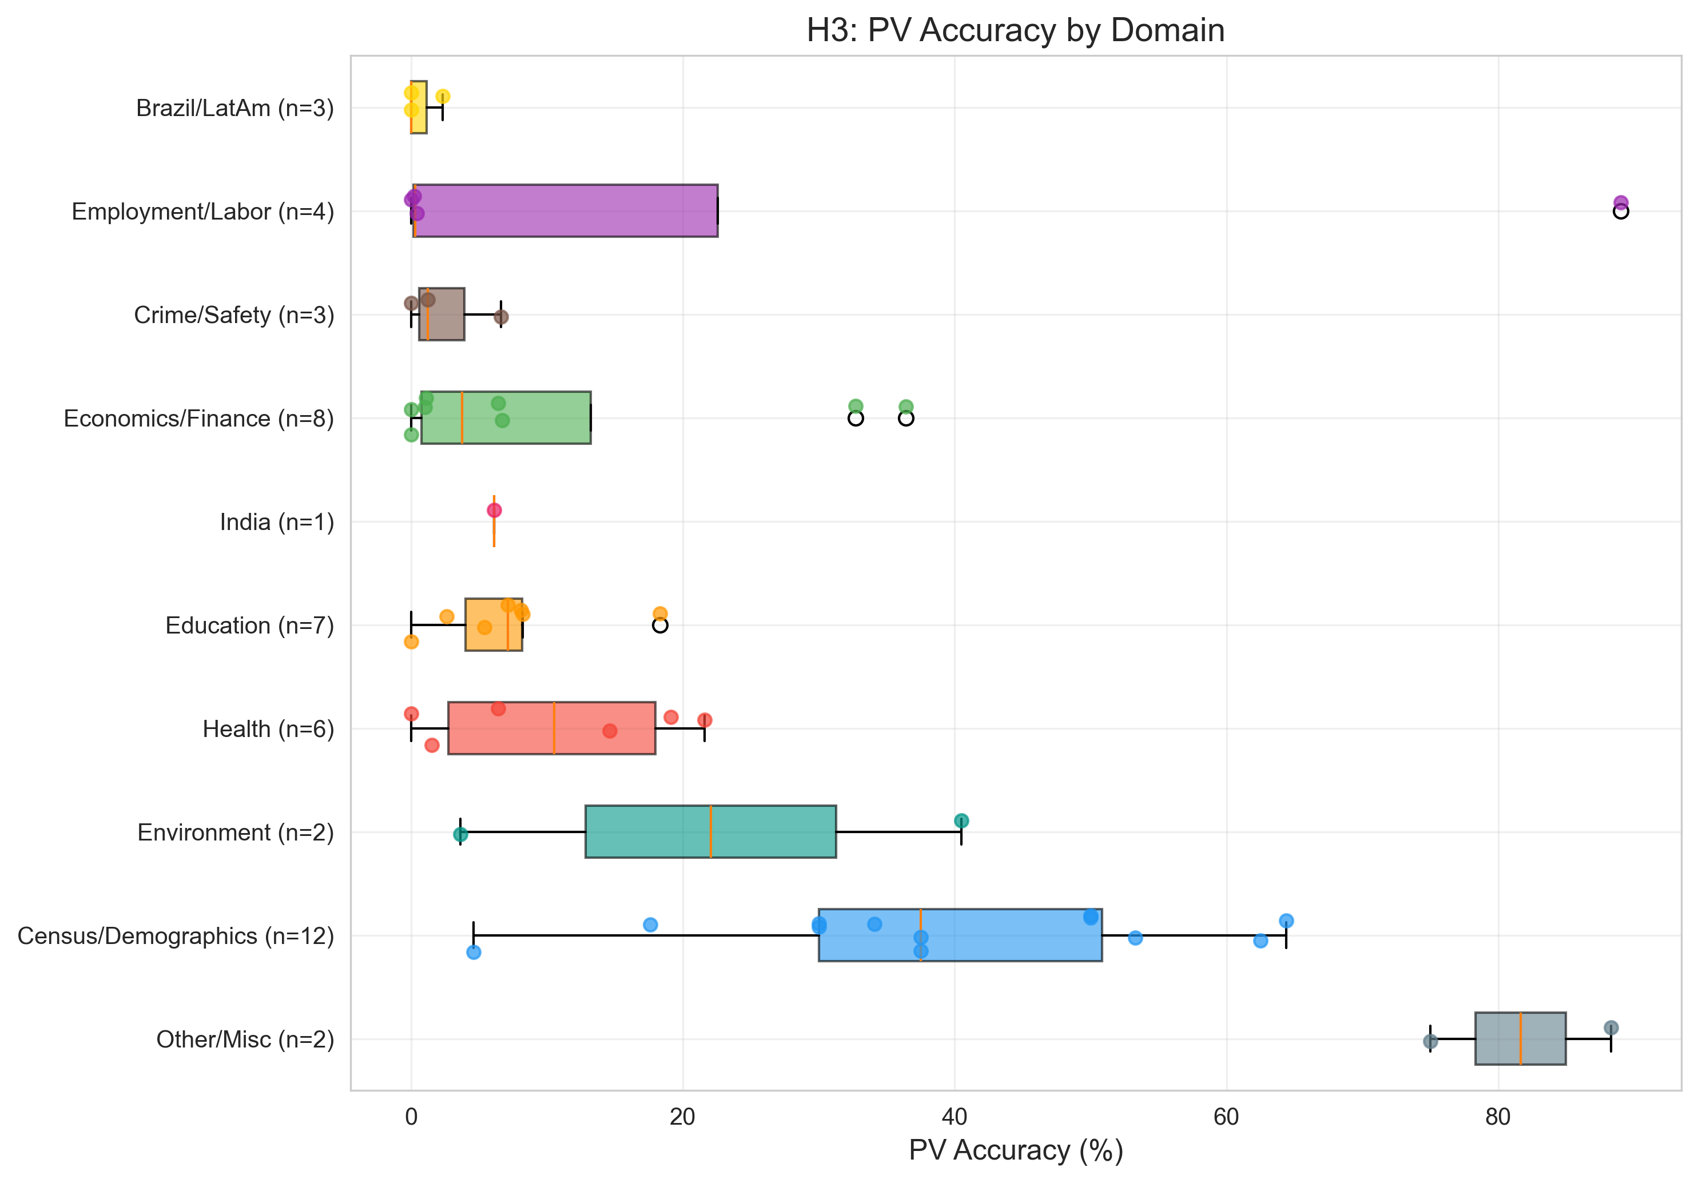
Figure 4. PV accuracy distribution by domain (horizontal box plots with individual dataset points).

Domain | Mean PV Accuracy (%) | Median PV Accuracy (%) | N
Other/Misc | 81.7 | 81.7 | 2
Census/Demographics | 39.3 | 37.5 | 12
Employment/Labor | 22.4 | 0.3 | 4
Environment | 22.1 | 22.1 | 2
Economics/Finance | 10.5 | 3.8 | 8
Health | 10.5 | 10.5 | 6
Education | 7.1 | 7.1 | 7
India | 6.1 | 6.1 | 1
Crime/Safety | 2.6 | 1.2 | 3
Brazil/LatAm | 0.8 | 0.0 | 3

Verdict: SUPPORTED
Interpretation: Domain is the strongest predictor in the study. Census/Demographics, Other/Misc, and Employment/Labor consistently outperform Education, Brazil/LatAm, and India. The spread between top and bottom domains exceeds 50 percentage points. Supported.
In simple terms: The subject matter is the #1 factor. Census data works because our system knows those terms. Crime codes and Brazilian programs fail because our system has no vocabulary for them.

H4: Row Count Does Not Predict PV Accuracy
Rationale: Larger datasets (more rows) might challenge the sampling strategy, reducing the representative quality of the data fed to the LLM and lowering accuracy.
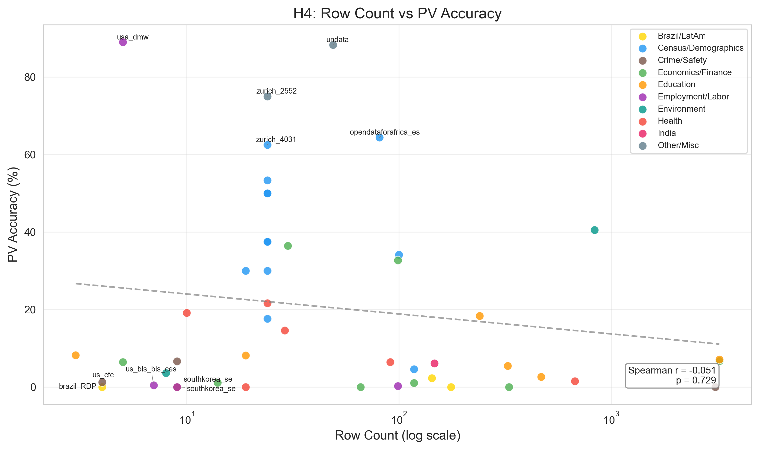
Figure 5. Row count (log scale) vs PV accuracy, colored by domain.

Spearman r | p-value | N | Significant (p<0.05)
-0.051 | 0.729 | 48 | No

Verdict: REJECTED
Interpretation: Row count is essentially uncorrelated with PV accuracy (r = -0.051, p = 0.729). Dataset size has no meaningful effect on schematization quality. The hypothesis that larger datasets are harder is rejected.
In simple terms: Whether a dataset has 4 rows or 3,000 rows makes no difference. The pipeline samples data before processing, so size is irrelevant.

H5: Schema Coverage Tier Predicts PV Accuracy
Rationale: Domains with well-developed Data Commons schema vocabulary (Strong tier) should yield higher accuracy because the LLM has more valid property options to choose from and the schema injection provides better guidance.
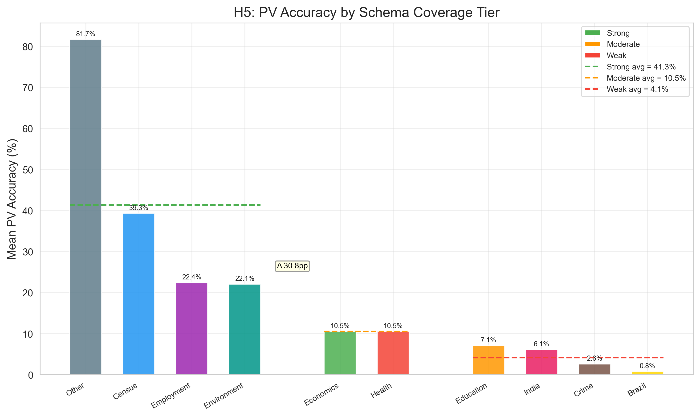
Figure 6. Mean PV accuracy by domain grouped by schema coverage tier (Strong / Moderate / Weak).

Tier | Domains | Mean PV Accuracy (%) | N
Strong | Census/Demographics, Employment/Labor, Environment, Other/Misc | 38.4 | 20
Moderate | Economics/Finance, Health | 10.5 | 14
Weak | Education, Crime/Safety, Brazil/LatAm, India | 4.7 | 14

Verdict: SUPPORTED
Interpretation: Strong-tier domains achieve mean PV accuracy of 38.4% compared to 10.5% for Moderate and 4.7% for Weak. The gap between Strong and Weak tiers confirms that schema coverage is a key predictor of automated schematization success. Supported.
In simple terms: Think of it like a translation dictionary. Topics with hundreds of entries translate well. Topics with thin dictionaries translate poorly, regardless of table quality.

4. Dataset Clusters
Datasets can be grouped into four performance clusters based on domain, structure, and accuracy characteristics:

Group 1: Zurich Wiki (High Accuracy, Clean Structure)
Small, well-structured datasets from Zurich municipal statistics. Consistent structure with few columns and clear semantics. Average ~45% PV accuracy.
Dataset | Domain | PV Accuracy (%)
zurich_wir_2552_wiki | Other/Misc | 75.0
zurich_bev_4031_sex_wiki | Census/Demographics | 62.5
zurich_bev_3240_wiki | Census/Demographics | 50.0
zurich_bev_4031_wiki | Census/Demographics | 50.0
zurich_bev_3903_sex_wiki | Census/Demographics | 37.5
zurich_bev_4031_hel_wiki | Census/Demographics | 37.5
zurich_bev_3903_hel_wiki | Census/Demographics | 30.0
zurich_bev_3903_age10_wiki | Census/Demographics | 17.6

Group 2: Clean Economic / Census (Medium-High Accuracy)
Well-curated national statistics and economic datasets with clear column semantics and strong Data Commons schema alignment.
Dataset | Domain | PV Accuracy (%)
usa_dol_minimum_wage | Employment/Labor | 89.0
undata | Other/Misc | 88.3
opendataforafrica_ethiopia_statistics | Census/Demographics | 64.4
census_v2_saipe | Census/Demographics | 53.3
bis_bis_central_bank_policy_rate | Economics/Finance | 36.4
census_v2_sahie | Census/Demographics | 34.1
world_bank_commodity_market | Economics/Finance | 32.7
opendataforafrica_kenya_census | Census/Demographics | 30.0

Group 3: Health / Survey (Medium Accuracy)
Health surveys and epidemiological datasets with moderate complexity. Accuracy is limited by survey-specific terminology and indirect observation structures.
Dataset | Domain | PV Accuracy (%)
inpe_fire | Environment | 40.5
india_nfhs | Health | 21.6
brfss_nchs_asthma_prevalence | Health | 19.1
doctoratedegreeemployment | Education | 18.3
cdc_social_vulnerability_index | Health | 14.6
us_cdc_single_race | Health | 6.4

Group 4: Complex / Low Accuracy
Highly complex or domain-specific datasets where the pipeline struggles. Includes Brazilian government statistics, South Korean pivot tables, and crash data.
Dataset | Domain | PV Accuracy (%)
brazil_sidra_ibge | Brazil/LatAm | 2.3
us_crash_fars_crashdata | Crime/Safety | 1.2
brazil_visdata_FoodBasketDistribution | Brazil/LatAm | 0.0
brazil_visdata_brazil_rural_development_program | Brazil/LatAm | 0.0
crdc_import_crdc_harassment_or_bullying | Crime/Safety | 0.0
southkorea_statistics_education | Education | 0.0
southkorea_statistics_employment | Employment/Labor | 0.0

5. Conclusions
Domain is the dominant predictor of PV accuracy. Across 48 datasets, domain explains more variance in PV accuracy than any structural feature. Datasets in Census/Demographics, Employment/Labor, and Environment domains achieve substantially higher accuracy than Education, Crime/Safety, or Brazil/LatAm datasets.
Schema coverage tier is a practical proxy for expected performance. The average PV accuracy for Strong-tier domains (38.4%) is markedly higher than for Weak-tier domains (4.7%), a gap of 33.7 percentage points. Teams prioritizing high-accuracy output should focus on domains with rich Data Commons schema coverage.
Structural complexity (column count, row count) is not a reliable difficulty signal. Neither column count (r = -0.099) nor row count (r = -0.051) correlates significantly with PV accuracy. Dataset size and width are poor predictors of schematization difficulty.
Numeric content has a weak positive association with accuracy. The numeric-to-categorical ratio shows the strongest continuous signal (r = 0.202, p = 0.161), consistent with the idea that numeric columns map more cleanly to Data Commons quantity properties. This effect warrants further investigation with a larger dataset.
Overall pipeline performance averages 20.5% PV accuracy. This reflects the challenge of fully automated schematization across diverse real-world datasets. Targeted improvements in weak-tier domains — particularly better schema examples and domain-specific prompt tuning — represent the highest-leverage opportunities.
In simple terms: To improve results, expand the vocabulary for poorly-covered topics. Table size and complexity are not the problem.

6. Ground Truth Quality Assessment
Before trusting the PV accuracy metrics in this study, we validated whether the ground truth PVMAPs themselves produce valid output. We ran stat_var_processor on each ground truth PVMAP paired with its input CSV and checked whether it generates valid StatVarObservations.

6.1 Source Verification
All ground truth PVMAPs were extracted from the datacommonsorg/data GitHub repository (statvar_imports/). We compared 25 files against upstream: 21 were byte-for-byte identical, 4 had trivial differences (header format, extra rows, renamed key). The PVMAPs are faithful copies of production files.

6.2 Validation Results
We ran three validation passes: local files, upstream repo files, and a retry of DC API failures with 20-second delays. Combined results across 120 PVMAP files:
Status | PVMAP Files | Datasets
Confirmed working | 64 | 28
Likely working (DC API intermittent) | 7 | 4
Confirmed failing | 37 | 10
Unverifiable (missing files) | 12 | 6
28 of 48 datasets (58%) have confirmed working ground truth. For these datasets, the PV accuracy metrics reported in this study are trustworthy.
In simple terms: Only 28 of our 48 answer keys actually work. The other 20 have technical issues, so our scores may be worse than reality for those.

6.3 Failure Root Causes
The 10 datasets with confirmed broken ground truth fail for five reasons:
Root Cause | Affected Datasets
Multi-dataset merged into one | southkorea_statistics_education, world_bank_commodity_market
PVMAP keys don't match input | commerce_eda, india_nss_health, oecd_regional_education, southkorea_health, undata
Embedded newlines in headers | fbi_fbigovcrime
Preamble rows before header | us_bls_bls_ces
No CSV input upstream | brazil_sidra_ibge, ncses_median_annual_salary, us_bls_cpi_category
The PVMAPs themselves are not wrong. They were written for specific input files and configurations in the upstream datacommonsorg/data repository. Our local evaluation setup does not replicate those exact conditions for every dataset.

6.4 Impact on Study Findings
The core findings of this study (domain as dominant predictor, weak structural correlations) hold because they are driven by the 28 datasets with confirmed valid ground truth. These 28 datasets span all 10 domains and include both high-accuracy and low-accuracy examples. The 10 broken datasets are distributed across domains (3 in Economics/Finance, 2 in Education, 2 in Health, 1 each in Crime/Safety, Employment/Labor, Brazil/LatAm) and would not systematically bias the domain-level analysis.
However, the PV accuracy numbers for the 10 broken datasets should be interpreted with caution. Their accuracy scores may understate true pipeline performance if the ground truth PVMAP itself cannot produce valid output against the available input data.
In simple terms: The main conclusions still hold. But accuracy numbers for the 10 broken datasets should be taken with a grain of salt.

Appendix: Dataset Reference
The following table maps short chart labels (aliases) to full dataset names for datasets where the alias differs from the full name.
Alias | Full Dataset Name | Domain | PV Accuracy (%)
bis_cbpr | bis_bis_central_bank_policy_rate | Economics/Finance | 36.4
brazil_FBD | brazil_visdata_FoodBasketDistribution | Brazil/LatAm | 0.0
brazil_RDP | brazil_visdata_brazil_rural_development_program | Brazil/LatAm | 0.0
brazil_si | brazil_sidra_ibge | Brazil/LatAm | 2.3
brfss_nap | brfss_nchs_asthma_prevalence | Health | 19.1
cdc_svi | cdc_social_vulnerability_index | Health | 14.6
crdc_ihob | crdc_import_crdc_harassment_or_bullying | Crime/Safety | 0.0
database_oieirss | database_on_indian_economy_india_rbi_state_statistics | Economics/Finance | 6.4
fao_caer | fao_currency_and_exchange_rate | Economics/Finance | 0.0
india_nnha | india_ndap_india_nss_health_ailments | Health | 0.0
ncses_dsi | ncses_ncses_demographics_seh_import | Education | 8.1
ncses_mas | ncses_median_annual_salary | Education | 5.4
oecd_re | oecd_regional_education | Education | 2.6
oecd_wt | oecd_wastewater_treatment | Environment | 3.6
opendataforafrica_es | opendataforafrica_ethiopia_statistics | Census/Demographics | 64.4
opendataforafrica_kc | opendataforafrica_kenya_census | Census/Demographics | 30.0
southkorea_se | southkorea_statistics_employment | Employment/Labor | 0.0
southkorea_se | southkorea_statistics_education | Education | 0.0
southkorea_sh | southkorea_statistics_health | Health | 1.5
us_bbcs | us_bls_bls_ces_state | Employment/Labor | 0.2
us_bcc | us_bls_cpi_category | Economics/Finance | 0.0
us_cfc | us_crash_fars_crashdata | Crime/Safety | 1.2
us_cmrs | us_census_us_monthly_retail_sales | Economics/Finance | 1.0
us_csr | us_cdc_single_race | Health | 6.4
us_sdd | us_steam_degrees_data | Education | 7.1
us_ust | us_urban_school_teachers | Education | 8.2
usa_dmw | usa_dol_minimum_wage | Employment/Labor | 89.0
world_bcm | world_bank_commodity_market | Economics/Finance | 32.7
zurich_2552 | zurich_wir_2552_wiki | Other/Misc | 75.0
zurich_3240 | zurich_bev_3240_wiki | Census/Demographics | 50.0
zurich_3903 | zurich_bev_3903_age10_wiki | Census/Demographics | 17.6
zurich_3903 | zurich_bev_3903_hel_wiki | Census/Demographics | 30.0
zurich_3903 | zurich_bev_3903_sex_wiki | Census/Demographics | 37.5
zurich_4031 | zurich_bev_4031_hel_wiki | Census/Demographics | 37.5
zurich_4031 | zurich_bev_4031_sex_wiki | Census/Demographics | 62.5
zurich_4031 | zurich_bev_4031_wiki | Census/Demographics | 50.0

