23COMP1039
NEHİR AYDIN

1)
GANT CHART

The chart is constructed based on the Work Breakdown Structure (WBS) and the activity durations and dependencies given in the assignment description.
The horizontal axis represents the project timeline in weeks (Week 1 to Week 54), while the vertical axis lists all project activities in accordance with their WBS numbering. Each horizontal bar shows the start week, duration, and finish week of the corresponding activity.
Activities that do not have direct dependencies are scheduled in parallel, whereas dependent activities start only after the completion of their predecessor tasks. The schedule is generated using the earliest start times obtained from the Critical Path Method (CPM), ensuring that the overall project duration is minimized.
The Gantt chart clearly visualizes:
- The sequence and overlap of activities,
- The parallel execution of independent tasks, and
- The overall project timeline, which is completed in 54 weeks.
This representation provides an effective overview of the project schedule and supports monitoring, coordination, and control of project activities throughout the software development lifecycle.

NETWORK CHART

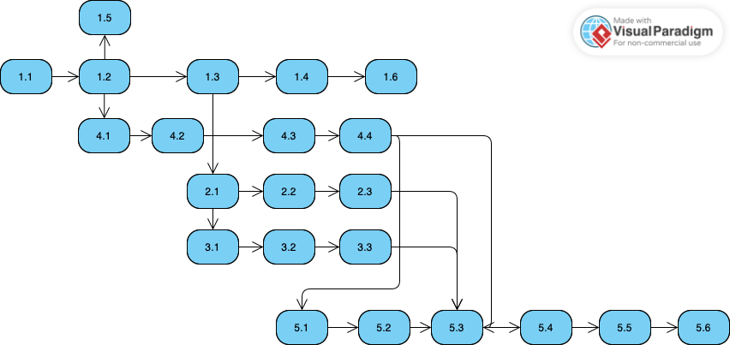

Activity Network Diagram Explanation (Question 1)

Each node in the diagram represents a project activity identified by its WBS code, and the directed arrows indicate the precedence relationships between activities. An activity can start only after all of its predecessor activities have been completed.
The network clearly shows the parallel execution of different development streams, including system design, CRM development, switching software development, and voice response system development. These parallel activities converge during the integration and testing phases, which are represented by activities 5.1, 5.2, and 5.3.
The diagram is constructed based on the Critical Path Method (CPM), which provides the basis for determining the minimum project completion time and identifying task dependencies. This activity network complements the Gantt chart by visualizing the logical order and interdependencies of project activities.
Overall, the Activity Network Diagram provides a clear and structured representation of the project schedule and supports effective planning, coordination, and control throughout the software development process.

