Neh Samir Joshi

19BEC1112

21/01/2022

**CSE2003**

**Data Structures and Algorithms**

**[LAB]**

**LAB – 2**

**Stacks and Queues using Linked Lists**

**Aim:** To learn how to implement stacks, queues and circular queues and its applications using Linked Lists.

**Software Required:** Code editor (e.g. VS Code, Dev C++), GCC/G++ compiler

**Task 1:** To create a stack using Linked list and perform basic operations

**Code:**

#include <iostream>

using namespace std;

struct Node

{

    int value;

    Node *next;

};

int top = -1;

void Display(struct Node *head)

{

    cout << "-----------" << endl;

    while (head != NULL)

    {

        cout << head->value << endl;

        head = head->next;

    }

    cout << "-----------" << endl;

    return;

}

void Push(struct Node **head, int data)

{

    struct Node *temp = new Node;

    struct Node *n = *head;

    temp->value = data;

    temp->next = NULL;

    if (top == -1)

    {

        (*head) = temp;

        top += 1;

        return;

    }

    while (n->next != NULL)

    {

        n = n->next;

    }

    top += 1;

    n->next = temp;

    return;

}

void Pop(struct Node **head)

{

    struct Node *n = *head;

    if (top == -1)

    {

        cout << "Stack is empty!" << endl;

        return;

    }

    if (top == 0)

    {

        *head = NULL;

        top = -1;

        return;

    }

    while (n->next->next != NULL)

    {

        n = n->next;

    }

    struct Node *del = n->next;

    free(del);

    n->next = NULL;

    top = top - 1;

    return;

}

int main()

{

    struct Node *head = new Node;

    Push(&head, 20);

    Push(&head, 30);

    Display(head);

    cout << "Now popping" << endl;

    Pop(&head);

    Display(head);

    return 0;

}

**Output:**

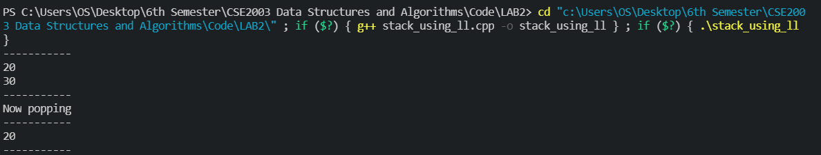

**Task 2: Implement queue using Linked Lists and perform enqueue() and dequeue() operations**

**Code:**

#include <iostream>

using namespace std;

struct Node

{

    int value;

    Node *next;

};

int rear = -1;

void Display(struct Node *head)

{

    cout << "-----------" << endl;

    while (head != NULL)

    {

        cout << head->value << endl;

        head = head->next;

    }

    cout << "-----------" << endl;

    return;

}

void Enqueue(struct Node **head, int data)

{

    struct Node *temp = new Node;

    temp->value = data;

    if (rear == -1)

    {

        temp->next = NULL;

        *head = temp;

        rear += 1;

        return;

    }

    temp->next = *head;

    *head = temp;

    rear++;

    return;

}

void Dequeue(struct Node **head)

{

    struct Node *n = *head;

    if (rear == -1)

    {

        cout << "Stack is empty!" << endl;

        return;

    }

    if (rear == 0)

    {

        *head = NULL;

        rear = -1;

        return;

    }

    while (n->next->next != NULL)

    {

        n = n->next;

    }

    n->next = NULL;

    rear = rear - 1;

    return;

}

int main()

{

    struct Node *head = new Node;

    Enqueue(&head, 10);

    Display(head);

    Enqueue(&head, 20);

    Display(head);

    Dequeue(&head);

    Display(head);

    return 0;

}

**Output:**

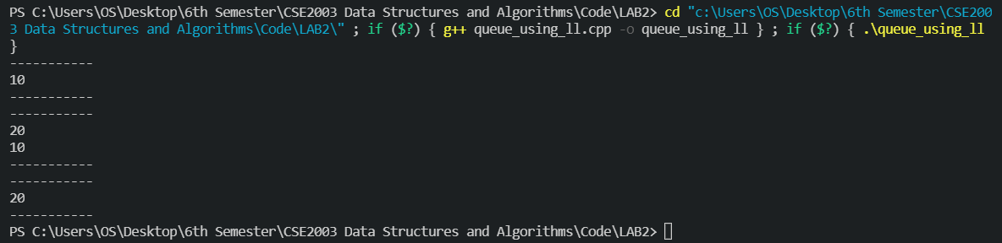

**Task 3: Implement a circular queue using Linked Lists**

**Code:**

#include <iostream>

using namespace std;

struct Node {

    int data;

    Node *next;

};

void Display(struct Node *head)

{

    if (head == NULL)

    {

        cout << "Circular queue is empty!" << endl;

        return;

    }

    struct Node *initial = head;

    do

    {

        cout << head->data << endl;

        head = head->next;

    } while (head != initial);

}

int GetLength(struct Node *head)

{

    int length = 0;

    if (head == NULL)

    {

        return length;

    }

    else if (head != NULL && head->next == NULL)

        return 1;

    else

    {

        struct Node *initial = head;

        head = head->next;

        length = 1;

        while (head != initial)

        {

            length++;

            head = head->next;

        }

        return length;

    }

}

struct Node *Enqueue(struct Node *head, int data){

    struct Node *temp = new Node;

    temp->data = data;

    if (GetLength(head) == 0)

    {

        head = temp;

        head->next = head;

    }

    else

    {

        struct Node *initial = head;

        while (head->next != initial)

        {

            head = head->next;

        }

        temp->next = initial;

        head->next = temp;

        head = initial;

    }

    return head;

}

struct Node *Dequeue(struct Node *head){

    int l = GetLength(head);

    if (l==0) {

        cout << "Circular Queue is empty!" << endl;

    }

    else if(l==1){

        head=NULL;

    }

    else {

        struct Node* newHead = head->next;

        struct Node* initial = head;

        while (head->next != initial) head = head->next;

        head->next = newHead;

        head = newHead;

    }

    return head;

}

int main(){

    struct Node *head = new Node;

    head = NULL;

    head = Enqueue(head, 10);

    head = Enqueue(head, 20);

    head = Enqueue(head, 30);

    head = Enqueue(head, 40);

    head = Dequeue(head);

    head = Dequeue(head);

    Display(head);

}

**Output:**

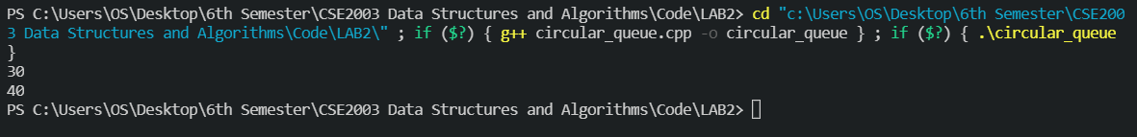

**Task 4: Implement the solution of tower of Hanoi for “n” number of disks**

**Code:**

#include <iostream>

using namespace std;

void solveProblem(int n, int from, int to, int intermidate){

    if (n==0){

        return;

    }

    solveProblem(n-1, from, intermidate, to);

    cout << "Moving disk " << n << " from rod " << from << " to rod " << to <<endl;

    solveProblem(n-1, intermidate, to, from);

}

int main(){

    solveProblem(2, 1, 3, 2);

    return 0;

}

**Output:**

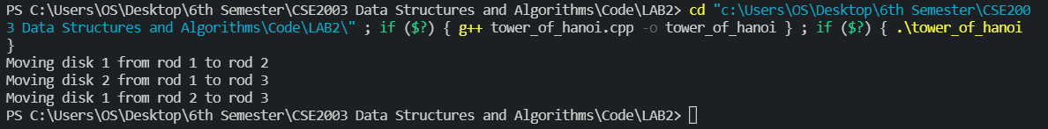

[For n=2]

**Task 5: Implement balancing parenthesis to check if the given string of parentheses are appropriately balanced.**

**Code:**

This has been implemented using Stack. For the stack code, refer to Task 1.

For all the other functions, this is the code:

char GetTop(struct Node *head)

{

    char top;

    while (head->next != NULL)

    {

        head = head->next;

    }

    top = head->data;

    return top;

}

bool CheckBalanced(string s, struct Node *head)

{

    for (int i = 0; i < s.length(); i++)

    {

        if (s[i] == '{' || s[i] == '[' || s[i] == '(')

        {

            head = Push(head, s[i]);

            continue;

        }

        if (GetLength(head) == 0)

            return false;

        if (s[i] == ')')

        {

            char top = GetTop(head);

            head = Pop(head);

            if (top == '[' || top == '{')

            {

                break;

                return false;

            } else continue;

        }

        else if (s[i] == ']')

        {

            char top = GetTop(head);

            head = Pop(head);

            if (top == '(' || top == '{')

            {

                break;

                return false;

            } else continue;

        }

        else if (s[i] == '}')

        {

            char top = GetTop(head);

            head = Pop(head);

            if (top == '[' || top == '('){

                break;

                return false;

            } else continue;

        }

    }

    if (GetLength(head) == 0)

        return true;

    else

        return false;

}

int main()

{

    struct Node *head = new Node;

    head = NULL;

    if (CheckBalanced("{{{(())}}}", head))

        cout << "Balanced!" << endl;

    else

        cout << "Unbalanced!" << endl;

}

**Output:**



**Conclusion**

Thus we have successfully implemented stacks and queues using Linked Lists and seen some of their basic applications.

*Neh Samir Joshi*

*19BEC1112*