Interpretable Machine Learning Identifies Molecular Signatures of Vaccine Response in Ferret Multi-Omics Data
Nehleh Kargarfard^{1,*}, Robert Dunne², Carol Lee¹, Laurence Wilson^{1,3}, Alexander J McAuley⁴
¹ Australian e-Health Research Centre, Commonwealth Scientific and Industrial Research Organisation, Sydney, NSW 2145, Australia
² Data61, Commonwealth Scientific and Industrial Research Organisation, Sydney, NSW 2015, Australia
³ Department of Biomedical Sciences, Macquarie University, Sydney, NSW 2109, Australia
⁴ Health & Biosecurity Research Unit, Australian Centre for Disease Preparedness (ACDP), Commonwealth Scientific and Industrial Research Organisation, 5 Portarlington Road, East Geelong, VIC 3219, Australia
* Corresponding author

Abstract
Interpretable machine learning (IML) offers a pathway to bridge predictive modeling and biological understanding in systems vaccinology. In vaccine response studies, models must not only achieve high accuracy but also provide transparent, rule-based explanations that can guide experimental or clinical interpretation. Here, we apply an IML framework combining TreeFARMS and Rashomon set analysis to multi-omics data from a controlled ferret vaccination study. The dataset comprised transcriptomic, proteomic, lipidomic, and metabolomic profiles collected across ten time points from animals receiving different Inovio vaccine formulations. Using TreeFARMS, we generated sparse, interpretable decision trees optimized for accuracy and compactness, and explored their Rashomon sets to identify stable and alternative molecular rules predictive of vaccination status. The resulting models achieved performance comparable to ensemble methods while producing concise if–then rules that directly linked measurable molecular features—such as AZGP1 expression and ketoleucine levels—to immune response patterns. This proof-of-concept study demonstrates that interpretable ML can capture biologically meaningful signatures of vaccine response without sacrificing predictive accuracy, providing a transparent and reproducible alternative to black-box approaches in multi-omics analysis.

1. Introduction
The COVID-19 pandemic has underscored the importance of understanding immune responses to vaccination through high-resolution molecular profiling. Multi-omics technologies now enable comprehensive characterization of host responses across transcriptomic, proteomic, and metabolomic layers. Machine learning (ML) has become a powerful tool in this space, supporting tasks such as vaccine response prediction, biomarker discovery, and integration of heterogeneous omics data ((Ng et al., 2023)(Biswas & Chakrabarti, 2020)(Bravi, 2024)). However, many high-performing ML models—particularly those based on deep learning or ensemble approaches—function as black boxes, offering limited insight into the biological mechanisms underlying their predictions. This lack of interpretability poses a major barrier for translational and clinical applications, where transparency and trust are essential.
Interpretable machine learning (IML) provides a pathway to address this challenge by producing models that are both accurate and explainable. In this study, we apply an IML framework to derive transparent, rule-based models from multi-omics data generated in a controlled ferret vaccination experiment. Whereas previous analyses of this dataset (Lee et al., n.d.) emphasized feature ranking via ensemble models, we demonstrate that interpretable ML can achieve comparable accuracy while directly revealing the molecular logic of vaccine response. Our approach serves as a proof of concept illustrating how interpretable models can complement traditional black-box workflows by providing concise, actionable rules that connect measurable molecular features to vaccination outcomes.

From the early stages of the pandemic, machine learning was rapidly applied to SARS-CoV-2 challenges, including genome classification (Singh et al., 2021), serological profiling (Rosado et al., 2021), prediction of viral–host protein interactions (Dey et al., 2020), and drug repurposing (Gawriljuk et al., 2021). While these studies demonstrated strong predictive performance, they were mostly based on black-box models such as Random Forests, deep learning, or ensemble methods, which limit their usability for clinical and public health decision-makers. Some attempts have been made to apply interpretability tools—for example, Wu et al. (2021) used SHAP, LIME, and PDP to interpret Random Forests and Neural Networks—but these approaches only provide post-hoc explanations of opaque models.
In practice, decision-makers often require models that are not only accurate but also transparent and easy to interpret. Interpretable ML has a long history, most notably in decision trees and rule lists, which present predictions as simple if–then rules (Quinlan, 2014; Angelino et al., 2018; Yang et al., 2017). However, classical greedy tree methods such as CART or C4.5 often produce unstable, suboptimal structures, while rule lists are limited to a single decision path. More recent work has introduced optimal sparse tree learners (Aglin et al., 2020; Verwer & Zhang, 2019; Hu et al., 2019; Lin et al., 2020), but these methods still focus on selecting a single “best” model.
Beyond selecting a single “best” model, the Rashomon perspective (Fisher et al., 2019) recognizes that many models can achieve near-identical performance. Exploring this model family reveals both stable rules—features consistently predictive across solutions—and alternative explanations, offering a richer view of biological heterogeneity.

We employ the TreeFARMS framework, coupled with Rashomon set exploration, to identify compact decision rules that distinguish vaccinated from unvaccinated ferrets. By exploring not only a single optimal model but also a family of near-optimal ones, our approach captures both stable and alternative molecular signatures associated with vaccine-induced immune responses. In this study, the classification target corresponds to the vaccination group (treatment arm), with the objective of identifying molecular features that differentiate the immune responses elicited by the different vaccination regimens. Importantly, the analysis does not use antibody titres or other measured vaccine-efficacy outcomes as prediction targets. This case study demonstrates the feasibility and utility of interpretable machine learning in complex multi-omics analyses, bridging the gap between predictive performance and biological insight.
This study also addresses a common challenge in immunological multi-omics: datasets with many thousands of molecular features but only a small number of experimental subjects. Such high-dimensional, low-sample settings are typical in controlled animal vaccine studies and pose difficulties for most machine-learning methods.

3. Methods
Machine learning analysis was performed using the TreeFARMS framework (Chen et al., 2022), which constructs families of accurate and reliable models through scalable optimal tree learning. The workflow consisted of five stages: (1) data input and preprocessing, (2) cross-validation setup, (3) model training with TreeFARMS, (4) Rashomon set exploration, and (5) interpretability and visualization. A schematic overview of this workflow is shown in Figure 1.
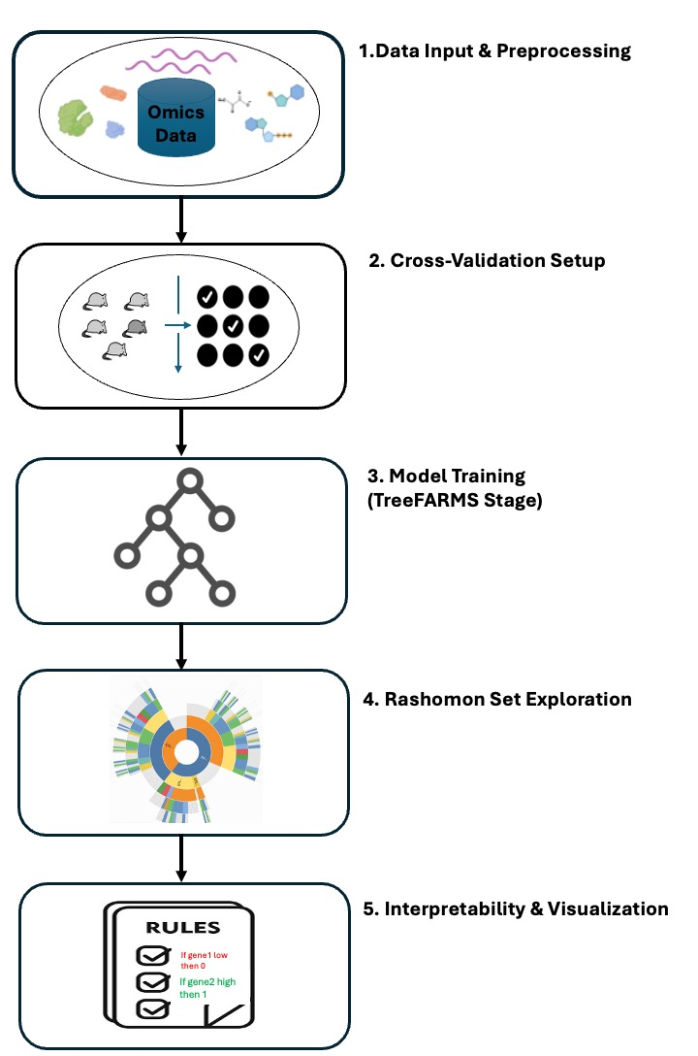
Figure 1. Schematic overview of the interpretable machine learning pipeline. (A) Data input and preprocessing; (B) Cross-validation setup; (C) Model training ; (D) Rashomon set exploration; and (E) Interpretability and visualization.
Dataset.
We analyzed data from a controlled ferret vaccination study involving sixteen adult ferrets (Mustela putorius furo) that were randomly assigned to vaccinated and control groups. Vaccinated animals received two intramuscular doses of DNA vaccines—INO-4800 (Wuhan-Hu-1 sequence) or INO-4802 (synthetic consensus sequence)—administered on Day 0 (prime) and Day 28 (boost), while control ferrets received phosphate-buffered saline (PBS). The study followed animals for ten time points, including baseline and post-challenge stages, to capture longitudinal immune responses. Multi-omics profiling was performed on blood and plasma samples, integrating transcriptomic, metabolomic, lipidomic, and proteomic measurements to characterize vaccine-induced changes across molecular layers. The dataset and preprocessing pipeline are described in detail here (Lee et al., n.d.).
For this work, we focused on the processed Dataset 2, in which each time point was treated as an independent sample to increase statistical power and mitigate the effect of repeated measures. Each sample was represented as a vector of multi-omics features. To ensure data quality, features with more than 20% missing values overall or more than 50% missing within a group were removed, followed by imputation, normalization, transformation, and scaling. This dataset enabled us to classify vaccinated vs. unvaccinated animals, compare INO-4800 vs. INO-4802 responses, and identify interpretable molecular signatures associated with vaccine protection.
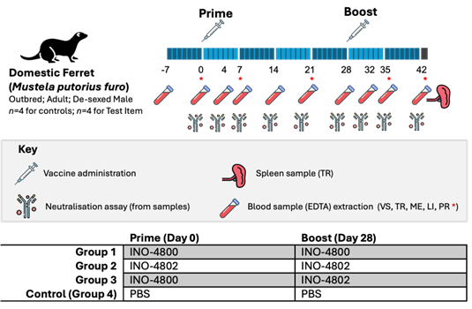
Figure 2. Experimental design of the ferret vaccination study.
Four treatment groups of ferrets received prime and boost vaccinations on Days 0 and 28. Multi-omics samples (transcriptomics, metabolomics, lipidomics and proteomics) were collected from blood and spleen at the indicated time points, following the workflow developed by the broader study. In this work, we analyse the integrated multi-omics data generated at the endpoint sampling time point only. Abbreviations: PBS = phosphate-buffered saline; TR = transcriptomics; ME = metabolomics; LI = lipidomics; PR = proteomics.
Pipeline.
Machine learning analysis was performed using the TreeFARMS framework (Chen et al., 2022), which constructs families of accurate and reliable models through scalable optimal tree learning. The workflow was implemented in Python (TreeFARMS v1.0) and followed the two-stage process outlined in the original method.
First, features were preprocessed using the threshold guessing algorithm from the TreeFARMS package to identify informative cut points for each feature, balancing granularity and stability. Continuous features were discretized using the threshold-guessing algorithm implemented in the TreeFARMS package. Specifically, the function compute_thresholds evaluates each continuous variable and identifies informative cut points by examining feature distributions and class separation. This procedure balances granularity with stability, ensuring that only thresholds that meaningfully contribute to predictive discrimination are selected.
The resulting threshold set was then applied to the data using the cut function, which converts each continuous feature into one or more binary indicator variables (e.g. feature ≤ threshold, feature > threshold). This transformation enables efficient mixed-integer optimization in downstream rule-based model training while preserving relevant structure in the original continuous variables.
Model training was performed using the GOSDT (Generalized Optimal Sparse Decision Trees) solver backend, which formulates decision tree learning as a global optimization problem. It minimizes a joint objective that balances classification error and tree complexity through a tunable regularization parameter (λ = 0.008). Each resulting model represents a compact, interpretable set of if–then rules describing relationships between molecular features and vaccination status.
To ensure generalizability, the data were split by animal using 5-fold stratified cross-validation, ensuring that all samples from a given ferret were contained entirely within a single fold. For each training fold, TreeFARMS generated a collection of near-optimal trees within a Rashomon bound. This bound defines the set of all models whose loss is within 5% of the global optimum, ensuring inclusion of alternative high-performing but distinct rule sets.
Model outputs—including rule structures, feature usage, and prediction paths—were automatically extracted and summarized to quantify rule stability and feature recurrence across folds. Stable features appearing in multiple near-optimal trees were considered biologically robust predictors of vaccine response.
To assess rule consistency and feature stability across near-optimal models, rule paths and feature occurrences were extracted from each TreeFARMS-generated tree. All if–then paths and their associated predictions were parsed from model outputs, and the frequency of each unique rule and feature was calculated across cross-validation folds. The resulting summaries quantified the recurrence of rules and features within the Rashomon set. Features appearing consistently across multiple near-optimal trees were interpreted as robust molecular signatures predictive of vaccination status.

4. Results
TreeFarms achieved 94% mean accuracy in classifying vaccinated vs. control ferrets. Each model contained 2–4 concise if–then rules connecting omics features to vaccination status, e.g. low Ketoleucine and low AZGP1 → Vaccinated.
Exploration of the 333 near-optimal models within the Rashomon set revealed consistent biological signals across diverse decision structures. Features such as AZGP1, Ketoleucine, and CLEC4D recurred in over 70% of high-performing trees, indicating robust, biologically stable predictors. The TimberTrek (Wang et al., 2022) visualization (Figure 3) shows that multiple models achieve similar accuracy using overlapping subsets of features, highlighting redundant yet meaningful biological pathways.

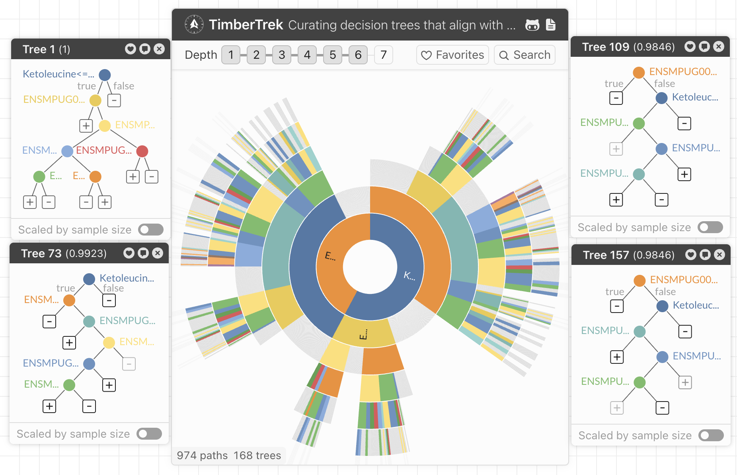
Figure 3. Rashomon set of TreeFarms models visualized with TimberTrek. Each colored path shows an accurate, interpretable tree with different molecular rules—highlighting multiple solutions for classification.
Table 1 summarizes the most recurrent features, linking them to immune modulation, metabolic adaptation, and cytokine regulation—key processes identified in (Lee et al., n.d.). This overlap reinforces the validity of interpretable models for capturing essential biological signals while remaining fully explainable.
Table 1. Stable molecular features repeatedly selected across Rashomon models. Recurrence reflects percentage of high-performing trees in which each feature appears; functional annotations derived from literature (Hassan et al., 2021; Li et al., 2022; etc.).
Feature ID / Name | Omics type | Recurrence (%) across models | Functional note
AZGP1 | Transcriptomic | 89 | Zinc-binding glycoprotein; linked to immune modulation(Hassan et al., 2008)
Ketoleucine | Metabolomic | 82 | Branched-chain amino-acid derivative; metabolic marker of inflammation(Holeček, 2018)
CLEC4D | Transcriptomic | 77 | C-type lectin receptor involved in pathogen recognition (Cummings et al., 2022; Simpson et al., 2023)
L-Alanine | Metabolomic | 74 | Energy metabolism and tissue repair(Holeček, 2024)
VCAN | Transcriptomic | 71 | Versican; extracellular-matrix component modulating immune cell migration(Wight et al., 2014)
NLRP3 | Transcriptomic | 68 | Inflammasome component associated with cytokine activation(Silva et al., 2023; Swanson et al., 2019)
CLDN1 | Transcriptomic | 63 | Tight-junction protein implicated in viral entry(Evans et al., 2007)

Benchmarking against standard ML models
To contextualize the performance of TreeFARMS, we compared it with three commonly used baseline models—Random Forest, Decision Tree, and LASSO (L1-regularized logistic regression)—trained on the same ferret-stratified folds and the same threshold-discretized features used by the interpretable pipeline.
Across folds, TreeFARMS achieved the highest mean accuracy (mean = 94.10, SD = 0.039), outperforming all three baseline models. The Random Forest achieved mean = 74.66, the Decision Tree achieved mean = 76.16, and LASSO achieved mean = 72.16. Importantly, TreeFARMS achieved this performance without ensembling while producing compact, transparent decision rules. Figure 4 summarizes the accuracy distributions across folds. This reinforces the observation that model simplicity and interpretability do not necessarily come at the expense of predictive performance.
We next examined whether the different algorithms converged on similar biomarkers of vaccination response. Table 2 summarizes agreement across the four models for a core set of biologically meaningful features.
A clear pattern emerged: TreeFARMS and Random Forest showed the strongest overlap, repeatedly selecting genes linked to immune activation (AZGP1, CLEC4D, NLRP3) and metabolites tied to amino-acid or energy metabolism (Ketoleucine, L-Alanine).
Because Random Forest does not return a single explicit model, we ranked features by their impurity-based importance and used the top 10 to enable a fair comparison across methods.
The Decision Tree model selected fewer features, likely due to strong depth regularization (max_depth=5), retaining only the most discriminative split points.
LASSO selected a distinct set of predictors, reflecting its linear sparsity constraint; many TreeFARMS/Random Forest features did not enter the LASSO model, suggesting they contribute through nonlinear interactions rather than additive effects. Supplementary Table 1 shows the top 10 features identified by these three ML methods.

5. Discussion
This case study demonstrates the practical value of interpretable machine learning for understanding vaccine response mechanisms in complex multi-omics datasets. Using TreeFARMS with Rashomon analysis, we re-examined the ferret vaccination data originally analyzed by (Lee et al., n.d.), showing that interpretability and predictive accuracy can be achieved simultaneously.
TreeFARMS produced compact, easily readable models that achieved test accuracies exceeding 94%, comparable to ensemble baselines such as Random Forest. While additional ensemble approaches such as XGBoost or gradient boosting could be considered, Random Forest serves as a representative black-box baseline, offering a robust comparison for assessing the trade-off between interpretability and accuracy.

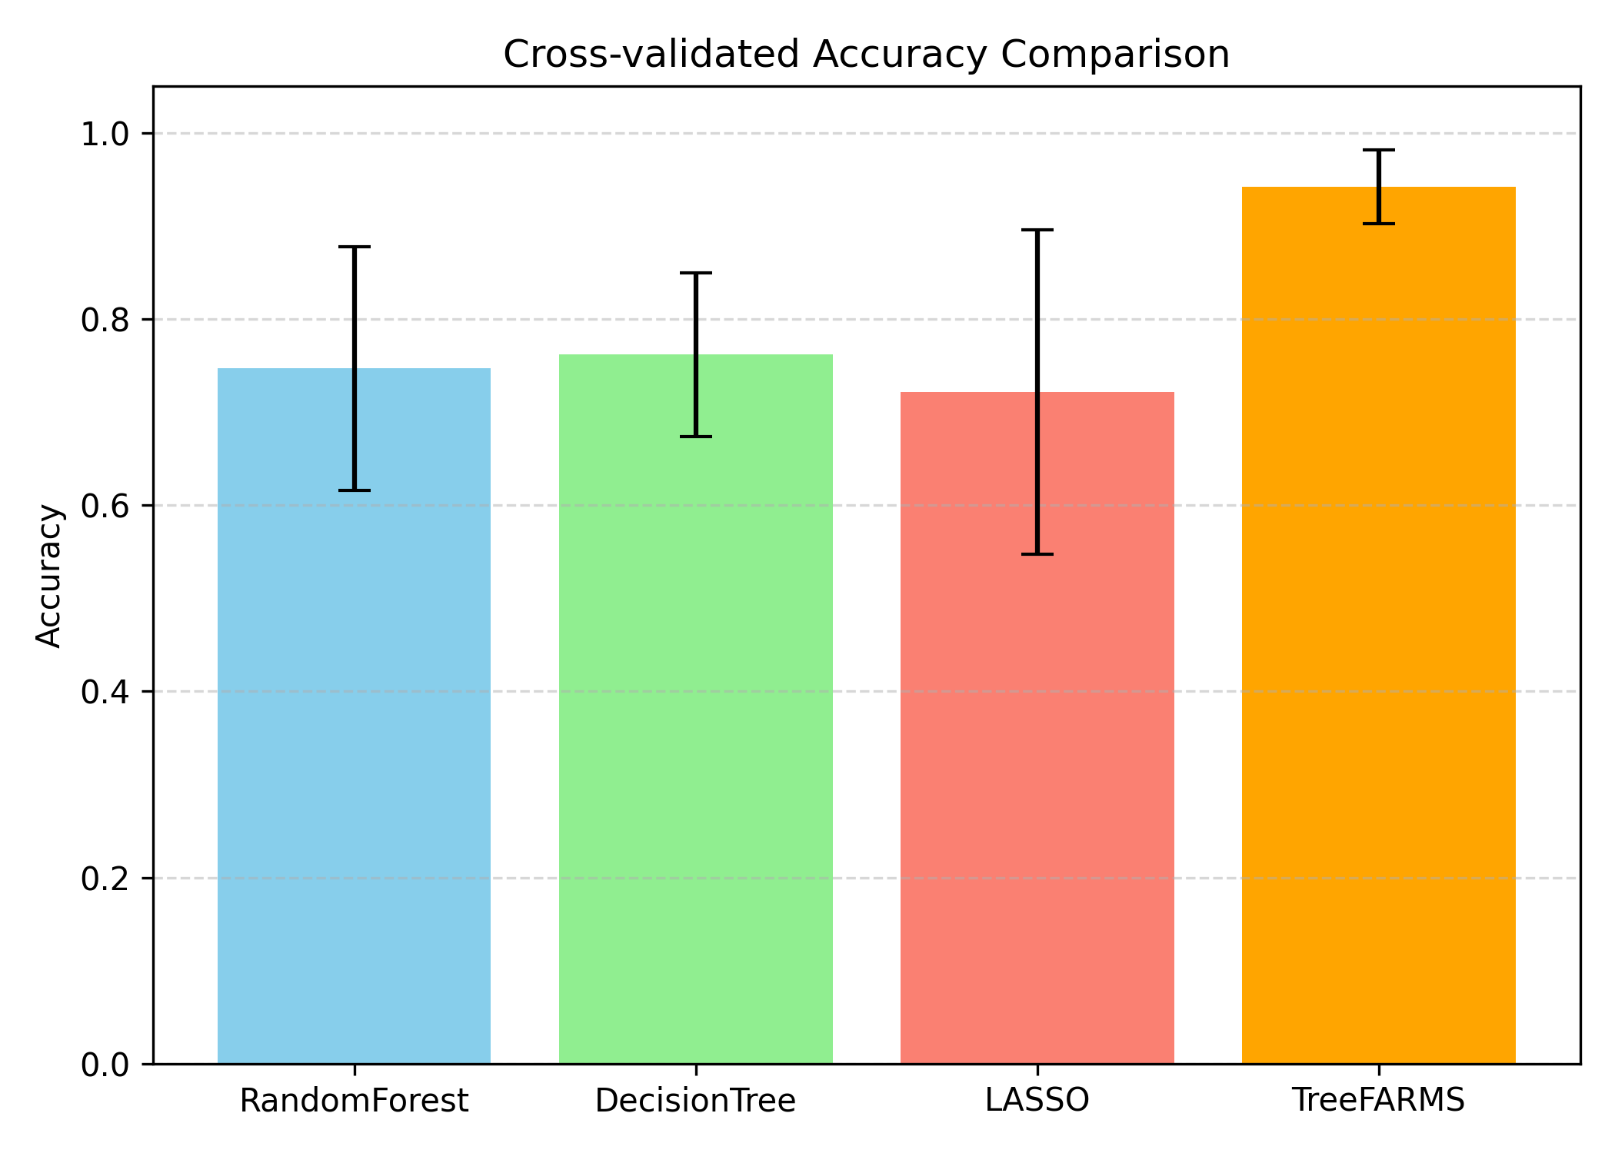
Figure 4. Cross-validated accuracy of TreeFARMS compared with baseline machine-learning models.
The stable features summarized in Table 1 highlight molecular processes central to vaccine-induced immunity. For instance, AZGP1 and Ketoleucine point to zinc-associated signaling and branched-chain amino acid metabolism, respectively—both key regulators of immune activation and metabolic adaptation. The recurrence of CLEC4D and NLRP3 underscores the involvement of innate immune sensing and inflammasome signaling, while VCAN and CLDN1 reflect extracellular and barrier components modulating immune interactions. Together, these reproducible features illustrate how interpretable models not only match black-box accuracy but also pinpoint biologically coherent pathways.
Table 2 Comparison of feature selection behavior across interpretable (TreeFARMS) and black-box models. TreeFARMS and Random Forest showed the highest agreement, consistently selecting key immune and metabolic markers, whereas LASSO and Decision Tree identified a more limited or distinct subset.
Features | TreeFARMS | Random Forest | Decision Tree | LASSO
AZGP1 | ✓ | ✓ | ✓ | ✗
Ketoleucine | ✓ | ✓ | ✗ | ✗
CLEC4D | ✓ | ✓ | ✗ | ✗
L-Alanine | ✓ | ✓ | ✗ | ✗
NLRP3 | ✓ | ✓ | ✗ | ✗

The extracted rules—such as low Ketoleucine and low AZGP1 → Vaccinated—provide a direct link between measurable molecular features and vaccination status. These features are consistent with broader evidence that branched-chain amino-acid metabolism and zinc-associated glycoproteins participate in immune and inflammatory regulation, although their precise roles in vaccine responses remain to be clarified (Kelly & Pearce, 2020; Ling et al., 2023). These interpretable ML findings complement the statistical analyses performed in the original study (Lee et al., n.d.). In that work, differential expression analysis identified several vaccination-associated genes.
Beyond identifying a single best model, Rashomon exploration revealed multiple, equally accurate trees containing overlapping but distinct rule combinations. This diversity reflects the biological redundancy of immune mechanisms, where different molecular pathways can yield comparable protective responses. Stable rules, such as those involving Ketoleucine, AZGP1, and CLEC4D, appeared across most high-performing trees, confirming their robustness and biological relevance.
Compared with ensemble approaches that provide only aggregate feature importance scores, TreeFARMS explicitly enumerates all near-optimal solutions, allowing direct comparison of interpretable hypotheses. This capacity to visualize both stable and alternative rules enhances scientific transparency and supports responsible AI principles in genomic research.
A key advantage of the TreeFARMS framework is its use of the GOSDT (Generalized Optimal Sparse Decision Trees) solver as the underlying optimization engine. In contrast to classical greedy approaches such as CART or C4.5—which make a sequence of locally optimal split decisions—GOSDT performs a global search over the decision-tree space using dynamic programming and branch-and-bound. This procedure provides a mathematical guarantee that the resulting tree is globally optimal under the specified objective, jointly minimizing classification error and tree complexity controlled by the regularization term λ. As a result, the interpretable models produced by TreeFARMS achieve the best attainable accuracy–simplicity trade-off within the sparse tree family.
GOSDT further maintains tight upper bounds on the potential performance of partially explored trees, allowing it to prune entire regions of the search space that cannot fall within the user-defined Rashomon bound. This makes exhaustive search computationally feasible while ensuring that no high-performing alternative trees are missed.
Crucially, this optimization structure enables complete enumeration of the Rashomon set through TreeFARMS. Prior methods typically rely on repeated sampling, perturbation, or bootstrap procedures to approximate near-optimal models, often producing incomplete or biased subsets. In contrast, TreeFARMS guarantees discovery of all sparse decision trees whose loss lies within the Rashomon bound of the global optimum (Xin et al., 2022). This complete enumeration provides a uniquely comprehensive view of model uncertainty, allowing us to assess rule stability, feature recurrence, and biological plausibility across all 333 near-optimal models rather than relying on sampled approximations.
Another notable strength of the TreeFARMS framework is its suitability for small-sample, high-feature datasets: rather than overfitting, it produces compact rule sets that generalize well even when the number of features vastly exceeds the number of individuals.
By embedding interpretability within the modelling process, rather than applying it post hoc, our framework allows decision-makers and experimentalists to trace each prediction to specific molecular conditions. Such transparency strengthens trust, facilitates biological validation, and enables integration of machine learning results into experimental design and public-health decision support.
Future work will extend this approach to larger cohorts and additional omics layers, assessing how Rashomon-derived rule sets generalize across vaccine platforms or host species. Integrating interpretable rules with mechanistic or causal models could further validate their biological significance and support explainable, reproducible analytics for next-generation vaccine studies.

Acknowledgments
Ferret vaccination and sample collection was co-sponsored by Inovio Pharmaceuticals and the Commonwealth Scientific and Industrial Research Organisation (CSIRO) as part of a vaccine immunogenicity study.
Omics analysis of collected samples was funded by the U.S. Food and Drug Administration (FDA), Office of the Chief Scientist, Office of Regulatory and Emerging Science Medical Countermeasures Initiative contract BAA-21-00123 Research Area #7 MCMWP #110. The article reflects the views of the authors and does not represent the views or policies of the FDA.
All work with animals was performed under an animal ethics protocol approved by the Animal Ethics Committee at James Cook University (AEC No. A2757). The authors would like to thank the Animal Studies Team at the CSIRO Australian Centre for Disease Preparedness for their help in preparing the ferrets for transportation to JCU, and Professor Seshadri Vasan for his valuable inputs.

Data availability
The datasets generated and/or analysed during the current study are available in the [insert name of repository] repository, [insert persistent URL to datasets].

Code availability
The TreeFARMS analysis workflow is available at:
https://github.com/nehlehk/iml-ferret-vaccine.
Due to institutional data sharing restrictions, the ferret omics dataset is not publicly available; processed feature matrices can be shared upon reasonable request.

References
Aglin, G., Nijssen, S., & Schaus, P. (2020). Learning optimal decision trees using caching branch-and-bound search. Proceedings of the AAAI Conference on Artificial Intelligence, 34(04), 3146–3153. https://ojs.aaai.org/index.php/AAAI/article/view/5711
Angelino, E., Larus-Stone, N., Alabi, D., Seltzer, M., & Rudin, C. (2018). Learning certifiably optimal rule lists for categorical data. Journal of Machine Learning Research, 18(234), 1–78.
Biswas, N., & Chakrabarti, S. (2020). Artificial intelligence (AI)-based systems biology approaches in multi-omics data analysis of cancer. Frontiers in Oncology, 10, 588221.
Bravi, B. (2024). Development and use of machine learning algorithms in vaccine target selection. Npj Vaccines, 9(1), 15.
Cummings, R. D., Chiffoleau, E., van Kooyk, Y., & McEver, R. P. (2022). C-Type Lectins. Essentials of Glycobiology [Internet]. https://pubmed.ncbi.nlm.nih.gov/35536935/
Danladi, J., & Sabir, H. (2021). Innate immunity, inflammation activation and heat-shock protein in COVID-19 pathogenesis. Journal of Neuroimmunology, 358, 577632.
Desterke, C., Turhan, A. G., Bennaceur-Griscelli, A., & Griscelli, F. (2020). PPARγ cistrome repression during activation of lung monocyte-macrophages in severe COVID-19. Iscience, 23(10). https://www.cell.com/iscience/fulltext/S2589-0042(20)30803-8
Dey, L., Chakraborty, S., & Mukhopadhyay, A. (2020). Machine learning techniques for sequence-based prediction of viral–host interactions between SARS-CoV-2 and human proteins. Biomedical Journal, 43(5), 438–450.
Evans, M. J., Von Hahn, T., Tscherne, D. M., Syder, A. J., Panis, M., Wölk, B., Hatziioannou, T., McKeating, J. A., Bieniasz, P. D., & Rice, C. M. (2007). Claudin-1 is a hepatitis C virus co-receptor required for a late step in entry. Nature, 446(7137), 801–805.
Fisher, A., Rudin, C., & Dominici, F. (2019). All models are wrong, but many are useful: Learning a variable’s importance by studying an entire class of prediction models simultaneously. Journal of Machine Learning Research, 20(177), 1–81.
Gawriljuk, V. O., Zin, P. P. K., Puhl, A. C., Zorn, K. M., Foil, D. H., Lane, T. R., Hurst, B., Tavella, T. A., Costa, F. T. M., Lakshmanane, P., Bernatchez, J., Godoy, A. S., Oliva, G., Siqueira-Neto, J. L., Madrid, P. B., & Ekins, S. (2021). Machine Learning Models Identify Inhibitors of SARS-CoV-2. Journal of Chemical Information and Modeling, 61(9), 4224–4235. https://doi.org/10.1021/acs.jcim.1c00683
Hassan, M. I., Waheed, A., Yadav, S., Singh, T. P., & Ahmad, F. (2008). Zinc α2-glycoprotein: A multidisciplinary protein. Molecular Cancer Research, 6(6), 892–906.
Holeček, M. (2018). Branched-chain amino acids in health and disease: Metabolism, alterations in blood plasma, and as supplements. Nutrition & Metabolism, 15(1), 33. https://doi.org/10.1186/s12986-018-0271-1
Holeček, M. (2024). Origin and roles of alanine and glutamine in gluconeogenesis in the liver, kidneys, and small intestine under physiological and pathological conditions. International Journal of Molecular Sciences, 25(13), 7037.
Hu, X., Rudin, C., & Seltzer, M. (2019). Optimal Sparse Decision Trees. Advances in Neural Information Processing Systems, 32. https://proceedings.neurips.cc/paper_files/paper/2019/hash/ac52c626afc10d4075708ac4c778ddfc-Abstract.html
Job Opportunities at NSW Health. (n.d.). NSW Health Careers. Retrieved September 21, 2025, from https://jobs.health.nsw.gov.au/moreinfo/applicant-guides
Kelly, B., & Pearce, E. L. (2020). Amino Assets: How Amino Acids Support Immunity. Cell Metabolism, 32(2), 154–175. https://doi.org/10.1016/j.cmet.2020.06.010
Lee, C., Dunne, R., Beale, D. J., Nguyen, T. V., Singanallur, N. B., Vuren, P. J. van, Liu, J.-W., Rowarth, S., Robertson, K., Miranda-Hernandez, S., Horwood, P., Bruce, M. P., Blasdell, K. R., Tachedjian, M., Boomer, A. C., Palombo, E. A., Smith, T. R. F., Broderick, K. E., Au, G. G., … McAuley, A. J. (n.d.). Multi-omics signatures indicative of status and effectiveness of vaccination against SARS-CoV-2 in ferrets.
Lin, J., Zhong, C., Hu, D., Rudin, C., & Seltzer, M. (2020). Generalized and Scalable Optimal Sparse Decision Trees. Proceedings of the 37th International Conference on Machine Learning, 6150–6160. https://proceedings.mlr.press/v119/lin20g.html
Ling, Z.-N., Jiang, Y.-F., Ru, J.-N., Lu, J.-H., Ding, B., & Wu, J. (2023). Amino acid metabolism in health and disease. Signal Transduction and Targeted Therapy, 8(1), 345. https://doi.org/10.1038/s41392-023-01569-3
Meng, H., Wang, S., Tang, X., Guo, J., Xu, X., Wang, D., Jin, F., Zheng, M., Yin, S., & He, C. (2022). Respiratory immune status and microbiome in recovered COVID-19 patients revealed by metatranscriptomic analyses. Frontiers in Cellular and Infection Microbiology, 12, 1011672.
Mondon, C. (n.d.). Classification and regression trees.
Ng, S., Masarone, S., Watson, D., & Barnes, M. R. (2023). The benefits and pitfalls of machine learning for biomarker discovery. Cell and Tissue Research, 394(1), 17–31. https://doi.org/10.1007/s00441-023-03816-z
Quinlan, J. R. (2014). C4. 5: Programs for machine learning. Elsevier. https://books.google.com.au/books?hl=en&lr=&id=b3ujBQAAQBAJ&oi=fnd&pg=PP1&dq=Quinlan,+J.+R.+1993.+C4.5:+Programs+for+Machine+Learning.+Morgan+Kaufmann&ots=sS6tRNHtB5&sig=Xd5ovJGs_iW3DMUGX7Jp5BnBOko
Rosado, J., Pelleau, S., Cockram, C., Merkling, S. H., Nekkab, N., Demeret, C., Meola, A., Kerneis, S., Terrier, B., & Fafi-Kremer, S. (2021). Multiplex assays for the identification of serological signatures of SARS-CoV-2 infection: An antibody-based diagnostic and machine learning study. The Lancet Microbe, 2(2), e60–e69.
Shcherbak, S. G., Changalidi, A. I., Barbitoff, Y. A., Anisenkova, A. Y., Mosenko, S. V., Asaulenko, Z. P., Tsay, V. V., Polev, D. E., Kalinin, R. S., & Eismont, Y. A. (2022). Identification of genetic risk factors of severe COVID-19 using extensive phenotypic data: A proof-of-concept study in a cohort of Russian patients. Genes, 13(3), 534.
Silva, M. J. A., Ribeiro, L. R., Gouveia, M. I. M., Marcelino, B. dos R., Santos, C. S. dos, Lima, K. V. B., & Lima, L. N. G. C. (2023). Hyperinflammatory response in COVID-19: A systematic review. Viruses, 15(2), 553.
Simpson, J. D., Ray, A., Marcon, C., Dos Santos Natividade, R., Dorrazehi, G. M., Durlet, K., Koehler, M., & Alsteens, D. (2023). Single-Molecule Analysis of SARS-CoV-2 Binding to C-Type Lectin Receptors. Nano Letters, 23(4), 1496–1504. https://doi.org/10.1021/acs.nanolett.2c04931
Singh, O. P., Vallejo, M., El-Badawy, I. M., Aysha, A., Madhanagopal, J., & Faudzi, A. A. M. (2021). Classification of SARS-CoV-2 and non-SARS-CoV-2 using machine learning algorithms. Computers in Biology and Medicine, 136, 104650.
Swanson, K. V., Deng, M., & Ting, J. P.-Y. (2019). The NLRP3 inflammasome: Molecular activation and regulation to therapeutics. Nature Reviews Immunology, 19(8), 477–489.
Verwer, S., & Zhang, Y. (2019). Learning optimal classification trees using a binary linear program formulation. Proceedings of the AAAI Conference on Artificial Intelligence, 33(01), 1625–1632. https://aaai.org/ojs/index.php/AAAI/article/view/3978
Wang, Z. J., Zhong, C., Xin, R., Takagi, T., Chen, Z., Chau, D. H., Rudin, C., & Seltzer, M. (2022). TimberTrek: Exploring and curating sparse decision trees with interactive visualization. 2022 IEEE Visualization and Visual Analytics (VIS), 60–64. https://ieeexplore.ieee.org/abstract/document/9973202/
Wight, T. N., Kang, I., & Merrilees, M. J. (2014). Versican and the control of inflammation. Matrix Biology, 35, 152–161.
Wu, H., Ruan, W., Wang, J., Zheng, D., Liu, B., Geng, Y., Chai, X., Chen, J., Li, K., & Li, S. (2021). Interpretable machine learning for covid-19: An empirical study on severity prediction task. IEEE Transactions on Artificial Intelligence, 4(4), 764–777.
Xin, R., Zhong, C., Chen, Z., Takagi, T., Seltzer, M., & Rudin, C. (2022). Exploring the Whole Rashomon Set of Sparse Decision Trees. Advances in Neural Information Processing Systems, 35, 14071–14084.
Yang, H., Rudin, C., & Seltzer, M. (2017). Scalable Bayesian rule lists. International Conference on Machine Learning, 3921–3930. http://proceedings.mlr.press/v70/yang17h.html

Supplementary information
Table S1 Top 10 features selected by Random Forest, LASSO, and Decision Tree models. Each column lists the highest-importance features for one model, derived from cross-validated analyses. Overlap between methods reveals consistently informative molecular markers, while differences reflect each algorithm’s unique selection mechanism.
Random Forest | Lasso | Decision Tree
ENSMPUG00000003456_CLDN1 | Ketoleucine | ENSMPUG00000005128_EMILIN2
ENSMPUG00000012286_NLRP3 | ENSMPUG00000014634_MKRN3 | ENSMPUG00000007479_PRDM16
ENSMPUG00000016615_DNAJB2 | ENSMPUG00000026895_Unknown | Ketoleucine
ENSMPUG00000008080_VCAN | L.Alanine | L.Norleucine
ENSMPUG00000001650_COLQ | ENSMPUG00000024388_Unknown | ENSMPUG00000002571_PFN2
ENSMPUG00000005128_EMILIN2 | X2.Methoxyestrone | ENSMPUG00000017343_KBTBD12
ENSMPUG00000001374_SLC19A3 | ENSMPUG00000014561_TCN1 | ENSMPUG00000002475_Unknown
ENSMPUG00000016744_CLEC4D | ENSMPUG00000010904_AZGP1 | L.Threonine
ENSMPUG00000010340_CCDC88A | ENSMPUG00000001013_ADAMTS1 | L.Sorbose
ENSMPUG00000006199_CLEC2A | Allylmalonic.acid | L.Serine

