Predicting Student Dropout and Academic Success with Machine Learning
An end-to-end data science project using Logistic Regression, Random Forest, XGBoost, and a Neural Network
Can machine learning identify patterns associated with whether a university student will graduate, remain enrolled, or drop out?
Student dropout is a complex educational challenge influenced by academic performance, financial circumstances, enrollment characteristics, and student background. In this project, I explored how machine learning can be used to predict student academic outcomes using a real-world higher-education dataset.
With the assistance of ChatGPT, I developed an end-to-end data science workflow in Google Colab, including exploratory data analysis, preprocessing, feature analysis, traditional machine-learning models, and a neural network.

The Dataset
I used the Predict Students’ Dropout and Academic Success dataset. The working dataset contained 4,424 student records, 36 input features, and one target variable. The prediction target has three classes: Graduate, Dropout, and Enrolled.
The target distribution was 2,209 Graduate students, 1,421 Dropout students, and 794 Enrolled students. Because the Enrolled group is substantially smaller than the Graduate group, accuracy alone is not enough to judge model quality; I also used Macro F1, which gives each class equal importance.
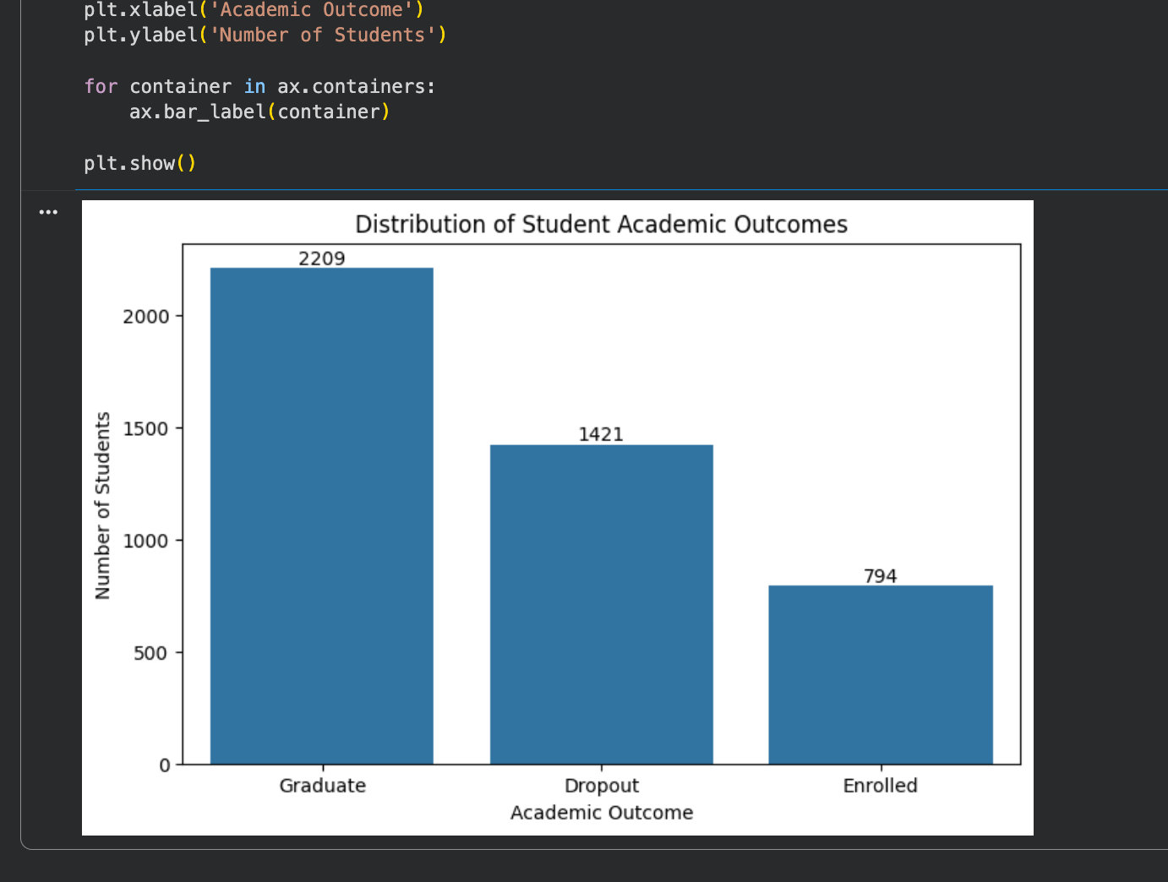
Figure 1. Distribution of student academic outcomes.

Exploratory Data Analysis
Before modeling, I explored how student characteristics and academic indicators differed across the three outcomes. Age at enrollment showed noticeable variation across outcome groups, suggesting that enrollment age may carry some predictive information.
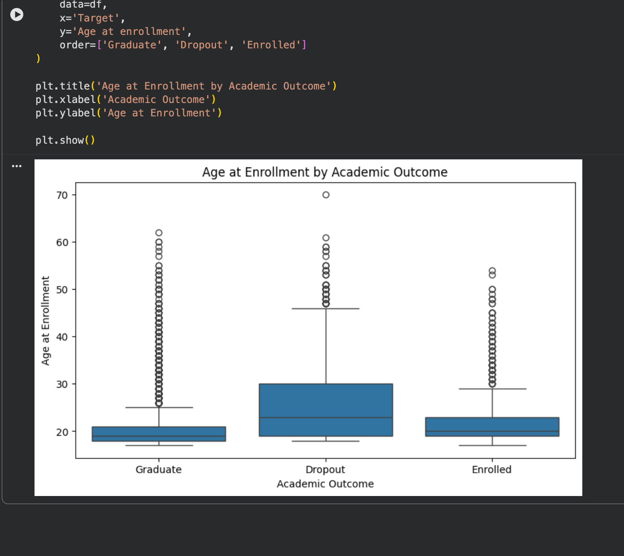
Figure 2. Age at enrollment across academic outcomes.
Financial and support-related variables also revealed useful patterns. Scholarship status and whether tuition fees were up to date showed different outcome distributions, indicating that academic success is connected not only to grades but also to students’ financial and institutional circumstances.
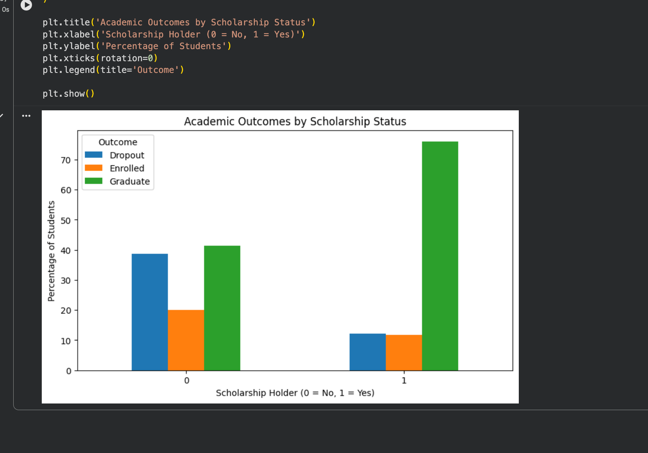
Figure 3. Academic outcomes by scholarship status.
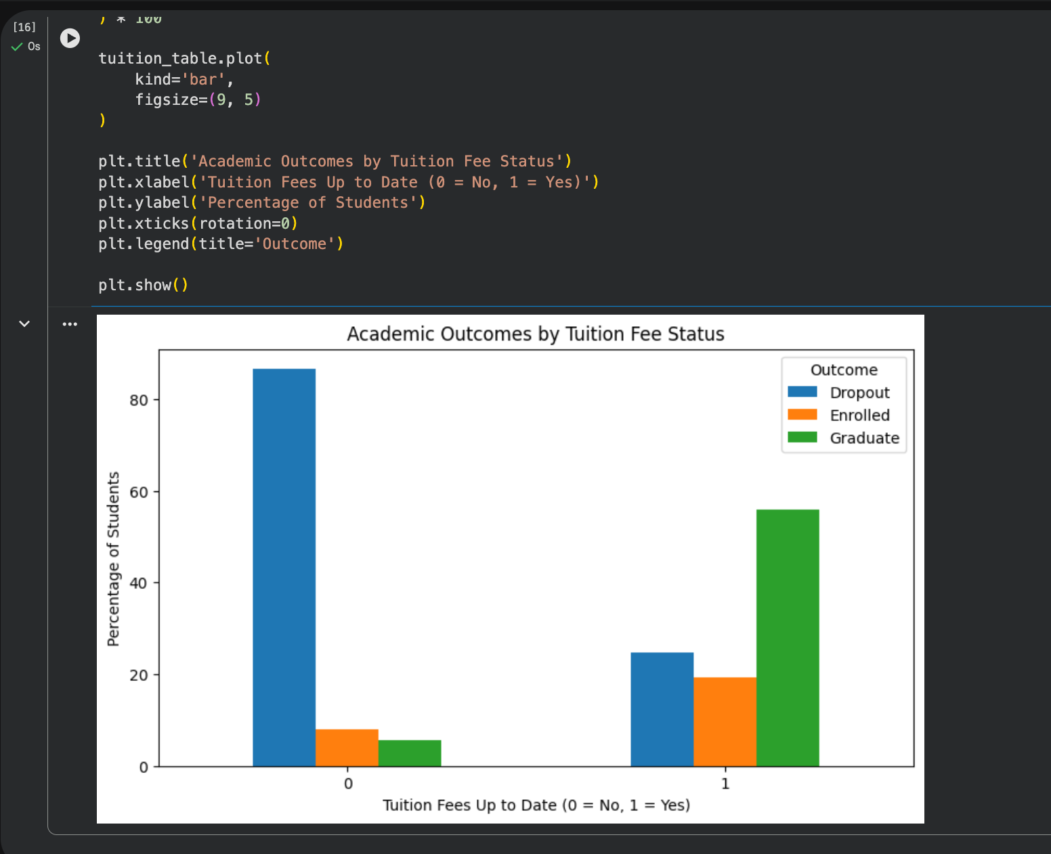
Figure 4. Academic outcomes by tuition-fee status.

Correlation and Important Academic Indicators
To make the categorical target usable for correlation analysis, I encoded Dropout as 0, Enrolled as 1, and Graduate as 2. The strongest positive correlations with the encoded outcome came from academic progress variables. Curricular units approved and grades in the first and second semesters were especially important. Tuition fees being up to date and scholarship status were also positively associated with higher outcomes.
The strongest negative correlations included age at enrollment, debtor status, gender, and application mode. These correlations should be interpreted as associations rather than proof of causation.
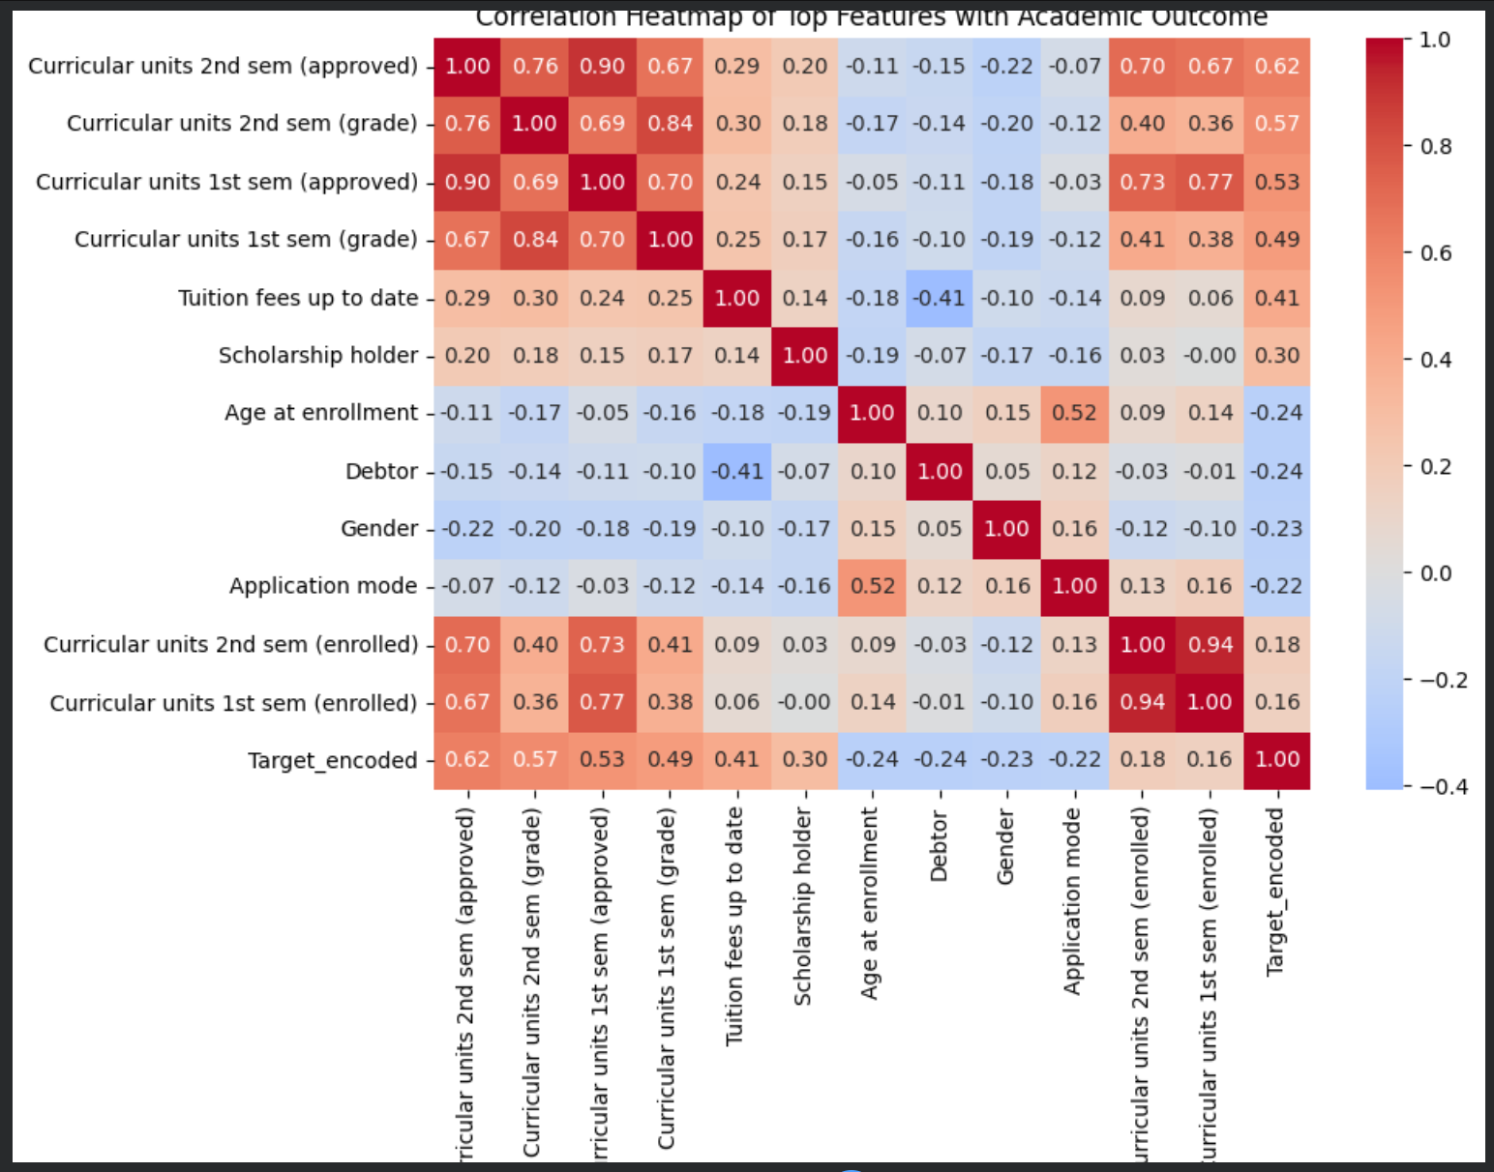
Figure 5. Correlation heatmap of selected features and academic outcome.

Preparing the Data for Machine Learning
I separated the 36 predictor variables from the target and used an 80/20 stratified train-test split. This produced 3,539 training samples and 885 testing samples while preserving the class proportions. For algorithms that benefit from standardized inputs, I fitted a StandardScaler on the training data and transformed the test data using the same scaler.
Four models were evaluated: Logistic Regression, Random Forest, XGBoost, and a feed-forward Neural Network. I compared them primarily using test accuracy and Macro F1 score.

Model 1: Logistic Regression
Logistic Regression provided a strong baseline, reaching 76.84% accuracy and a Macro F1 score of 0.6826. It performed particularly well on the Graduate class, with 0.93 recall, but the Enrolled class was more difficult, with recall of 0.33.
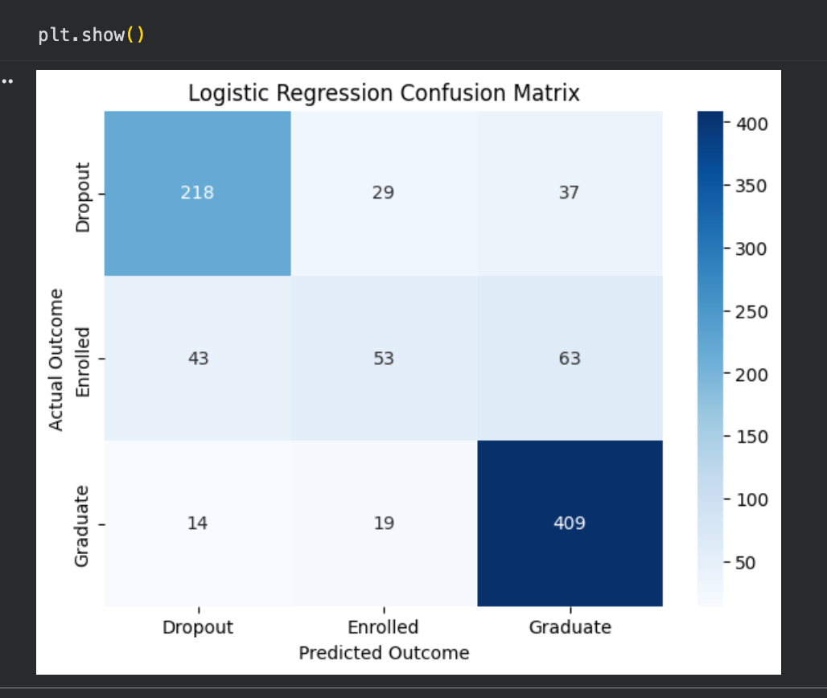
Figure 6. Logistic Regression confusion matrix.

Model 2: Random Forest
Random Forest improved the overall balance of predictions. It achieved 77.40% accuracy and a Macro F1 score of 0.7001. The model correctly classified 411 of 442 Graduate cases and improved Enrolled recall to 0.38.
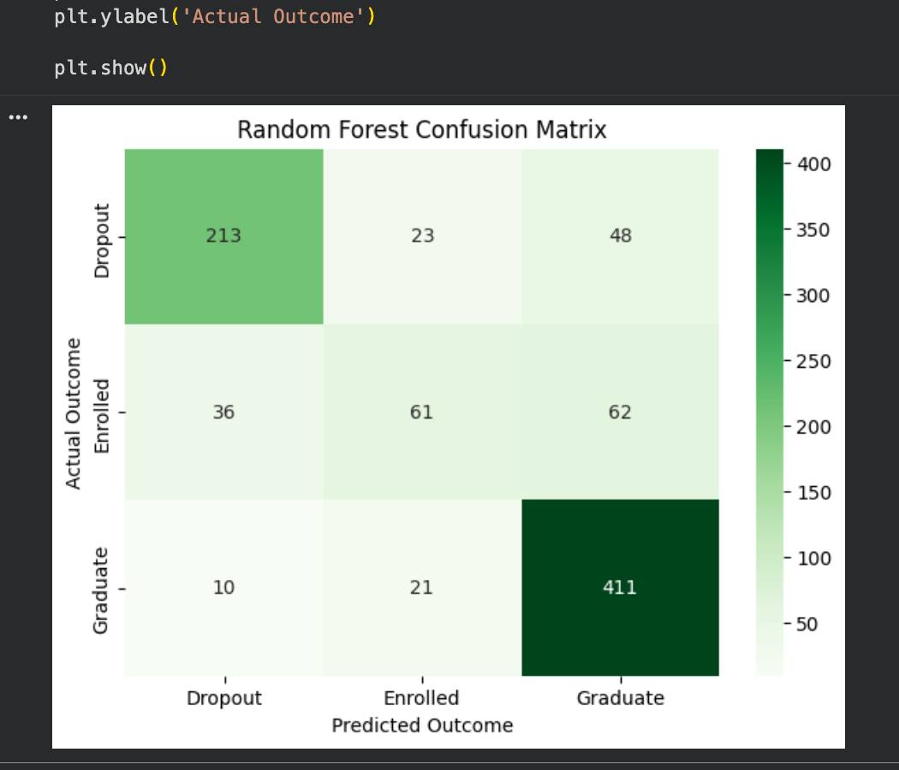
Figure 7. Random Forest confusion matrix.
Random Forest also made it possible to inspect feature importance. The most important feature was Curricular units 2nd sem (approved), followed by Curricular units 2nd sem (grade), Curricular units 1st sem (approved), and Curricular units 1st sem (grade). This reinforces the EDA finding that recent academic performance is highly informative for predicting student outcomes.
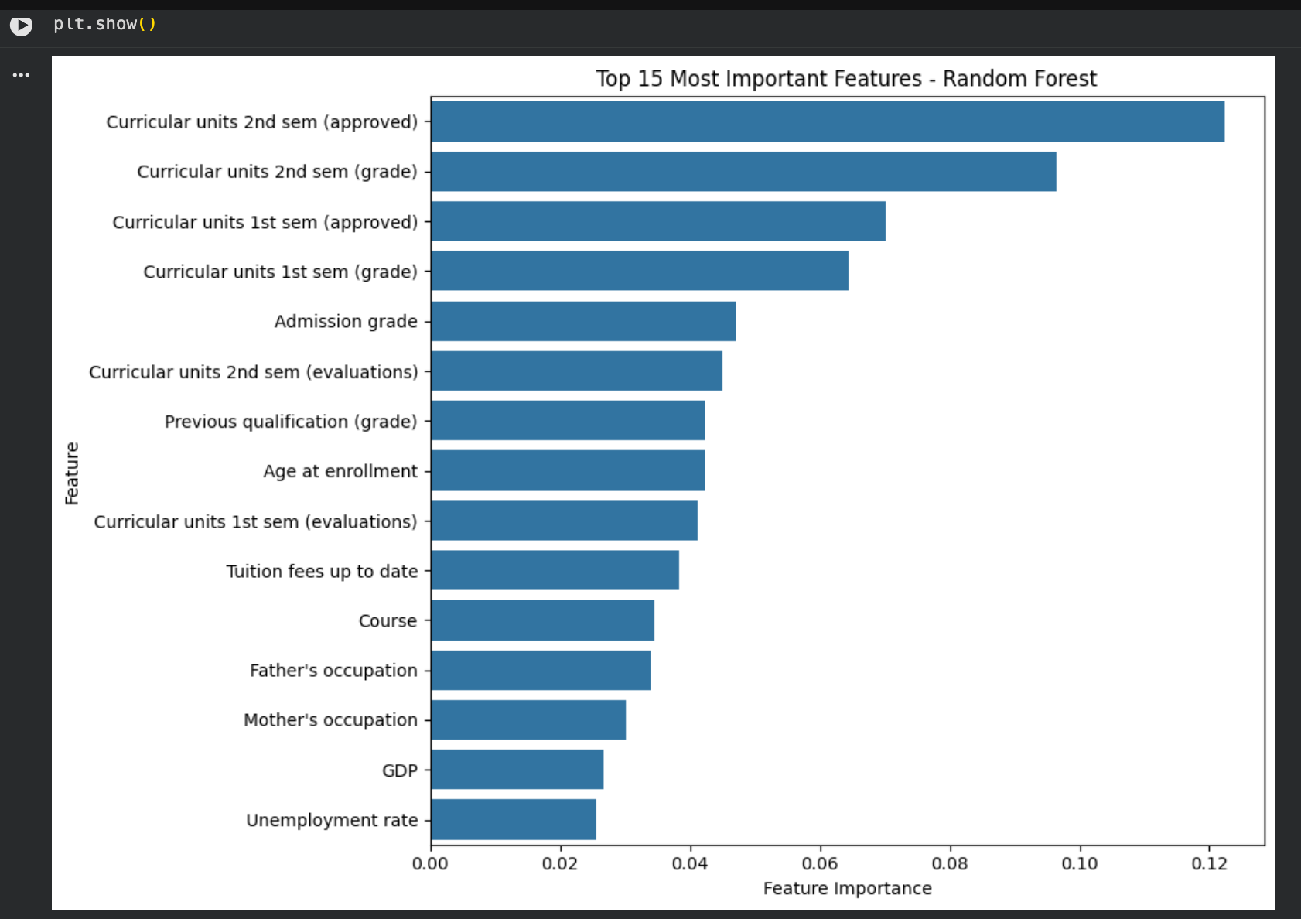
Figure 8. Top 15 Random Forest feature importances.

Model 3: XGBoost
XGBoost produced the best Macro F1 score of the four models. Its test accuracy was 77.06%, while its Macro F1 score reached 0.7052. The Enrolled class remained the hardest to identify, but XGBoost achieved 0.44 recall for this class, higher than the other tested models.
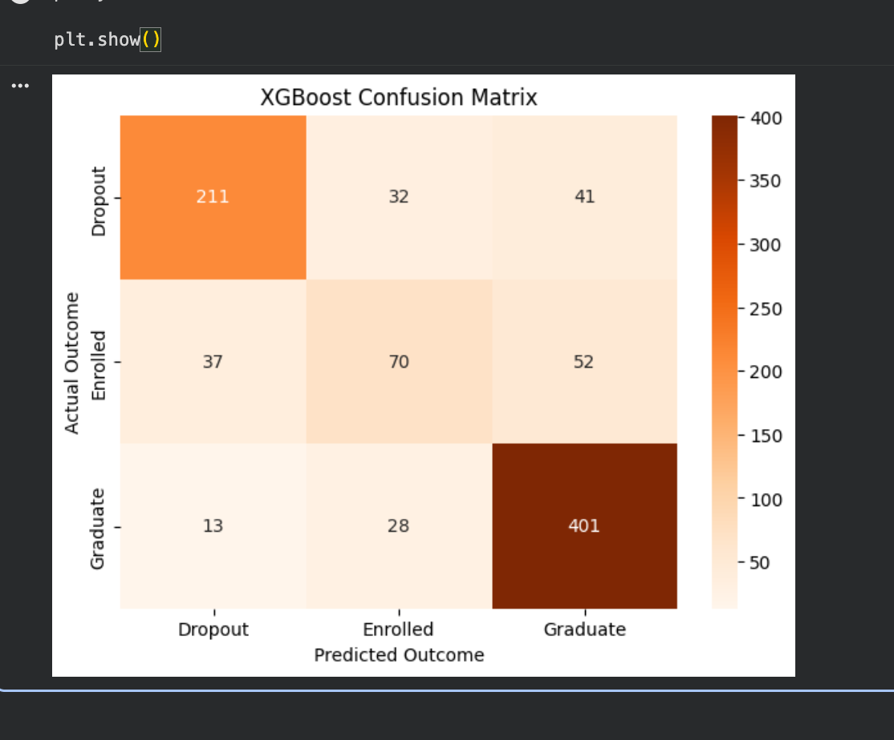
Figure 9. XGBoost confusion matrix.

Model 4: Neural Network
I also built a feed-forward neural network with three hidden Dense layers containing 128, 64, and 32 units, ReLU activation, dropout regularization, and a three-unit softmax output layer. The network used Adam optimization, sparse categorical cross-entropy, and early stopping based on validation loss.
The neural network achieved 75.59% test accuracy and a Macro F1 score of 0.6838. The training curves show a persistent gap between training and validation performance. Validation loss did not improve as training loss decreased, which suggests some overfitting despite dropout and early stopping.
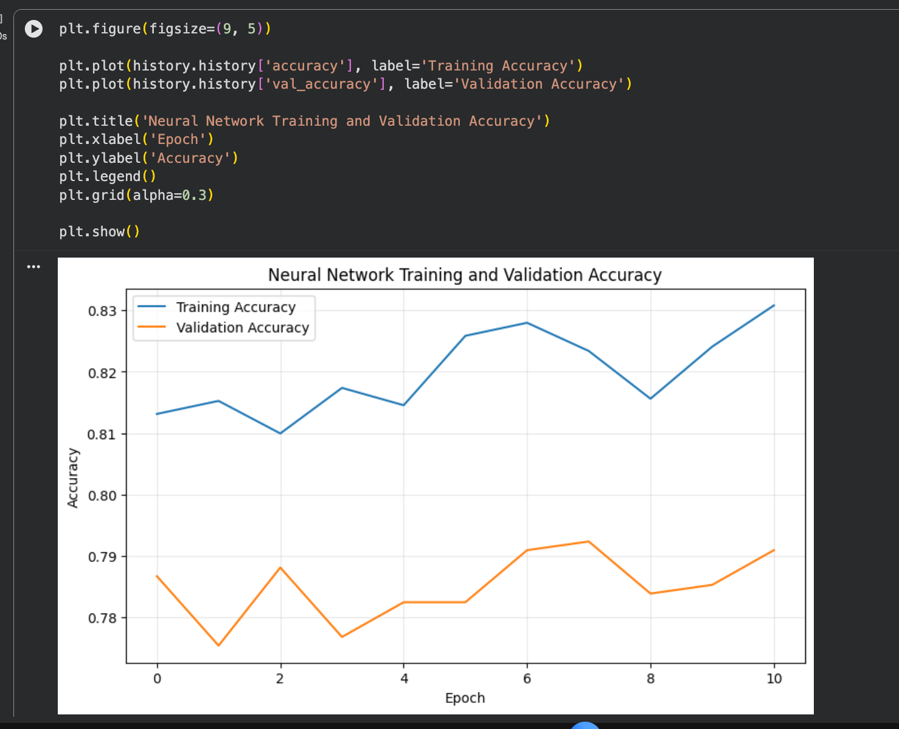
Figure 10. Neural-network training and validation accuracy.
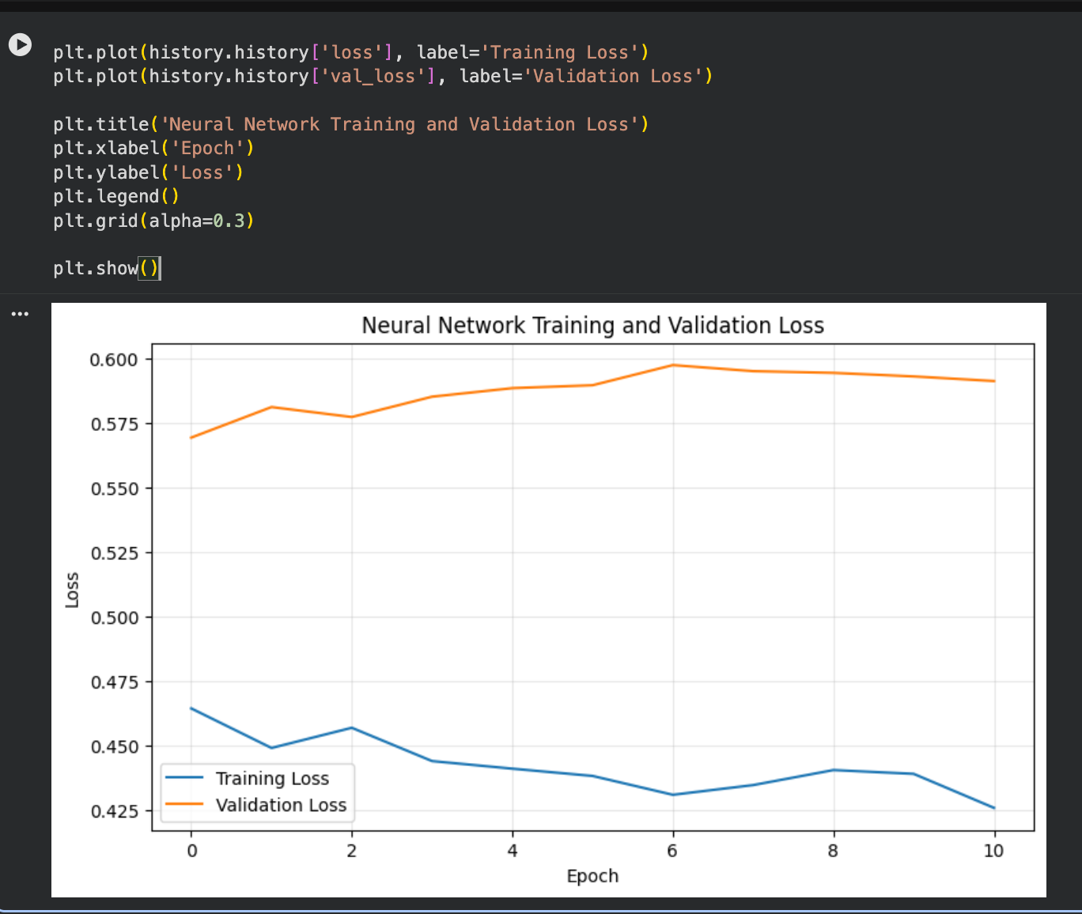
Figure 11. Neural-network training and validation loss.

Comparing the Models
The four models produced fairly similar accuracies, but Macro F1 revealed meaningful differences in how well they handled all three classes. XGBoost ranked first by Macro F1, while Random Forest achieved the highest accuracy.
Model | Accuracy | Macro F1
XGBoost | 0.7706 | 0.7052
Random Forest | 0.7740 | 0.7001
Neural Network | 0.7559 | 0.6838
Logistic Regression | 0.7684 | 0.6826
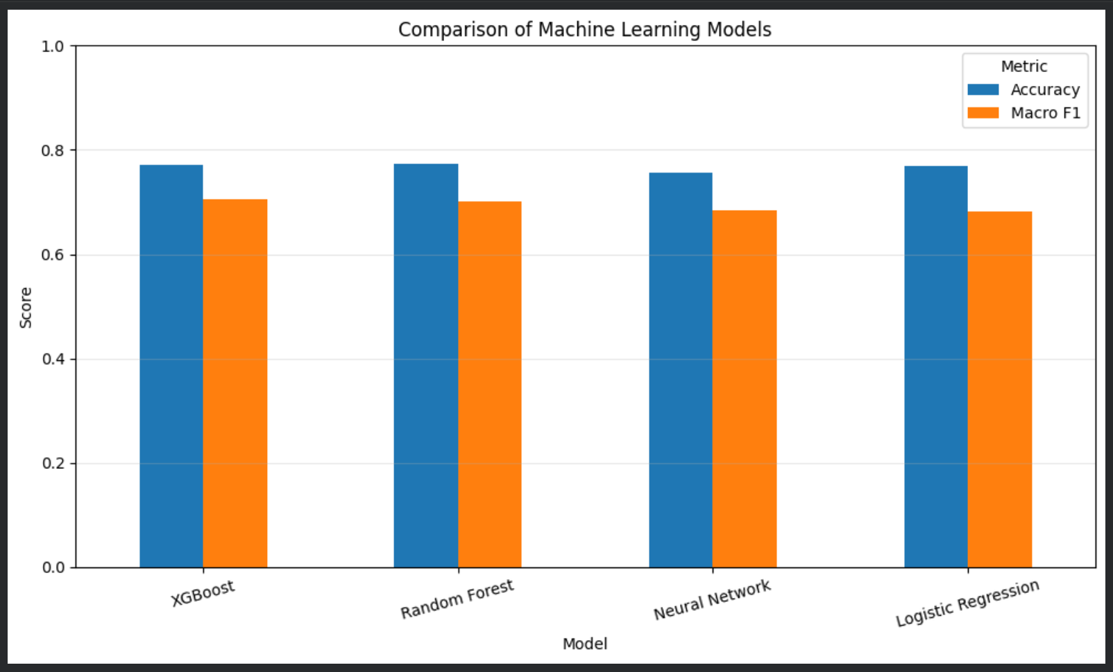
Figure 12. Comparison of accuracy and Macro F1 across the four models.

What Did I Learn?
The most important result was not simply which algorithm won. Across the analysis, academic progress during the first two semesters consistently emerged as the strongest signal. Numbers of approved curricular units and semester grades dominated both correlation analysis and Random Forest feature importance.
The results also demonstrate why multiple evaluation metrics matter. Random Forest had the highest accuracy, but XGBoost had the highest Macro F1 score. Since the dataset contains an imbalanced three-class target and the Enrolled class is difficult to predict, Macro F1 provides a more balanced view of model performance.
Another useful observation came from the neural network. A more complex model did not automatically outperform traditional machine-learning methods. For this structured tabular dataset, XGBoost and Random Forest were more effective than the neural network used here.

Conclusion
This project demonstrated a complete machine-learning workflow for predicting student academic outcomes, from exploratory analysis and preprocessing through model training, evaluation, visualization, and interpretation.
Among the tested approaches, XGBoost provided the best balanced performance with a Macro F1 score of 0.7052, while Random Forest achieved the highest accuracy at 77.40%. The analysis suggests that early academic performance—especially approved curricular units and semester grades—is highly informative when predicting whether a student will graduate, remain enrolled, or drop out.
A practical extension of this work would be to improve identification of the Enrolled class through additional class-balancing strategies, hyperparameter tuning, and more detailed feature engineering. The model could also be explored as part of an early-warning system designed to help institutions identify students who may benefit from timely academic or financial support.

Tools Used
Python • Google Colab • pandas • NumPy • Matplotlib • Seaborn • scikit-learn • XGBoost • TensorFlow/Keras • ChatGPT
Medium copy tip: paste the text section-by-section, then upload the matching figure shown directly below each section in this document.

