**Step-By-Step Process of downloading the application**

Step 1:

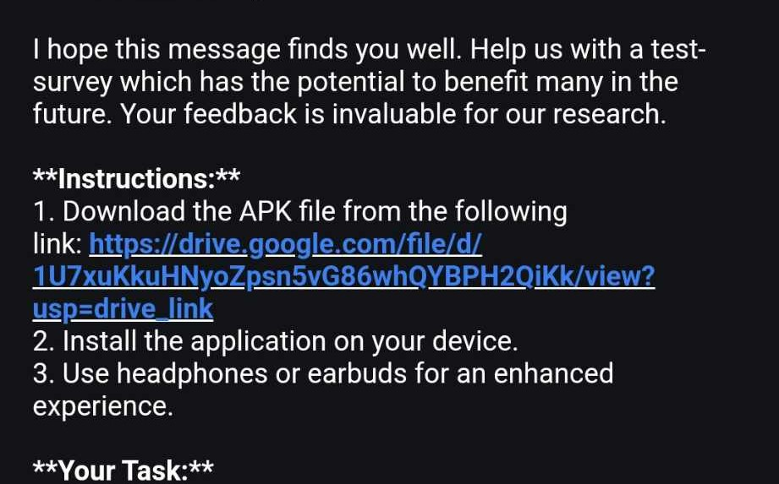

Open the **drive link** from your mobile device (IOS or Android)

Step 2:

|  |  |
| --- | --- |
|  |  |

At the bottom you will find the option of opening it using **Package Installer**. Press that option.

Step 3:

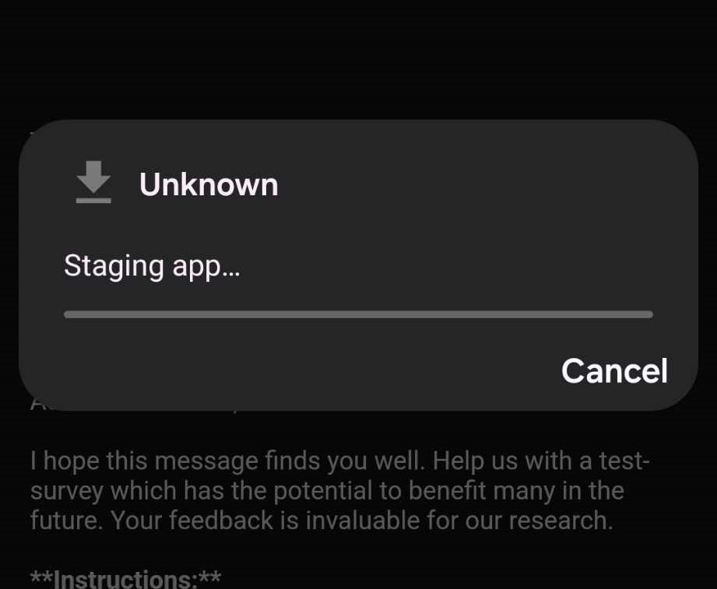

|  |  |
| --- | --- |
|  |  |

IF this option appears then go to **settings** and turn on **Allow permission**

Step 4:

|  |  |
| --- | --- |
|  |  |

Then you will receive the installation option. Press on **Install**.

Step 5:

|  |  |
| --- | --- |
|  |  |

Press on **More details**. You will find the option of **Install anyway**. Press on that.

Step 6:

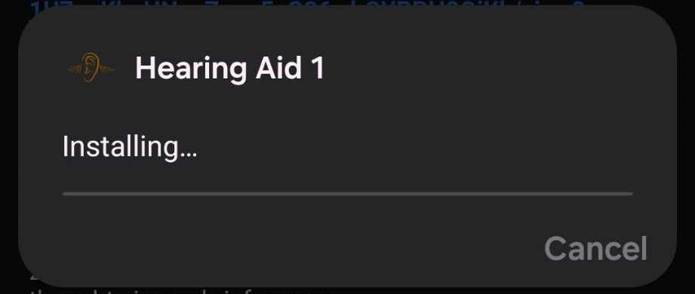

The Application will be installed

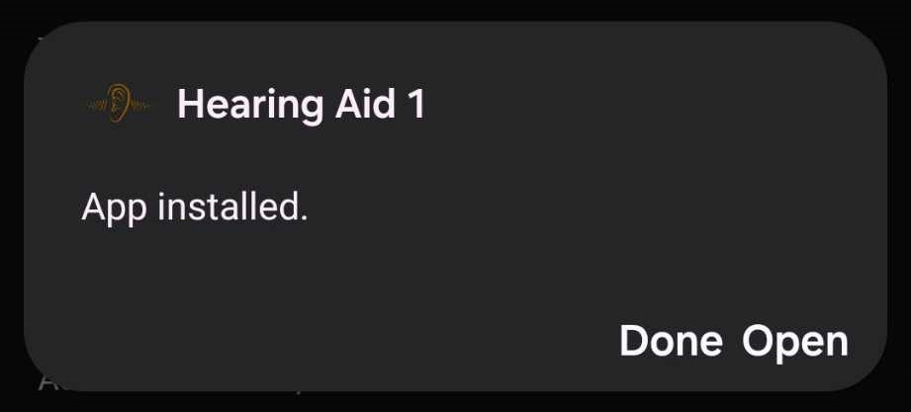

After installation Press **Open**

Step 7:

|  |  |
| --- | --- |
|  |  |

It will take permission for recording audio and after granting permission you can now use the application.   
  
Press Start Recording and adjust the amplification based on your own preference.