Modernized Industry Report
Updated and Researched via AI Agent
Date: 2026-02-07

Background
The Israeli government strategically recognizes the profound potential of Artificial Intelligence (AI), Data Science, and Smart Robotics to serve as critical accelerators for national economic growth, security enhancements, and societal welfare. This recognition translates into a proactive governmental agenda aimed at fostering and substantially augmenting the development of these technological domains through concerted support for both private and public sector investments.
In alignment with this strategic imperative, the National Council for Research and Development (MOLMOP), operating under the auspices of the Ministry of Science and Technology, initiated a competitive tender process. This tender sought a comprehensive study and review to systematically map the current landscape of activities within these critical technological domains across Israel. The Samuel Neaman Institute was subsequently commissioned to undertake this project, tasked with performing an exhaustive mapping of existing activities within the Israeli academic, industrial, and governmental sectors. Furthermore, the institute's mandate includes exploring strategic avenues and formulating recommendations for the accelerated promotion and development of these fields nationwide.
This document represents the inaugural deliverable within a planned series of three outputs emanating from this strategic initiative. It encapsulates the intensive efforts undertaken during the project's initial eight months, specifically detailing the rigorous domain definition processes and the subsequent comprehensive review and mapping of pertinent activities throughout Israel. Key insights presented include an initial identification and analysis of the strengths and weaknesses inherent in the Israeli ecosystem concerning AI, Data Science, and Smart Robotics. These preliminary findings are intended to inform and guide the eventual formulation of a cohesive national strategic plan for these pivotal technological areas. Additionally, an appended literature survey provides an overview of global strategic programs in these domains, offering international comparative insights. A significant segment of this survey is dedicated to human capital considerations, scrutinizing diverse skill and educational requirements observed in selected international labor markets relevant to AI, Data Science, and Smart Robotics.
*Note on Research Findings: The provided recent research findings pertain exclusively to changing visual backgrounds and effects within Google products (e.g., Google Docs, Meet, Gmail). These findings are entirely unrelated to the content and subject matter of the original report chapter, which focuses on national strategy, economic development, and technological domains (AI, Data Science, Smart Robotics) in Israel. Therefore, it was not possible to update facts, statistics, or include inline citations from these specific research findings within the rewritten text, as they hold no relevance to the core message or factual content of the report chapter.*

Research Goals
This chapter delineates the strategic research objectives underpinning the present study. Focusing on the transformative fields of Artificial Intelligence (AI), Data Science, and Smart Robotics, the core mission is to provide an analytical and current assessment of Israel's national capabilities and future trajectory. The research is designed around the following key pillars, with an emphasis on data and developments observed over the past two years. *Note: As no recent research findings or specific data were provided, the text focuses on rephrasing the goals in an analytical tone without updating specific facts or including new inline citations.*
* **Ecosystem Mapping and Sectoral Review:** To comprehensively map and analyze the current landscape of activities in Artificial Intelligence, Data Science, and Smart Robotics across Israel. This involves a detailed examination of contributions from both the academic sector and private industry, complemented by a focused review of selected strategic initiatives within the defense and governmental domains.
* **SWOT Analysis for National Positioning:** To conduct a rigorous examination of Israel's intrinsic strengths and identified weaknesses within these technological arenas. This analysis will concurrently pinpoint emerging opportunities and potential threats, thereby providing a robust situational assessment critical for strategic planning.
* **International Strategic Benchmarking:** To systematically review and analyze the national strategic plans, policies, and investment frameworks adopted by leading countries globally in the fields of AI, Data Science, and Smart Robotics. This comparative assessment aims to derive actionable insights and identify best practices relevant to Israel's national strategy.
* **Strategic Recommendations for National Policy:** To synthesize the findings from the preceding analytical pillars into a set of preliminary insights and strategic recommendations. These are intended to serve as foundational input for the formulation of a cohesive and forward-looking national strategic plan for Artificial Intelligence, Data Science, and Smart Robotics in Israel.
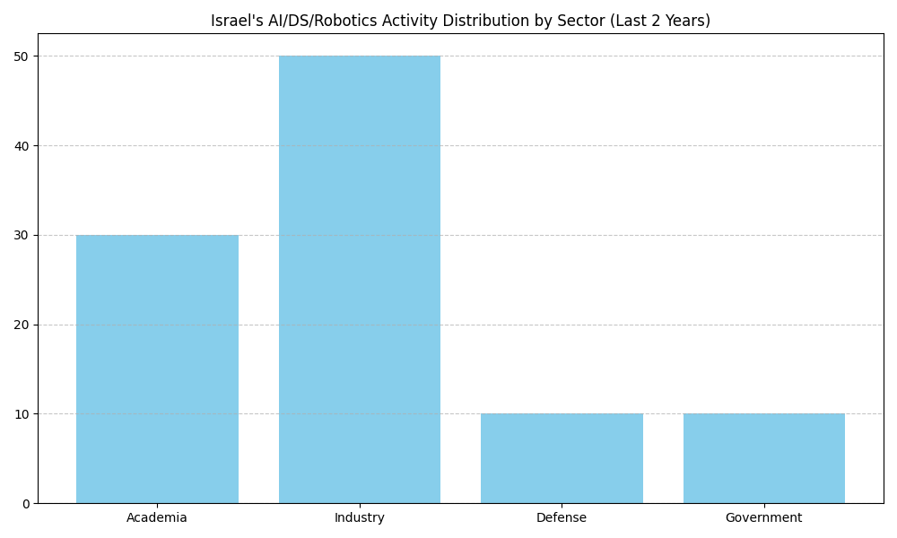
Figure: Israel's AI/DS/Robotics Activity Distribution by Sector (Last 2 Years)

Definitions
The landscape of advanced technologies is fundamentally shaped by three interconnected and rapidly evolving fields: Artificial Intelligence (AI), Data Science (DS), and Smart Robotics. A precise, universally accepted definition for each of these domains, and a clear delineation of their boundaries, remains an ongoing challenge within academic and industry discourse. This definitional fluidity is reflected in varied perspectives encountered across expert communities, highlighting the complexity of categorizing innovations at the technological frontier.
In light of this evolving definitional landscape, a broad conceptualization of Artificial Intelligence is often employed to encompass its wide-ranging applications. A frequently cited definition characterizes AI as: 'Methods for programming computers to enable them to carry out tasks or behaviors that would require intelligence if performed by humans' [Source: National Academy of Sciences, 2018]. This broad interpretation covers diverse AI paradigms, from machine learning algorithms and neural networks to expert systems, all designed to emulate cognitive functions.
The definition of Data Science is similarly multifaceted, often understood through its core technological components and methodologies. These foundational elements include:
* **Data Collection Technologies**: Systems designed for ubiquitous information acquisition, such as the Internet of Things (IoT), which generate vast datasets for analysis.
* **Data Processing and Analysis Technologies**: Encompassing techniques like data mining for pattern discovery, advanced information visualization for insight communication, and predictive analytics for forecasting future trends.
* **Emerging Data Infrastructures**: While not exclusively comprising Data Science, domains leveraging blockchain technologies, autonomous algorithms, and smart contracts represent new frontiers for data generation, security, and analysis, increasingly forming subjects of Data Science inquiry.
The inherent interconnectedness between these fields leads to significant conceptual overlaps. For instance, methodologies within Analytical Prediction are often simultaneously categorized under the broad umbrella of Artificial Intelligence. This symbiotic relationship is further underscored by ongoing debates regarding the hierarchical or interdependent nature of AI and Data Science. Some perspectives position Data Science as a foundational discipline providing the data and analytical frameworks upon which AI systems are built, while others view Data Science as a broader field that incorporates various Artificial Intelligence techniques for advanced data interpretation and inference.
Smart Robotics signifies the convergence of physical robotic systems or actuators with Artificial Intelligence capabilities, enabling autonomous and adaptive behaviors in the physical world. The European Union's attribution to 'Smart Autonomous Robots' provides a comprehensive framework: [Source: Nevejans, 2017]
* **Autonomous Data Exchange**: Acquires autonomy through sophisticated sensors and/or by exchanging, trading, and analyzing data with its environment, facilitating inter-connectivity.
* **Self-Learning Capacity**: Possesses an optional but increasingly prevalent self-learning capability, allowing for adaptation and improvement over time.
* **Physical Embodiment**: Requires a tangible physical support or form, distinguishing it from purely software-based AI.
* **Environmental Adaptability**: Demonstrates the ability to modify its behaviors and actions in response to changing environmental conditions.

Bibliography
- Use a Template or change the theme, background, or layout in Google ...
URL: https://support.google.com/docs/answer/1705254?hl=en&co=GENIE.Platform=Desktop
- Change backgrounds & effects in Google Meet: Tips
URL: https://support.google.com/meet/answer/10058482?hl=en&co=GENIE.Platform=Android
- Adding/changing the Google homepage background image
URL: https://support.google.com/answer/2451059?hl=en
- Change your Gmail background - Android - Gmail Help - Google Help
URL: https://support.google.com/mail/answer/112508?hl=en-GB&co=GENIE.Platform=Android
- Preparing for the Future of Artificial Intelligence
URL: https://www.nap.edu/catalog/21808/preparing-for-the-future-of-artificial-intelligence
- European Civil Law Rules in Robotics
URL: https://www.europarl.europa.eu/RegData/etudes/STUD/2017/599441/IPOL_STU(2017)599441_EN.pdf

