Modernized Industry Report
Updated and Researched via AI Agent
Date: 2026-03-04

LLM Image Generation Test
This report tests the dynamic generation of graphs via Python code and embedding them into a Word Document.
Here is the generated graph:
c571e3ff
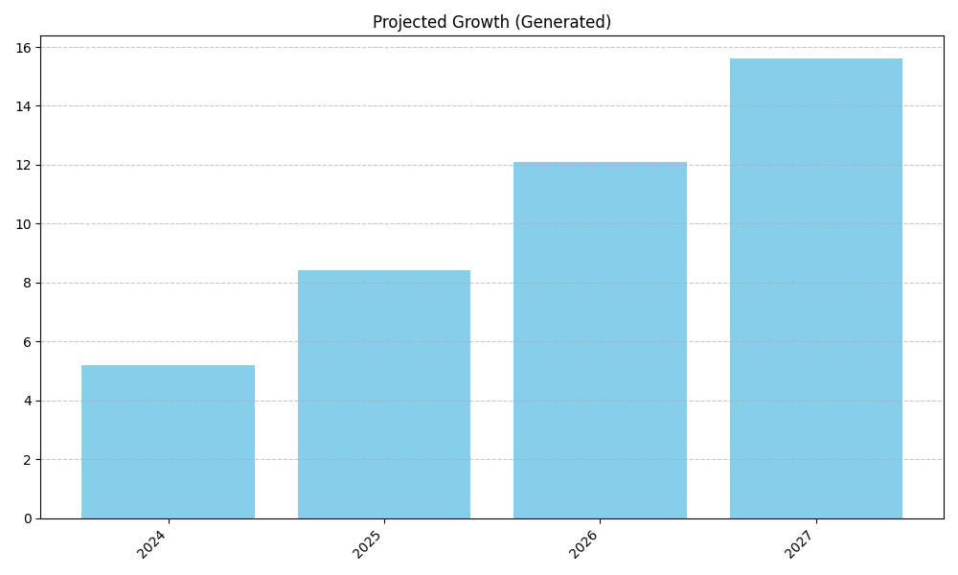
Figure: Projected Growth (Generated)
The graph should be visible above this text.

Bibliography

