Web blogging

**Ruby on Rails**

NetBeans, MySQL, WeB Brick and JRuby

|  |  |
| --- | --- |
| 1. **ABSTRACT** | 3 |
| 1. **INTRODUCTION** | 4 |
| 1. **OBJECTIVE** | 5 |
| 1. **PROPOSED SOLUTION** |  |
| 4.1 **Technologies and Approach** | 7 |
| 4.2 **Architectural Concept** | 8 |
| 4.3 **Design Patterns Used** | 8 |
| 4.3.1 MVC design pattern | 8 |
| 4.4 **Screenshots** | 9 |
| 4.5 **Testing** | 15 |
| 1. **Assumptions & Future Enhancements** | 16 |
| 1. **Hardware & Software Used** | 17 |
| 1. **Steps in running the project** | 18 |
| 1. **References** | 19 |

|  |  |  |  |
| --- | --- | --- | --- |
| layout_center | 1. Abstract | | |
|  | |  |
| It is a collaborative project for which our team is providing web site for social site that uses features like blogs and forums as well as articles to voice their opinion .The user is able to login as we have provided the authentication feature where he can sign up and then login the website .We have the administrator who controls the privileges that who can see what and what restrictions to put on the users .Each user who signs up creates his own profile where he can write about himself post his photo as well as see others user profiles. The site is a fun site where the registered user can talk about any of the relevant issues blog about relevant topics, look at other peoples articles .Thus a lot of information is shared through the website and also freedom is given to the user to discuss whatever he wants to write hence it a kind of innovative website.  This document presents an overview of our design approach, assumptions, considerations, limitations and future enhancements for the social network blogging website. | | |

|  |  |
| --- | --- |
| *layout_center* | 2. Introduction |

A web site is platform unbiased, language unbiased also can be retrieved over World Wide Web. Ruby on Rails is an open source Web framework causing a lot of excitement among Web developers. By supporting agile development techniques and a philosophy of "convention over configuration," it has enabled many developers to radically reduce the time and pain involved in creating Web applications. Since Rails emerged from the open source world, until recently you had to use MySQL .Ruby on Rails, or "Rails" for short, hasn't risen to fame in the Web development world without reason. Rails was originally conceived out of real-world requirements, having emerged through the refactoring of a large Web application that its author, David Heinemeier-Hansson, was writing. This origin means that Rails is optimized to achieve its goals, rather than being the result of an abstract API architecture, with all the tendencies such things have to sprawl.

One of the biggest time-savers in Rails is convention over configuration. Simple things such as naming your data model class with the same name as the corresponding database table means that you don't have to write needless mapping code, as do techniques such as always using "id" as the primary key name. Of course Rails provides get-outs and overrides, but the idea is only to use these when necessary.

|  |  |
| --- | --- |
| layout_center | 3. Objective |

The website has the following core functionalities:

1. Authentication page for the user to signup.
2. Administrator role to define privileges to the users.
3. Creation of the blogs by the users.
4. Creations of articles and forums by the users.
5. Creation of the user profiles by the users.
6. Creation of new pages for the website.

# layout_center 4. PROPOSED SOLUTION

## Technologies and Approach

**JRUBY**

JRubyis a java implementation of the Ruby Programming Language, being developed by the JRuby team. It is free software released under a three-way license. JRuby is tightly integrated with Java to allow the embedding of the interpreter into any Java application with full two-way access between the Java and the Ruby code. JRuby was originally created by Jan Arne Petersen, in 2001. At that time and for several years following, the code was a direct port of the Ruby 1.6 code. With the release of Ruby 1.8.6, an effort began to update JRuby to 1.8.6 features and semantics. Since 2001, several contributors have assisted the project, leading to the current (2008) core team of four members. The NetBeans Ruby Pack, available since Net Beans 6.8, allows IDE development with Ruby and JRuby , as well as Ruby on Rails for the two implementations of Ruby.

Following plugins were installed in the Netbeans IDE 6.8RC1.

RedCloth 4.2.2

mislav\_will\_paginate 2.3.11

Paginator 1.1.1

paperclip 2.3.1.1

rmagic 2.12.0

Imagemagick

**My SQL**

**MySQL** is a relational database system (RDBMS) that has more than 6 million installations. MySQL stands for "My structured Query language". The program runs as a server providing multi-user access to a number of databases. The project has made its source code available under the terms of the [GNU General Public License](http://en.wikipedia.org/wiki/GNU_General_Public_License), as well as under a variety of [proprietary](http://en.wikipedia.org/wiki/Proprietary_software) agreements. MySQL is owned and sponsored by a single firm; the Swedish company of 2009 Oracle Corporation began the process of acquiring Sun Microsystems. MySQL is often used in free download projects that require a full-featured database management system, such as Word Press, [php BB](http://en.wikipedia.org/wiki/PhpBB" \o "PhpBB) and other software built on the [LAMP](http://en.wikipedia.org/wiki/LAMP_(software_bundle)) software stack. It is also used in very high-scale [World Wide Web](http://en.wikipedia.org/wiki/World_Wide_Web) products including [Wikipedia](http://en.wikipedia.org/wiki/Wikipedia), [Google](http://en.wikipedia.org/wiki/Google) and [Face book](http://en.wikipedia.org/wiki/Facebook).

In the project we have used My SQL in conjunction with Net beans for storing the database of the website.

|  |  |
| --- | --- |
| *layout_center* | 4.2. Architecture |

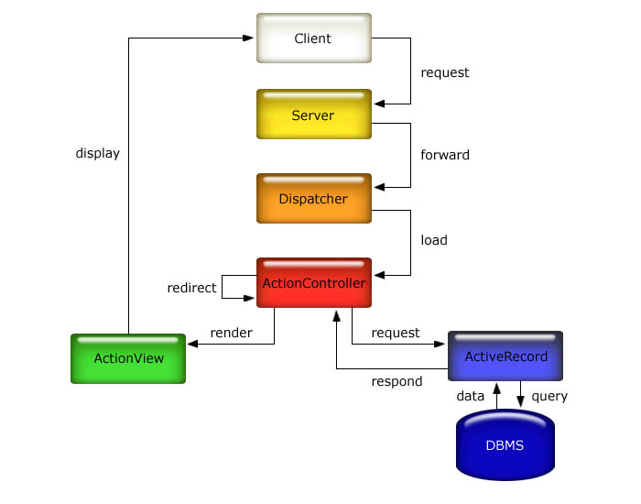

**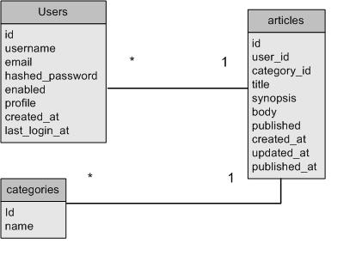**

In the ruby on rails website (Tunes) we have the model view controller pattern where are using Net beans as IDE where we had to install plug-ins like Image Magick , Rmagick as well as Paperclip as well as Red Cloth.

The above interaction shows the interaction of the model view controller in our Tunes website

|  |  |
| --- | --- |
| layout_center | **4.3 Design Pattern** |

**Model View Controller Design Pattern:**

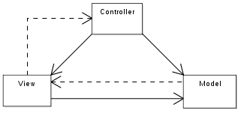

**Model**

Is the domain-specific representation of the data upon which the application operates. Domain logic adds meaning to raw data (for example, calculating whether today is the user's birthday, or the totals, taxes, and shipping charges for shopping cart items). When a model changes its state, it notifies its associated views so they can refresh.

Many applications use a persistent storage mechanism (such as a database) to store data. MVC does not specifically mention the data access layer because it is understood to be underneath or encapsulated by the model. Models are not data access objects; however, in very simple apps that have little domain logic there is no real distinction to be made. Also, the Active Record is an accepted design pattern which merges domain logic and data access code - a model which knows how to persist itself.

**View**

Renders the model into a form suitable for interaction, typically a user interface element. Multiple views can exist for a single model for different purposes.

**Controller**

Receives input and initiates a response by making calls on model objects.

An MVC application may be a collection of model/view/controller triplets, each responsible for a different UI element.

MVC is often seen in web applications where the view is the HTML or XHTML generated by the app. The controller receives GET or POST input and decides what to do with it, handing over to domain objects (i.e. the model) that contain the business rules and know how to carry out specific tasks such as processing a new subscription.

|  |  |
| --- | --- |
| layout_center | **4.4 Screenshots** |

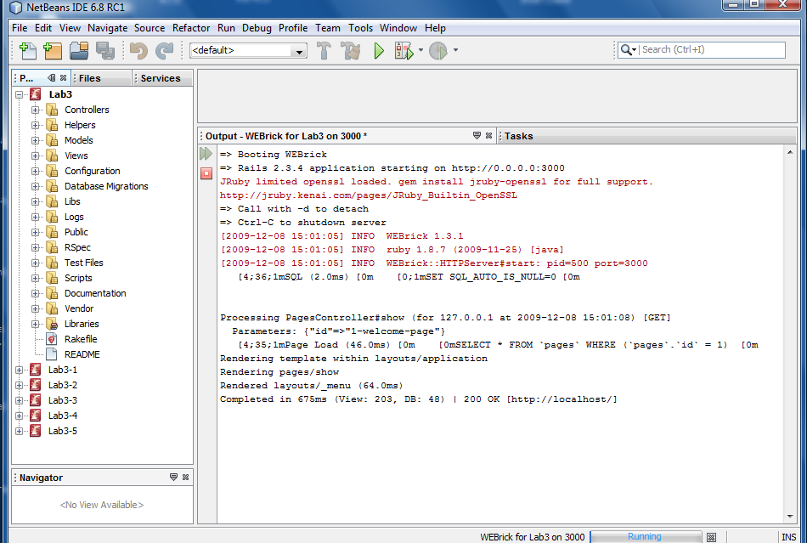

Netbeans starting up WEBrick server

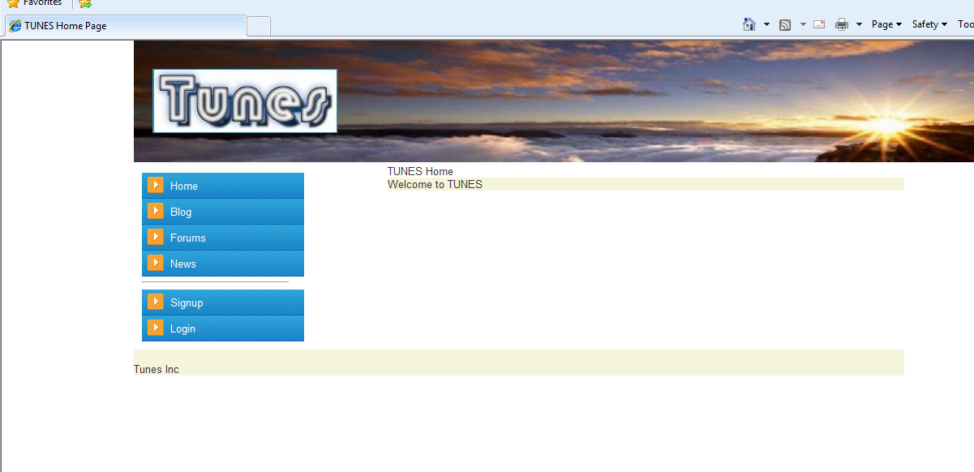

Home page of the Tunes In

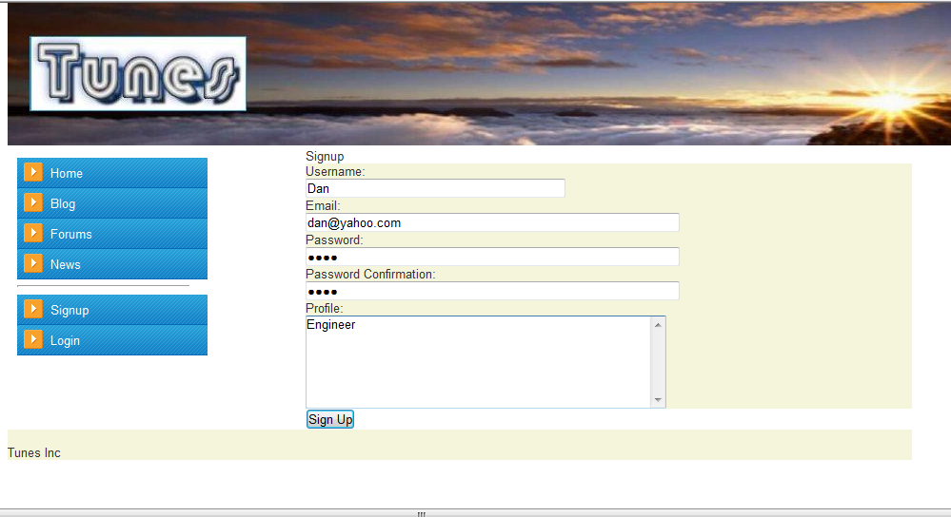

New user Dan signing up to Tunes site

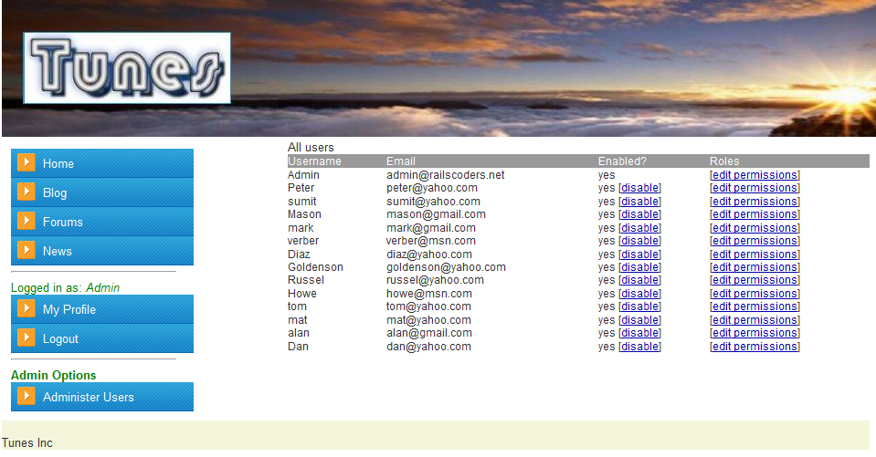

Admin logged in the Tunes site to give or deny permission to the users

Admin username : admin

Admin password: admin

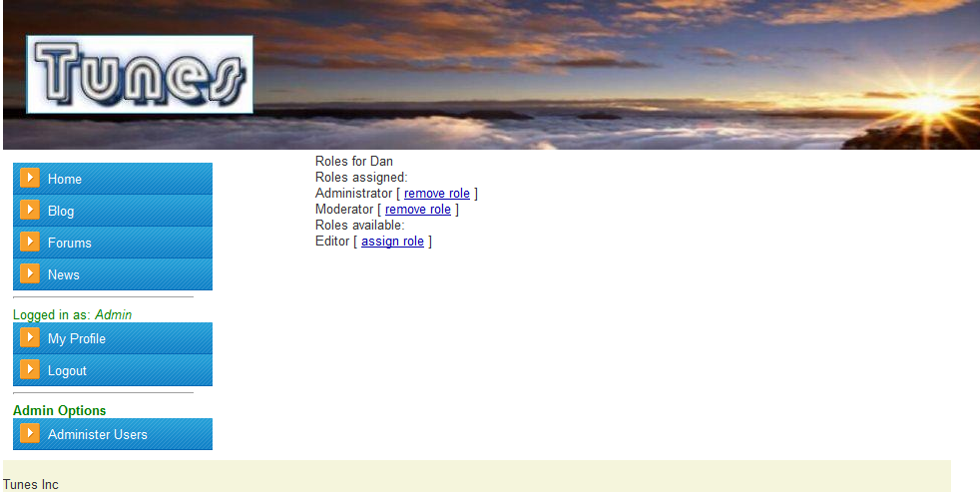

Admin assigned Administrator and moderator role to Dan. Admin can change the role of the people by changing their role by clicking the Administer Users button.

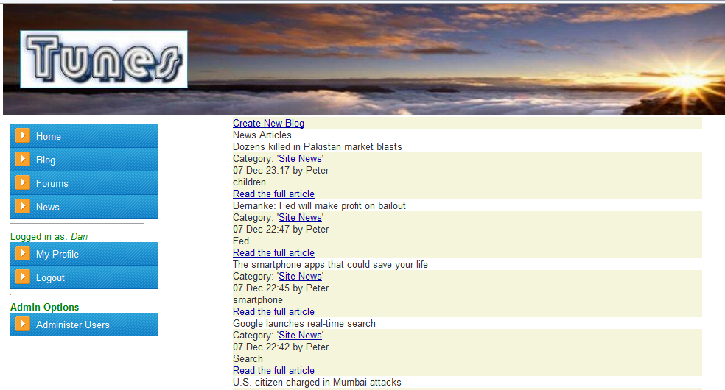

Blog page, user can create a new blog by clicking the Create New Blog link.

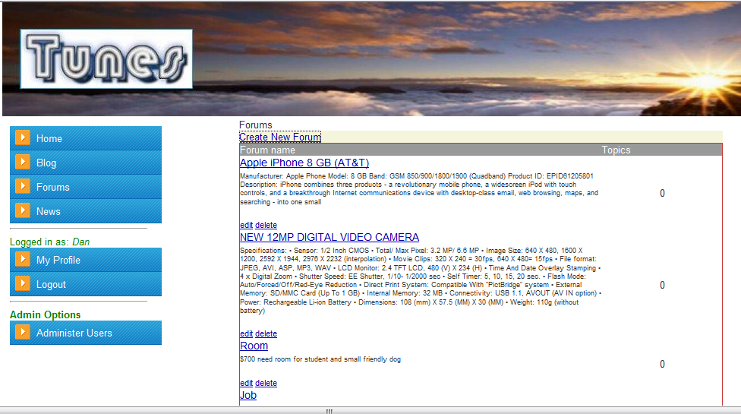

Forum display, User can create new Forum by clicking the Create New Forum link.

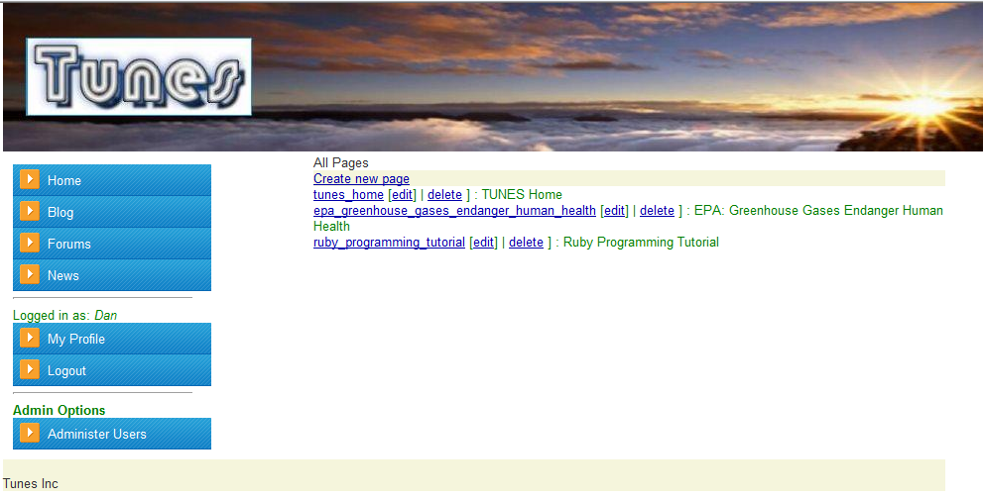

News Page, User can create a new News page by clicking Create new page link.

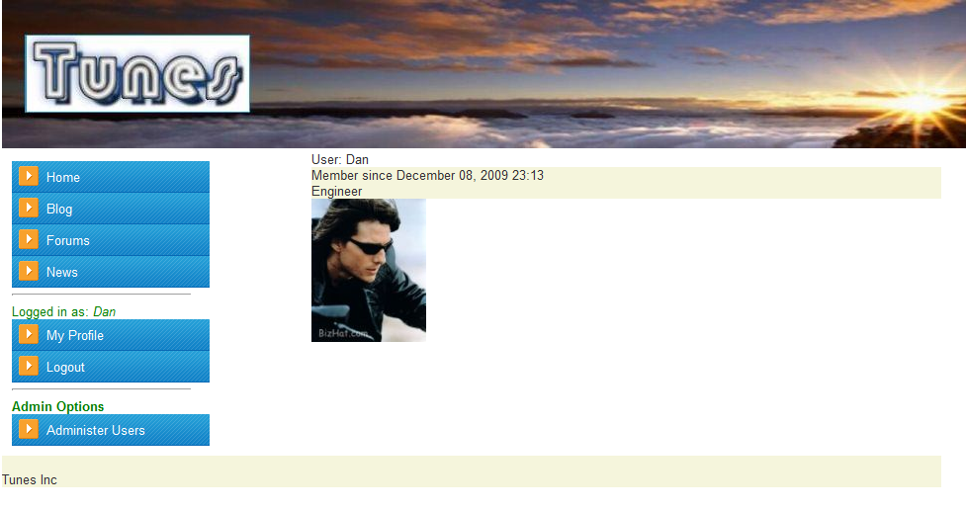

Dans profile page, user can create and update his profile by clicking the My Profile link.

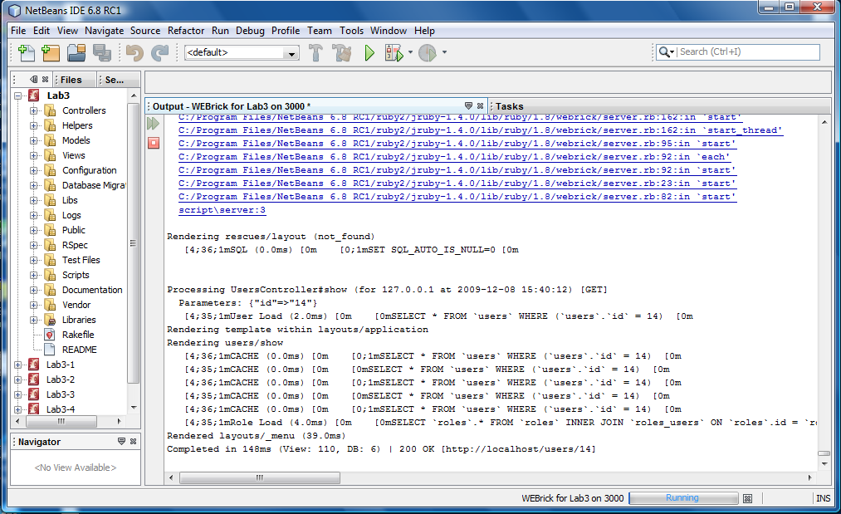

Netbeans displays MySQL database table updates.

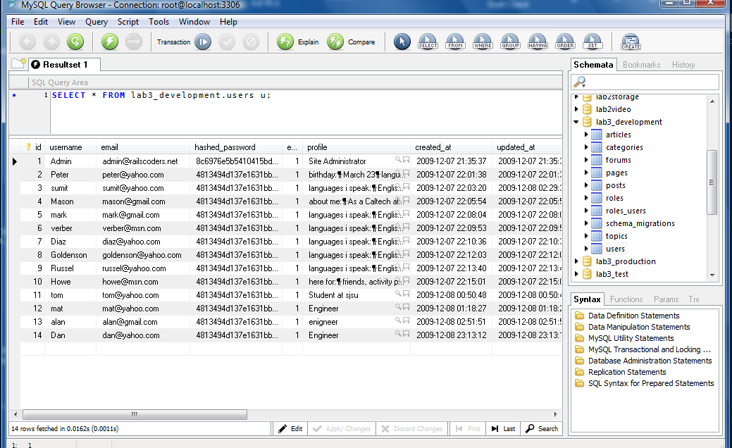

MySQL query browser shows user Dan added to the user table.

Testing.

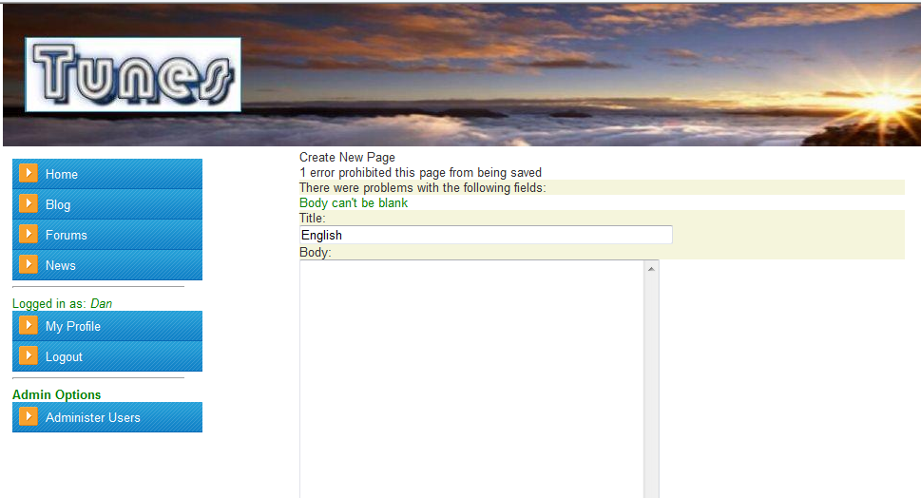

User creates News and didn’t write the message in the body. So Ruby is validating the edit box by saying Body can’t be blank.

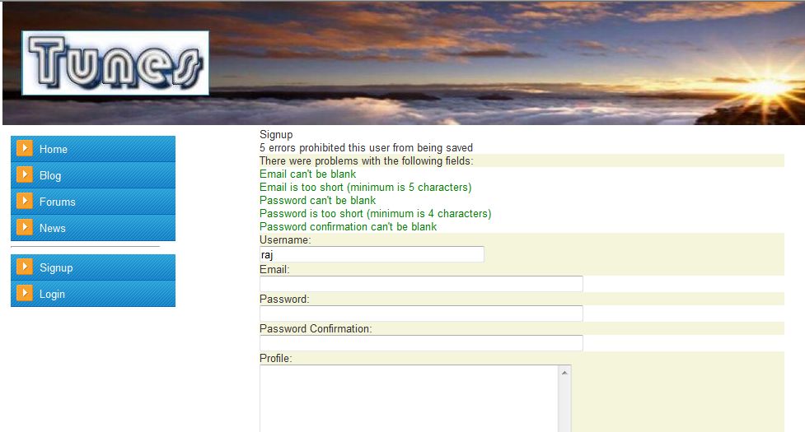

User signup validation.

|  |  |
| --- | --- |
| layout_center | **5. Assumptions & Future Enhancement** |

**Assumptions:**

1. We assumed that the website is fully functional and can be easily deployed on the internet for public usage.
2. The website is running on Web brick server on port 3000 so it can be run by any other server as well as any port of user choice.
3. We are using MySQl database and any other data base can be used for the website we assume Ruby supports that.

**Future Enhancements**:

We can send e-mail and build a news letter mailing list.

We can add friends and their details.

We can add tags to the photo gallery.

We can integrate it with web 2.0.

We can add user created themes to the blogging engine.

We can scale and make the website more efficient.

|  |  |
| --- | --- |
| layout_center | **6. Hardware & Software Used** |

**Hardware:**

Processor: Intel Core 2 duo 2.0 GHz

Ram: 4 GB

HD: 180 GB

**Software**:

Net Beans 6.8 RC1

MySQl

WeB Brick

JRuby

|  |  |
| --- | --- |
| layout_center | **7. Steps for running the project** |

We developed project using Netbeans IDE 6.8 RC1.

OpenProject – select – Lab3

Create database in MySQL Lab3\_development

RightClick on project folder Lab3 – click - Run/Debug rake task.

RighClick on project folder Lab3 – select – Migrate Database – click – To current version

Rightclick on project folder Lab3 – click - Run

Administrator must give Editor, Administrator and moderator role to the user.

After creating the project the default

Admin username : admin

Admin password: admin

|  |  |
| --- | --- |
| layout_center | **8. References** |

1. <http://www.wikipedia.org/>
2. Practical Rails social Networking Sites by Alan Bradburne.
3. Rails Solutions by Justin Williams
4. <http://rubyonrails.org/>
5. <http://ootips.org/mvc-pattern.html>