**BookReview web app using Ruby on Rails and Mangodb**

Install mangodb

Start mangodb from the bin folder ./mongod

Create new rails project in the command line.

rails new bookreview –JO

J - skip prototype

O – skip activerecord

Add the following files in the Gemfile

gem ‘mongoid’

gem ‘bson’

gem ‘bson_ext’

type >> bundle install

Generate config file mongoid.yml for mangodb

Type >> rails g mongoid:config

rails g controller books

rails g controller reviews

rails g model Book title:string name:string

rails g model Review book_id:integer name:string comment:string rating:integer

Mangodb started

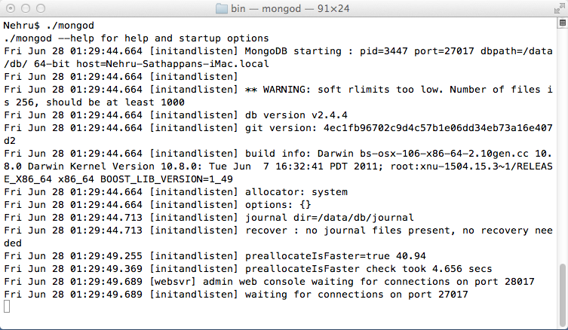

Manual creation of book and review data

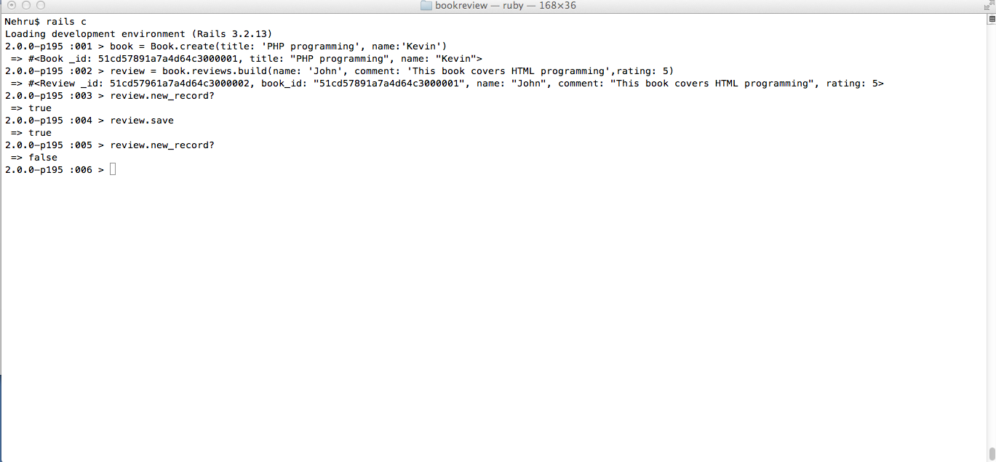

verification of book and review data in mangodb

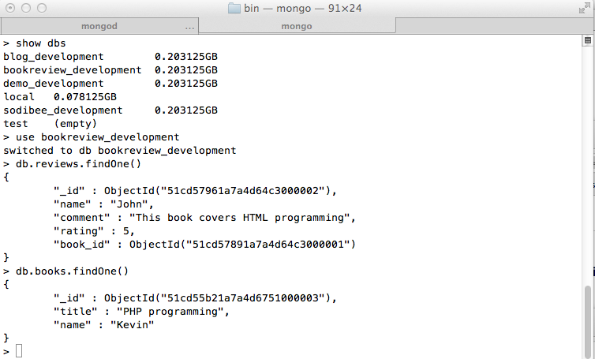

Front page

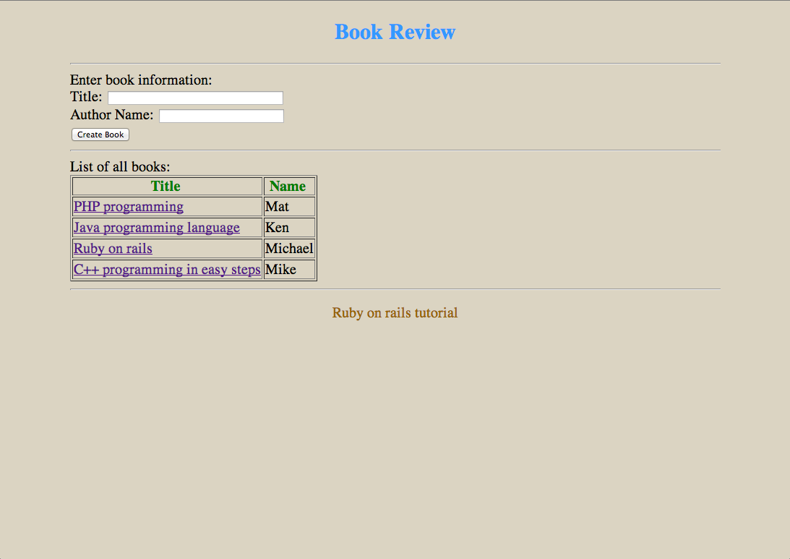

Review Page

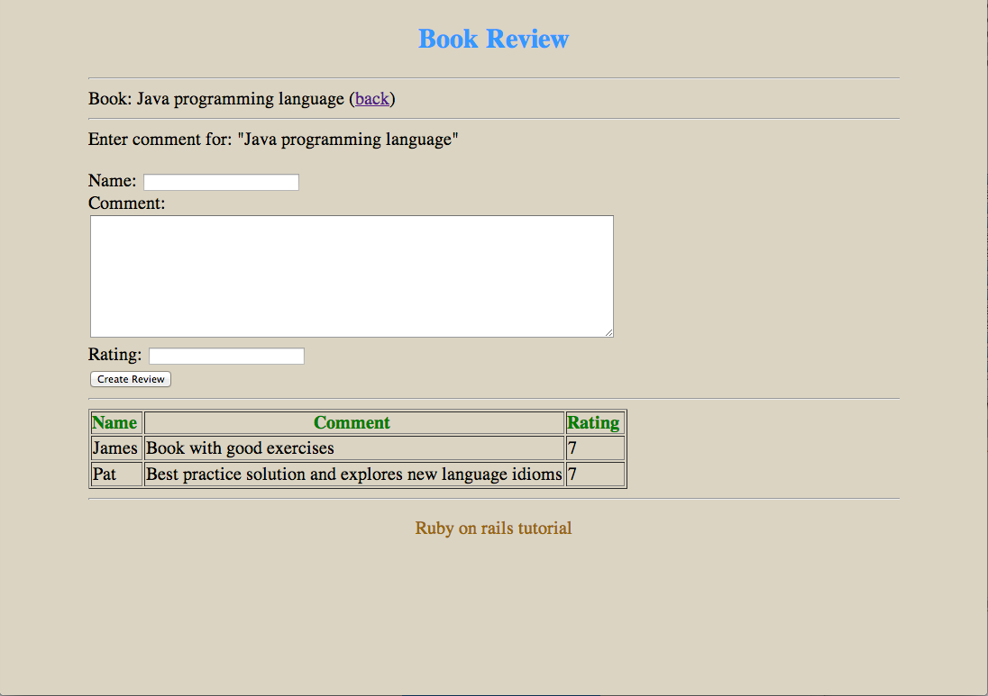

mongodb data output

