SaaS on Google Cloud (App Engine)

University Admission Portal

GWT, BigTable, JDOQL, Java HTML and CSS
Table of Contents
Chapter 1. Project Overview 5
Introduction 5
State of the Art Summary 6
Chapter 2. Project Architecture 8
Chapter 3. Technology Descriptions 11
Chapter 4. Project Design 13
Chapter 5. Project Implementation 25
Chapter 6. Performance and Benchmarks 34
Chapter 7. Deployment, Operations, Maintaince 41
Chapter 8. Summary, Conclusions. 43

Glossary……………………………………………………………………………........44
References……………………………………………………………………………….45

List of Tables

Figure 1. Architecture Diagram ………………………………………………………………..11

Chapter 1. Project Overview
Introduction
The companies around the globe are transforming their organization towards cloud computing. The cloud computing is a technology which is located in a distance data center and the consumers are utilizing the service for a price. In this project, we selected Google’s App Engine to host our application because of the services it offers to the customers. This technology allows us to develop application using Java or Python. By deploying our application “admission tracker” in App engine will enable the student to access our portal anywhere in the globe. If we develop the same application using standalone systems, without cloud infrastructure needs more resources and man power and to cope with the technological changes in the industries. As a customer we don’t need to worry about the inner details of the systems and this will allow us to focus on our application.
Proposed Areas of Study and Academic Contribution
Software engineering plays an important role in the design and development of the software systems. The software architects use various tools provided by the software engineering consortium to design the application software. The commercially available tools like Rational Rose and Vision helps the student to design the software. The software engineering trains the students using various tools and the application of various tools in the software development. Also software engineering teaches, the student, different phases in software development, from initial conception to the final product completion. This method helps the student to debug the system if there is an error in the overall functionality of the system by fine tuning particular phase in the software development.
The Google’s App engine supports the application developed in Java or Python. For a person to develop application in App engine must familiar with Java or Python. We are using java in this application development, because it supports object oriented paradigm and also Google developed its GWT (Google Web Toolkit) using Java. Google provided a plugin for the Eclipse which is used to develop the application for App engine. The plugin helps to create App engine project and allows deploying the application into the App engine.
The software designer must familiar with the distributed application development. There are lots of differences in the application development for standalone and distributed methods. Also App engine doesn’t have a relational database, but it supports a BigTable which is used to store the data in the App engine. BigTable supports persistence Api to query the BigTable. So the developer must be familiar with relational database management system.
State of the Art Summary
Cloud Computing is an upcoming new technology where we can use software as a service. In cloud computing, maintenance and location of hardware is not an issue and we pay as per usage of resources. Cloud computing makes use of shared resources which can be accessed anywhere using internet. Google, Amazon and Salesforce are the some of the major cloud service providers [4]. Our System uses cloud service offered by Google in form of Google App Engine. It facilitates by allowing us to develop and host web based applications into the Google cloud. Designing a scalable web based application may be tricky because data request from user all over the world and serviced by multiple distributed data centers around the globe. So we focused mainly on design and deployment of our application. The security and scalability will be provided by the App Engine.
The App Engine from Google provides a datastore which takes care of load-balancing and distribution of data and this makes the developer to focus on the business logic. The datastore consists of services provided by Google are BigTable and Google File Systems [1]. Even though Cloud Computing is emerging, most companies are still not convinced to deploy their application in the public domain. Their main concerned is that data may be compromised. Most companies realized that cloud computing is the next big thing in IT and they are actively involved in the cloud computing infrastructure development [2]. This project is based on the Model View Controller pattern and this separates the user interaction from the application classes. Because of these separations we can able to design the interfaces without changing domain model. Here, Controller (Listener) handles the interaction between Big Table and graphical user interface (GWT) [3,5].

Chapter 2.Project Architecture:
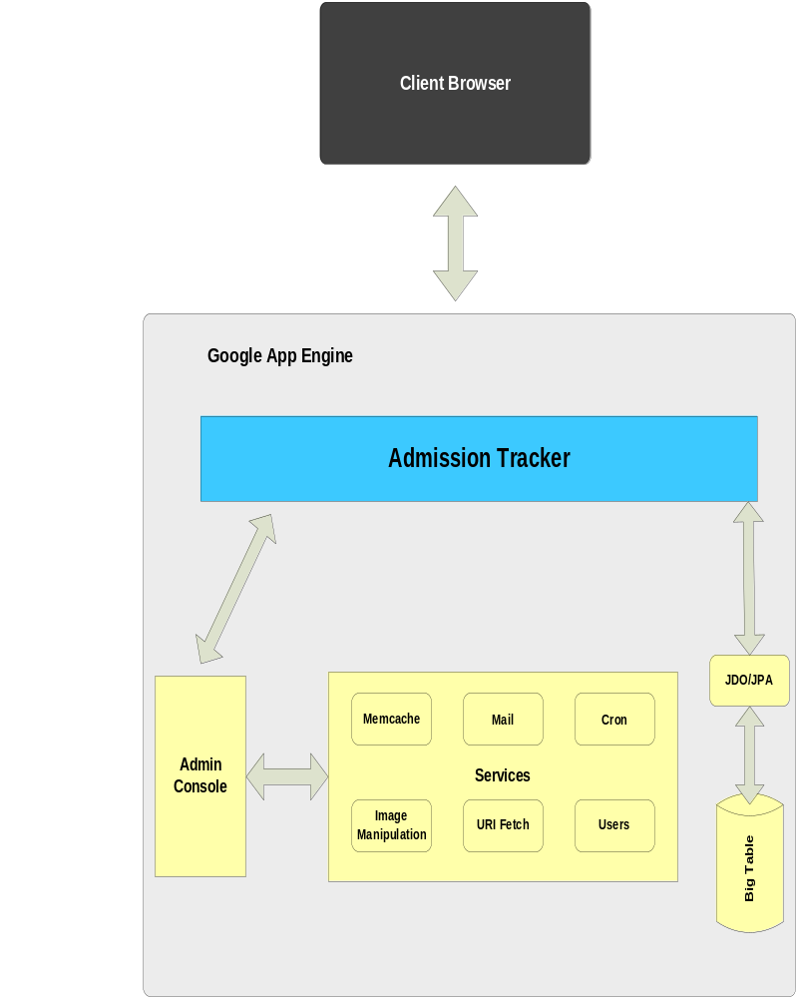
Architecture Subsystems
The block diagram in the above figure comprises various components of Google App Engine infrastructure. The architecture of the App Engine is different from the web application server in the sense that it will prevent the developer to open a socket and to run a background process.
Client Browser: The function of the client browser is to access the admission tracker application.
Admin Console: The Admin Console of Google App Engine provides access to public version of the application. Anyone can access the console by visiting this link https://appengine.google.com/.
Services: Google App Engine provides various services which are listed below:
- Memcache: Memcache is used for an application to create an in-memory data cache for persistent storage across some tasks.
- Mail: The Mail service provides useful feature to applications by sending email messages across different applications using Java Mail API.
- Image Manipulation: In order to manipulate image data, App engine provides useful feature to crop, rotate, flip and resize the images.
- URI Fetch: Using URI Fetch, App engine can communicate with other applications or resources using HTTP and HTTPs requests.
- Cron: Cron is a Task Scheduling Service which operates at defined time intervals.
JDO/JPA: App Engine provides access to data store (big table) using JDO/JPA.
Big Table: Big Table is compressed and high performance database system which is built on Google File System. Google provides access to Big Table as part of Google App Engine.

Chapter 3. Technology Descriptions
Java:
Java is the platform independent language developed by the Sun Microsystems now a subsidiary of Oracle Corporation. Java is used in variety of Computing Platforms from embedded devices and mobile phones to enterprise servers and super computers. It requires JVM (Java Virtual Machine) and SDK installed in our computer. We used Java in our project along with GWT to develop the application which is deployed on the Google cloud.
GWT:
Google Web Toolkit is the toolkit used to developed browser based applications. The goal of GWT is to developed productive web applications for developers without having any knowledge of XMLHttpRequest and Javascript.
JPA
App Engine provides access to data store (big table) using JDO/JPA.JPA provides very quick accessibility to database and completely hides the database from the implementation. Also, using JPA is a required objective.
JPA is database agnostic; it is not dependent on any particular database. JPA implementation can be applied to any type of datastore. There are various implementation vendors like Hibernate, Oracle, Toplink and Eclipse Link. In future, if the choice of database changes, it can easily be done with minor changes.
Big Table: Big Table is compressed and high performance database system which is built on Google File System. Google provides access to Big Table as part of Google App Engine. It maps two arbitrary string values i.e. row key and column key and three dimensional mapping i.e. timestamp into associated byte array. It is not relational database and hence can be defined as one kind of multi-dimensional sorted map. We used Big Table in our project for storing data of Students and University Registrar.

Chapter 4. Project Design
4.1 Use Case Diagram:
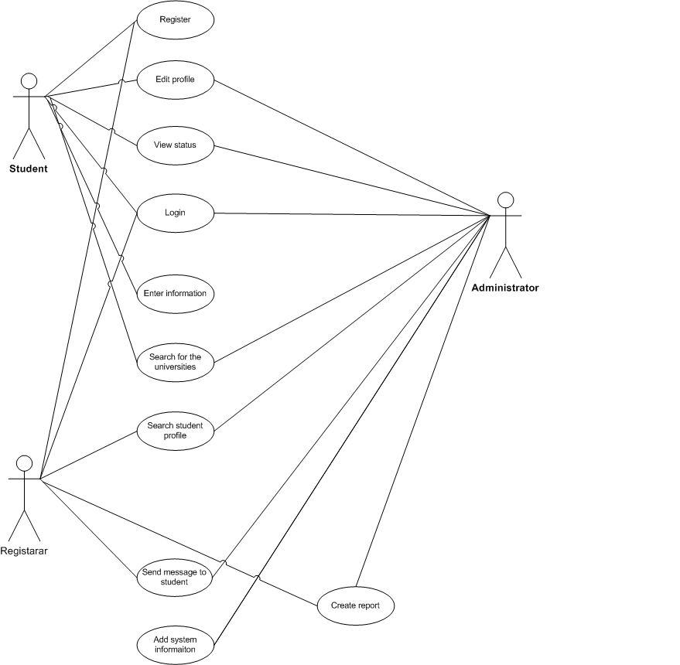

  - Use Case Descriptions
4.2.1 Registration
ID: UC 01
Name: Register
Type: Sub
Actors:
- Student
- Registrar
Description:
In this use case the Student/Registrar registers with the admission tracker
system by inputting his personal information like email, phone and
login credentials which is saved in the database for future logins.
Pre-conditions:
The student/registrar should be a new user who has not registered.
Post-conditions:
The student can access and edit his profile information and apply to
different universities.
Flow
Main Flow:
1) Student tries to register in the system.
2) System checks whether the student is already registered.
3) Student fills the registration form with all the required information.
4) The system updates the database with student information.
Alternate Flow:
- Student attempts to register with the system.
- System checks whether the student is already registered.
- System identifies a registered student and redirects him to login page.
4.2.2 Status Check
ID: UC 02
Name: Status Check.
Type: Sub
Actors:
- Student
- Registrar
Description:
A student can check his application status with respect to the universities applied.
The registrar can modify the application status based on his credentials.
Pre-conditions:
Student/Registrar should be a registered user and student should be logged in
and should have applied to the universities.
The registrar of particular university accesses the student application and makes a decision.
Post-conditions:
The students view the status of his application with respect to university.
Main Flow
The registrar modifies the status of student.
Student checks the status of the application with respect to the university.
4.2.3 Log In
ID: UC 03
Name: Log In
Type: Sub
Actors:
- Student
- Registrar
- Administrator
Description:
User of the system logs in the admission tracker by giving his credentials with respect to his role.
Pre-conditions:
The user should be registered user in the system.
Post-conditions:
The student fills out the application form.
The registrar processes the application.

Main Flow
The user opens the admission tracker log in form.
The user inputs the credentials and logs into the system.
4.2.4 Search for universities
ID: UC 04
Name: Search for Universities
Type: Base
Actors:
- Student
Description:
The student searches for the universities to apply.
Pre-conditions:
The student should be registered with the admission tracker and should be logged in.
Post-conditions:
The student selects the universities to apply.
The student fills out the application form of the particular university
Main Flow
The student logs into the admission tracker.
The student searches for the universities or a particular university by inputting
the university name.

4.2.5 Search student profile
ID: UC 05
Name: Search student profile
Type: Base
Actors:
- Registrar
- Administrator
Description:
Registrar/Administrator of the system logs into the admission tracker by giving his credentials. The registrar checks the profile of the students who have applied for that university and make decision based on the student credentials.
Pre-conditions:
The student should be registered with the system.
The student should have applied to a particular university.
Post-conditions:
The registrar looks at the student profile and his qualifications.
The registrar makes a decision on the admission of the student and changes
his status.
Main Flow
The Registrar/Administrator logs in the system and looks at the student profile.
The registrar checks the profile of the students who have applied for admission in
that particular university.
4.2.6 Create report
ID: UC 06
Name: Create report
Type: Child
Actors:
- Administrator
Description:
The administrator creates a report/summary of the number of
students applied to the particular universities. The registrar can view
the reports and look at the statistics which includes student admission,
enrollment as well as rejection for particular universities.
Pre-conditions:
Student should apply to a particular university.
The registrar should log into the admission tracker to view the report.
Post-conditions:
The registrar looks at the report and statistics of the students and gets an
overview of the admission process.
Main Flow
The administrator creates a report/summary of the number of
students applied to a particular universities.

4.3 Sequence Diagrams
4.3.1 Administrator Interaction Sequence
Diagram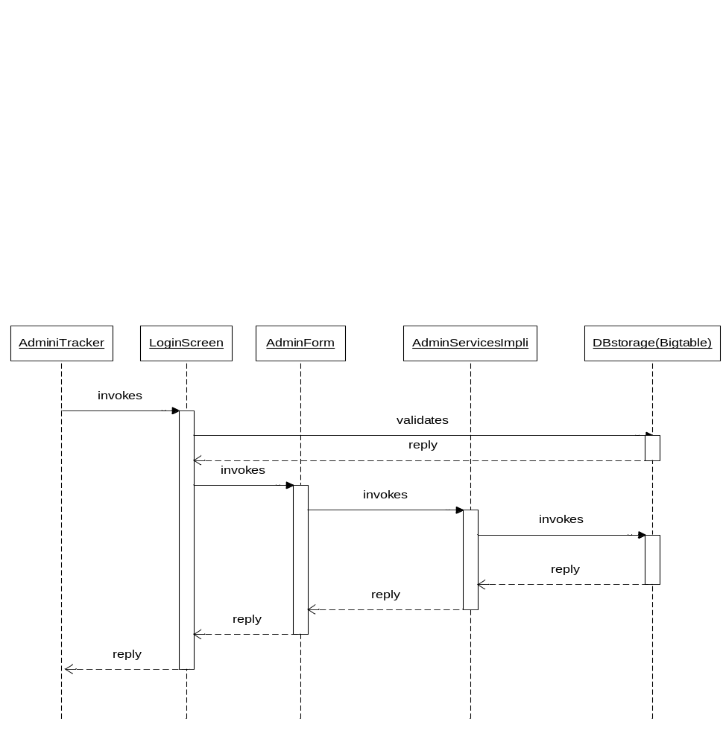

4.3.2 Student Application Submission Sequence Diagram
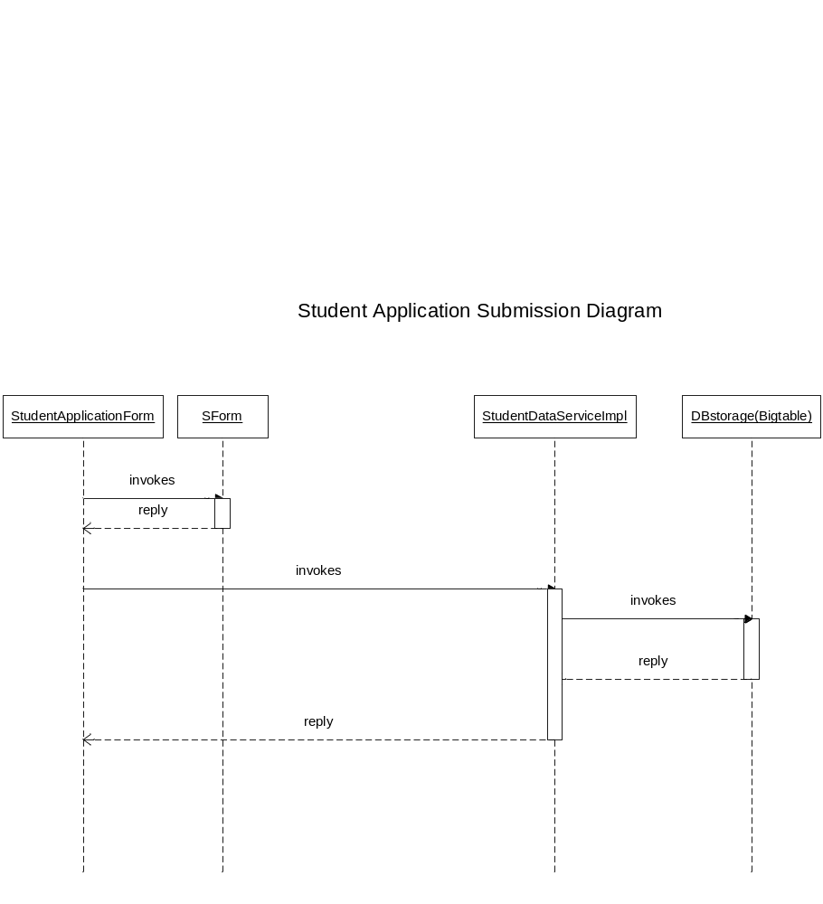

4.3.3 Registrar checking application sequence diagram
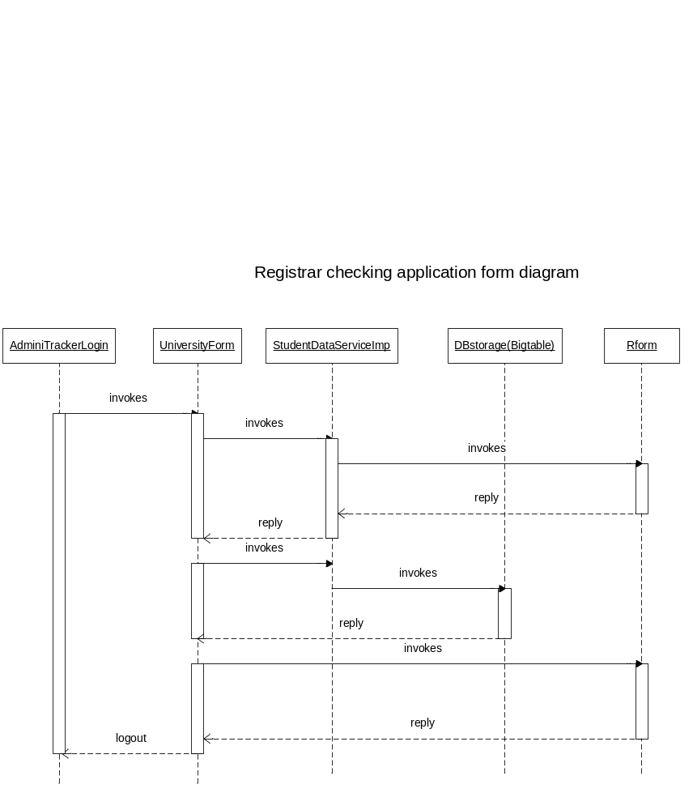

  - Class Diagram

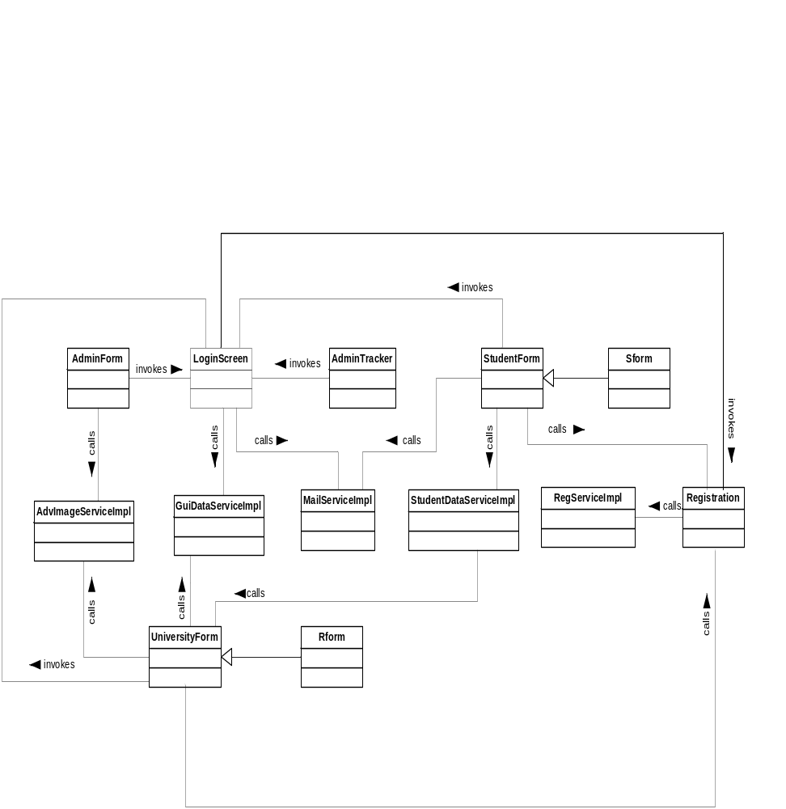

Chapter 5: Project Implementation

University Admission helps students apply multiple universities and tracks their admission status and acts as communication link between them and respective universities. The User Interface of University Admission is simple easy to understand and very user friendly.
The UI mainly divides into 3 main categories a) Student b) Registrar c) Administrator
Login Page
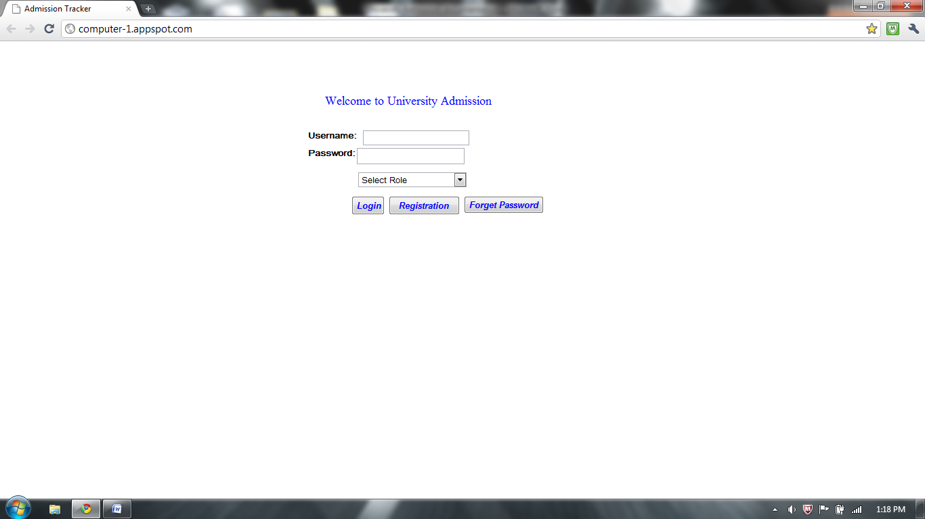
Login:
This is the main page when on launching the University Admission website .We have kept it very simple where the new user has to Register by clicking the Registration tab .If the user is already a registered member then he just has to enter his username, password and login the University Admission site. A student ,registrar, administrator can login by selecting their respective roles using the dropdown tab.
Registration form:
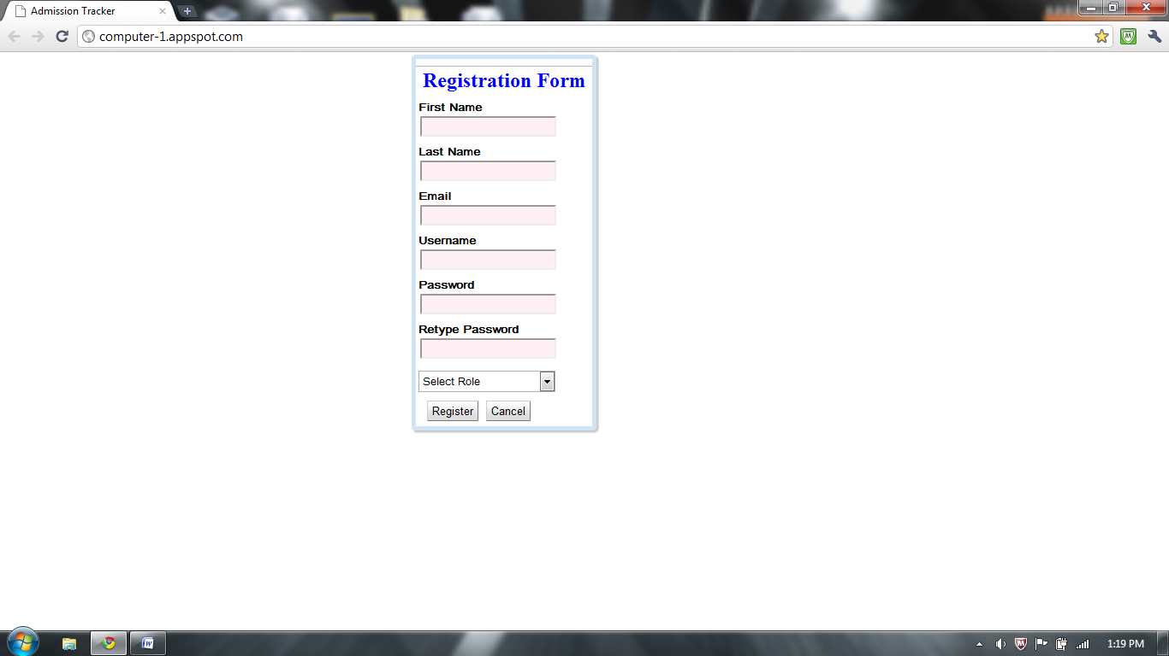
A new user has to register first before login in to the site .User has to provide has name , e-mail, set a password and select his role (student/registrar/admin) and register thereby updating the Big table (cloud DB).
Forget Password: The forget password feature allows user to enter his e-mail address which he used to register and system sends his password through an e-mail notification.

Student Page
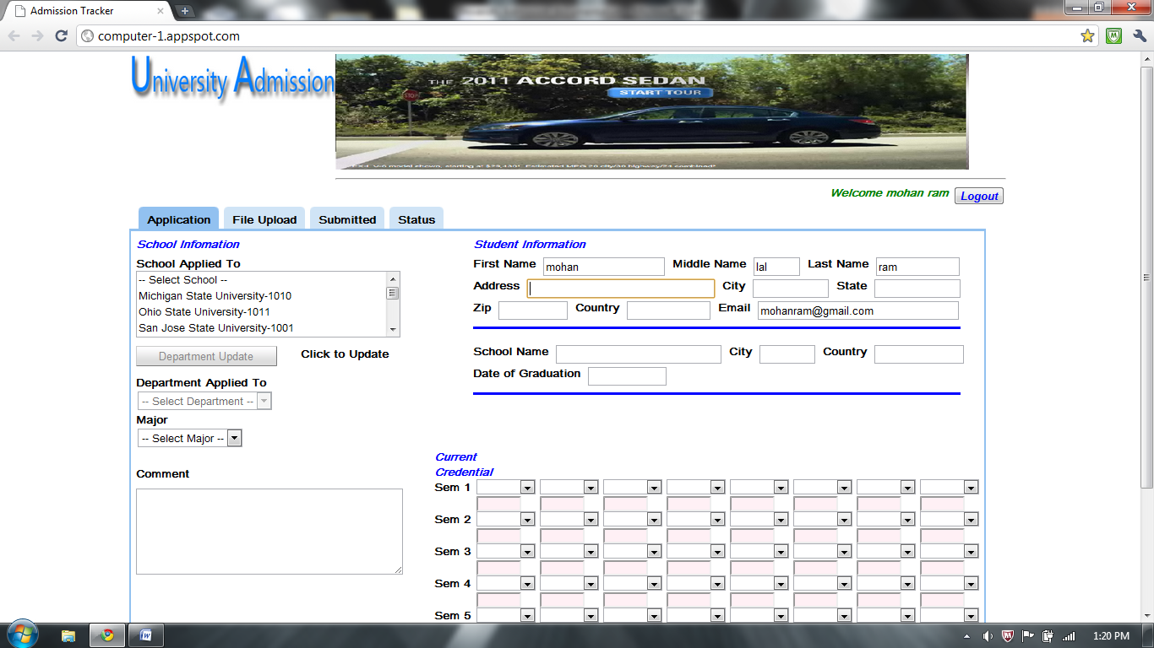

The student page is categorized into Application, File upload, Submitted, Status.
Student Application:
In the application view student has to first fill his basic information comprising of Name, address ,City ,State, Country, E-mail, School etc. The student also has to enter all his semester marks. The Student has an option of selecting which universities he has to apply including the department and major.

Multiple University Selection:
In order to save valuable time of the student we have included a multiple university selection feature allowing user to select multiple Universities at one time including department and Major which are common to selected universities.
Comment section:
The student can write short paragraph about himself or any information he wants to convey to the University Registrar explaining him the importance of getting into desired university.
File Upload:
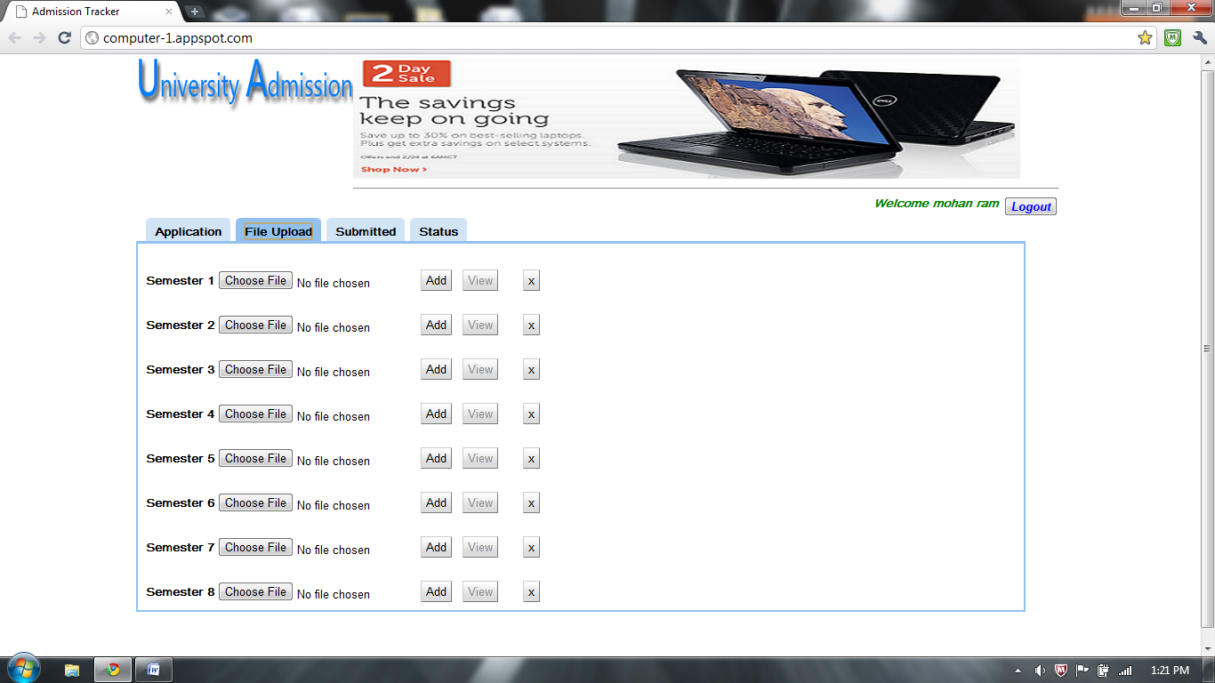
We have provided a feature of uploading semester mark sheets of the students of their Undergrad degrees. A student can upload maximum 8 files. He can view the file after uploading or even delete it if he wishes to upload a new one. The format of the file that can be uploaded is Jpeg, Bitmap, png, Word or a pdf.

Submitted:
The submitted view shows a list of applications that the student has submitted in terms of date, University name, department , major, code and email. We have added a feature where if the student changes his mind he can edit the application by clicking edit button or delete a by clicking the cross(x) tab.
Status:
This is one of the most important pages as it lets the student know which Universities have accepted his admission application. The status tab shows a status with respective to university and summary which a registrar of university conveys the student. A summary may include a welcome message or any more documents or information a registrar may want from the student.

Registrar Page
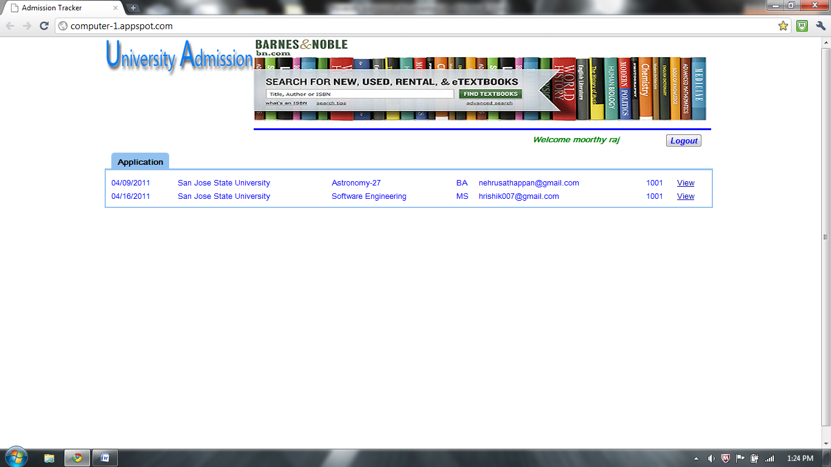

On login in the University Admissions the Registrar of particular university will see a list of students applied under different departments and majors. The registrar can view each application by clicking the view .It will show all the information filled by student and all the semester documents student has attached. On viewing the document the registrar can update the status of the student and write message to the student which would be shown in status and summary of student page.

Administrator Page
Admin page is categorized into Users, Application, Information and advertisements
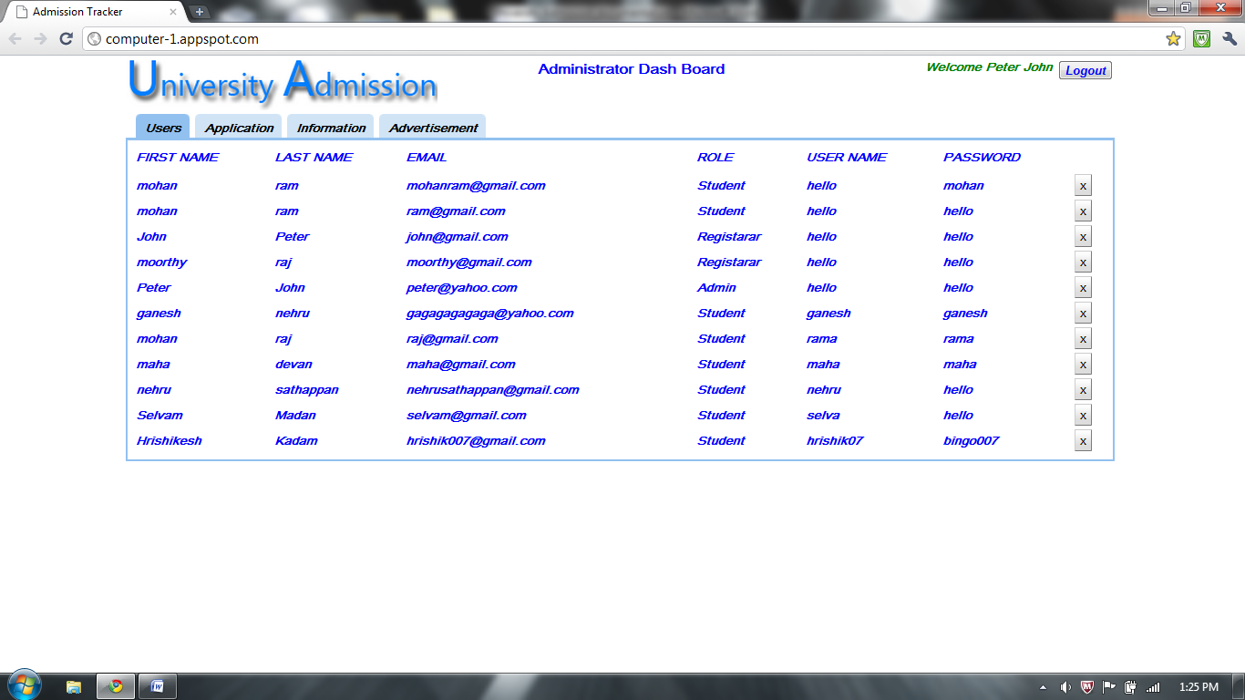
Users:
The administrator of the website can see all the users including students and registrars. He has privilege of seeing their name, email, passwords and roles. He has the right to remove any user if he finds any one of them in violation of the rules of the website .There is a cross(X) button at the end of each user for erasing his profile.

Application:
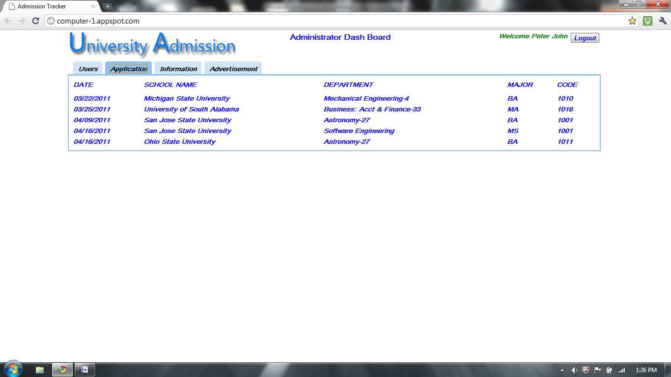
The application view shows a list of all the applications including different Universities, departments, majors and university code.
Information:
In the information page the administrator can view a list of all the universities and the number of admission application each university has received.

Advertisement Edit page
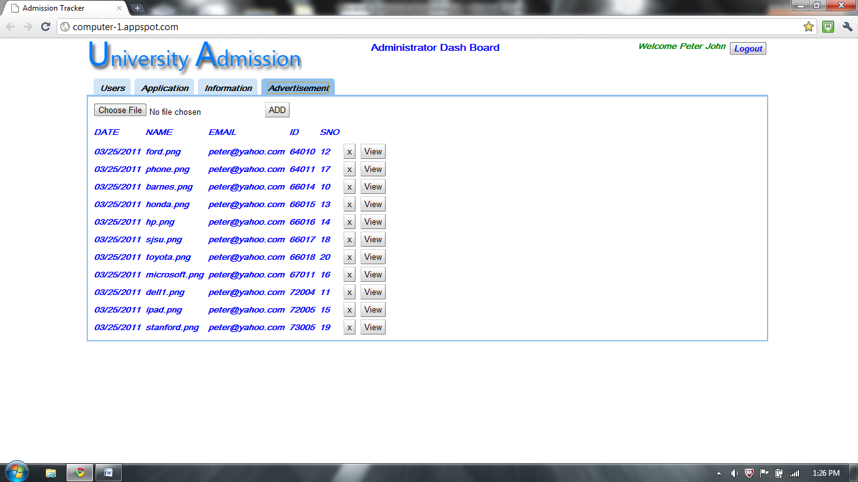
This is one of the most important page as it draws revenue to the website. The administrator is able to advertise the ads from various sponsors. Besides universities the sponsors are the main source of income for the site. The administrator can upload the advertisement images which can be targeted to specific university students. The administrator can preview and edit the sponsor advertisements.

Chapter 6: Performance and Benchmarks:
The working and functionality of any system relies on the how the project is put into practice. For the project to be efficient and bug free it should be thoroughly tested using different software testing methodologies.

Extent of Testing:
In software development in order to make an excellent and superior product besides a well development process there is need of efficient testing process. The testing process should be divides in to number of phases handled by the good testing team. There is a need of first a Test plan which highlights the modules that will be tested, test coverage depicting which module in the project will be tested. The timeline of testing will be calculated and most importantly the tools that will be used for testing the website would be decided.
The test plan consists of test scenarios employing both black box and white box testing methodologies. There would be functional testing , correctness of the website according to the specifications and through manual testing.

Test Goal:
The main goals of the test plan are
- To execute through test on the system.
- To identify bugs in system using number of tools and fix them.
- To make sure that system meets non-functional and functional specifications.

Tools
We are going to use a powerful in-browser testing tool called Selenium which would qualify for both Black box and White box testing.

Unit Testing:
We are using Selenium where a through manual testing done on each page of the website , checking for the desired output and flow of the website will be automated . The white box testing includes writing Junit scripts run in Selenium RC in Eclipse tool.
Testing done using Selenium Tool
Selenium is a powerful web based testing tool used for creating cross-browser testing automation scripts. It is one of the most widely used testing tools used in the industry and most importantly it’s a freeware. We have used Selenium for testing the website and created automated login and verification scripts for student, registrar and admin.
Student login:

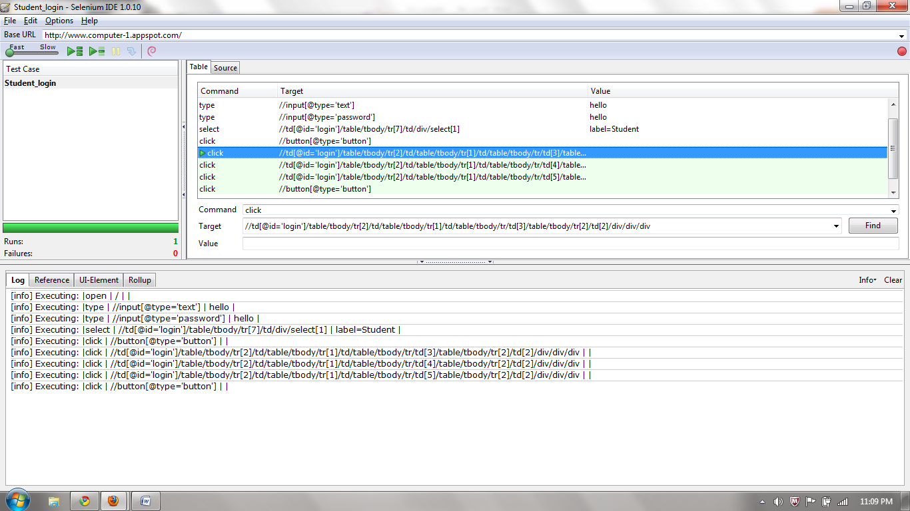

Junit script for Student login:

package com.student_login.tests;

import com.thoughtworks.selenium.*;
import java.util.regex.Pattern;

public class StudentLogin extends SeleneseTestCase {
public void setUp() throws Exception {
setUp("http://www.computer-1.appspot.com/", "*chrome");
}
public void testStudentLogin() throws Exception {
selenium.open("/");
selenium.type("//input[@type='text']", "hello");
selenium.type("//input[@type='password']", "hello");
selenium.select("//td[@id='login']/table/tbody/tr[7]/td/div/select[1]", "label=Student");
selenium.click("//button[@type='button']");
selenium.click("//td[@id='login']/table/tbody/tr[2]/td/table/tbody/tr[1]/td/table/tbody/tr/td[3]/table/tbody/tr[2]/td[2]/div/div/div");
selenium.click("//td[@id='login']/table/tbody/tr[2]/td/table/tbody/tr[1]/td/table/tbody/tr/td[4]/table/tbody/tr[2]/td[2]/div/div/div");
selenium.click("//td[@id='login']/table/tbody/tr[2]/td/table/tbody/tr[1]/td/table/tbody/tr/td[5]/table/tbody/tr[1]/td[2]");
selenium.click("//button[@type='button']");
}
}

Registrar Login:
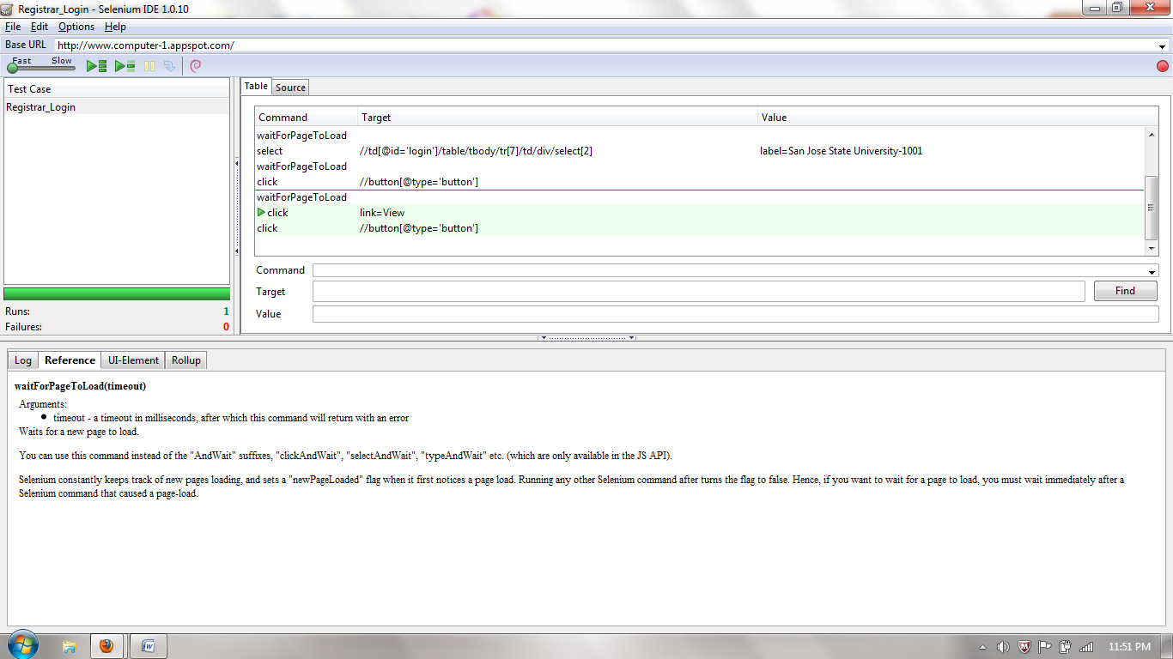

Script
package com.registrarlogin.tests;

import com.thoughtworks.selenium.*;
import java.util.regex.Pattern;

public class Untitled extends SeleneseTestCase {
public void setUp() throws Exception {
setUp("http://www.computer-1.appspot.com/", "*chrome");
}
public void testUntitled() throws Exception {
selenium.open("/");
selenium.type("//input[@type='text']", "hrishik0");
selenium.type("//input[@type='text']", "hrishik07");
selenium.type("//input[@type='password']", "bingo007");
selenium.select("//td[@id='login']/table/tbody/tr[7]/td/div/select[1]", "label=Registarar");
selenium.select("//td[@id='login']/table/tbody/tr[7]/td/div/select[2]", "label=San Jose State University-1001");
selenium.click("//button[@type='button']");
selenium.click("link=View");
selenium.click("//td[@id='login']/table/tbody/tr[2]/td/table/tbody/tr[2]/td/div/div[2]/table/tbody/tr[1]/td/div/button[1]");
selenium.click("//td[@id='login']/table/tbody/tr[2]/td/table/tbody/tr[2]/td/div/div/table/tbody/tr[3]/td[7]/a");
selenium.click("//td[@id='login']/table/tbody/tr[2]/td/table/tbody/tr[2]/td/div/div[2]/table/tbody/tr[1]/td/div/button[1]");
selenium.click("//button[@type='button']");
}
}

Admin Login:
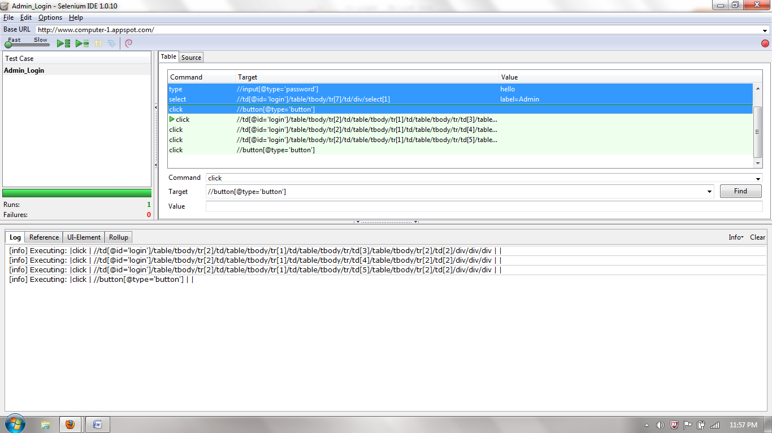

Admin Script:
package com.adminlogin.tests;

import com.thoughtworks.selenium.*;
import java.util.regex.Pattern;

public class Untitled extends SeleneseTestCase {
public void setUp() throws Exception {
setUp("http://www.computer-1.appspot.com/", "*chrome");
}
public void testUntitled() throws Exception {
selenium.open("/");
selenium.type("//input[@type='text']", "hello");
selenium.type("//input[@type='password']", "hello");
selenium.select("//td[@id='login']/table/tbody/tr[7]/td/div/select[1]", "label=Admin");
selenium.click("//button[@type='button']");
selenium.click("//td[@id='login']/table/tbody/tr[2]/td/table/tbody/tr[1]/td/table/tbody/tr/td[3]/table/tbody/tr[2]/td[2]/div/div/div");
selenium.click("//td[@id='login']/table/tbody/tr[2]/td/table/tbody/tr[1]/td/table/tbody/tr/td[4]/table/tbody/tr[2]/td[2]/div/div/div");
selenium.click("//td[@id='login']/table/tbody/tr[2]/td/table/tbody/tr[1]/td/table/tbody/tr/td[5]/table/tbody/tr[2]/td[2]/div/div/div");
selenium.click("//button[@type='button']");
}
}

Chapter 7. Deployment, Operations, Maintenance

Deployment: After the overall application is tested deployment is done. Our project is to design and develop a student admission portal for the universities. Our application student admission portal is deployed on Google cloud environment and will be offered as service. So people can use this application from any part of the world. Portal allows student to login and also to create their own respected profile in order to use this application. After login into the application, student has to enter all the respective details in order to apply for any of the respective university. University Admissions Registrar on login into the application of particular university will see a list of students who applied under different departments and majors. The registrar can view each application and can update the status of the student.
The administrator of the application can see all the users including students and registrars who have registered into the application. He has privilege of seeing their name, email, passwords and roles. Administrator has all the rights to delete the particular profile of the student and registrar.
Operations:
- Student inputs all information required in the application form and store the data.
- Student can update the relevant information entered in the form.
- Student can view the status of the application.
- Student can upload the marksheets.
- Registrar can modify the status of the student application.
- Registrar can send the email to the student.
- Administrator can view students and registrar in the system.
- Administrator can delete the profile of students and registrar.
Maintenance: Maintaining the application is very important after deployment considering the system performance and scalability of the application. We are providing security of the application by providing the authentication. The system will be available 24x7 for the users.

Chapter 8. Summary and Conclusion

Summary:
The main goal of our project is to provide the admission portal for students on Google cloud environment using Google App Engine. The benefit for choosing this project was to get deep knowledge of the emerging new technologies in the cloud services and to learn more about services provided by them. At initial stage we were facing challenges to deploy our project on Google cloud, and the reason behind that was we were very new to use this technologies. We referred different books and articles and then we were able to use all this things. We use different technologies like Java, GWT and Big Table which is use by the Google App Engine in order to deploy on Google cloud.
By deploying our application “University Admission Tracker” in App engine will enable the student to access our portal anywhere in the globe. If we develop the same application using standalone systems, without cloud infrastructure needs more resources and man power and to cope with the technological changes in the industries

Conclusion:
In this project, we have learned how to manage our time based on the project schedule that we have created. At the start of our project, we have spent considerable amount to time to research about the topic on Software as a Service. Then we have created a preliminary document that contains the architecture, class diagram, sequence diagram of our project. Also we have learned how to develop software for the cloud based system. The future of the enterprise computing is going to be in the cloud and we have a firm knowledge of it. This project gives us more experience on how to develop software for multiple cloud vendors.
Glossary:
URL: Uniform Resource Locater
GWT: Google Web Toolkit
JSP: Java Server Pages:
CSS: Cascading Style Sheets
HTTP: Hyper Text Transfer Protocol
HTML: Hyper Text Markup Language
J2EE: Java Enterprise Edition
JAR: Java Archive
POJO: Plain Old Java Object
API: Application Program Interface
JTA: Java Transaction API
MVC: Model View Controller
GUI: Graphical User Interface

References
[1] “Beginning Java Google App Engine” – Dyle Roche and Jeff Douglas
In the above book, the author clearly explained the architecture of the BigTable and how to design and deploy an application in the Google App Engine. Also the author described Persistence and how to apply that technology in the Google’s BigTable. By using this book we have learned how to develop an application for Google cloud. From this book it is easy to learn the app engine framework, libraries and their limitations in the cloud. This book helps us to setup the system using GWT toolkit and Google Eclipse plugin and to deploy our first application in the Google cloud.
[2] “Cloud Computing, Implementation, Management and Security” – John W. Rigginghouse, James F. Ransome
The author clearly explained, how to design cloud computing strategy and they summarized the risks involved in cloud computing and stressed the steps necessary to lessen the risk. In chapter 2, the author explained how virtualization technology plays an important role in the cloud computing. Also the author explained other web services like Communication as a service (Caas), Infrastructure as a service (Iaas), Monitoring as a service (Maas), Platform as a service (Paas), and Software as a service (Saas). In chapter 4, the author explained how to develop a virtualized infrastructure using a open source components to develop a powerful system to run multiple operating systems in a single physical machine.
[3] “Object Oriented Design with UML and JAVA” – K.BARCLAY, J.SAVAGE
In this book the author clearly explained Object Oriented Modeling using UML and Java. We have used this book in this project to design the class diagram. The authors explained the Object Oriented software development in a clear and concise way.
[4] “Cloud Computing, A Practical Approach” - Toby Velte ,Anthony Velte, Robert Elsenpeter
Cloud computing is a platform which allows other systems to use the resources from remote locations just by using the internet which is cost effective. The author explained the details of the cloud computing platform and the services offered by those systems. The book explains the components in the cloud and its benefits and the maintenance cost associated with the system. Also the book compares the cloud platform provider and the services offered by those companies.
[5] “Expert Spring MVC and Web Flow” - Seth Ladd,Darren Davison,Steven Devjver
The book explains the spring MVC pattern .It includes the model view controller.
It explains modal as the data structure and view is where the layout or the display of the page. The user clicks or interacts with the user interface where controller retrieves data
from database (model) and displays back to user interface. The book explains the flow of
request and response in a website and what is ideal .The book also gives an overview of
the spring frame work.

