**Photo view app for iPad using HTML5 and CSS3**

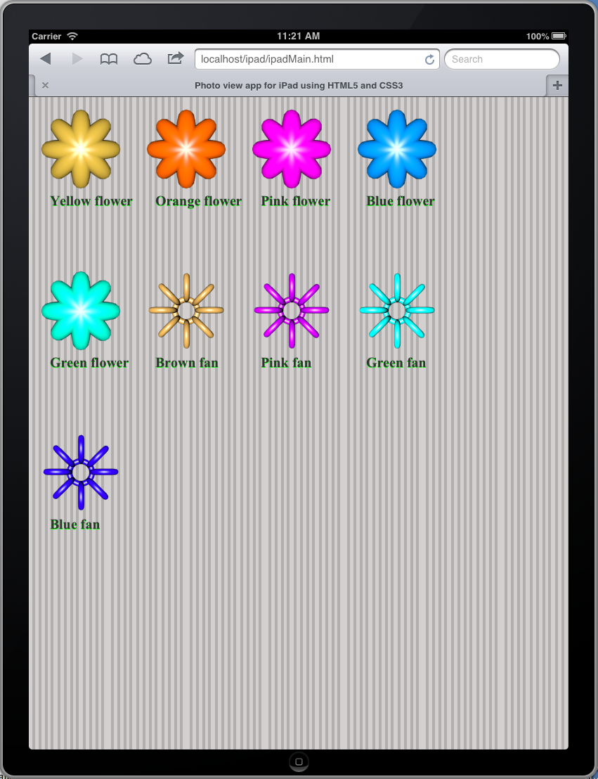

**iPad web app**

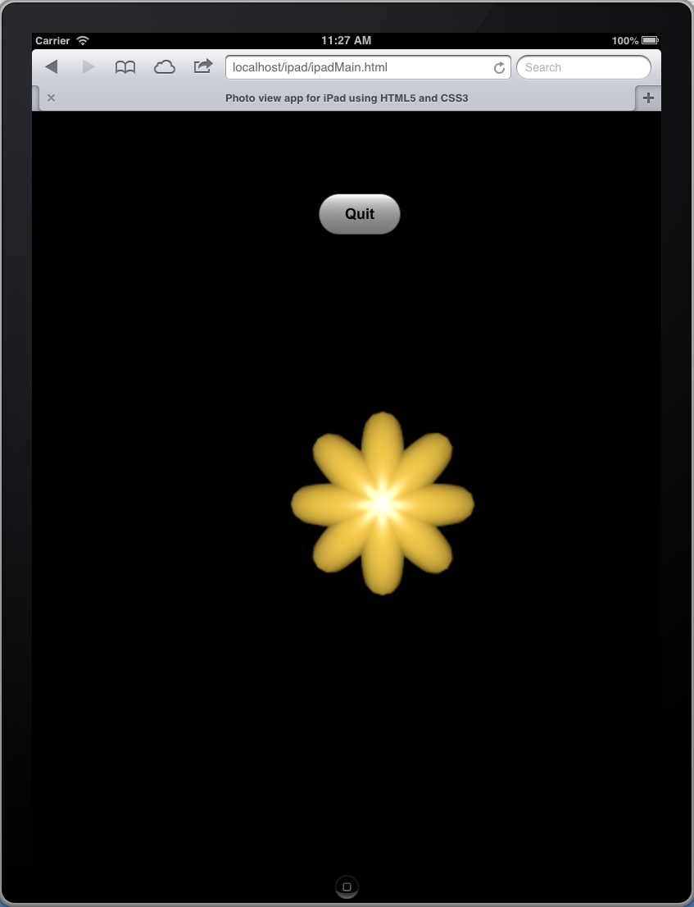

**App display enlarged phots**

<!DOCTYPE html>

<html lang="en">

<head>

<meta charset="utf-8" />

<title>Photo view app for iPad using HTML5 and CSS3</title>

<meta name="viewport" content="width=device-width, initial-scale=1.0, maximum_scale=1.0, user-scalable=no" />

<style>

body{

margin: 0;

padding:0;

font: 28px/26px Arial;

background-image: url(photo/back.png);;

}

.photoList{

width: 100%;

}

#photoUnique ul.photoSet{

list-style: none;

margin: 0;

padding:10px;

z-index: 10;

position: absolute;

}

#photoUnique ul.photoSet p.text{

position:relative;

left:20px;

margin: 0px;

font: bold 15pt/10pt Times New Roman;

color: #333;

text-shadow: 0 1px 0 #0F0;

}

#photoUnique ul.photoSet img{

-webkit-border-radius: 10px;

}

#photoUnique ul.photoSet li{

width: 150px;

height: 230px;

padding: 0;

float: left;

}

#photoShow{

background-color: black;

height: 100%;

width: 100%;

position: absolute;

top:0;

left:0;

z-index: 5;

opacity: 0;

-webkit-transition: all 500ms ease-out;

}

#photoShow.showBright{

opacity: 1;

z-index: 30;

}

#photoShow.showDim{

opacity: 0;

z-index: 5;

}

#photoShow img{

-webkit-transform: translateZ(-1000px) rotateY(180deg) translateZ(1000px);

-webkit-transition: all 1000ms ease-out;

opacity: 0;

}

#photoShow img.displayLocalImage{

-webkit-transform: translateZ(0) rotateY(0deg) translateZ(0);

opacity: 1;

}

#photoShow img.hideLocalImage{

-webkit-transform-origin:center left;

-webkit-transform: scale(.1) rotateY(-90deg) translateZ(1000px);

opacity: 0;

}

#photoShow img{

position:absolute;

top:350px;

left:300px;

}

#textName{

position:absolute;

top:50px;

left:100px;

}

#textName .showText{

-webkit-transform: scale(1);

opacity: 1;

}

#textName .hideText{

-webkit-transform: scale(0);

opacity: 0.5;

}

#textName.textBright{

opacity: 1;

z-index: 30;

}

#textName.textDim{

opacity: 0;

z-index: 5;

}

</style>

<script type="text/javascript">

function displayPhoto(clickedImage){

//Get big image attribute in the img tag

var imageDisplay = clickedImage.getAttribute('bigPicture');

//Get list of image items from the document

var imageList = clickedImage.parentNode.parentNode.getElementsByTagName("img");

var nameList = clickedImage.parentNode.parentNode.getElementsByTagName("p");

//Number of images in the list

var totalImage = imageList.length;

var selected = 0;

var cap;

for(var i=0;i<totalImage;i++)

{

if(imageList[i].getAttribute('bigPicture')==imageDisplay)

{

selected = i;

cap = nameList[i].innerHTML;

break;

}

}

//Get the location where to insert the bigPicture

var loc = document.getElementById('photoShow');

//Create image

var pasteImage = document.createElement('IMG');

pasteImage.src =imageDisplay;

//var textDisplay = clickedImage.getElementsByTagName("p");

//Attach image in the document

loc.appendChild(pasteImage);

//add button

var element = document.createElement("input");

//Assign different attributes to the element.

element.type = "button";

element.value = "Quit"; // Really? You want the default value to be the type string?

element.name = "ClickME"; // And the name too?

element.id = "buttonID";

element.style ="position: absolute; left: 100px; top: 100px;";

element.style="font-weight: bold"

element.onclick = function() { // Note this is a function

location.reload();

};

loc.appendChild(element);

var textLoc = document.getElementById("textName");

window.setTimeout(function(){

pasteImage.className="displayLocalImage";

},100);

document.getElementById('photoShow').className = 'showBright';

textLoc.className = 'textBright';

document.getElementById('buttonID').style.height= "50px";

document.getElementById('buttonID').style.width= "100px";

document.getElementById('buttonID').style.position= "absolute";

document.getElementById('buttonID').style.top= "100px";

document.getElementById('buttonID').style.left= "350px";

document.getElementById('buttonID').style.font= "bold 18px Arial";

pasteImage.onclick=function(){

pasteImage.className="hideLocalImage";

window.setTimeout(function(){

loc.removeChild(pasteImage);

loc.removeChild(element);

if(selected < (totalImage -1))

{

displayPhoto(imageList[selected + 1]);

}

else

{

displayPhoto(imageList[0]);

}

},500);

}

}

</script>

</head>

<body>

<section class="photoList" id="photoUnique">

<ul class="photoSet">

<li>

<img src="photo/fan5.png" bigPicture="photoBig/fan5-big.png" onclick="displayPhoto(this);">

<p class="text">Yellow flower </p>

</li>

<li>

<img src="photo/fan5a.png" bigPicture="photoBig/fan5a-big.png" onclick="displayPhoto(this);">

<p class="text">Orange flower </p>

</li>

<li>

<img src="photo/fan5b.png" bigPicture="photoBig/fan5b-big.png" onclick="displayPhoto(this);">

<p class="text">Pink flower </p>

</li>

<li>

<img src="photo/fan5c.png" bigPicture="photoBig/fan5c-big.png" onclick="displayPhoto(this);">

<p class="text">Blue flower </p>

</li>

<li>

<img src="photo/fan5d.png" bigPicture="photoBig/fan5d-big.png" onclick="displayPhoto(this);">

<p class="text">Green flower </p>

</li>

<li>

<img src="photo/fan6.png" bigPicture="photoBig/fan6-big.png" onclick="displayPhoto(this);">

<p class="text">Brown fan </p>

</li>

<li>

<img src="photo/fan6a.png" bigPicture="photoBig/fan6a-big.png" onclick="displayPhoto(this);">

<p class="text">Pink fan </p>

</li>

<li>

<img src="photo/fan6b.png" bigPicture="photoBig/fan6b-big.png" onclick="displayPhoto(this);">

<p class="text">Green fan </p>

</li>

<li>

<img src="photo/fan6c.png" bigPicture="photoBig/fan6c-big.png" onclick="displayPhoto(this);">

<p class="text">Blue fan </p>

</li>

</ul>

<div id="photoShow"></div>

<div id="textName"></div>

</section>

</body>

</html>