SecureCorp
Security Assessment Report
Penetration Testing & Security Monitoring Evaluation

Prepared by:
NEHRU PRASANTH M
Junior Cybersecurity Consultant

Date: July 28, 2026
CONFIDENTIAL — Prepared for SecureCorp Inc.

Executive Summary
SecureCorp commissioned this security assessment to evaluate the effectiveness of its customer portal's defenses and its security monitoring capability. The assessment combined offensive testing (simulated attacks against a representative environment) with defensive validation (checking whether the deployed SIEM, Wazuh, detected each attack).

Key Findings
- All attack techniques tested — password brute forcing (against both the web login and SSH), SQL Injection, Cross-Site Scripting, and Command Injection — succeeded against the current environment.
- The most severe vulnerability identified, Command Injection, allows an attacker to execute arbitrary commands on the server and was NOT detected by the existing security monitoring.
- SQL Injection, which can expose the entire customer database, was similarly NOT detected.
- The security monitoring platform performed well against simpler, well-known attack signatures (password guessing, script injection) but has a meaningful gap against attacks that don't match its default detection patterns.

Top Risks to the Business
- Full server compromise via Command Injection, undetected by current monitoring
- Mass customer data exposure via SQL Injection, undetected by current monitoring
- Account takeover via weak password policies (detected, but preventable)

Top Recommendations
- Remediate the Command Injection and SQL Injection vulnerabilities as the highest priority — both allow severe impact and are currently invisible to monitoring.
- Extend the SIEM's detection rules to cover these attack patterns, closing the visibility gap identified in this assessment.
- Strengthen authentication (password policy, MFA) to reduce the risk of account compromise.
This assessment demonstrates that having a SIEM in place is a necessary but not sufficient control — its default configuration requires tuning against an organization's specific application risks to provide meaningful protection.

Scope & Rules of Engagement
This engagement was authorized only against the lab environment personally built for this project. The following Rules of Engagement governed all testing activity:
- Only systems inside the personally-built lab were assessed. No public website, IP address, or third-party device was scanned, probed, or attacked.
- No other student's machine or account was accessed at any point.
- Password attacks were limited strictly to accounts created within the lab for this purpose.
- Every finding in this report is backed by evidence — screenshot, terminal output, or log excerpt.
- Testing was conducted from a WSL 2 attacker environment against a bridged Ubuntu VM, both residing on a personally-controlled home network.
This is an individual engagement — the lab, testing, and this report were built and performed solely by the author.

Lab Environment
- Target: Ubuntu 22.04 LTS Server, bridged networking, IP 192.168.31.7
- Attacker platform: WSL 2 (Ubuntu) on Windows host
- Vulnerable web application: DVWA (Damn Vulnerable Web Application), security level set to "low"
- SIEM: Wazuh 4.9.2 (manager, indexer, dashboard), self-monitoring via built-in Agent 000

Network Diagram
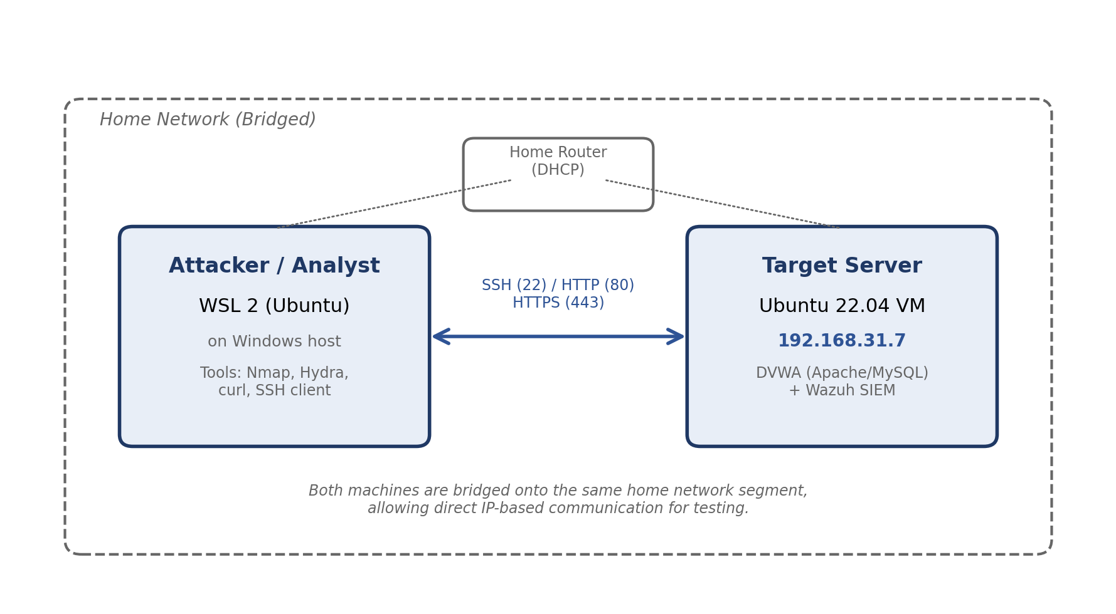
The attacker/analyst environment (WSL 2) and the target server (Ubuntu VM) are both bridged onto the same home network segment, communicating over SSH (22), HTTP (80), and HTTPS (443).

Asset Inventory
Asset | Type | Owner / Department | Why It Matters
Employee laptops & workstations | Hardware | IT Director, employees | Entry point for phishing/malware; daily productivity depends on them
Ubuntu web server | Hardware/Infra | IT Director, sysadmin | Hosts the customer-facing portal
Customer portal web app | Software | IT Director, customers | Handles logins, customer data, support tickets
Internal company website | Software | Marketing/IT | Public-facing brand presence
Customer & employee database | Data | IT Director, HR | Highest-sensitivity asset — contains PII
Employee user accounts & credentials | Personnel/Data | HR, IT | Compromise enables broader access
Internet-facing connection | Connectivity | IT Director | Underpins availability of all online services

CIA Analysis
Asset | Confidentiality | Integrity | Availability
Customer database | PII must not be exposed | Records must not be altered | Staff need reliable access
Customer portal app | Sessions/tokens must stay private | App logic/data must not be tampered with | Downtime = lost business
Employee credentials | Passwords/hashes must never leak | Accounts must not be modifiable improperly | Employees need login access
Ubuntu web server | SSH/config access restricted | OS/files must not be modified | Server uptime underpins portal
Employee laptops | Local files/credentials protected | Malware shouldn't alter files | Staff need working machines

Risk Assessment
Asset | Threat | Vulnerability | Impact | Risk Rating | Recommendation
Portal login / SSH | Brute force | No lockout or MFA | Account takeover, fraud | High | Lockout, MFA, strong passwords
Customer database | SQL Injection | Unsanitized input in queries | Mass data theft | High | Parameterized queries
Portal app / users | XSS | No output encoding | Session hijacking, phishing | Medium | Output encoding, CSP
Ubuntu web server | Command Injection | User input passed to shell | Full server compromise | Critical | Avoid shell calls with user input
Employees | Phishing | No awareness training | Initial access point | Medium | Security awareness training
Database, systems | Insider threat | No RBAC / audit logging | Data theft, sabotage | Medium | RBAC, audit logging
Employee laptops | Malware | No patch mgmt / EDR | Ransomware, lateral movement | Medium | Patch management, EDR
Internet connection | Denial of Service | No rate limiting | Portal downtime | Low | Rate limiting, firewall rules

Methodology
This assessment followed a structured consulting lifecycle: Scoping & Discovery (Week 1), Assessment (Week 2), Detection & Investigation (Week 3), and Remediation & Reporting (Week 4). The lab environment was fully deployed and understood before any attack was attempted, including deployment of the Wazuh SIEM so that all subsequent findings could be validated against real monitoring data rather than assumption.

Application Map
An inventory of DVWA's login page and the vulnerability modules used during this assessment, noting what each module does and what input it accepts.
Module | Purpose | Input Accepted
Login page | Authenticates users into the portal | Username, password
Brute Force | Demo login form vulnerable to repeated attempts | Username, password (GET parameters)
SQL Injection | Looks up a user record by ID | User ID (text field)
XSS (Reflected) | Displays a greeting using submitted input | Name (reflected into page HTML)
Command Injection | Pings a supplied IP address | IP address (passed to system shell)
DVWA Security | Controls site-wide vulnerability difficulty | Security level selector
Observation: All tested modules accept free-text input via simple HTML forms with no client-side or server-side restriction at the "low" security setting, which is precisely what allows each attack in this assessment to succeed.

Network Reconnaissance
Command used: nmap -sV -p- 192.168.31.7
Port | State | Service | Notes
22/tcp | open | OpenSSH 8.9p1 | Admin access; brute-force target
80/tcp | open | Apache httpd 2.4.52 | Hosts DVWA
443/tcp | open | HTTPS | Wazuh dashboard
1514-1515/tcp | open | Wazuh agent comms | Internal SIEM traffic
55000/tcp | open | Wazuh API | Manager REST API

Attack Simulation Findings

Attack Log
Attack | Target / Module | Payload / Method | Timestamp | Result / Evidence
Brute Force | DVWA Login Form | curl script (Hydra v9.6 bug workaround) | Jul 28, ~15:51 | Correct password found (1/6 attempts)
Brute Force | SSH — testuser (dedicated) | hydra -l testuser -P wordlist | Jul 28, 10:03:04–09 | "password1234" found
Brute Force | SSH — secadmin (supplementary) | hydra -l secadmin -P wordlist | Jul 27, 06:19:08–12 | Password found in 6 tries, ~4 sec
SQL Injection | DVWA SQL Injection module | %' or '0'='0 | Jul 27, ~11:57 | Full user table (5 records) dumped
XSS (Reflected) | DVWA XSS (Reflected) module | <script>alert(...)</script> | Jul 27, 12:08 | Script executed in browser
Command Injection | DVWA Command Injection module | 127.0.0.1 && whoami | Jul 27, 12:13 | "www-data" returned in output

Finding Detail — Brute Force
DVWA Login Form: Due to a confirmed upstream bug in Hydra v9.6 (condition-parsing regression affecting F=/S= flags, documented in the tool's public issue tracker with no available fix), a short custom curl script was used instead to achieve the equivalent result. The correct admin password was identified out of 6 attempts, with all other attempts correctly reported as failed.
SSH — testuser: A dedicated, low-privilege account was created specifically for this test, separate from the primary administrative account. Hydra identified the correct password ("password1234") in a single pass.
SSH — secadmin (supplementary): The primary administrative account's password was also found to be crackable via the same small wordlist, completing in approximately 4 seconds — included here as additional evidence of weak credential practices.

Finding Detail — SQL Injection
The payload %' or '0'='0 bypassed the intended single-record lookup and returned all 5 user records in the database, demonstrating that unsanitized user input was concatenated directly into a SQL query.

Finding Detail — Cross-Site Scripting
The injected script <script>alert('XSS Vulnerability Found')</script> executed directly in the browser, confirming the application reflects user input into the page without sanitizing or encoding it.

Finding Detail — Command Injection
The payload 127.0.0.1 && whoami returned normal ping output plus an additional line (www-data) — the output of the injected command — confirming arbitrary OS command execution in the context of the web server's account. This is the most severe finding of the assessment.

Detection Notes & Incident Timeline

Detection Note 1 — Brute Force (Detected)
Method: Wazuh Threat Hunting, query rule.groups: authentication_failed. Result: 10 alert events found, clustered within a two-second window, auto-classified under MITRE ATT&CK "Password Guessing" and "SSH" technique categories. The sub-second timing between failed attempts is itself a strong indicator of automated tooling.

Detection Note 2 — SQL Injection (Not Detected)
Method: Wazuh Threat Hunting, queries against rule.groups: web and narrowed time-range browsing. Result: No alert was generated at any point. Wazuh's default rule appears to pattern-match overtly malicious markers (e.g., <script> tags), which this SQLi payload did not contain — a genuine gap requiring custom detection rules.

Detection Note 3 — Cross-Site Scripting (Detected)
Method: Wazuh Threat Hunting, query rule.groups: web. Result: One alert generated (rule 31106, level 6), automatically mapped to MITRE ATT&CK T1190 (Exploit Public-Facing Application) and compliance frameworks (NIST 800-53, PCI DSS, GDPR).

Detection Note 4 — Command Injection (Not Detected)
Method: Wazuh Threat Hunting, time range narrowed to the exact attack window. Result: No alert was generated — the most significant detection gap in this assessment, given this was also the most severe attack performed.

Detection Summary
Attack | Severity | Detected? | Method
Brute Force (SSH) | High | Yes — automatic | Rule 5760/5503, MITRE-mapped
SQL Injection | High | No | Gap identified
XSS (Reflected) | Medium | Yes — automatic | Rule 31106, MITRE-mapped
Command Injection | Critical | No | Gap identified
Key finding: Detection coverage does not correlate with attack severity. The two most severe attacks (SQL Injection and Command Injection) were both missed by default detection rules, while a medium-severity attack (XSS) was caught automatically simply because its payload matched a generic pattern-matching rule.

Incident Timeline
Time | Event | Source (Wazuh/Log) | Evidence / Notes
Jul 27, 06:19:08–12 | Brute force against SSH (secadmin) | Hydra terminal output | Password cracked in ~4 sec
Jul 27, 11:49:13–15 | 10 auth failure events logged | Wazuh SIEM (rule 5760/5503) | Automatic detection confirmed
Jul 27, ~11:57 | SQL Injection payload submitted | DVWA / Apache access log | No Wazuh alert generated
Jul 27, 12:07:57 | XSS payload submitted, alert fired | Wazuh SIEM (rule 31106) | Automatic detection confirmed
Jul 27, 12:13 | Command Injection payload submitted | DVWA application | No Wazuh alert generated
Jul 28, 10:03:04–09 | Brute force against SSH (testuser) | Hydra terminal output | Dedicated low-priv account cracked
Jul 28, ~15:51 | DVWA login brute force (curl script) | Terminal output | Correct password identified

Incident Summary
Between July 27–28, 2026, a series of simulated attacks were conducted against the SecureCorp customer portal and supporting infrastructure as part of this authorized assessment. All attacks succeeded in compromising their target objective. Of the four core attack types (Brute Force, SQL Injection, XSS, Command Injection), two were automatically detected by the deployed Wazuh SIEM, and two produced no detection under the platform's default configuration.

Root Causes
- Weak password policy with no account lockout or MFA (enabled Brute Force success on both DVWA login and SSH)
- Lack of input validation / parameterized queries on the customer portal (enabled SQL Injection)
- Lack of output encoding on user-reflected content (enabled XSS)
- Unsafe use of user input in system shell commands (enabled Command Injection)
- SIEM default rule set does not cover SQL Injection or Command Injection patterns specific to this application

Immediate Recommended Actions
- Change all default/weak credentials used during this assessment
- Prioritize remediation of Command Injection (highest severity, least detectable)
- Develop custom Wazuh detection rules for SQL Injection and Command Injection patterns

Recommendations
Area | Current State | Recommendation | Priority
Authentication | No lockout, no MFA, weak passwords accepted | Enforce strong password policy + lockout + MFA | High
Input Handling (Database) | Raw input concatenated into SQL queries | Parameterized queries / prepared statements | Critical
Output Handling | User input reflected without encoding | Output encoding + Content Security Policy | High
Input Handling (OS) | User input passed directly to shell | Avoid shell calls with user input; use safe APIs | Critical
Security Monitoring | Default rules miss SQLi and Cmd Injection | Develop custom Wazuh detection rules | High
Access Control | No RBAC or audit logging observed | Implement RBAC and audit logging | Medium
Patch Management | No defined patching cadence | Establish regular patch management schedule | Medium
Security Awareness | No employee training program | Conduct periodic security awareness training | Medium
Network Exposure | SIEM ports reachable from general network | Restrict SIEM ports to management segment | Low
Availability / DoS | No rate limiting on internet-facing services | Apply rate limiting and firewall rules | Low
Backup Strategy | No backup policy observed | Establish and test regular backup procedures | Medium

Appendix: Evidence Index
Evidence File | Description
week1-vm-created.png | Target VM created and running
week1-wsl-to-vm-ping.png | Network connectivity confirmed
week1-ssh-wsl-to-vm.png | SSH access established
week1-apache-default-page.png | Web server operational
week1-dvwa-login-page.png / dashboard.png | Vulnerable web application deployed
week1-wazuh-install-complete.png | SIEM installation completed
week1-wazuh-dashboard.png | SIEM dashboard operational
week1-wazuh-agent-000-active.png | Self-monitoring agent active
week2-nmap-scan.png | Network reconnaissance results
week2-bruteforce-dvwa-login.png | DVWA login brute force execution
week2-bruteforce-testuser-ssh.png | Dedicated low-priv SSH brute force
week2-bruteforce-ssh.png | Supplementary secadmin SSH brute force
week2-sqli-before.png / payload-dump.png | SQL Injection execution and result
week2-xss-alert-triggered.png | XSS attack execution
week2-cmdinjection-normal.png / payload.png | Command Injection execution and result
week2-detection-bruteforce.png | Brute force detection confirmed
week2-detection-xss-found.png | XSS detection confirmed
week2-detection-sqli-not-found.png | SQL Injection detection gap confirmed
week2-detection-cmdinjection-not-found.png | Command Injection detection gap confirmed

Report prepared as part of a self-directed home lab security assessment project, modeled on a professional penetration testing and SOC analysis engagement.

