
VILNIUS UNIVERSITY
FACULTY OF MATHEMATICS AND INFORMATICS
INFORMATION SYSTEM ENGINEERING

IMPENSA
DOCUMENTATION

Maksim Barbašov
Igor Repkin
Table of Contents
Background 3
Idea 3
Team Structure 3
Technologies 4
Devops 6
Gantt chart 7
Functionality Walkthrough 8
Homepage 8
Registration 8
Login 8
Dashboard 9

Background
- Impensa translates from Latin as expense, outlay, expenditure. The idea behind the website is to provide users with a simple and effective expense management app. This documentation is intended to familiarize the reader with: the idea behind the project, scope of work, app functions, development schedule, used technologies, and team members.

Idea
- We are an open-source alternative to products such as Mint, Simplifi, or PocketGuard. Although the functionality of the app is not as advanced, we're designed to be more developer-friendly. Impensa allows you to see where all your money goes by easily adding and categorizing expenses.

Team Structure
- Maksim Barbašov
  - responsible for front-end development and documentation.
- Igor Repkin
  - responsible for back-end development, deployment and documentation.

Technologies
- Full-stack JavaScript:
  - We use Node.js to power our servers and React to power our frontend. Almost all of the code you'll touch in this codebase will be JavaScript.
- Express JS
  - Our backend framework of choice. Express.js, or simply Express, is a back end web application framework for Node.js, released as free and open-source software under the MIT License. It is designed for building web applications and APIs. It has been called the de facto standard server framework for Node.js.
- PostgreSQL
  - PostgreSQL, also known as Postgres, is a free and open-source relational database management system emphasizing extensibility and SQL compliance.
- React
  - React is a free and open-source front-end JavaScript library for building user interfaces based on UI components. It is maintained by Meta and a community of individual developers and companies. React can be used as a base in the development of single-page or mobile applications.
- React Chart.js 2
  - a free open-source JavaScript library for data visualization, which supports 8 chart types: bar, line, area, pie, bubble, radar, polar, and scatter.

Devops
- GitHub
  - a provider of Internet hosting for software development and version control using Git. It offers the distributed version control and source code management functionality of Git, plus its features.
- Digital Ocean
  - DigitalOcean is an American cloud infrastructure provider headquartered in New York City with data centers worldwide. DigitalOcean provides developers with cloud services that help to deploy and scale applications that run simultaneously on multiple computers.
- Figma
  - a vector graphics editor and prototyping tool which is primarily web-based, with additional offline features enabled by desktop applications for macOS and Windows.
- Discord
  - instant messaging and digital distribution platform. Users communicate with voice calls, video calls, text messaging, media, and files in private chats or as part of communities called "servers".

Gantt chart
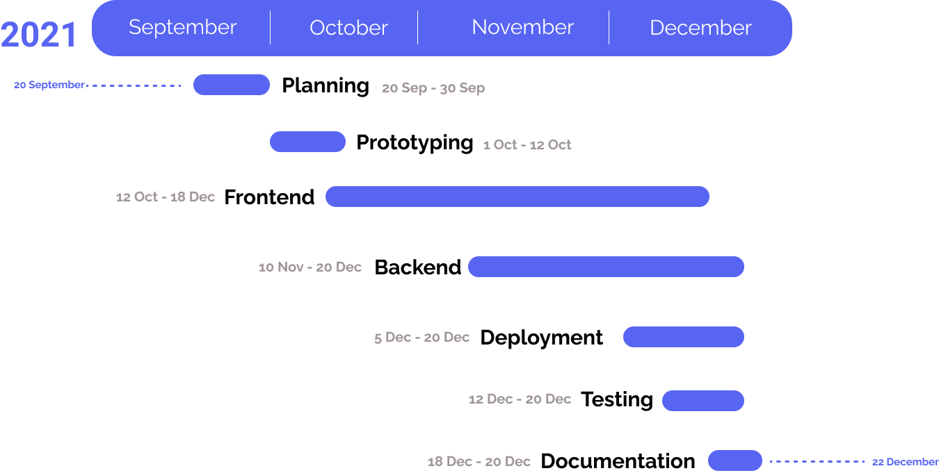

Functionality Walkthrough

Homepage
Potential user is met with Impensa's landing page which features all the essential parts of functional as well as links to the GitHub repository.

Registration
User's attempts to access the app dashboard from the homepage, without authentication, will inevitably result in a redirect to the homepage. Navbar at the top of the homepage gives the user an option to either sign into their account or register a new one. The "Sign Up" button will redirect the user to the registration page. We are using a separate page and not a modal, to provide a password manager an opportunity to input preset values in inputs. Four inputs must be filled in for an account to be created; Namely: "Name", "Currency", "Email", "Password". All the above could be later modified in the settings. Once all the needed data is provided, the user is redirected to the dashboard.

Login
The registered account can then be accessed via the login page. The user is required to provide the email and password. If the data is correct the user is redirected to the dashboard page.

Dashboard
After the successful login or registration user is redirected to the dashboard. The dashboard is the main page of the app. Impensa has 4 subpages on the dashboard. The first one is the overview page. On it, the user can see the 4 latest expenses and the graph of all expenses as well as how much was spent today. The second page is expenses. The user is presented with a donut chart and all expenses made in the current month. The third page is an archive where the user can review every single expense he has ever made. And the last page is settings where the user can change his password, email, or name. Apart from the main 4 pages, the user can also press the logout or contact buttons. The logout button removes the JWT token from the storage and the user is disconnected. Contact button leads to our forum on Github.

