**Exercise: Stock Trader use cases**

Features for the Stock Trader Program:

1. **User Login**: Users should be able to log in to the application using their credentials.
2. **Buy Stocks**: Users can buy stocks by specifying the stock symbol, quantity, and purchase price.
3. **Sell Stocks**: Users can sell stocks from their portfolio by specifying the stock symbol and quantity.
4. **View Stock Portfolio**: Users can view their current stock portfolio, including the number of shares owned and the purchase price for each stock.
5. **Retrieve Current Stock Prices**: The program should be able to fetch the current market prices for stocks in the user's portfolio.
6. **Compute Portfolio Value**: Users can check the current value of their entire stock portfolio based on current market prices.

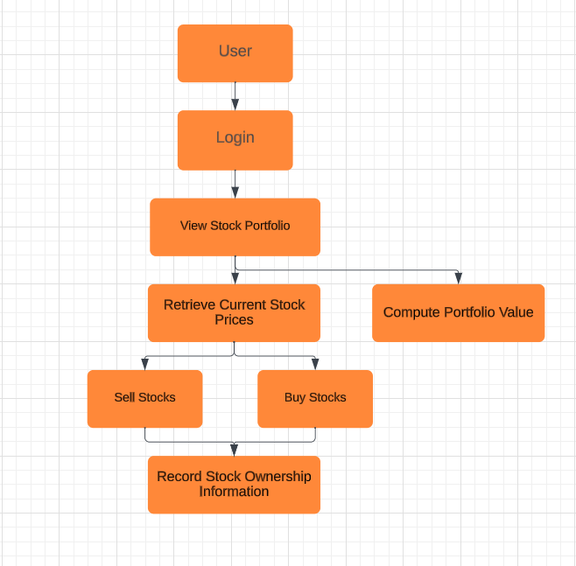**Use Case 1:** User Login

* Actors: User
* Description: Allows users to log in to the Stock Trader program using their credentials.
* Trigger: User initiates the login process.
* Pre-conditions: None.
* Post-conditions: User is logged in, granting access to other features.

**Use Case 2:** Buy Stocks

* Actors: User
* Description: Enables users to purchase stocks by specifying the stock symbol, quantity, and purchase price.
* Trigger: User decides to buy stocks.
* Pre-conditions: User must be logged in.
* Post-conditions: Stocks are added to the user's portfolio with the specified details.

**Use Case 3:** Sell Stocks

* Actors: User
* Description: Allows users to sell stocks from their portfolio by specifying the stock symbol and quantity.
* Trigger: User decides to sell stocks.
* Pre-conditions: User must be logged in, and they should own the stocks they want to sell.
* Post-conditions: Stocks are removed from the user's portfolio, and the user receives funds based on the sale.

**Use Case 4:** View Stock Portfolio

* Actors: User
* Description: Permits users to view their current stock portfolio, including the number of shares owned and the purchase price for each stock.
* Trigger: User wants to check their portfolio.
* Pre-conditions: User must be logged in.
* Post-conditions: User can see a summary of their stock holdings.

**Use Case 5:** Retrieve Current Stock Prices

* Actors: User
* Description: Allows the program to fetch the current market prices for stocks in the user's portfolio.
* Trigger: User requests to get the latest stock prices.
* Pre-conditions: User must be logged in.
* Post-conditions: Current market prices for stocks in the portfolio are updated.

**Use Case 6:** Compute Portfolio Value

* Actors: User
* Description: Enables users to calculate the current value of their entire stock portfolio based on current market prices.
* Trigger: User decides to compute their portfolio's current value.
* Pre-conditions: User must be logged in, and stock prices must be up to date.
* Post-conditions: User receives the total current value of their portfolio.

**Use Case 7:** Record Stock Ownership Information

* Actors: User
* Description: Allows users to record information about stocks they own, including the amount owned, purchase date, and purchase price.
* Trigger: User wants to add detailed information about a stock they own.
* Pre-conditions: User must be logged in.
* Post-conditions: Detailed information about the stock ownership is added to the user's portfolio, including the quantity owned, purchase date, and purchase price.
* This use case addresses the requirement to keep track of a trader's investments and store additional information about stocks owned. Thank you for pointing it out, and I hope this addition is helpful.