Problems:
There are 28243 user_ids in “payer_at_30.csv” and “users.csv”. 4.858 % of users pay for a game after 30 days. In order to predict which users should we activate adds in Stage II. I built a predictive model for a binary classification.

Data cleaning:
- In machine column: lobby and Lobby are the same, lobby was replaced by Lobby; missing data was replaced by Unknown.
- All rows with the same user_id, machine, user_level, bank_balance are considered as one loging. Removing these duplicates helps reduce turns.csv from 8943337 rows to ~47000 rows.

Features engineering:
This is supervised learning with binary classes: payer_at_30. I engineered features:
classes: "payer_at_30"
existing features: "platform", "gender", "age_range", "device_type"
new features:
"machine_play_most": which machine/game users play the most
"avg_time" : on average how many time users log-in per day?
"level_change_rate" : rate of changing levels
"max_user_level" : maximum level user obtain
"balance_change_rate": average change of bank balance
"abs_balance_change": absolute change of bank balance
"max_balance": maximum bank balance
"time_start": after install corhot, when did users start playing?

Features planning to create related to user behavior: (easy to build)
- Number of times users play in the: morning, noon, afternoon, evening, night.
- On average how many time users play in week day, and in weekends.

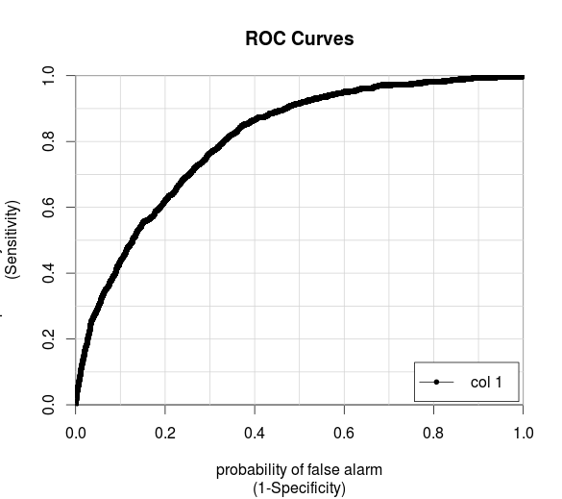
Glm binary model: Easy to build, easy to scale out, fast
- Split data into 70% for training and 30% for cross validation
- Key features: max_user_level, platformiOS, level_change_rate, avg_time, max_balance. See photos include with this file.
- Obtained area under curve = 0.8066975 (good result)
- Output is the probability for user will pay_at_30. Best cut off is at 0.0438875

threshold | accuracy
0.0438875 | 0.7043131

- So the answer is user with probability < 0.0438875 should activate with ads.

How to improve model?:
- Engineering extra features (above)
- More data! For example, more data will let features {"avg_time", "level_change_rate", "max_user_level", "abs_balance_change", "max_balance"} converge. Better prediction.
- Bagging with other models. But I am not sure people use bagging in industry?!

How to run my scripts:
- OS: Ubuntu
- Python 2.7.6, libraries: pandas, numpy,
- R: libraries: ggplot2, gridExtra for plotting; caTools, pROC for easy plotting ROC curves and calculating area under curve as well as finding best cut-off.
- Files python are for cleaning and engineering features.
- Predictive model is in R file. I use R (3.0.2) because, I have some categorical variables. I can build glm model using scikit-learn package. Easy and doable task, but I need extra time.

Question 2: If we can control the frequency of ads showing, how do you decide the number of ad impressions shown to a given user in a fixed amount of turns played (e.g., showing 2 ads every 10 turns vs showing 5 ads every 10 turns)?

I think I will base on the cut-offs: let say I find a cut-off_01 so that higher than this cut-off, I don't show add. Cut-off_02 so that between cut-off_01 and cut-off_02 I show 2 adds every 10 turns. And lower and cut-off_02 I will show 5 adds every turns.

Question 1: Use another technique (statistical approach, different algorithm) to build a second model. How does this model compare to the first model? What disadvantages/advantages does it have over the previous model?

In R file, I use random Forest model without any fancy tuning yet. This model give higher accuracy 0.8116812 (ntrees=1000). From my experience, randomForest gives high accuracy, but it is hard understand feature importance. I think it is slower than glm. I don't know how does it scale for real “big data” project.

